

Curriculum Mapping Tool

User Guide

Version 4.0

# Version History

|  |  |  |  |
| --- | --- | --- | --- |
| Date | Version | Author | Description |
| 05/4/2013 | 1.0 | Dr Qurat Tariq  Michelle Martin | First version of user guide for WSU Curriculum Mapping Tool with details of technical as well as pedagogical aspects |
| 1/6/2014 | 2.0 | Dr Qurat Tariq  Michelle Martin | Major upgrade Bulk Upload of templates, Validation of Unit and Course data, added reporting functionality |
| 4/5/2015 | 3.0 | Michelle Martin | New Unit Header field Embedded Academic Numeracy Development and related reports |
| 10/8/2015 | 3.1 | Michelle Martin | Replace Engagement in Curriculum with Work Integrated Learning |
| 31/3/2016 | 3.2 | Michelle Martin | New functionality in Employee Course Permissions allocation  New Sustainability mapping for GAs 6 and 9 |
| 05/4/2017 | 4.0 | Jim Vaughan  Michelle Martin | Conversion from MS Access to Azure-based application |

# Acknowledgements

Development of the Curriculum Mapping Tool drew on our experience of using the *Curtin Curriculum Mapping Tool* developed by the Office of Teaching & Learning at Curtin University of Technology and the *Subject Overview Spreadsheet* (SOS) developed by the Teaching & Learning Centre of the Faculty of Business, University of Technology Sydney.

The CMT was developed by the Office of PVC Education under the leadership of:

**Dr Betty Gill,** Associate PVC Education, Health & Science – concept & development;

With substantive contributions from:

**Dr Sara Denize**, Deputy Dean, School of Business – concept & development;

**Ms Michelle Martin**, Consultant – technical development;

**Ms Sharon Short**, Project Officer, Office of PVC Education – project management;

**Dr Qurat Tariq**, Course Quality Officer – pedagogical input, drafting and coordination of user guide production;

**Ms Lauren Thompson**, Curriculum Advisor – pedagogical input;

**Ms Rosemary Thompson**, Lecturer in Higher Education – pedagogical input;

**Dr Thuy Vu**, Curriculum Advisor –pedagogical input;

**Dr Carol Russell**, Senior Lecturer in Higher Education – pedagogical input;

**Dr Evelyn Hibbert**, Learning Advisor Academic Literacy – pedagogical input;

**Lauren Ross**, Learning Advisor Academic Literacy- pedagogical input;

**Dr Caroline Henderson-Brooks**, Learning Advisor Academic Literacy – pedagogical input;

**Lisa Hanlon**, Course Quality Officer – pedagogical input.

# Table of Contents

1. Curriculum Mapping and Alignment Process 7

1.1 Introduction 7

1.2 The Context 8

1.3 The Process 8

1.3.1 Phase 1. Charting the Existing Landscape (Course) 9

1.3.2 Phase 2. Charting the Existing Landscape (Units) 9

1.3.3 Phase 3. Capturing Complete Data into CMT (Mapping) 9

1.3.4 Phase 4. Reviewing Course Data (Curriculum Alignment) 9

1.3.5 Phase 5. Revising Course (Curriculum Alignment) 9

2. Data Captured by the Mapping Process 10

2.1 Key information required – Course Data 10

2.1.1 Course Learning Outcomes (CLOs) 10

2.1.2 Professional Accreditation (PA) 10

2.1.3 Graduate Attributes (GA’s) 10

2.1.4 CLO-GA mapping 10

2.1.5 PA-CLO mapping 10

2.1.6 AQF CLO mapping 11

2.1.7 List of Units to be mapped 11

2.2 Key information required –Unit Data 11

2.2.1 Basic Unit Information 11

2.2.2 Unit Learning Outcomes (ULOs) 11

2.2.3 Levels of thinking 12

2.2.4 ULO-CLO mapping and levels of Assurance 12

2.2.5 Blended Learning Profile 12

2.2.6 Work Integrated Learning 13

2.2.7 Research in Curriculum 14

2.2.8 Embedded Academic Literacy Development 14

2.2.9 Embedded Academic Numeracy Development 15

2.2.11 Validation Features 20

3. Curriculum Mapping Tool (CMT) Application 21

Introduction 21

Permissions within the program 21

Type of Users and available functions 21

CMT layout and navigation 22

3.1 Maintain Existing Data - Courses 23

3.1.1 Create a new course 23

3.1.2 Edit, Copy, Delete, Restore courses 24

3.1.3 Course Learning Outcomes 26

3.1.4 Professional Accreditation Mappings 27

3.1.5 AQF Level Definition/s and Mapping 28

3.1.6 Course Assessment Modes 29

3.1.7 Add Units to Course 29

3.1.8 Unit Sets 31

3.1.9 Course Views 34

3.1.9 Course Reporting 35

3.2 Maintain Existing Data - Units 38

3.2.1 Relationship of Units to Courses 38

3.2.2 Add New unit 38

3.2.3 Edit existing unit 41

3.2.4 Deleting Units 41

3.2.5 Preview Unit Summary 42

3.2.6 Unit Validation Summary 43

3.3 Administrator only functions 44

3.3.1 Maintain Reference data 44

3.3.2 System Administration 45

Appendix A: Anderson and Krathwohl’s Taxonomy 48

Appendix B: Assurance of Learning 50

Appendix C: Levels of Authenticity 53

Appendix D: Validation Reporting For System Administrator 55

# List of Figures

Figure 1. Curriculum Mapping and Alignment Process using CMT 8

Figure 2 Taxonomy of the cognitive Domain – then and now 48

Figure 3 Assuring learning 50

Figure 4 Example of a simplistic curriculum map 51

Figure 5 UWS Assurance of Learning Level definitions 52

# List of Tables

Table 1. Anderson and Krathwohl’s Levels of Thinking 12

Table 2. Levels of Assurance of ULO-CLO Mapping 12

Table 3. Description of various blended learning profiles 13

Table 4. Description of levels of Work Integrated Learning 13

Table 5. Types of student learning around research 14

Table 6. Various levels of embedded academic literacy development 14

Table 7. Various levels of embedded academic numeracy development 15

Table 8. Assessment types with description 15

Table 9. Assessment modes and corresponding assessment types 16

Table 10. Assessment due dates 18

Table 11. Types of Markers 19

Table 12. Feedback Types 19

Table 13. Various levels of authenticity with examples 20

Table 14. Available functionalities with authorised user access 21

Table 15. Course Validation reference 55

Table 16. Unit Validation reference 56

1. Curriculum Mapping and Alignment Process

1.1 Introduction

This initiative supports Objective 2 of the WSU L&T Plan 2012-2014: Curriculum Standards.

The WSU Curriculum mapping tool (CMT) has been designed to support and enable comprehensive mapping of curricula so as to demonstrate alignment and integration across the curriculum. The production of visual representations (and summaries) of key elements (described below) of the curriculum enable their alignment and scaffolding across the curriculum to be demonstrated, provide evidence to evaluate the adequacy of that alignment, identify gaps, inconsistencies, under-representation of key elements, as well as strengths and coherence across the curriculum. The tool also enables the mapping of Professional Standards (i.e. requirements of Professional Accreditation bodies) across the curriculum to facilitate the development of documentation required for professional accreditation.

The development of the CMT is a work in progress and version 1 has been released to a limited number of people in the first instance to allow any problems with the tool to be identified and corrected. A mechanism for updating the tool following any such corrections has been implemented and advice is provided to all users by the Project Manager: Sharon Short, when this is required.

As development has progressed, issues have arisen requiring further clarification, such as the range of assessment modes which are available for selection. This list of assessment modes and definitions is primarily developed to facilitate the use of Curriculum Mapping Tool (CMT). It is hoped that schools consider and utilise the list beyond CMT, i.e. to achieve clarity and uniformity of assessment terms across disciplines or across units, in a way that is appropriate to each school.

The list is intended to cover the majority of assessment modes used at WSU. Mode definitions and examples will assist in clarifying the ways in which each mode may be interpreted and is used across disciplines and also to encourage consistency in the terminology used to present those modes to students.

The list is intended to be comprehensive yet as small as possible, to adequately reflecting the range of different modes of assessment utilised across disciplines. The list has been provisionally endorsed by Senate Education Committee.

It is planned that further enhancements to the tool will be made, however given the complexity of the task and the urgent need of many disciplines for an effective and efficient way to undertake curriculum mapping, including for professional accreditation purposes, version 1 of the tool has been released for use from March 2013. The working party is interested in hearing feedback from users of the tool and indeed ideas for further inclusions or capacities which users believe will enhance the utility of the tool. All such feedback should be provided to the Project Manager: Sharon Short ([s.short@WSU.edu.au](mailto:s.short@uws.edu.au)).

1.2 The Context

Increasingly changes in the higher education policy and regulatory landscape (TEQSA, AQF; HE Standards Panel) place increasing emphasis on quality assurance and accountability, with institutions required to evidence graduate outcomes and standards and the means by which they are achieved and assured.

For example, the Higher Education Standards Panel in the *Draft Standards for Course Design and Learning Outcomes* (March 2013; see [www.HEstandards.gov.au](http://www.HEstandards.gov.au)) clearly emphasises and reinforces the importance of curriculum mapping, through articulation of the following standards:

* ‘The relationship between the overall learning outcomes for each course of study and the learning outcomes for units that contribute to the course of study is demonstrable;
* The assessment of student learning, whether at unit level, course level, or in combination, encompasses all specified learning outcomes for each course of study;
* Methods of assessment are consistent with the types of learning outcomes being assessed and are capable of validly and reliably confirming that specified learning outcomes are achieved’.

In addition, the standards require not only ‘the mastery of specific disciplinary and/or interdisciplinary knowledge and skills characterising the field of study’ – the traditional focus of academics, but they also require that course learning outcomes are informed by:

* ‘The generic skills and attributes required of graduates (WSU Graduate Attributes);
* The application of generic skills and attributes in the context of the field of study including the communication skills required, and
* The requirements of employment related to the field of study’.

The CMT has been designed to support and enable these aspects to be articulated and demonstrated across the curriculum. It also provides a mechanism by which to map student assessment load and distribution across units which constitute the course, to encourage and facilitate a whole-of-course perspective and review of assessment design and distribution.

1.3 The Process

This section outlines a suggested process for carrying out a cycle of curriculum review by using the newly developed Curriculum Mapping Tool (CMT). Templates have been developed and are provided as attachments to this guide to assist with the process. The commencement of the process will be through nomination of course by the concerned Deputy Dean or APVC(Ed) for mapping, which may also be requested to them by the DAP.

|  |  |
| --- | --- |
|  |  |
|  |

Figure 1. Curriculum Mapping and Alignment Process using CMT

1.3.1 Phase 1. Charting the Existing Landscape (Course)

**Suggested Staff:** Curriculum Advisor (CA), Course Quality Officer (CQO), DAP

The DAP provides the following information to CA/CQO:

* Course Learning Outcomes (CLO) and their mapping to WSU Graduate Attributes (GA)
* Professional Accreditation Competencies list, if applicable, and mapping to CLO
* List of Course Units to be mapped (Core units plus any others required)

1.3.2 Phase 2. Charting the Existing Landscape (Units)

**Suggested Staff:** CA, CQO, DAP, ACA, Unit Coordinators

CA/CQO gives briefing to all members of the review/teaching team about the CMT, its functionality and key principles underlying its development and use. The members are given an overview of Anderson and Krathwohl’s Taxonomy (Levels of Thinking) (see **2.1.2(0)** **2.2.3 Levels of thinking** and **Appendix A**) and the type of unit information required to be entered in CMT for each unit e.g. Blended Learning profile, Work Integrated Learning, Research in Curriculum and other assessment details. This is elaborated through reference lists of available options. Academics are also informed about ULO to CLO mapping and the associated three levels for Assurance of learning (Introduced, Developed, and Assured) (**Appendix B**, description in Error! Reference source not found.**4**). Work in this phase can be achieved in a mini workshop, the duration of which will be determined based on the group’s needs and knowledge of the above curriculum aspects.

1.3.3 Phase 3. Capturing Complete Data into CMT (Mapping)

**Suggested Staff:** CA, CQO

The information gathered in phase 1 and 2 is entered in CMT. Reports are generated and forwarded to the DAP and ACAs for initial analysis.

1.3.4 Phase 4. Reviewing Course Data (Curriculum Alignment)

**Suggested Staff:** DAP, ACA, Unit Coordinators, CA, CQO,

The whole course team identifies any issues exposed by CMT reports and discusses strategies to address those issues. Questions may be raised around the following issues:

* Coverage of GA and Professional competencies, as required
* Scaffolding and assurance of each CLO in the course
* Graduate attributes developed and measured through a variety of teaching and assessment styles and modes
* Student workload around assessments over a study period (i.e. across all core units)
* Assessment methods supported by teaching activities to close the loop in ensuring attainment of unit learning outcomes (i.e. capable of validly and reliably measuring ULO achievement)
* Teaching and learning activities which assist students to develop and measure increasingly higher levels of thinking through progression of the course

1.3.5 Phase 5. Revising Course (Curriculum Alignment)

**Suggested Staff:** Deputy Dean, DAP, ACA, Unit Coordinators, CA, CQO

In light of conclusions drawn in phase 5, unit coordinators work on units needing revision. The updated unit information are submitted by the agreed deadline to the DAP, CA and CQO. The revised units are fed in the ‘Build Scenario’ area of the tool to obtain updated maps. Deputy Dean, DAP, CA and CQO review the reports and confirm the revised course or identify further changes.

All unit coordinators are informed of the decision and are asked to prepare documents after making identified changes, if any, for the unit approval process.

DAP initiates the course approval process through SAC.

2. Data Captured by the Mapping Process

The first part of this section lists the key data elements that are required to be inserted in the tool database. It also elaborates on the definitions and restrictions associated with each item. Items requiring further description have been linked to either available external resources or relevant material added as appendix.

Two ways to upload data in bulk are explained in sections 2.3 and 2.4. A template with title ‘CMT Unit Data Template’ has been prepared to facilitate bulk upload of data in the pilot phase. Details of the template and the associated instruction guide on filling the template are included in section 2.3.

2.1 Key information required – Course Data

Data required is divided into two categories: Course-related and Unit-related

2.1.1 Course Learning Outcomes (CLOs)

* CLOs are clear and succinct *learner (student)-centred* statements that describe the knowledge, skills, or personal and professional attributes that students will be able to demonstrate upon successful completion of the program.
* A capacity to insert a maximum of 30 CLOs is provided in the tool.
* It is required that each CLO statement be given a short description (i.e. label) of up to 30 characters (including spaces) for neat presentation on reports.

2.1.2 Professional Accreditation (PA)

* The tool enables courses accredited by professional bodies to demonstrate alignment of the curricula with the competency standards set by the body.
* PA statements are the graduate professional competency requirements from the accrediting body that must be addressed in the accredited course design.
* Currently, there is no limitation on the number or length of PA statements which can be inserted.
* The tool has the capacity to map multiple PAs to unit learning outcomes (ULOs).

2.1.3 Graduate Attributes (GA’s)

* The WSU Graduate Attributes (nine) have been incorporated into the CMT.
* The GA’s have been listed at the “domain” level, except for the first attribute. Because this attribute refers to multiple specific literacies (communication, numeracy, social skills, information and technology literacies) then these levels have been specified.

2.1.4 CLO-GA mapping

* Assurance of WSU Graduate Attributes is achieved by aligning them with CLOs (ensuring their coverage and articulation within their disciplinary context).
* Each CLO of a course needs to be mapped to at least one and a maximum of two WSU Graduate Attributes (GA)

2.1.5 PA-CLO mapping

* Assurance of PA competencies in the course is captured in the PA-CLO mapping.
* Each PA attribute must be mapped to at least one CLO.

**Note:** An additional option has been provided in the tool to enable mapping of PAs directly to the comprising units’ ULOs. **(See 3.1.3)**

2.1.6 AQF CLO mapping

The Australian Qualifications Framework (AQF) is the national policy for regulated qualifications in Australian education and training. All qualifications offered by the university must be AQF compliant by 2015. A feature has been added in the tool to enable mapping of the Course Learning Outcomes to the corresponding AQF level and learning outcomes criteria for Knowledge, Skills and Application of knowledge and skills.

2.1.7 List of Units to be mapped

* All units that form the core of the course need to be added in the database and linked to the course.
* The tool allows the user to determine the level of mapping. For example, for a singular course then all units which students must complete for graduation would be added to the database and mapped. However, where a course is structured with a number of key programs for example, then each key program (core, plus specialist KP units) would be added and mapped.

2.2 Key information required –Unit Data

2.2.1 Basic Unit Information

This includes ‘Unit Code’, ‘Unit Title’, ‘Level number’ and whether the unit is offered in a ‘1H or 2H’ session.

**Note:** Nomination of 1H or 2H for unit offering is included so that the assessment maps will incorporate additional weeks which 1&2H sessions comprise. No other information about session is included, as when the units are incorporated into the course database their session of offering “within *that* course” is specified.

2.2.2 Unit Learning Outcomes (ULOs)

* Similar to CLOs, ULOs are concise statements that describe what the students will know or be able to do upon successful completion of the unit.
* ULOs are narrower in scope than CLOs and some may have focus specific to the discipline of the respective unit. However, it is important to note that all ULOs contribute towards realization of CLOs.
* It is recommended that about 6-8 discrete learning outcomes are developed for each unit which are clear and measurable.
* Note: It is intended that the tool will restrict the number of ULO’s to maximum eight in the future. However, this restriction has been removed during the pilot phase so that existing ULO, which in some instances exceed this number, can be inserted for mapping of existing courses to inform their review. During this phase all ULO’s above eight will appear in red.
* It is suggested that Anderson and Krathwohl’s Taxonomy of learning is used to frame learning outcomes. A brief description on various levels of this taxonomy is provided below and a resource, including, examples of action verbs for each level, is attached as Appendix A
* It is important to ensure that the ULOs are measurable (use concrete active verbs) and include a combination of lower and higher order thinking skills.
* Further guiding material on writing effective learning outcomes can be found in the [WSU Assessment Guide](http://www.uws.edu.au/__data/assets/pdf_file/0004/449860/Assessment_Guide.pdf), developed by Teaching Development Unit (Pg. 9-14)
* [Expanded Taxonomy of Learning](http://ideal.uiowa.edu/files/ideal.uiowa.edu/files/Expanded-Taxonomy-of-Learning.pdf), developed by Centre for teaching at University of Iowa which also provides definitions of taxonomy levels and additional examples of related verbs for each level.

2.2.3 Levels of thinking

Each ULO must be assigned a level from the six levels of Anderson and Krathwohl’s Taxonomy of learning, briefly described in the table below. (See Appendix A for further details)

Anderson and Krathwohl’s Taxonomy is a revised version of Blooms Taxonomy and divides cognitive process into six increasingly complex levels of thinking.

Table 1. Anderson and Krathwohl’s Levels of Thinking

|  |  |  |
| --- | --- | --- |
| Level No. | Level of Thinking | Cognitive Process |
| 1 | Remember | Retrieve relevant knowledge from long-term memory. |
| 2 | Understand | Construct meaning from instructional messages, including oral, written, and graphic communication. |
| 3 | Apply | Carry out or use a procedure in a given situation. |
| 4 | Analyse | Break material into constituent parts and determine how parts relate to one another and to an overall structure or purpose. |
| 5 | Evaluate | Make judgments based on criteria and standards. |
| 6 | Create | Put elements together to form a coherent or functional whole; reorganize elements into a new pattern or structure. |

2.2.4 ULO-CLO mapping and levels of Assurance

* Each ULO is to be mapped to one or more CLO (Maximum 3) to confirm alignment of the unit with the course outcomes.
* Assurance of learning levels are provided to allow the articulation of where in the curriculum (i.e. which ULOs) the key concepts, skills and attributes articulated in the course learning outcomes are developed and ultimately assured (i.e. assessed at the level expected of a graduate).
* The ULO-CLO mapping and specification of the level of assurance at which the CLO is recognised enables the identification of how course learning outcomes are being taught and ultimately assessed at the graduate level (i.e. “assured”).
* Three levels of assurance are included as described in Table 2.

Table 2. Levels of Assurance of ULO-CLO Mapping

|  |  |
| --- | --- |
| **Level of Assurance** | Description |
| Introduced | The Unit Learning Outcome is introducing concepts and/or skills associated with and contributing to Course Learning Outcome recognition. |
| Developed | Further development of concepts and/or skills which have already been introduced and contribute to Course Learning Outcome recognition. |
| Assured | The Course Learning Outcome or component part is assessed **at the level expected of a graduate**, thus assured. |

Two key unit characteristics (blended learning profile and whether units involve community engagement as a learning strategy) have been included within the tool in order to facilitate reporting on these two strategic university priorities.

2.2.5 Blended Learning Profile

Six categories describing the mode of delivery of the unit and its blended learning profile have been incorporated. These categories have been developed in collaboration with the Blended Learning implementation team and may be subject to change as the Universities strategy and understanding of variation in blended learning profiles develops.

Available options are given in Table 3 below.

Table 3. Description of various blended learning profiles

|  |  |
| --- | --- |
| Blended Learning Profile | Description |
| Face-to-Face Only | Learning activities take place face-to-face on campus, supported by WSU site. |
| Blended (Online) | Mixture of face-to-face and online delivery of learning activities |
| Blended (other) | May involve face-to-face activities, but includes (or is solely) other activities such as practicum, workplace learning etc. |
| Online Only | All learning activities are online with no compulsory attendance required. |
| External with workshop | Learning is predominantly off campus and may include online delivery, but with compulsory intensive attendance (eg. Workshop) |
| External only | All learning activities take place off campus, by other than online means, with no compulsory attendance. |

2.2.6 Work Integrated Learning

* WIL refers to a range of approaches and strategies that involve using the workplace and community as a site and/or source for learning. As a site, students undertake a work/community related project or a placement in a work/community environment as part of their study program. As a source, students engage with work, work-like and community experiences to learn about the professional work, the community, possible careers, and themselves.
* WIL can be incorporated into the curriculum at different levels: (a) whole units being designated for WIL experience; and (b) WIL components being incorporated into units to prepare students for WIL experience.
* Whole WIL units may be classified into: Service-learning; Industry projects; Work placement – observational; Work placement – experiential; Structured practicum.
* WIL components as part of units may include: Simulations (Moot court, Business case, Objective Structured Clinical Examination), Guest lectures, Site visits or Field trips.

Table 4. Description of levels of Work Integrated Learning

|  |  |
| --- | --- |
| Work Integrated Learning | Description |
| Service Learning | Service learning involves students engaging in not-for-profit or philanthropic activities/projects with a community partner to experience WIL and civic engagement. Service learning reflects the twin dynamics of experiential learning and service to the community. |
| Industry Projects | Involve students engaging in projects as individuals or within a team to meet the needs from the industry. These projects require students to integrate their multiple aspects of learning with the practice of work in addressing the industry’s needs. Examples may include: Capstone projects, Industry-driven research projects, or Projects for internal/external clients. |
| Work placement - observational | Requires students to be physically attending a professional workplace for a substantial period of time, observe everyday practice of the profession and learn from reflecting on that experience. |
| Work placement – experiential | Is a direct work experience where students perform everyday practice of the profession in the professional workplace and learn from reflecting on that experience. |
| Structured Practicum | Requires students to perform a prescribed list of professional activities in the professional workplace and achieve competencies that are determined by professional or industry bodies. |
| Nil |  |

Note: Cadetship, internship, placement, practicum or equivalent types of WIL can be categorised as Work placement-observational, Work placement-experiential, or Structured practicum depending on the nature of the experience planned for the students

2.2.7 Research in Curriculum

Learning to interpret, evaluate and utilise research, the research process and ultimately the generation of knowledge through researching is a fundamental hallmark of university education. This element has been incorporated into the tool to evidence how this learning is scaffolded across the curriculum. Table 5 elaborates the available options.

It is expected that all material taught in various units at WSU is informed by research, thus no nil option is included.

Table 5. Types of student learning around research

|  |  |
| --- | --- |
| Research in Curriculum | Description |
| Research informed learning | Learning about research done by others; the outcomes of recent research are explicitly included in the curriculum |
| Learning to do research | Learning research skills and methods; learning how to conduct research in the discipline |
| Learning in research mode | Enquiry-based learning; students produce or co-produce knowledge through researching |

2.2.8 Embedded Academic Literacy Development

* Academic literacy is students’ ability to use the English language to make and communicate meaning in spoken and written contexts.
* To improve student retention and their academic success, it has become increasingly important for universities nationwide to implement strategies to embed and integrate academic literacy skills within specific disciplinary contexts.
* WSU is taking serious initiatives to address development of academic literacies across each course taught at the university and to identify areas of low provision. Whilst clearly all units contribute to the development of academic literacy skills, this field of the tool seeks to collect information about the units which are intentionally designed to introduce, develop or assure academic literacies in their units. The available options for this field are listed below in Table 6.

Table . Various levels of embedded academic literacy development

|  |  |
| --- | --- |
| Embedded Academic Literacy Development | Description |
| No *Primary* Responsibility | The unit does not have explicit/primary responsibility for embedding academic literacy development in a course |
|
| Introduced | Unit has primary responsibility for introducing embedding, of explicit academic literacy skill development and support resources including early written diagnostic assessment task |
|
|
| Developed | Unit has primary responsibility for embedding key academic literacies development including assessment & feedback building on those introduced in earlier unit(s) |
|
|
| Assured | Unit has primary responsibility for assuring appropriate standard of academic literacy for a graduate of the discipline of study |

2.2.9 Embedded Academic Numeracy Development

* Academic numeracy is students’ ability to use numeric data and representations to make and communicate meaning in spoken and written contexts.
* To improve student retention and their academic success, it has become increasingly important for universities nationwide to implement strategies to embed and integrate academic numeracy skills within specific disciplinary contexts.
* WSU is taking serious initiatives to address development of academic numeracy across each course taught at the university and to identify areas of low provision.
* Whilst clearly all units contribute to the development of academic numeracy skills, this field of the tool seeks to collect information about the units which are intentionally designed to introduce, develop or assure academic numeracies in their units.

Table 7. Various levels of embedded academic numeracy development

|  |  |
| --- | --- |
| EAND type | Description |
| No *Primary* Responsibility | The unit does not have explicit/primary responsibility for embedding academic numeracy development in a course |
|
| Introduced | Unit has primary responsibility for introducing embedding, of explicit academic numeracy skill development and support resources including an early diagnostic assessment task |
|
|
| Developed | Unit has primary responsibility for embedding key academic numeracies development including assessment & feedback building on those introduced in earlier unit(s) |
|
|
| Assured | Unit has primary responsibility for assuring appropriate standard of academic numeracy for a graduate of the discipline of study |

2.2.10 Assessment details

Following is the list of particulars required for each assessment item in the unit.

It is acknowledged that units may have multiple components of a single assessment item with different weightage, task structure, submission date etc.

When such components have different assessment mode, task/marking structure, feedback type, Authenticity, these can be entered as separate items. However, if components vary only in weights and due dates, they should be entered as one combined item. (See section 0 and Appendix D for detailed instructions with example)

**Assessment Type**

An assessment can be classified as one of the following types.

Table 8. Assessment types with description

|  |  |
| --- | --- |
| Assessment Type | Description |
| Coursework | assessment that is not invigilated and occurs at any time during a unit of study | |
| Midsemester Exam | assessment that is invigilated and occurs during a unit of study other than the University examination period | |
| Final Exam | assessment that is invigilated and occurs at the end of a unit of study during the University examination period | |

2.2.10 Assessment details cont.

For further clarification, an **Invigilated assessment** is defined as**:***Assessment that has a pre-determined set of conditions on the way the assessment is taken, and thus, is closely watched over to ensure the conditions are met.*

This category helps course developers and managers in a number of disciplines to report proportion of invigilated vs. non-invigilated assessment as required by their accrediting and regulating bodies. It is expected that the Assessment Types do not need to be communicated directly to students (unlike assessment modes, which may be used as the descriptor of the assessment item in the learning guides for instance). Once an appropriate Assessment Type is chosen for a task, a Mode from the available list is then selected in CMT. Each Type has only certain modes available for selection (Please see below).

**Assessment Mode (WSU recommended classification)**

To enable mapping of assessment in the Curriculum Mapping Tool (CMT) a definitive list of assessment modes (item) needed to be incorporated. A working party was established with representation from the three cluster areas in order to develop the list of modes for inclusion, along with a clear definition and examples of common items of assessment which fit under each mode.

This list of assessment modes and definitions is primarily developed to facilitate the use of Curriculum Mapping Tool (CMT). It is hoped that schools consider and utilise the list beyond CMT, i.e. to achieve clarity and uniformity of assessment terms across disciplines or across units, in a way that is appropriate to each school.

The list is intended to cover the majority of assessment modes used at WSU. Mode definitions and examples will assist in clarifying the ways in which each mode may be interpreted and is used across disciplines and also to encourage consistency in the terminology used to present those modes to students.

The list is intended to be comprehensive yet as small as possible, to adequately reflecting the range of different modes of assessment utilised across disciplines. The list has been provisionally endorsed by Senate Education Committee.

Please note below some conditions on selecting assessment mode for an assessment type.

Table 9. Assessment modes and corresponding assessment types

| Assessment Mode | Description | Corresponding Assessment Type |
| --- | --- | --- |
| Annotated bibliography | A list of relevant research/work on a topic, with brief analysis or evaluation justifying the relevance to the topic | Coursework |
| Applied project | A product where theory is applied, or discovered through reflective practice, to create a model, a design, a program, a composition, or other creative work  *Examples include: Computer software, Music composition, Construction model, Prototype, Visual representation, Drawing, Concept map* | Coursework |
| Case Study | A description and/or analysis of a real-life situation  *Examples include: Health case study, Ethnographic observation* | Coursework |
| Critical Review | A written constructive criticism or judgement based on criteria  *Examples include: Review/ critique of performance, published work, artefact, construction, Critical appraisal.* | Coursework |
| Debate | An argument for and against a specific topic, often in teams and according to certain rules | Coursework |
| Discourse Analysis | A close examination of a spoken, written or visual text |  |
| Essay | An extended written response to a question, problem, issue, or a sub-set of questions.  *Examples include: Descriptive essay, Analytical essay, Argumentation essay, Structured essay.* | Exam & Coursework |
| Interview | A formal meeting conducted to elicit information from a person or group  *Examples include: Patient interview, Client interview* | Exam & Coursework |
| Learning Contract | Student-negotiated, self-directed assessment | Coursework |
| Literature Review | A written paper based on systematic and explicit identification, evaluation and interpretation of existing bodies of work | Coursework |
| Log/ Workbook | A record of observations, activities or goals that have been met/not met, often in chronological order  *Examples include: laboratory workbook, professional placement log, study journal* | Coursework |
| Multiple Choice | Response to a question selected from pre-determined set of answers  *Examples include: (Extended) Matching questions, True/False, MCQs.* | Exam only |
| Numerical Problem Solving | A comprehensive examination and analysis of information which involves the use of mathematics to generate a solution | Exam & Coursework |
| Participation | Student engagement with content, either online or face-to-face, according to explicit criteria  *Examples include: Tutorial participation, Online participation* | Coursework |
| Peer Review | A documented, critical judgment by students of peer work | Coursework |
| Portfolio | A student compilation of work with a coherent structure, collected over a period of time  *Examples include: e-portfolio, achievement showcase* | Coursework |
| Poster | A representational work for public display containing text and graphic elements  *Examples include: (poster) Exhibition* | Coursework |
| Practical | A demonstration of technical/professional skills  *Examples include: Teaching demonstration, Clinical or laboratory skills demonstration,* *Rehearsal process or performance, Listening tests.* | Exam & Coursework |
| Presentation | The process of showing and/or explaining content to an audience  *Examples include: Oral presentation, Audio-visual presentation* | Coursework |
| Professional placement performance | Demonstration of professional skills and abilities evaluated in a workplace context.  *Examples include: Clinical performance evaluation, 360° feedback, Clinical placement summary, Record of work experience form, Professional experience report* | Coursework |
| Professional task | An activity performed by professionals in everyday practice of the profession  *Examples include: advisory letter, health brochure, curriculum (lesson) plan, computing programming task* | Exam & Coursework |
| Proposal | A plan for potential future work, often with justification  *Examples include: Research proposal, Business proposal, Project proposal* | Coursework |
| Quiz | Non-invigilated response to a number of questions, the format of which may include MCQs and/or short answer | Coursework |
| Reflection | An evaluation of student’s own learning that includes narrative and critical/ analytical thinking  *Examples include: journal entry, reflective statement* | Coursework |
| Report | A structured analytical account of a project, investigation or process.  *Examples include: Scientific research report, Business report, Project report, Media report* | Coursework |
| Self- Assessment | An assessment of own knowledge, work, skill or ability according to criteria | Coursework |
| Short Answer | A brief written response in the form of words, symbols, or diagrams  *Examples include: Short answer questions, Musical notating, Minor problem-based questions.* | Exam only |
| Simulation | Action within a reproduction of a professional/disciplinary environment  *Examples include: Technology (usually digital), Experiential, Role play, OSCE* | Exam & Coursework |
| Summary | A short synopsis in prose of an article, chapter or other text | Coursework? |
| Thesis | An extended piece of research designed to set up and defend an intellectual position taken by its author | Coursework |
| Translation | Text being rendered/changed/converted from one language to another language | Coursework |
| Viva voce | A verbal explanation/account of a topic, problem or task  *Examples include: Oral examination* | Exam & Coursework |

**ULOs assessed**

This is the list of ULOs assessed by each assessment item/component.

All ULOs should be assessed and over assessment of the same learning outcomes should be avoided.

Assessment items appropriate for assessing the learning outcomes should be identified and an assessment should not generally address all ULO’s.

**Due date**

Select the week number when the assessment item (or component) is due for submission. Various options available are as follows

Table 10. Assessment due dates

|  |  |
| --- | --- |
| Due Date | Description |
| Weekly | For assessment that is conducted every week e.g. Quiz, Self-reflection, lab reports etc. |
| Multiple | For assessment that has multiple components/parts/stages, each due for submission in a different week (by the same student/group). It is required to select week numbers for this option |
| Week x | For assessment that is due in a particular week. Please select the required week number from the drop-down list. |

It is acknowledged that in some units, one assessment item may have different due dates for different groups of students. In that case, it is advised that a date is entered which is valid for the majority of the group or is a more sensible representation of the whole submission (e.g. latest date). Please DO NOT select ‘multiple’ option, as each student is going to submit their work only ONCE.

**Percentage weight**

Weight assigned to a particular assessment item (or component) in terms of percentage. The tool will automatically add up the percentages and display in red if it exceeds 100%.

**Threshold % and Description**

This option can be used for assessment items which have threshold requirements attached. The minimum marks that the student must achieve in order to pass the task are entered in terms of percentage. A description can also be added to include additional details.

**Satisfactory?**

This option can be used for items that do not have grades assigned to them. If an item is assessed on satisfactory/non-satisfactory scale, this option should be selected by ticking the check box

**Task structure**

This option describes how students are required to perform a particular assessment task. Available options are ‘Individual’ or ‘Group’.

**Marking structure**

This option describes how students will be marked on their performance for a particular assessment task. Available options are ‘Individual’ or ‘Group’.

**Marker**

This option describes the person who will be marking the assessment and will be responsible for providing feedback to students. Available options are:

Table 11. Types of Markers

|  |
| --- |
| Marker |
| Instructor only |
| Industry only |
| Peer only |
| Self only |
| Instructor /industry |
| Instructor /peer(s) |
| Instructor /self |
| Other |

**Feedback type**

This option captures the type of feedback given back to students for a particular assessment. Categories mentioned below encompass both face-to-face and online feedback types, where applicable.

Feedback type is configured to be set to N/A for final exam. Available options are:

Table 12. Feedback Types

|  |
| --- |
| Feedback Type |
| Whole Class |
| In Person |
| In class |
| Returned work |
| Peer |

**Feedback due**

Select the week when feedback will be given to students for a particular assessment item (or component). Feedback due is also configured to be set to N/A for final exam. Available options are the same as given above in **Table 10 (Assessment due dates)**.

**Level of authenticity**

Authenticity in assessment is determined by the degree to which the task connects learning at university with what graduates would be doing in the workplace. Tasks with higher levels of authenticity are typically open-ended, require a component of reflection on practice, and involve collaboration with people beyond university settings.

It is expected that a range of assessment tasks will (appropriately) be constructed at lower levels of authenticity and that students will have opportunities to work on tasks with higher levels of authenticity as they progress through their program of study.

Available options are given in Table 13. See **Appendix C** for more details on these levels.

Table 13. Various levels of authenticity with examples

| Level of authenticity | Definition | Examples |
| --- | --- | --- |
| **Low** | Assesses theoretical knowledge and/or skills, at remembering/comprehending levels | Knowledge test;  Mathematical calculation;  Essay; |
| **Medium** | Assesses theoretical knowledge and skills at applying/analysing levels, as used in professional contexts | Report;  Laboratory experiment;  Class presentation; |
| **High** | Assesses applied knowledge and skills in contextualised setting; involves self-reflection | Treatment plan;  Business proposal;  Fieldwork; |
| **Very high** | Assesses professional activity in context or for real world audience; requires critical self-reflection | Practicum teaching;  Treat patient;  Creative work for external audience |

2.2.11 Validation Features

CMT includes features to enable course editors and administrators to validate the data that has already been entered in the database. Validation can be performed on unit, unit set or course level. This feature will generate validation report for the selected unit, unit set or course highlighting incorrect and/or missing data. The validation report for unit set is a collection of unit validation reports for all units included in the set. For details on contents of each report, please refer to **Appendix D**. Further technical details on how the reports can be generated can be found in section 3.

3. Curriculum Mapping Tool (CMT)

This section introduces the Curriculum Mapping Tool software and its operational aspects. It provides a list of available functions in section 3.2. This part also describes various user groups with associated permissions. Section 3.3 includes instructions on setting up the software on your computer for all users. The last section introduces the reader to common features of the tool and the layout of its interface.

Introduction

The WSU Curriculum Mapping Tool is a cloud-based application that provides data capture, validation, summary and analysis of curriculum data described in section 2 of this document.

The CMT is accessed via the link: <cmt.westernsydney.edu.au>

Permissions within the program

Users will need to be added to the permissions register within the program. Currently, Sharon Short ([s.short@WSU.edu.au](mailto:s.short@uws.edu.au)) will be managing this role on behalf of APVC(Ed). Users need to provide:

* Network User/ WSU Staff ID
* Name
* Email Address
* Course Code and title. Also whether they are administrator for the course/s (administrators can add permission for others to edit their course/s

Type of Users and available functions

The user’s WSU staff number is used by the CMT to lookup permission to access different functions of the CMT.

The tool categorizes user groups according to their levels of access. Following is a depiction of three user groups embedded in the software with a list of accessible functionalities. Please note the overlapping hierarchy of access functions for higher level users.

Table 14. Available functionalities with authorised user access

|  |  |  |  |  |
| --- | --- | --- | --- | --- |
| **Functions** | **Description** | **Authorised Users** | | |
| Generate Reports | Generates tables, charts and summary and validation reports using data from a selection of units and courses | Editor |  |  |
| Edit Unit Data | Enables edition in unit data e.g. ULOs, mapping, assessment details etc. where user has edit permission for the primary course for that unit |
| Edit Course Data | Enables edition in course data e.g. CLOs, PA, mapping, unit sets etc. where user has edit permissions |
| Add New Unit | Allows addition of a new unit into CMT |
| Delete Unit | Allows deletion of an existing unit from CMT |
| Add New Course | Allows addition of a new course into CMT |
| Maintain Edit Course permissions | Course administrator – can delete course and assign edit permissions for course to other users | Course Administrator | |
| Delete Course | Allows deletion of an existing course from CMT |
| Maintain Reference Data | Enables additions and editions in reference data lists | Administrator | |
| Manage Users | Addition of new users and changes in access permissions e.g. providing editor/admin access to a course |
| Validation -multiple units and courses | Run validation reports across groups of units (e.g. by primary course) or multiple units/courses |

CMT layout and navigation

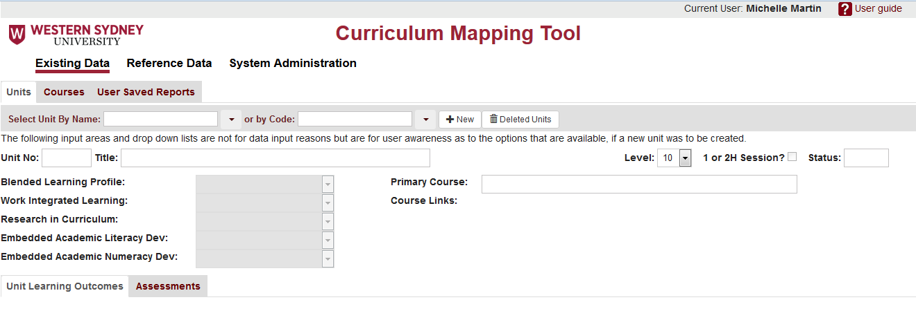

**Level 3**

**Level 2**

**Level 1**

The opening form presents all information in a hierarchy of three levels as marked in the screenshot above.

**Level 1** represents major functional areas in the CMT. Note only the Existing Data link will be visible for Edit only and Course Administrator level.

* Existing Data (for Edit and Course Administrators)
* Reference Data (for Administrator only)
* System Administration (for Administrator only)



**Level 2** accesses Unit maintenance, Course maintenance and stored reports created in the Course area.



Units and Courses initially show all headings with blank values. A unit or course is then selected by name or code in the provided drop-down lists. Options available for fields such as Blended Learning Profile can be viewed by hovering over the field **even in the blank state.**



**Level 3** offers further information for the selected level 2 item. For example **Units** tab will display two level 3 tabs (shown in screenshot below) i.e.

* Unit Learning Outcomes
* Assessments

3.1 Maintain Existing Data - Courses

The Existing Data is available to all types of users in the CMT.

In general, a course would be created first, then the units which belong to that course. This is so that these units can be assigned their primary course.

**Note:** **Course Edit permissions** must be assigned in the System Administration area for the user to have continued edit access to a course after it has been created.

The process for new courses is:

1. Add a new course as described in 3.1.1. Only header information needs to be added at this stage.
2. Apply to a System Administrator (at the moment, Sharon Short) to be given continued edit access to that course.
3. The course will then be listed in Existing Data, Courses dropdown list.

3.1.1 Create a new course

Select the **Courses** tab, then **+New Course**

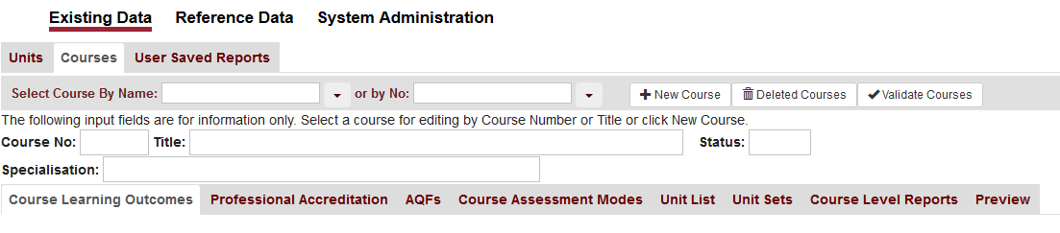

Course header details are entered into the popup window:

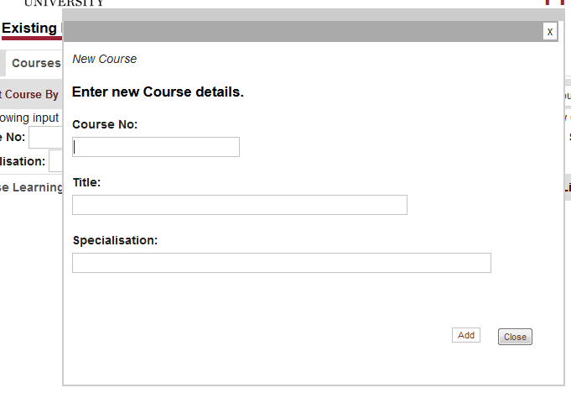

* + Enter the **Course No** (up to 8 alphanumeric

characters)

* + Enter Course Title (up to 100 alphanumeric

characters)

* + Specialisation is optional(up to 100

alphanumeric characters)

* + To cancel saving new course, click **Close**
  + To create new course, click **Add**

Either button closes popup and returns to Course form

At this point, the other course information can be completed by clicking the **Edit** button to unlock the form for editing. It will change to **Stop Editing** as shown below

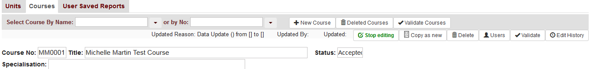

3.1.2 Edit, Copy, Delete, Restore courses

Courses for which the user had either Edit or Course Administration permissions will appear in the dropdown lists.

Courses can be selected by clicking the dropdown buttons at right of the Course Name or No dropdown lists:

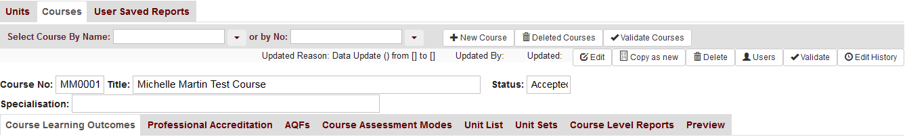

OR by **typing a search value**, which will limit the search list as you type:

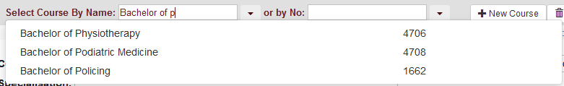

1. **Admin or Edit permissions for this course?**

If the user only has **Edit** permissions for this course they cannot delete nor add other users to this course, and their screen will appear as:



If they have **Admin** permissions, additional buttons allow extra functions as shown:



**ii. Creating a New Course from an Existing Course**

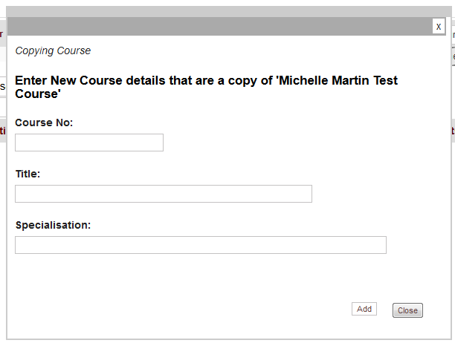Where two courses are similar, it can save a lot of time in creating each course from scratch by using the **Copy as New** button. A popup window will appear where the new course header details can be entered (same character length and type as for a new course):

* Click the **Add** button to create copy of the

course with all associated CLOs, PAs, Unit

Sets etc.

* Click the **Close** button to cancel course

copy.

**iii. Deleting Courses (and how to get them back!)**

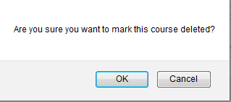When the **Delete** button is clicked, the user has an opportunity to cancel the deletion.

If “OK” is selected, the course is removed from the current working list, along with all its CLOs, PAs and their mappings, Units, Unit Sets, CLO/ULO mappings and Course Views.

**It is not actually deleted**.

Click on the **Deleted Courses** button to find all deleted courses in your permissions list.

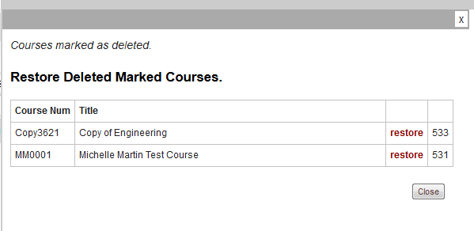

Click the **restore** button and **Close** the window to reinstate the course. It will reappear in the Select Course lists.

**iv. Adding permissions for other users to edit a Course**

If the user has Admin Permissions for a course, they can add other users to the course (Edit permissions only, not Admin) via the **Users** button.

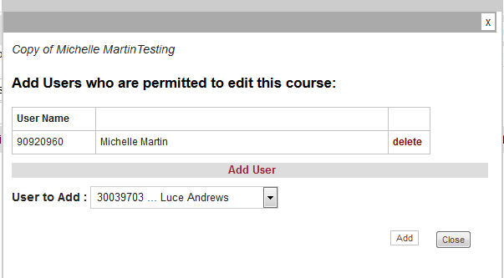

Select a user from the User to add dropdown list and click the **Add** button. Repeat this for each user to be added.

3.1.3 Course Learning Outcomes

The purpose of this tab is twofold:

* Enter and edit Course Learning Outcomes
* Map Graduate Attributes to Course Learning Outcomes

1. **Add new CLO**

* 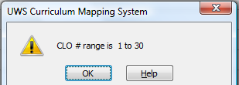Click into the CLO # field in the last row and enter a whole number between 1 and 30 (Decimal numbers can also be added, if need may arise e.g. to group CLOs together in categories). **If CLO # is greater than 30**, then the message appears (click OK to continue). The number must be changed to be between 1 and 30.
* Enter a Short Description (up to 30 characters) which will appear on reports
* Enter a long description which will be listed in full in the Course Preview report
* 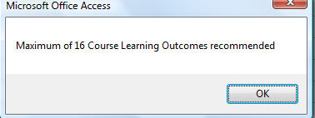**If a CLO number is entered on the 17th row**, a message appears – click OK to continue. This is only a recommendation, there is no programmed limit.

1. **Map Graduate Attributes to CLO**

* Click on the **+** button to open popup window where multiple GAs can be mapped to the CLO.



Number of Mapped GAs (not editable)

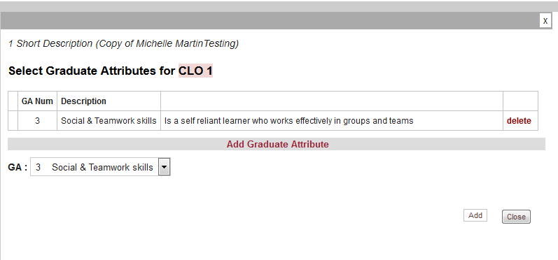

Select **GA** from the dropdown

Click on the **Add** button and the GA will appear in the list.

Repeat to add different CLOs.

3.1.4 Professional Accreditation Mappings

The second tab in Courses is used to map Professional Accreditation attributes both to CLOs and also directly to ULOs. Because there can be more than one Professional Accreditation body associated with a course, multiple PA sets can be created, each with a list of PA Attributes:

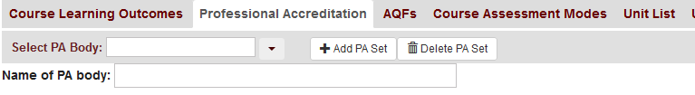

Select a PA Body for this course

**i Add new PA Body and PA Attributes**

* Click **+Add PA Set** and the **PA body** popup window will appear:

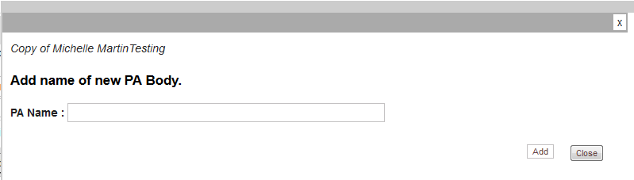

Enter name of PA body then **Add** to create PA Body in this course.

* Next, enter PA Attributes, starting with **PA Num** on first row . This field takes up to 5 alphanumeric characters to cater for sub-standards e.g. 1.2.
* There is no limit on number of PA attributes for a PA Body

Selected PA Body

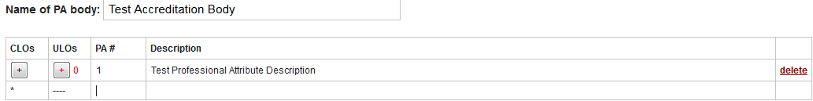

# mapped ULOs

PA Body Attributes

# mapped CLOs

Map PAs to CLO/s

Map PA directly to ULO/s

**ii Map CLOs and ULOs (cannot map ULOs until Units have been added to course!)**

* Operation of these popups is the same as for CLO/GA mappings
* There is no limit on number of CLOs or ULOs that can be mapped to a PA attribute

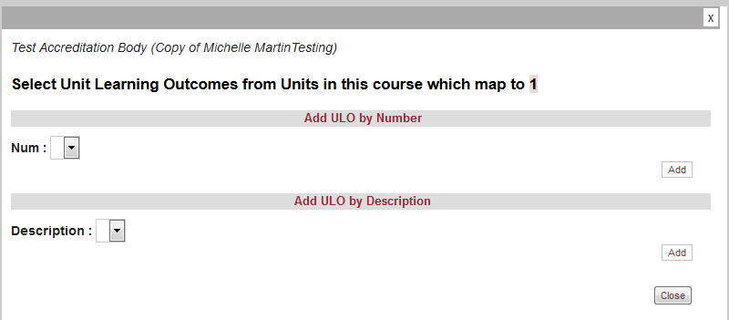

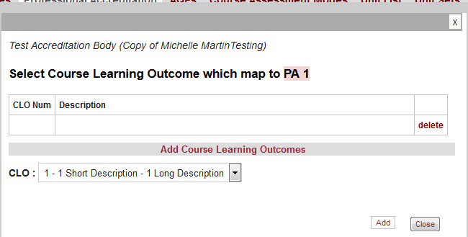

3.1.5 AQF Level Definition/s and Mapping

A course may contain multiple AQF Levels. Each AQF Level has a set list of AQF attributes which are standard institute-wide and automatically added when an AQF level is added to the course.

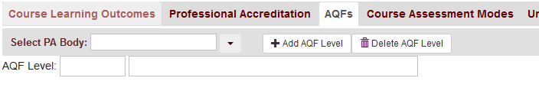

1. **Add new AQF Level**

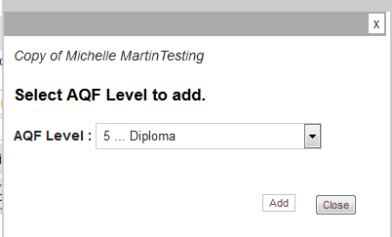

* Click **+ Add AQF Level** and select **AQF Level** in the popup

windowdropdown box.

* Click **Add** button to add the AQF Level to the course and

close the window.

The resultant Course AQF form now shows the AQF items associated with the AQF Level, ready for mapping to CLOs:

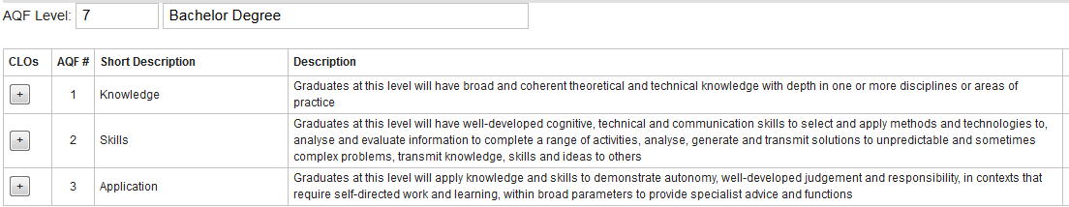

1. **Map CLOs**

* Operation of these popups is the same as for PA/CLO mappings
* There is no limit on number of CLOs that can be mapped to an AQF item

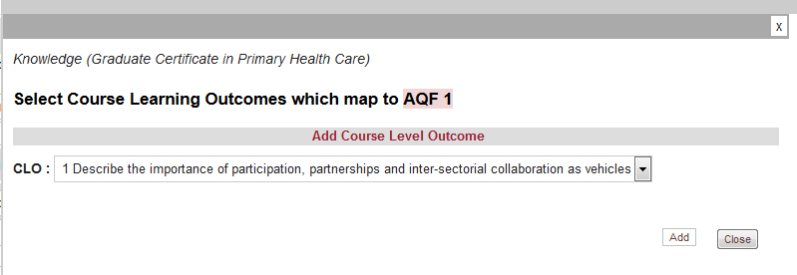

3.1.6 Course Assessment Modes

The assessment modes for this course will appear in the dropdown list under **Assessment Mode** in **Units** where this is the **Primary Course**. If the Unit requires a different assessment mode which is not in the list, negotiation must be made with the coordinator of the Primary Course for the unit. This may occur where the unit is included in another course which has different requirements because of its context in that course.

**\*\*Note to course owners: If a new Assessment Mode is required for your discipline, it must first be added to the master Assessment Mode list. (See Sharon Short).**

Add all Assessment Modes in one click!

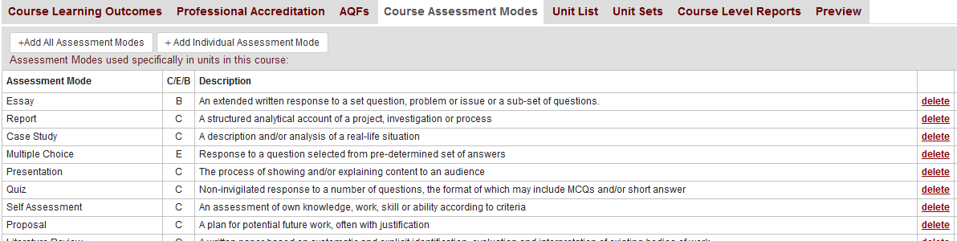

B=Both, C=Coursework only, E=Exam only

Individual assessment modes can be selected via the **+ Add Individual Assessment Mode** button opening the pop window:

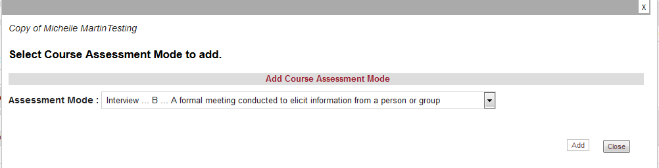

3.1.7 Add Units to Course

**(These units must have already been added through the Units tab)**

The Course Unit List is built by clicking the **+Add New Unit button** and selecting a unit from the popup window:

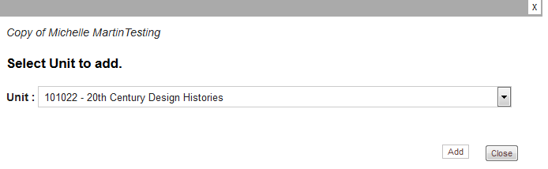

The resulting Course Units list appears with the Unit Learning outcomes displayed on the right side, ready for mapping to CLOs in this course:

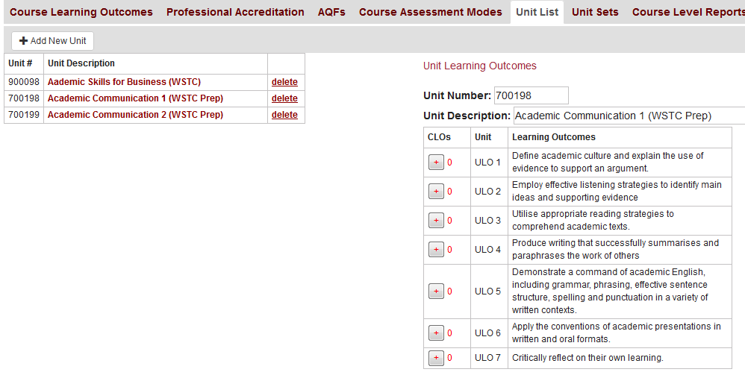

**Unit Validation Report?**

# mapped CLOs

1. **ULO/CLO Mapping**

Up to **3 CLOs** can be mapped to a ULO by clicking the + button under **CLOs** above.

Multiple CLOs can be added in the popup window below. Both **CLO** and **Assurance of Learning** must be selected for each mapping. (For more information, see **Appendix B**).

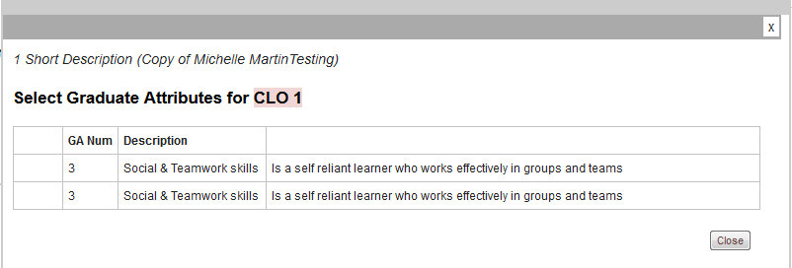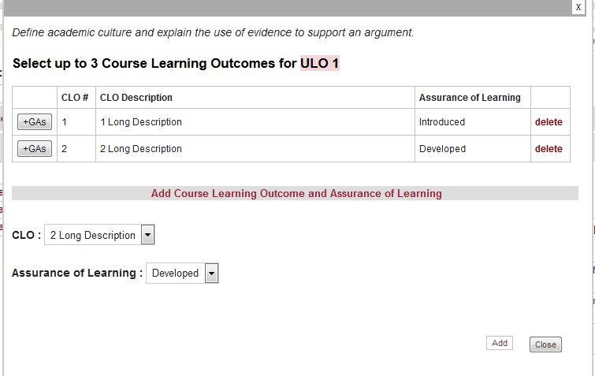

Click here to show GAs mapped to this CLO

The +GAs button can be clicked to open a read-only popup window of GAs that have been mapped to the CLO on the CLO tab in this course.

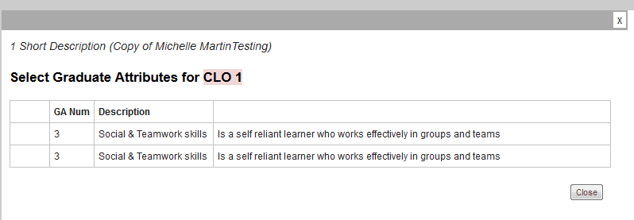

**ii Unit Validation Report**

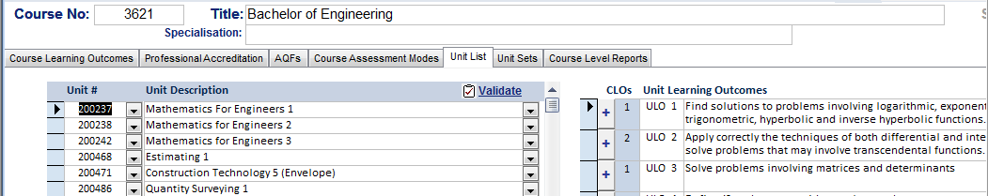The Validate button on this tab opens a popup window where multiple units from this course can be selected. This can be useful to ensure the integrity of the unit data before units are grouped into unit sets for analytical reporting.

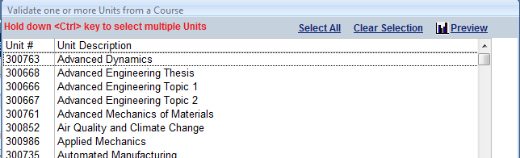The Preview button opens a report which looks similar to the individual **Unit Validation** report (see section 5.2.5).

3.1.8 Unit Sets

**(no limit on number of Unit Sets/Course or number of Units/Unit Set)**

Once a Unit List has been created for the course, **Units** need to be grouped into **Unit Sets** for reporting. The choice is entirely up to the group managing that course as to how Unit Sets are selected.

**Note:** There can be **multiple Unit Sets** with the **same units** in them, but only one can be selected at a time per **Course View Reporting** (See 3.1.9)

Select a Unit Set from this course

Validation report for one or more Unit Sets in this course

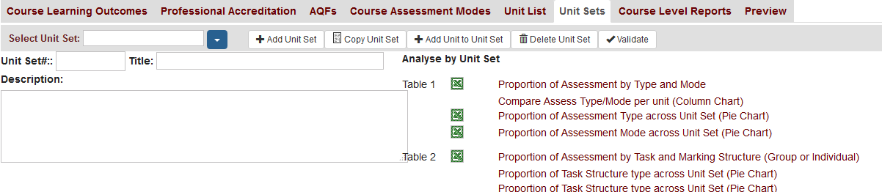

1. **Create Unit Set**

* Click **+Add Unit Set** to open new Unit Set popup:

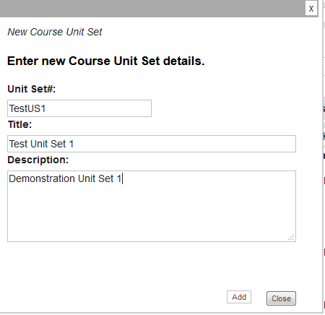

* **Unit Set No** (up to 8 alphanumeric characters)
* **Title** (up to 100 alphanumeric characters)
* **Descriptive title** (1000 characters)

OR

* Select a Unit set with a similar Unit List and Click **+Copy Unit Set**

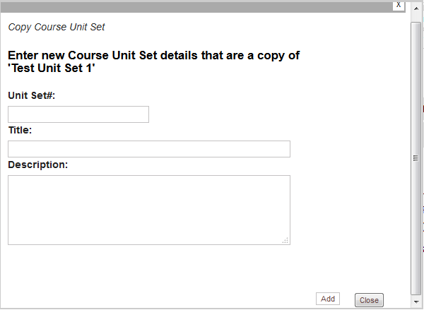

* Enter new Unit Set details as above. The associated Unit List will be copied over.

This feature has been incorporated to save time, in instances where many of the same units will be components of different sets. For example in a course with multiple key programs where the core is the same, then the core unit set could be copied from one KP map already done and inserted into another, then only having to add the specialist (KP) units.

1. **Create Unit List for Unit Set (no limit)**

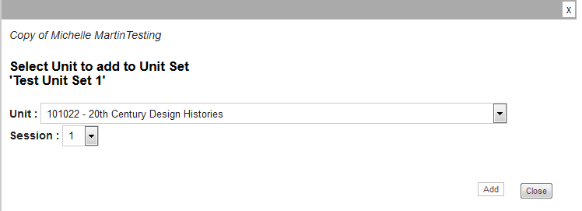

* Select a **Unit** from the dropdown to add (the Unit List for this course).
* The **Session number** is required to be **entered** **on every Unit** for reporting purposes
* **Note** – **units from more than one session** can be in the **same Unit Set**

1. **Validation Report for Unit Sets**

As on the Units tab, there is a validation button which opens up a popup window where one or more Unit Sets from this course can be selected to show in the validation report. It shows validation information about the units in the chosen Unit Set/s.

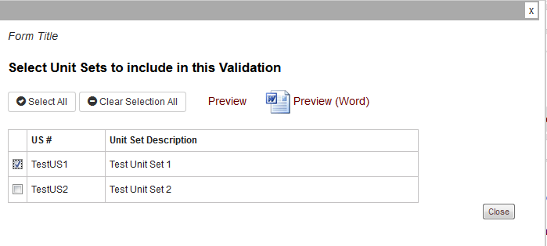

Tick one or more Unit Sets in the list and then choose one of the **Preview** options.

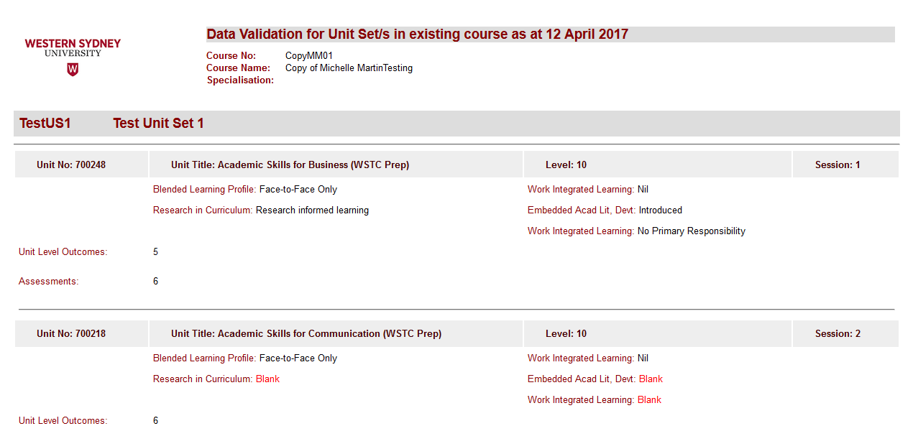

1. **Analysing Unit Sets**

There are 10 different Tables of data available for Unit Set Analysis. Some Tables provide reports in tabular, column chart and/or pie chart layouts. These are accessed through right hand side of the Unit Sets tab. Reports can be viewed in either a new web page (**NOT PRINT PREVIEW)** or Excel workbooks.

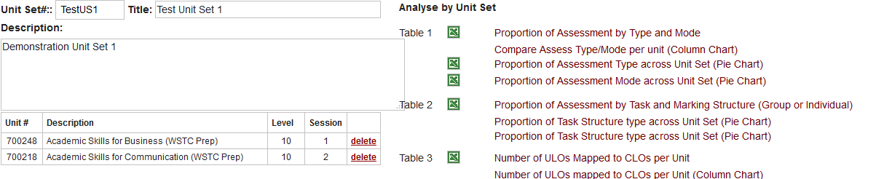

**Creating and saving Excel Reports**

When the Excel icon is clicked at the left of the report descriptions, a workbook is created.

The user will be prompted by the web browser to open or save the Excel file:

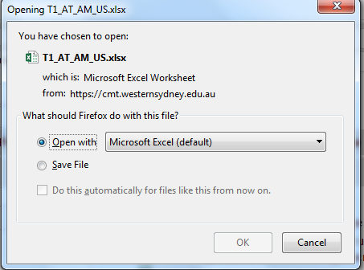

Whether the file is opened and later saved from Excel, or saved from this popup, the workbook will be saved on the web for later access – i.e. **User Saved Reports** tab.

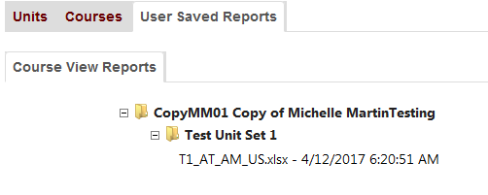

Note that a folder and subfolder is automatically built for the Course and Unit Set.

Where there are multiple reports for a table, there may be multiple sheets containing the pivot table and chart/s in one Excel workbook for example Table 4 RIC:

Workbook **based on** template T4 RIC US1.xlt

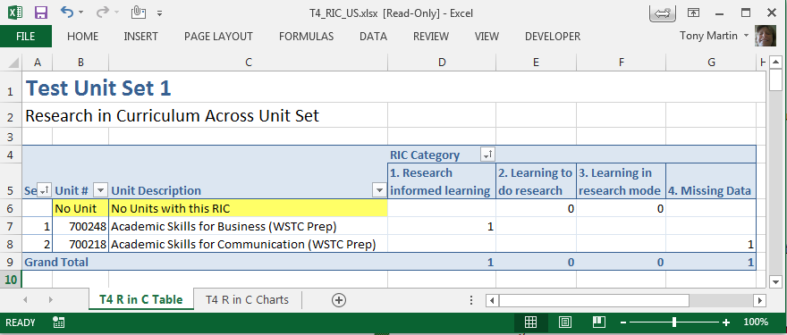

Data can be filtered through dropdowns

Unit Set title

3.1.9 Course Views

**(no limit on number of Course Views or Unit Sets/Course View)**

To analyse at a course level, combinations of Unit Sets and Sessions are brought together in a **Course View.**

**At least one Course View MUST BE CREATED BEFORE REPORTS CAN BE RUN**

Click into **Description of View** field and enter a meaningful title for the view, reflecting the *reason for grouping the unit sets* and also the session/s the view covers.

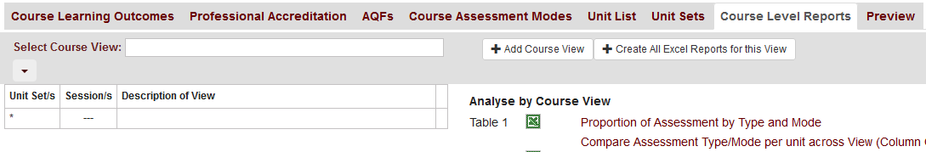

Once the Description of View has been entered, the Unit Set/s and Session/s buttons appear.

1. **Add Unit Sets to View**

* Click on the **+US** button at left of the Description of View field and a popup window will appear for entering the Unit Sets

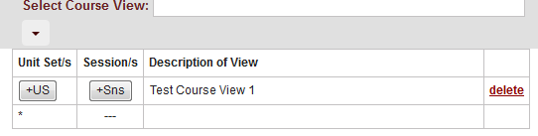

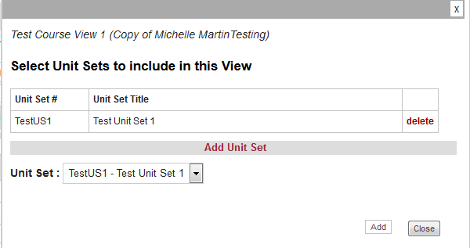

Select a Unit Set to add from the dropdown and click **Add** to add it to the list above.

Select Unit Sets by Unit Set #. **When another Unit Set is added which contains one or more common units, an error** will appear as below:

* 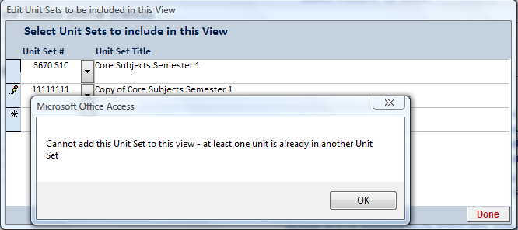

**This cannot be allowed** as it will skew the reports. Click **OK** to close the error window and **ESC** to undo the incorrect Unit Set.

1. **Add Sessions to View**

Click on the **+Sns** button at left of the Description of View field and a popup window will appear for entering Sessions:

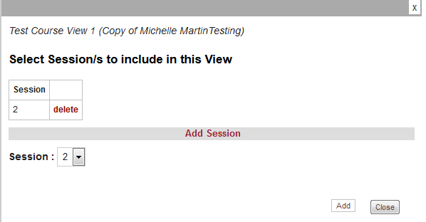

Only sessions which occur in the Unit Sets in this view will appear on the list

**Note: Ensure Unit Sets are selected for the view first before selecting Sessions.**

3.1.9 Course Reporting

The course does **not** have to be unlocked for edit to be able to run these reports. There are three areas of summary and analysis reporting for a course:

* **Course Preview:** A summary of the course where mappings are described in statements rather than charts
* **Course Level Analysis**: Groups of Unit Sets and Sessions which have been saved as a **Course View.** These reports are in either Pivot Table or Chart form
* **Course Level Validation**: Highlights incomplete data or data outside suggested parameters.

1. **Course Preview**

The Course preview report is accessed by clicking the Preview tab:

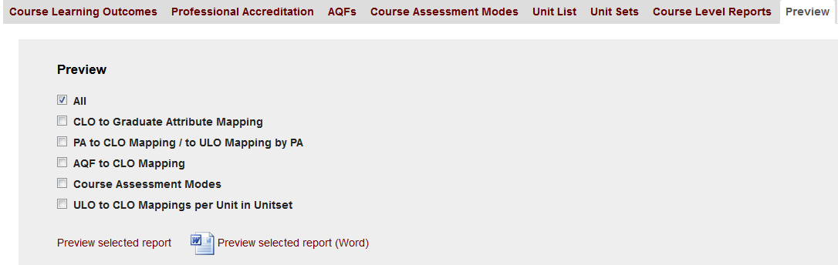

Export to Word document

View on new tab in browser

The report is divided into sections of which one or more can be selected as often not all the summary information is required.

1. **Course Level Analysis**

These present data spanning multiple Unit Sets and/or Sessions in a graphical manner. They are accessed via the **Course Level Reports** tab. Tables 1 to 10 and 12 are the same as those for Unit Sets but there is also Table 11 which relates to Professional Accreditation mappings which was only required for Course Views.

**A Course View must be selected in order to run these reports.** (Refer 3.1.8 – Creating Course Views)

Course view reports in browser view or Excel workbooks are run as per Unit Set reports. They will also appear in the User Saved Reports tab for later access.

**Creating a set of Tables (reports) for a View**

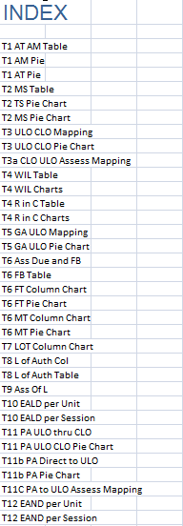Course View reporting has the additional ability to combine:

* All reports from one course view into one workbook
* Selected reports from multiple course views into one workbook

per report.

For example, this course view named **First Year** can conveniently present all the different aspects of the view in one place. (Good for emailing or printing).

The first sheet contains an index of all the different sheets in the workbook, and each sheet is labelled to indicate the Table number and also whether the data is in tabular, Pie chart or Column Chart format.

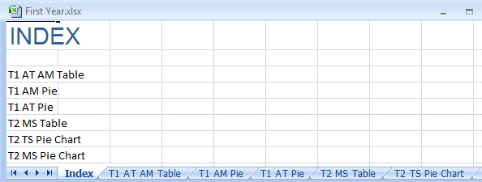

**Comparing data from different Course Views in a particular report**

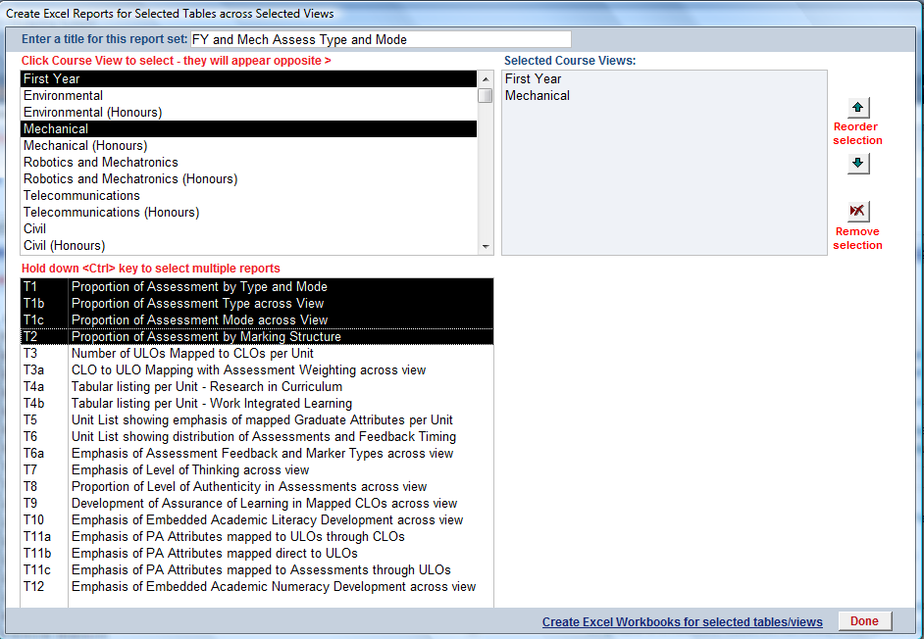This allows selected tables from multiple course views to be merged into a workbook. This “view” is given a title which is used to create a folder under the course. Selection is made through a popup window: Note that Course Views can be reordered or removed from the selected list using the buttons at right. Click the link next to Done button to create the reports.

This set of reports would be created in a new folder **FY and Mech Assess Type and Mode** under the Engineering Course folder. Inside that there will be a folder created for each of the three reports i.e. T1, T1b, T1c and T2. Each of these will contain a workbook for each course view, and a workbook with one sheet for each of the selected course views.

1. **Course Level Validation**

This report shows a summary of data which is outside agreed parameters (e.g. minimum number of CLOs) or missing data. It also lists the number of items in different elements of the course description e.g. number of CLOs, Professional Accreditation bodies, Course Assessment modes etc. For a full list of course and Unit Set validations, refer **Appendix D**.

There are two levels of course validation:

* Multiple course validation
* Selected Course validation



The **Validate Courses** button opens a selection window so that one or more courses can be validated at one time:

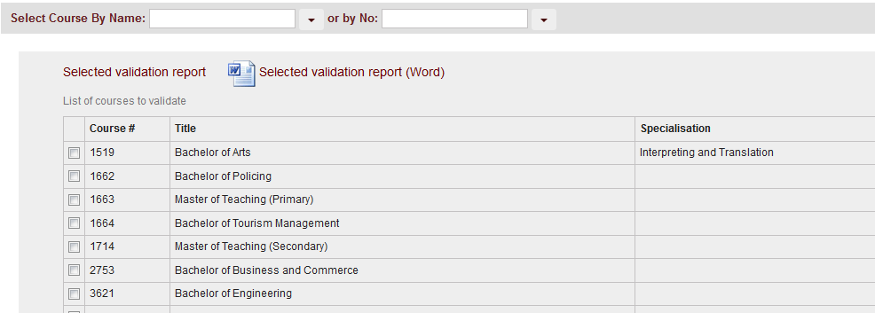

This list contains all courses which the user has permission to edit.

As per other summary reports, it can be seen in the browser or exported to Word.

The **Validate** button produces the same format report for the currently selected course.

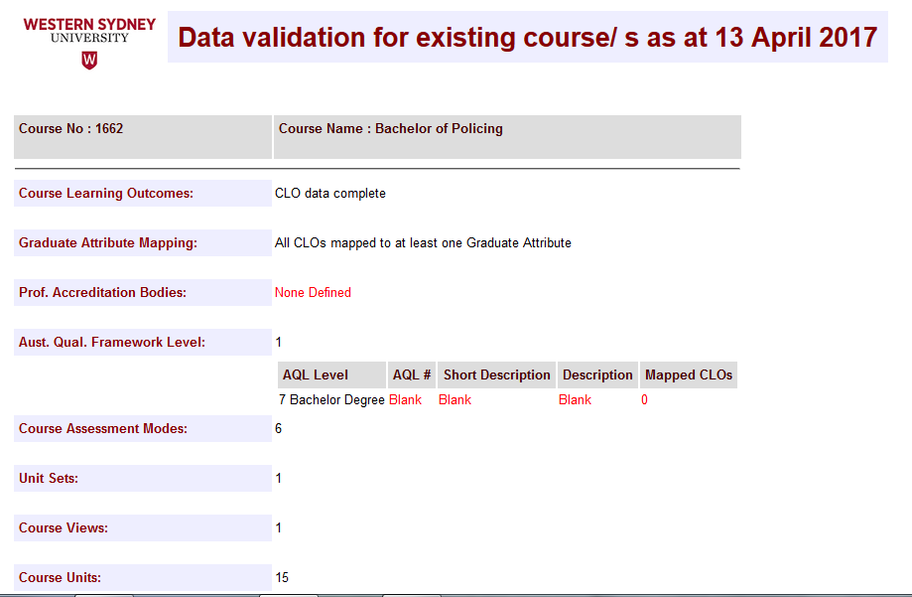

3.2 Maintain Existing Data - Units

Units have been included on a separate tab from Courses because they can occur in **multiple courses**. The course which has authority over the unit will be designated as the **Primary Course** for the unit. This course should be created BEFORE the units for which it is the primary course so it can be assigned when the unit is first created.

3.2.1 Relationship of Units to Courses

Unit Learning Outcomes are mapped against different elements of a course. These mappings are done WITHIN THE COURSE. In this way, the unit and its ULOs are defined ONCE on the Unit tab, and then can be mapped MULTIPLE TIMES inside different courses.

**It is important that units are assigned to a Primary Course**.

Users can only edit units which have **no primary course** assigned or they have **edit permission for the Primary Course**. All other units can be viewed read-only.

3.2.2 Add New unit

- Select **Existing Data, Units tab, +New** button.

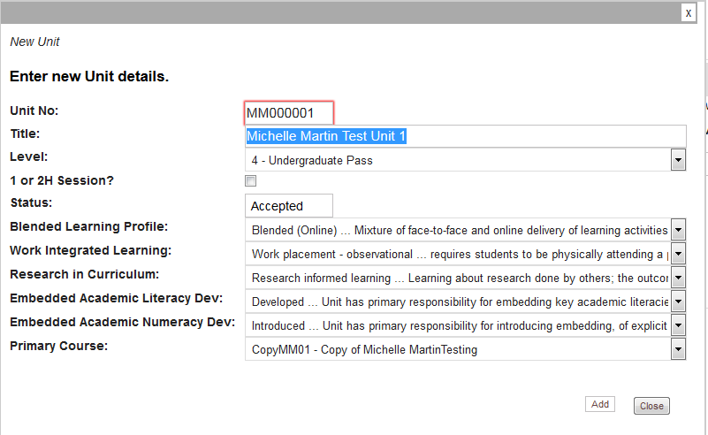

* Enter a **Unit No** (up to 8 alphanumeric characters)
* Enter a **Unit Title** (Up to 255 alphanumeric characters)
* Select a **Level** from 0 to 9
* **1 or 2H Session** should be ticked if the term is longer than 16 weeks. It is important that this is ticked for longer sessions so that the extra weeks can be selected for Assessment Due and Feedback Due on the Assessments Tab.
* **Blended Learning Profile, Work Integrated Learning, Research in Curriculum, Embedded Academic Literacy Development** and **Embedded Academic Numeracy Development** should all have values selectedas these values are used in Course reporting.
* Select the **Primary Course** which will have authority over this unit.

If these values are left blank, they will appear under **Missing Data** in the reporting, and may skew results.

1. **Add Unit Learning Outcomes**

**(no limit but warning after number 8)**

* Click straight into the **ULO #** field in the next available row (*). Enter the ULO # and description.

Open popup window showing mapped CLOs in all courses

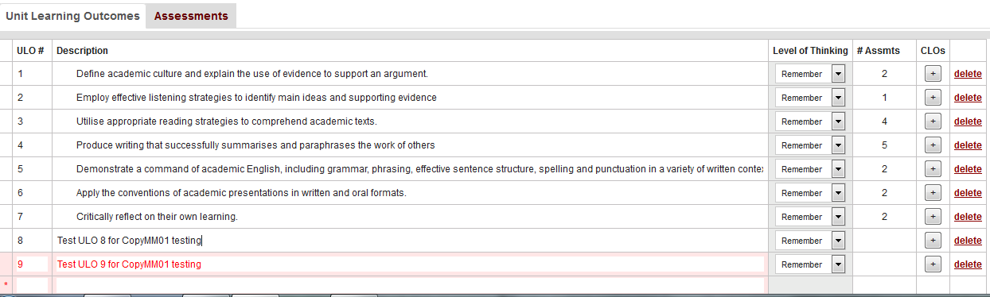

* After **ULO 9** is entered, a warning message will appear:

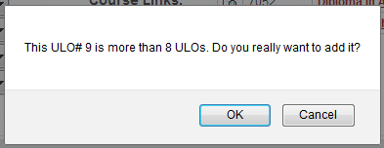

If OK is chosen, this ULO and subsequent ULOs will be highlight in pink as shown above.

* Ensure **Level of Thinking** is selected – it is used in reporting and will be shown as Missing Data, skewing results, if it is left blank. For more information on Level of Thinking, refer Appendix A - Anderson and Krathwohl’s Taxonomy
* The last column, **Assessments**, is not editable, but shows the number of Assessments which have been mapped to this ULO. This is described in **iii.** below.

**ii Assessments**

Each row in the Assessments table represents one component of Unit Assessment.

# mapped ULOs

Event Number

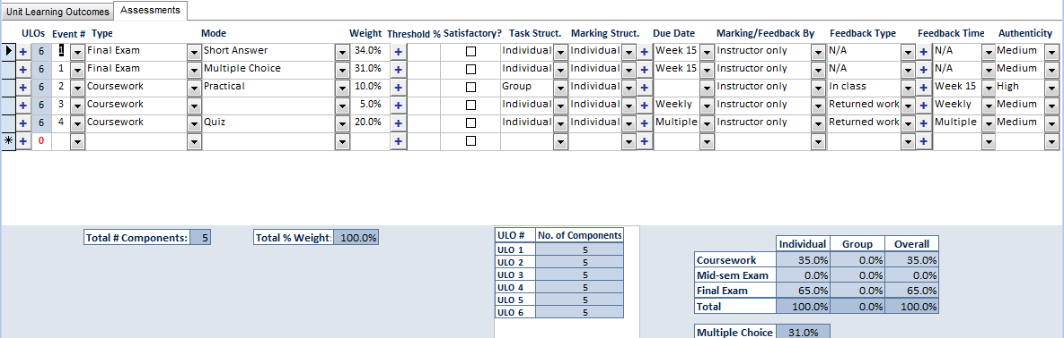

Displays in red if greater than 100%

+ Opens popup window to map ULO/s to Assessment Item

It is particularly important to fill in ALL FIELDS in each row. All of this information is used in Course Analysis and results will be inaccurate if all values are not filled in.

**ii Assessments cont.**

**Assessment Events** are components, or rows, that have the same *Event Number, Assessment Type, Due Date and Feedback Time*. There can be multiple rows with the same Event Number but different Modes. E.g. a Final Exam can be made up of Multiple Choice and Short Answer questions, so it is mapped as the same event # twice, repeating the type (exam) twice, and then specifying the mode (multiple choice and short answer) with the total % weighting for the item (exam) divided between the two components. The weight is part of the overall Unit, not a percentage of the assessment event.

When **Assessment Type** is entered on a row with the same Event number as another row, the Due Date and Feedback Time are copied in from the existing row.

There can be multiple Events with the same Assessment Type if the assessment does not occur at the same time.

**Assessment Mode** options are determined by those defined in the Assessment Modes tab of the Primary Course defined for this unit. **Refer Section 3.1.5**.

Assessment Modes can be defined for Coursework, Exams or both. So the list of assessments available in the unit depends on the Primary Course AND the Assessment Type.

Mid-semester Exams and Final Exams have less options than Coursework.

**Weight** is a percentage of the component in the unit, not the event. Total % Weight will display in red if components total more than 100%. It is important that this column is 100% for Course Reporting to be valid.

**Thresholds** can apply which determine the minimum competency required to complete the assessment. Where this cannot be expressed quantitatively, the + button at left provides a popup window where descriptive text can be entered. This field is not mandatory.

**Satisfactory** is a checkbox which can means that the assessment item is a competent / not yet competent type.

**Marking** and **Task Structure**  - choose from dropdown option of Group or Individual.

**Due Date** and **Feedback Timing** either goes to 16 weeks or 26 weeks depending on the 1 or 2H check box. There is a schedule attached to each component where a week or weeks can be ticked. This is accessed clicking the Plus button in either the **Due Date** or **Feedback Timing** field:

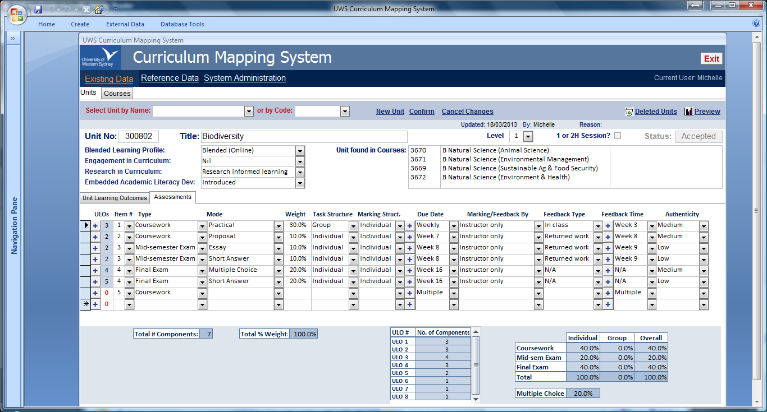A specific week is automatically ticked in the schedule when it is selected in the Due Date or Feedback Timing dropdown boxes.

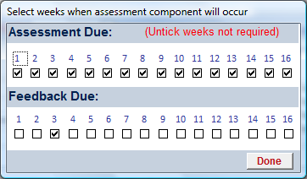

If **Weekly** is selected, every week is automatically ticked as shown. Assessment Due and/or Feedback Due can be ticked or unticked as required.

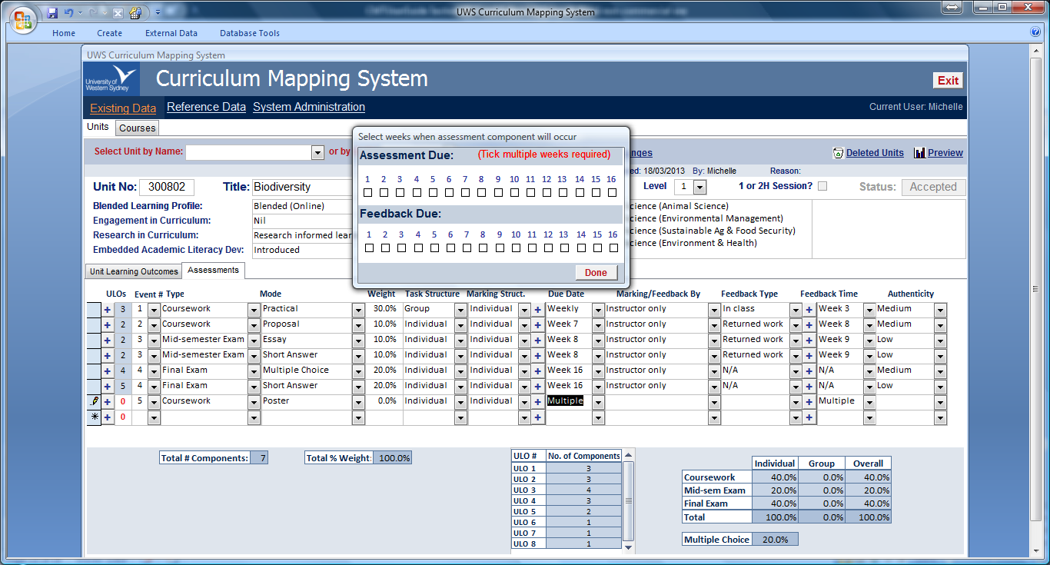

If **Multiple** is selected, the schedule is automatically opened so that the specific multiple weeks can be selected:

Note: **Feedback Timing** is generally not recorded for **Final Exams**. If an Assessment Type of Final Exam is selected, a message will appear:

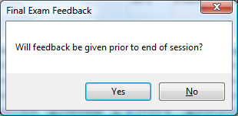If **No** is selected, then both Feedback Type and Feedback Timing will be set to **N/A**.

If **Yes** is selected, the selected Feedback Week and Type will remain.

**ii Assessments cont.**

**Authenticity** should be filled in as it is used in reporting. Detailed descriptions have been provided in the dropdown list to ensure that the correct Level of Authenticity is selected for the assessment item. See **Appendix C** for full listing.

**iii Map ULOs to Assessment Items**

This is an important mapping, as it is used inside courses to connect CLOs to Assessment information through the ULO mapping, i.e. CLO > ULO>Assessment Item

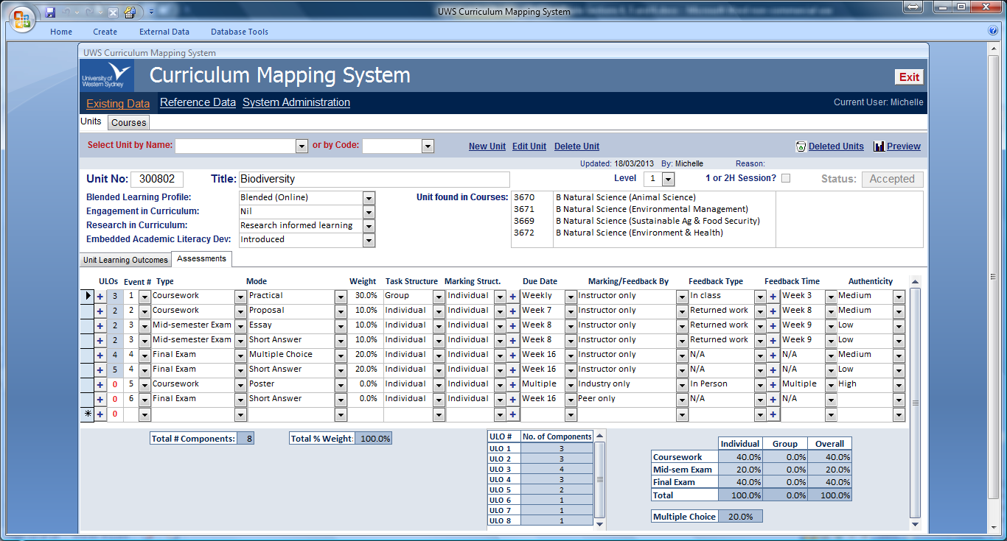

Number of mapped ULOs

Open ULO to Assessment Mapping

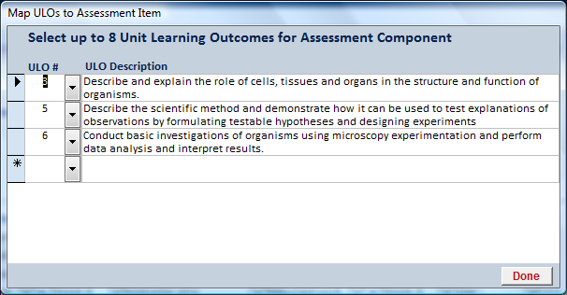There are no error messages preventing more than 8 learning outcomes being mapped because the 8 ULO per Unit has not been enforced when ULOs are added to the unit. This may change as ULO lists are reformulated to fit into maximum 8 ULOs.

3.2.3 Edit existing unit

Units can be selected by either **Name** or **Code** as shown:



As for Courses, if a search value is typed in rather than the dropdown button clicked, the dropdown list will be filtered as you type as shown above.

If the user has edit permissions for the Primary Course, the **Edit Unit** button will be available.

When the **Edit Unit** button is selected the button changes to **Stop Editing**, as per courses.

3.2.4 Deleting Units

1. **Cancel a new unit**

A **New Unit** can be cancelled from the New Unit popup window. If it is simply closed without the Add button having being clicked, the new unit will not be added.

**ii Delete an existing unit**

If a user has **Course Administrator permissions** for the **Primary Course** of the unit, the Delete Unit button will be active. As for Courses, this will only **MARK** the unit as deleted. It can be reinstated by opening the Deleted Units list and unticking the unit.

3.2.5 Preview Unit Summary

This report is available to all users, even those with read-only permissions.



This is a descriptive summary showing Unit Header information, ULOs/Level of Thinking list and Assessment Summary. As for the Course Summary, both a browser view and **Word export** is available.

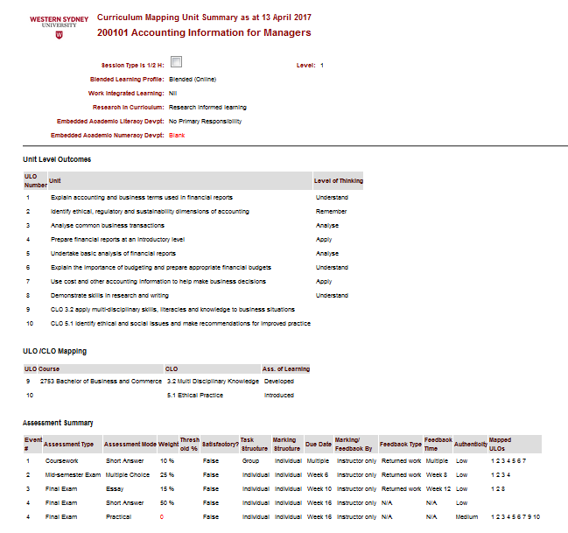

3.2.6 Unit Validation Summary

As for Preview, all users can run a Unit Validation report. It highlights missing information or values which falls outside of agreed parameters.



A full list of validation checks is shown in **Appendix D** – Unit Validation. This report shows Unit Header information as well as missing data in red.

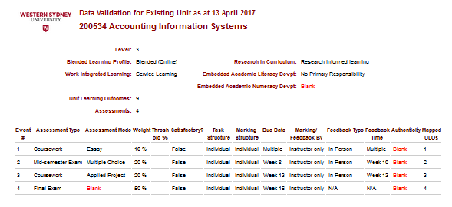

3.3 Administrator only functions

When a user has **system-wide Administrator permissions**, they will see the **Reference Data** and **System Administration** links when they open the CMT.

3.3.1 Maintain Reference data

This reference data contains WSU-wide agreed values for all the different drop-down lists in Units and Courses.



**Reference Data** is split into 4 tabs in order to make the various lists easy to find. Each tab has a dropdown list from which individual lists can be selected for editing:



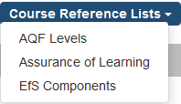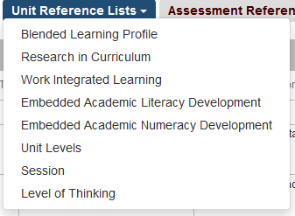 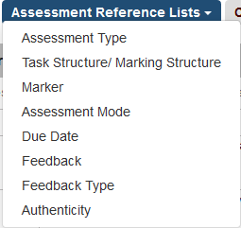

**Lists should be kept in the same order as they currently are** – otherwise the indexes which are not seen, but are used to connect these categories to values in Units and Courses, will no longer match up to the description that was originally intended in the Unit or Course. **This could drastically affect reporting results.**

Some lists contain a row with description **Missing Data**. **This must be kept at the end of the list**. It is not seen in Unit or Course dropdown lists, but is used for reporting to replace blanks so that values that have not been mapped or referred to are still filling out the pivot table or chart.

3.3.2 System Administration

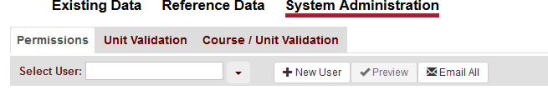The System Administrator is able to maintain **User permissions** and perform **Unit and Course Validation** for multiple units/courses at a time through the **System Administration** link.

**i. Maintain User Permissions**

All staff need to be added to the Permissions list in order to gain access to the CMT.

There are two levels of Access:

1. *Access to CMT functions* (i.e. Existing Data, Reference Tables, System Administration)

|  |  |  |  |
| --- | --- | --- | --- |
|  | **Edit Existing Data** | **Edit Reference Files** | **System Administration** |
| **Admin** | **√** | **√** | **√** |
| **Edit** | **√** |  |  |

1. *Access to Courses*

Only a user with **Admin** permissions at **Level 1** can **assign Course Permissions**

|  |  |  |  |
| --- | --- | --- | --- |
|  | **Edit Course / Units with Primary Course edit permissions** | **Delete Course/ Units with Primary Course edit permissions** | **Assign other users edit permissions to this course** |
| **Admin** | √ | √ | √ |
| **Edit** | √ |  |  |

**Add new User**

Click the **+New User** button and input fields will appear and also a list of courses to add to the new user. The **User ID** is the **staff Network User ID** and is used to verify identity for single sign-on into the CMT.

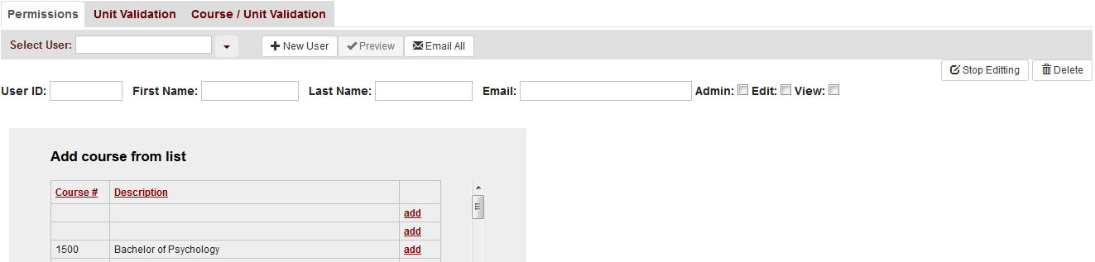

**Edit User**

Select existing user from **Select User** dropdown list. The list is ordered by Last Name, which can be typed in to filter the dropdown list as in the Unit name or Course name dropdowns.

Scroll down **Add Course from List** and click the **add** button to add course permissions, tick Admin or Edit as appropriate.

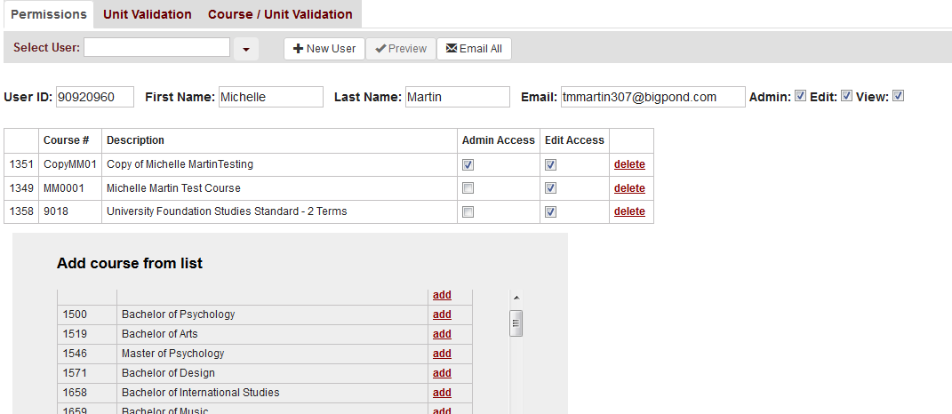

1. **Validate multiple Units**

The purpose of validation in this area is to gain an overall view of data integrity in groups of units, e.g. all units in a selected Primary Course such as Associate Degree in Engineering as shown below:

Select a Primary course from the dropdown list, and then units for validation can be selected using the tickboxes against each unit.

The **Select All** and **Clear Selection All** buttons can be used to speed up unit selection.

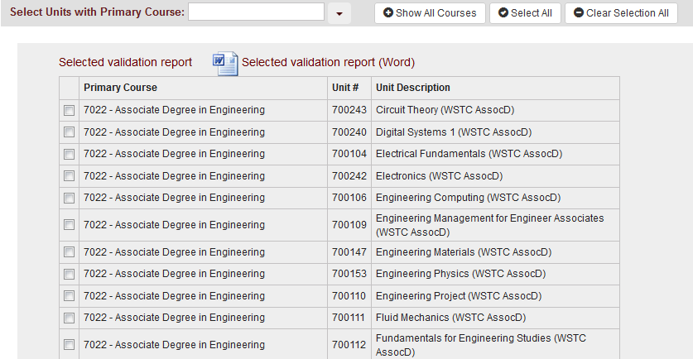

The report can be viewed in the browser or exported to Word, as per Preview and Validation reports in other parts of the CMT.

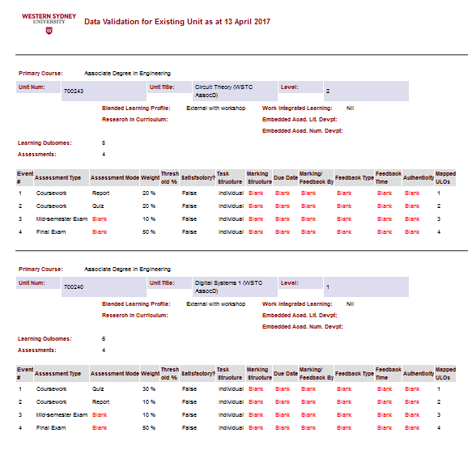

**iii Validate multiple Courses**

This report allows multiple courses to be selected so that data integrity can be checked for logical groups of courses (e.g. all Psychology courses).

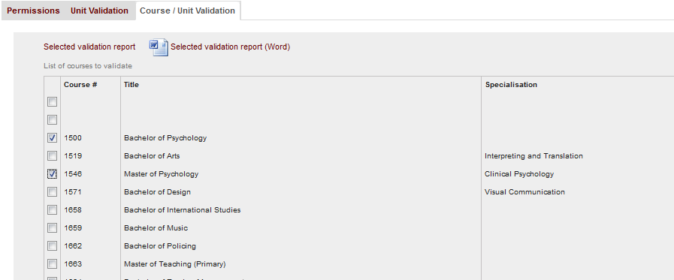

The report follows the format of the **Course Validation report** on the **Existing Courses** tab. The report is available in the browser or exported to Word:

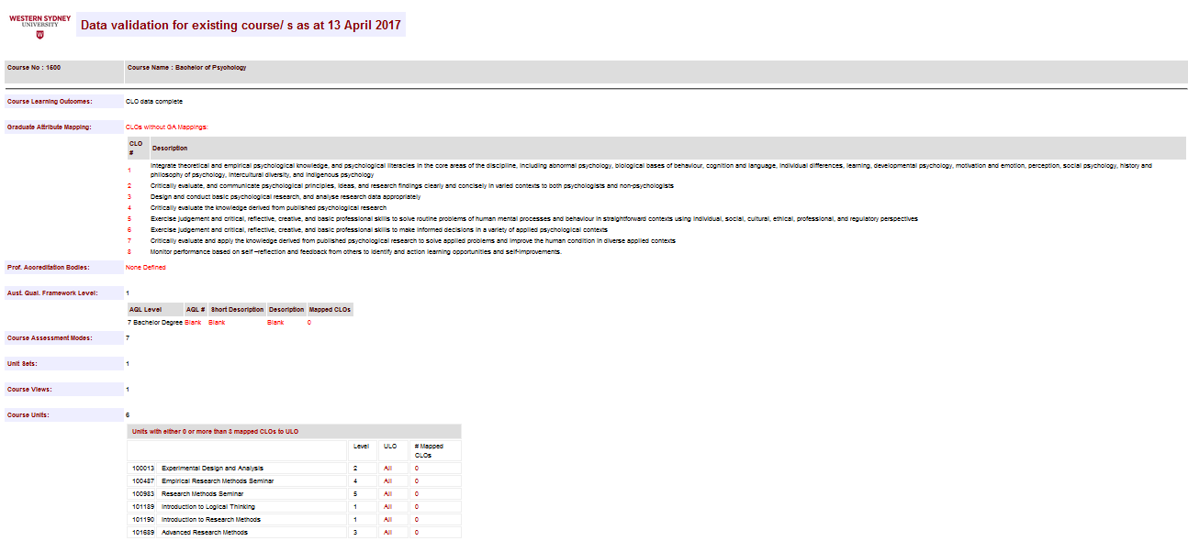

Appendix A:   
Anderson and Krathwohl’s Taxonomy

**Anderson and Krathwohl’s Taxonomy of the Cognitive Domain**

Anderson and Krathwohl’s taxonomy of the cognitive domain is a revised version of Bloom’s original taxonomy. The redefined taxonomy is the work of Lori Anderson (Bloom’s former student) and David Krathwohl (one of Bloom’s partners for the original work).

The main differences between the two taxonomies are as follows:

1. Rewording from nouns to verbs for the different levels in the taxonomy;

2. Renaming of some levels;

3. Repositioning of the top two levels;

4. The incorporation of the Knowledge dimension (Factual, Conceptual, Procedural and Metacognitive) to the Cognitive Process dimension making the taxonomy two dimensional.

A pictorial representation that highlights points 1 - 3 is shown in Figure 2 while the Table following gives the structure of the cognitive process dimension.

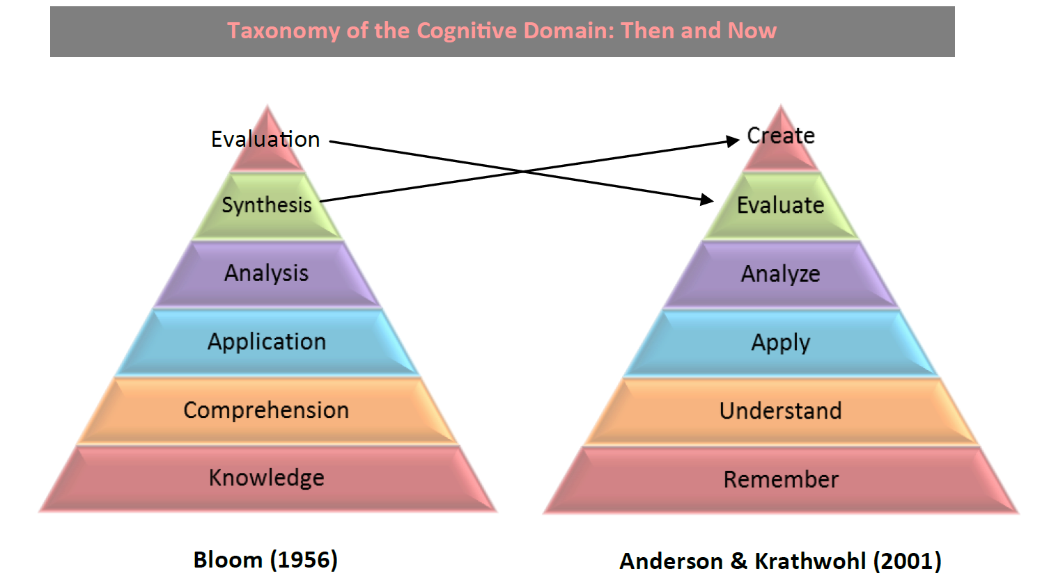

**Figure 2 – Taxonomy of the cognitive Domain – then and now**

|  |  |  |  |
| --- | --- | --- | --- |
| Structure of the Cognitive Process Dimension of the Revised Taxonomy (Krathwohl, 2002) | | | |
| CATEGORY | EXAMPLE | EXAMPLE OF ACTION VERBS | |
| Remember:  Retrieving relevant knowledge from long-term memory | **√** Recognizing  **√** Recalling | | Identify, List, Name, Define |
| Understand:  Determining the meaning of instructional messages, including oral, written, and graphic communication | **√** Interpreting  **√** Exemplifying  **√** Classifying  **√** Summarising  **√** Inferring  **√** Comparing  **√** Explaining | | Discuss, Describe, Illustrate, Review, Conclude, Explain, Interpret |
| Apply:  Carrying out or using a procedure in a given situation | **√** Executing  **√** Implementing | | Apply, Develop, Restructure, Calculate, Demonstrate, Organize |
| Analyse:  Breaking material into its constituent parts and detecting how the parts relate to one another and to an overall structure or purpose | **√** Differentiating  **√** Organizing  **√** Attributing | | Analyse, Compare, Contrast, Examine, Investigate, Deduce |
| Evaluate:  Making judgements based on criteria and standards | **√** Checking  **√** Critiquing | | Judge, Assess, Evaluate, Rate, Validate, Appraise, Criticize |
| Create:  Putting elements together to form a novel, coherent whole or make an original product | **√** Generating  **√** Planning  **√** Producing | | Compose, Produce, Design, Assemble, Create, Plan, Set up, Propose, Develop, Construct |

Appendix B:   
Assurance of Learning



**Figure 3 Assuring learning -** http://assuringlearning.com

In the Welsh language they have just one word that means both to teach and to learn “dysgu”. This makes a lot of sense because can we really say we have taught something if our student has not learnt? Assuring Learning is a basic educational principle of asking: have the students learnt what we expected them to learn and if not what can we do to help them achieve in the future? In this way it can be seen as a process to measure the accomplishment of educational aims and to ensure continual improvement of learning experiences.

**What is it?**

To assure is to make a statement or indication that inspires confidence; a guarantee or a pledge. Therefore, assurance of learning involves confidently and explicitly articulating our expectations for what a student will be able to do on completion of a course, setting criteria and standards, actively facilitating learning towards attainment of the outcomes and systematically gathering, analysing and interpreting the evidence to determine how well performance matches those expectations.

It is important to remember that in this process, the learning outcomes, standards and the academic program are being assured, NOT the student, teacher or the institution per say. Assurance of Learning can be seen as seeking answers to the following questions:

1. What will our students learn? What are our expectations?

2. How will they learn it?

3. How will we know they have learned it or not?

4. What will we do if they have not learned it?

5. If they have not learned it, how will we try to fix this?

Three levels are provided in assuring learning, to allow the articulation of where in the curriculum (which ULO’s) the key concepts, skills and attributes articulated in the course learning outcomes are **Introduced**, **Developed** and ultimately **Assured** (i.e. assessed at the level expected of a graduate). WSU level definitions are provided at the end of this document.

**Why do we do it?**

***For Institutions/Faculties:***

1. Articulation to internal and external stakeholders of the clear goals set by the faculty
2. Evaluation of how well the school accomplishes the educational aims at the core of its activities.
3. Assurance to external constituents such as potential students, trustees, public officials, supporters, and government or professional accreditors, that the organisation meets its goals.
4. Framework for the school and faculty members to improve the curriculum, through analysis, identification and adjustment to the course and unit structure or sequencing to ensure they lead to appropriate outcomes

***For Teachers:***

1. Are the course learning outcomes likely to be met by the design of each contributing unit?
2. Are the learning outcomes likely to be met by the students?
3. What is needed in curriculum and pedagogy to create better overall alignment?

***For Students:***

1. **Clarity** – students are able to see the links and development of graduate attributes through clearly stated learning objectives, and through the interactive use of assessment rubrics
2. **Control** – due to progressive nature with explicit objectives, students can take control of their learning through regular tutor feedback and self-assessment
3. **Progression** – students will be introduced, and further developed in the graduate attributes before assessed at the level expected of a graduate for assurance

**How do we indicate it?**

Given that an academic course is made up of a series of units, in order to assure that high level educational aims for a course have been met, the units that comprise that course must be examined closely. Curriculum mapping is a process that allows for an indication of how each core unit and its unique Unit Learning Outcomes (ULOs) contributes to the attainment of Course Learning Outcomes (CLOs). This contribution is expressed as levels allowing for introduction, further development and then assurance of the objectives at the level expected of a graduate.

It is common for a core unit to contribute to the progression of several CLOs, however only the one(s) which are a major focus of the unit should be expressed in the curriculum map. This is for simplicity, as well as to reduce the risk of over-assessment in any particular unit. One way to begin to build a curriculum map is to ask- to which unit do we assign ultimate responsibility for introducing, developing or assuring each CLO? Another question which can assist the process is- on which unit(s) would staff focus on, to improve student learning related to a particular CLO?

**How does it relate to assessment?**

Curriculum alignment and assessment allows an analysis of whether the various units in a course enable students to pursue the planned outcomes, and whether they are adequately assessing students to ensure they have been achieved. To ensure that a Course Learning Outcome has been introduced, developed or assured, an assessment must be undertaken and evidence acquired from the student at each of the levels.

The completion of every assessment task gives important information about how well students have learnt and provides valuable evidence of their new or refined knowledge and skills from the learning experience. Student achievement does not just represent student effort and ability, it is a function of how well courses are designed and conducted to lead to the assessed outcomes.

Therefore, assessment also gives important information about teaching and curriculum design. If students don’t “get it” then this acts as a flag on a problem to be fixed through the assurance of learning process. Unit level assessment data should be used for course improvement as poor student outcomes can reflect gaps in the course structure. Better student outcomes can be achieved through more effective units and their correct arrangement in the course. Curriculum alignment ensures courses likely pursue desired outcomes and alignment of assessment with outcomes and activities offers data to point to issues to address.



**Figure 4 -** Example of a simplistic curriculum map showing progression of course learning outcomes at the levels of Introduce, Develop and Assure. This is a sample for illustration of the concept only.

**How does it fit into the bigger picture?**

Assuring learning is a continual improvement process of learning experiences that goes hand in hand with curriculum review practices involving:

* establishing measurable Course Learning Outcomes (CLOs) that reflect national, professional and individual institution requirements
* establishing measurable Unit Learning Outcomes (ULOs) for each core unit within the course
* creating a curriculum map and specifying the relationship between CLOs and ULOs, signalling where each CLO is Introduced, Developed or Assured at the level expected of a graduate.
* analysing the curriculum and undertaking any necessary redesign of unit outcomes, activities or assessment
* communicating the CLOs, ULOs and the relationship between them to students
* assessing, reviewing and reporting on student performance in the learning outcomes
* collecting evidence and data for each learning outcome (feedback, work samples and performance data)
* identifying areas for course or unit development and benchmark with other institutions
* closing the loop with actions to stimulate continuous development through critical and reflective discussion

**Can a Curriculum Mapping Tool help?**

The newly created curriculum mapping tool for UWS has the capacity to assist in the process of assuring learning. Course learning outcomes are entered into the database with an indication of which unit learning outcome(s) introduce, develop or assure each outcome. The mapping tool then produces a matrix of these relationships which can be used to facilitate an analysis of the curriculum, such as to identify areas of overemphasis or gaps. The Curriculum Mapping Tool uses the following definitions:

|  |  |
| --- | --- |
| *Introduced……* | The Unit Learning Outcome is introducing concepts and/or skills associated with and contributing to Course Learning Outcome recognition. |
| *Developed……* | Further development of concepts and/or skills which have already been introduced and contribute to Course Learning Outcome recognition. |
| *Assured………..* | The Course Learning Outcome or component part is assessed at the level expected of a graduate, thus assured. |

**Figure 5 -** UWS Assurance of Learning Level definitions

Appendix C:   
Levels of Authenticity

**Authenticity** in assessment is determined by the degree to which the task connects learning at university with what graduates would be doing in the workplace. Tasks with higher levels of authenticity are typically open-ended, require a component of reflection on practice, and involve collaboration with people beyond university settings.

It is expected that a range of assessment tasks will (appropriately) be constructed at lower levels of authenticity and that students will have opportunities to work on tasks with higher levels of authenticity as they progress through their program of study.

| Level of Authenticity | Description & Example |
| --- | --- |
| Low | Task assesses theoretical knowledge and/or skills, independent of professional or real world context.  Beginning level of intellectual engagement focused on remembering and comprehending.  Does not require self-reflection or peer input. |
| Do a knowledge test (eg in an exam);  Label parts of a diagram (eg of a microscope or the human digestive system);  Summarise information;  Write an essay;  Do a mathematical calculation;  Identify part(s) of a process or procedure;  Answer comprehension questions in oral test; |
| Medium | Task assesses theoretical knowledge and skills as used in professional or real world contexts.  Medium to beginning level of intellectual engagement focused on comprehending, applying, analysing.  May involve self-reflection, peer feedback or peer assessment. |
| Describe steps in conducting a clinical examination;  Write a report or case study on a given topic or observed scenario;  Conduct a laboratory experiment by following instructions;  Solve a problem (eg by doing a mathematical calculation);  Present a topic / case to the class and interact with audience;  Use industry-standard software or equipment (eg use SolidWorks to produce a 3D rendered model); |
| High | Task assesses applied knowledge and skills in a contextualised setting.  High to medium level of intellectual engagement focused on analysing evaluating, creating.  Involves self-reflection and collaboration with peers, industry, professionals |
| Design and deliver a lesson to peers;  Diagnose and propose treatment for a virtual or simulated patient/client;  Design, conduct and evaluate an experiment;  Write a report / essay / case study drawing on your own experience in the workplace;  Write a legal document that meets professional standards;  Design/prepare a creative work and present to peers;  Prepare a business proposal that could be presented to virtual or simulated clients;  Conduct a fieldwork project; |
| Very High | Task assesses professional or real world activity in a workplace setting or for a professional/real world audience.  High level of intellectual engagement focused on evaluating, creating, synthesising.  requires critical self-reflection and collaboration with professionals / real world context |
| Design and deliver a lesson in a school;  Diagnose and treat a patient/client;  Design, conduct and evaluate an experiment in an industrial/professional context or the results of which will inform practice in the real world;  Write a legal document that can be used in a legal transaction;  Design and produce a creative work and present to an external audience;  Present a business proposal to a client/consumer group;  Design and conduct a fieldwork project; |

*Adapted from: Authentic Assessment Framework, Curtin University; Quickbite: Authentic Assessment, Clair Hughes, University of Queensland; Online learning assessment levels of authenticity, Wisconsin Technical College System Foundation;*

Appendix D:   
Validation Reporting For System Administrator

**Course Level Validation**

Course data validation is found in the CMT in Existing Courses and System Administration – Course Validation. Below is a reference list of validations performed on Course data.

|  |  |  |
| --- | --- | --- |
| Field | Validation | Message / formatting on Validation report |
| Course Code | Not blank | Blank |
| Course Title | Not blank | Blank |
| **Course Learning Outcomes** | At least one defined | None Defined |
| Course Learning Outcomes Validation | One or more fields missing | CLOs with Missing Data |
| CLO Number | Not blank | Blank |
| CLO Short Description | Not blank | Blank |
| **CLO Description** | Not Blank | Blank |
| Graduate Attribute Mapping to CLOs | At least one per CLO | CLOs without GA Mappings  List of CLOs with no GAs |
| **Professional Accreditation Bodies** | At least one PA Body defined | None Defined |
| For each PA Body: | At least one PA Item defined | No PA Items defined for this PA Body |
| **PA Items will be listed if there is NOT at least one Mapped CLO or ULO** | At least one Mapped CLO or ULO | 0 |
| AQF Level | At least one AQF Level defined | None Defined |
| **AQF Items:**  Mapped CLOs | Not 0 | 0 |
| Course Assessment Modes | At least one defined  Less than 5 defined | None Defined  Only *n* defined |
| Unit Sets | At least one Unit Set defined | None Defined |
| **Units in Unitset**  Each Unit: Level, Session | At least one Unit in Unit Set  Not blank | No Units Defined for this Unit Set  Blank |
| **Course Views**  Course views with no Unit sets listed | At least one defined  At least one Unit Set defined | None Defined  Course Views with no Unit Sets |
| Course Units | At least one defined | None defined |
| **Each Unit:**  List Unit ULOs where there is not: | At least one mapped CLO  More than 3 mapped CLOs | 0  Number of Mapped CLOs |

Table . Course Validation reference

**Unit Level Validation**

Unit data validation is found in the CMT in:

* Existing Units
* Existing Courses

– Units in Course, Units in Unit Set Validation

* System Administration – Unit Validation.

Below is a reference list of validations performed on Unit data.

Table 16. Unit Validation reference

|  |  |  |
| --- | --- | --- |
| Field | Validation | Message / formatting on Validation report |
| Unit Code | Not blank | Blank |
| Unit Title | Not blank | Blank |
| Unit Level | Not blank | Blank |
| Blended Learning Profile | Not blank | Blank |
| Work Integrated Learning | Not blank | Blank |
| Research in Curriculum, EALD and EAND | Not blank | Blank |
| Unit ULOs | At least one ULO defined | None Defined |
| Level of Thinking | Not blank | Blank |
| Unit Assessments | At least one ULO defined | None Defined |
| For each Assessment Item: |  |  |
| Event | Not blank | Blank |
| Type | Not blank | Blank |
| Mode | Not blank  (will appear as blank if a deleted Assessment Mode has been selected) | Blank |
| Weight | Not 0 | Blank |
| Task Structure | Not blank | Blank |
| Due Date | Not blank | Blank |
| Marking Structure, | Not blank | Blank |
| Marking/Feedback by | Not blank | Blank |
| Feedback Type | Not blank | Blank |
| Feedback Time | Not blank | Blank |
| Level of Authenticity | Not blank | Blank |
| Mapped ULOs | At least one defined | 0 |