ROTARY CLUB AWARDED EXCELLENCE AWARD
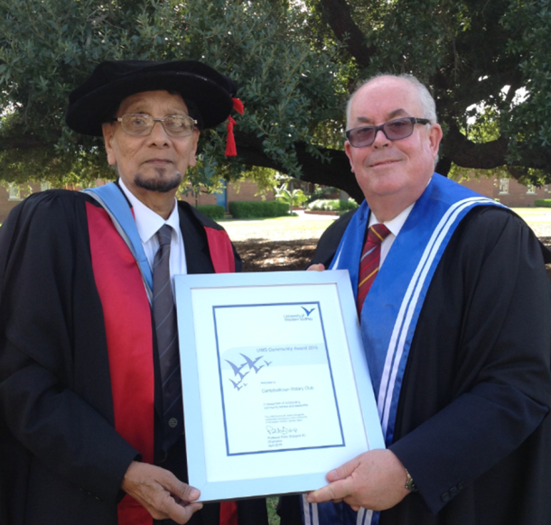
The Rotary Club of Campbelltown received the 2015 Excellence in Partnership Award from the University of Western Sydney at the graduation ceremony held for UWS graduates on 16 April 2015. In presenting the award to Paul Manick, the President of the Rotary Club of Campbelltown, Professor Scott Holmes, the Deputy Vice-Chancellor and Vice-President (Research and Development) said, “The Rotary Club of Campbelltown and the Rotary Club of Koshigaya, in Japan, were instrumental in establishing the University of Western Sydney’s Campbelltown Rotary Observatory as an ongoing sustainable international project for teaching and research in science education, physics and astrophysics. Over the last ten years over 50,000 members of the public, including school-aged children and the local Aboriginal and Torres Strait Islander community, have participated in the Observatory’s innovative programs. The majority of funding for this project was raised by the Campbelltown Rotary Club. This has enabled the UWS Campbelltown Rotary Observatory to engage with the public and local schools in the latest developments in science and engineering, holding astronomy nights and lectures by eminent scientists, including Professor Brian Schmidt, 2011 Nobel Prize winner in physics. The Rotary Club has also been an active supporter of the highly successful Science Experience (now called Engineering Frontiers) which is run from the Observatory and involves high achieving year 10 students. The programs that have been administered through the UWS Rotary Observatory have provided UWS wide international and national publicity including Forbes magazine, the Discovery Channel, The Australian, Sydney Morning Herald, SBS and the ABC’s Catalyst program”.
According to Dr Ragbir Bhathal, the Director of the Observatory, the award to the Rotary Club is “a well deserved recognition of the role it has played and continues to play in the life of the community. It is probably one of the best joint partnership projects with a community based organisation undertaken by the University. It has paid tremendous dividends to the community and the University. The community sees the Observatory as a people’s observatory. It has enabled the Observatory and members of the Macarthur Astronomical Society to run astronomy nights for the benefit of the public. The Observatory’s programs are free to the public and the schools”.
For more information contact: r.bhathal@uws.edu.au or 02 47360834.

