PGSE-WATERGATE: A Spin-Echo-based PGSE NMR sequence with excellent solvent suppression

This is a pulsed gradient spin-echo NMR diffusion sequence incorporating WATERGATE-based solvent signal suppression [1,2]. The sequence provides superb solvent suppression without phase distortion. The sequence is easy to set up and particularly robust with respect to parameter settings. Since it is based on a spin-echo, the sequence is especially suited to measuring the diffusion coefficients of small molecules in low viscosity solutions such as is commonly required in biomolecular NMR experiments (e.g., probing ligand-protein interactions by measuring the ligand diffusion coefficient). This version of the pulse sequence computes sets the variable delays to give the shortest pulse sequence and therefore echo time (τ) delays. A more complicated variant is available which allows particular τ values to be set.
For cases where T₁ >> T₂ or a suitable value of the echo time (τ) cannot be found to overcome the deleterious effects of J-modulation effects the PGSTE-WATERGATE sequence is preferable.

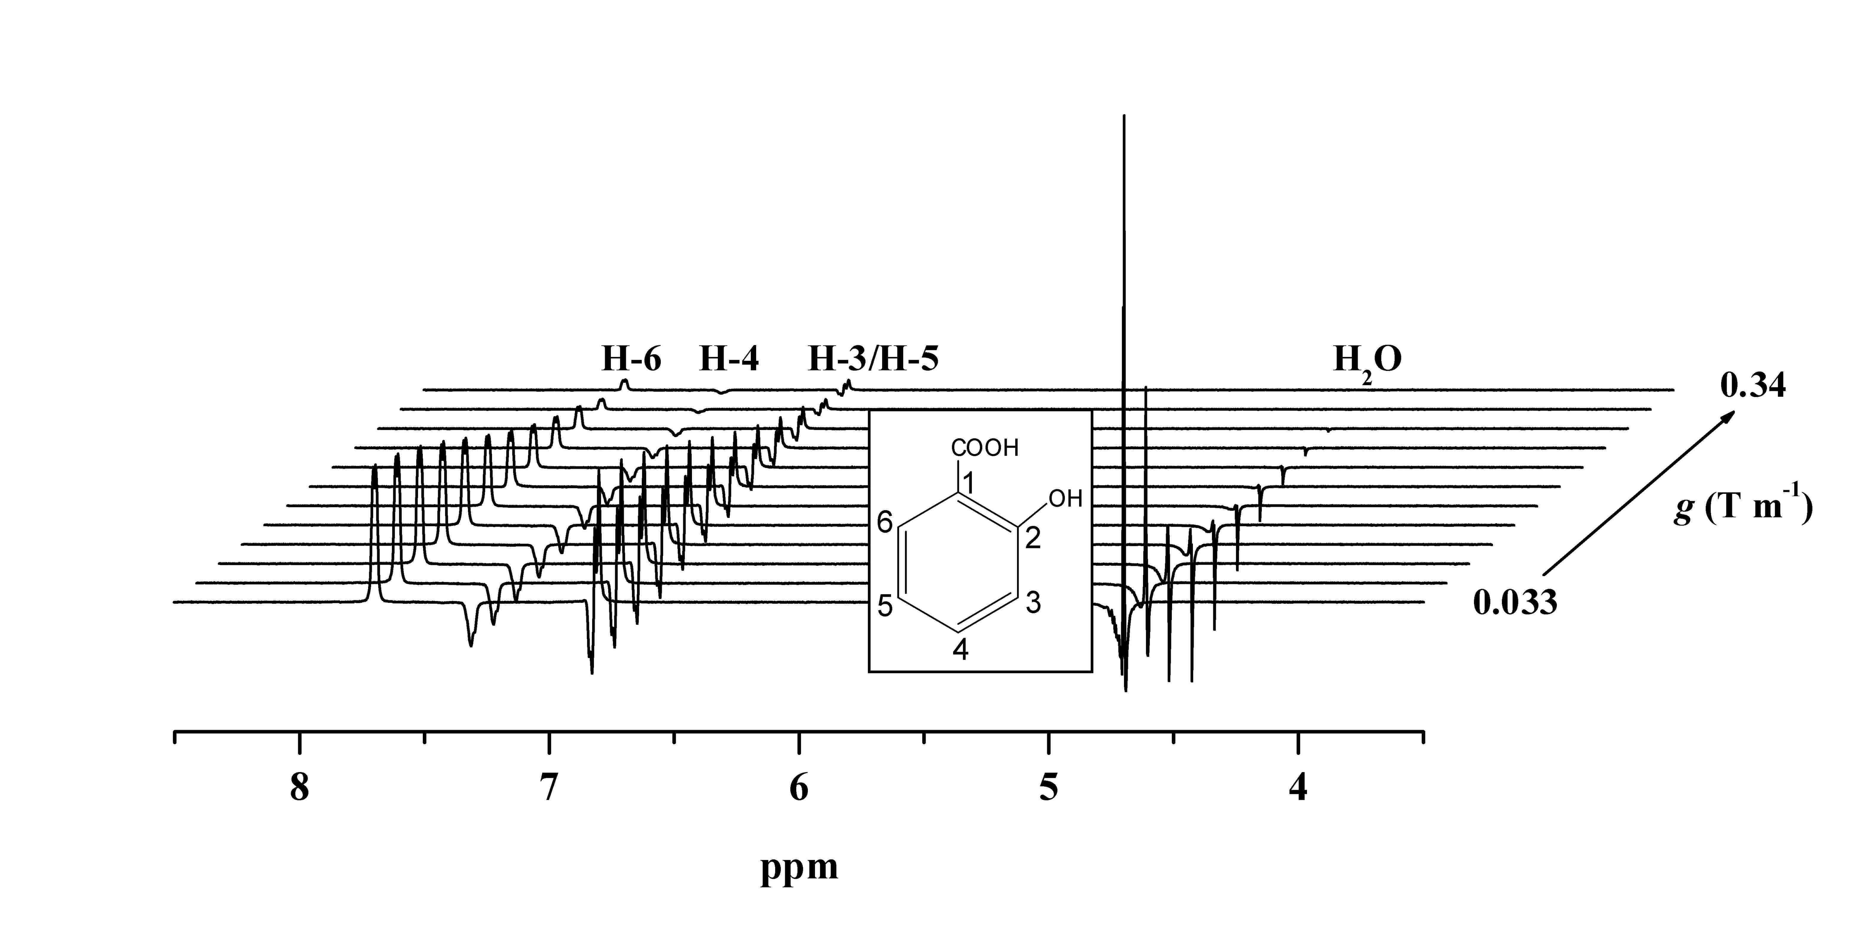

Figure 1. The PGSE-WATERGATE sequence (top), and a series of 500 MHz ¹H PGSE-WATERGATE spectra of a sample containing 80 mM salicylate (inset) and 0.5 mM bovine serum albumin in water (10:90 ²H₂O–¹H₂O) at 298 K (from ref. [1]).

The sequence and other information can be downloaded HERE. The sequence is for a Bruker spectrometer. After unzipping the file please follow the instructions below:

Experimental Setup
1. Installation of the Sequence
Copy the TXT file of the pulse sequence into /opt/topspin/exp/stan/nmr/lists/pp/user.

Please note the comments in the sequence.

2. How to run the sequence and analyse the data
The PGSE-WATERGATE experiment is run like a standard PGSE sequence in that suitable values of Δ and δ are chosen so that the signal will be almost completely attenuated at the maximum value of g used (input using gpz1). It is convenient to use an ‘au program’ to increase gpz1 from spectrum to spectrum. A simple modification allows this to be run in ‘2D’ mode.

Data analysis simply involves fitting an exponential (A exp(–γ²g²δ²D(Δ – δ/3)) with A and D the fitting parameters) to obtain the diffusion coefficient D. Further details can be found in [3].

Reference
[1] Price, W. S.; Elwinger, F.; Vigouroux, C.; Stilbs, P., PGSE-WATERGATE, a New Tool for NMR Diffusion-Based Studies of Ligand-Macromolecule Binding. Magn. Reson. Chem. 2002, 40 (6), 391-395.
(https://doi.org/10.1002/mrc.1029)

[2] Price, W. S., Pulsed Field Gradient NMR as a Tool for Studying Translational Diffusion, Part I. Basic Theory. Concepts Magn. Reson. 1997, 9 (5), 299-336.
(https://doi.org/10.1002/(SICI)1099-0534(1997)9:5%3C299::AID-CMR2%3E3.0.CO;2-U)

[3] Price, W. S., Pulsed Field Gradient NMR as a Tool for Studying Translational Diffusion, Part II. Experimental Aspects. Concepts Magn. Reson. 1998, 10 (4), 197-237.
(https://doi.org/10.1002/(SICI)1099-0534(1998)10:4%3C197::AID-CMR1%3E3.0.CO;2-S)

Notes
It would be appreciated if you could cite the reference paper [1] above after utilising the PGSE-WATERGATE sequence in your research work.

PGSE-WATERGATE (opens in a new window) – link

