Western Sydney University Student Elections Guide
National Union of Students (NUS) Delegates – National Conference
2021

ELIGIBLE CANDIDATES LISTED ON THIS PAGE HAVE NOT SUPPLIED A CANDIDATE IMAGE OR CANDIDATE STATEMENT

Zohra ADBEL-FATTAH,
Peipei GU,
Mary HINCHCLIFFE,
Inayat INAYAT,
Ashley FLOCKHART,
John LEWIS,
Jayeshwari PILLAY,
Jasmine RICCIARELLI,
Tiffany SHARPE, and
Emmanuel WAHAJ

ABBAS, Muhammad
NO IMAGE AVAILABLE

19968663 Muhammad ABBAS
My name is Muhammad Nouman. I am an International student who started the university with Master’s degree in Electrical Engineering in Feb 2020. The question is always raised about the trust and the capability of new students becoming the member of Student Council and today I want to prove them wrong with my beliefs, my power and my faith in achieving the highest mark. Being a young graduate, I have come across many issues in different processes which I would like to make them notified under the management . I accept the challenge and I will prove myself that the young and new talent has much more capacity, ability, energy and enthusiasm to compete to raise awareness among our people to have a healthy and sustainable environment.

BAKER, Leahanne

19691116
Leahanne BAKER
Hi Everyone! My name is Leahanne Baker and, this is why you should vote for me for National Union of Students conference delegate. I will make a great candidate for this position as I have experience in leadership and teamwork. In 2019 I was in the SRC at Western Sydney University as Campus Representative for Nirimba. This opportunity was a wonderful and life-changing experience. While as Nirimba Campus representatives, we were able to fund some great activities, programs, food and fun day events, and opportunities for the students. I can provide, support, and help more students and make sure students are being listened to for what they want and what they need! When you vote for me, you will see change, growth, and development for all students. VOTE FOR LEAHANNE BAKER No.#1

BEKKER, Fred
NO IMAGE AVAILABLE
19367402 Frederick BEKKER
The Nation Union of Students (NUS) is an organisation, deeply in debt, that we pay annual fees to be a member of. Since 2019 your SRC has paid a total of $10,000 to be a part of this organisation. In return they have provided questionable returns to us as a student community. Once a year, your student fees fund students to booze it up at the NUS National Conference, where there have been many reports of bullying, threats and intimidation, and obtuse political stalwartly. If elected, I will hold this organisation to account and make sure that WSU students voice is heard. A set of key performance indicators (KPI’s) shall be formulated, and if this is not held to, a recommendation will be made to the SRC to hold a referendum on disaffiliating from this toxic organisation.

BONATTI, Daniel
19257310
Daniel, BONATTI
NO STATEMENT AVAILABLE
CHAN, Daphne
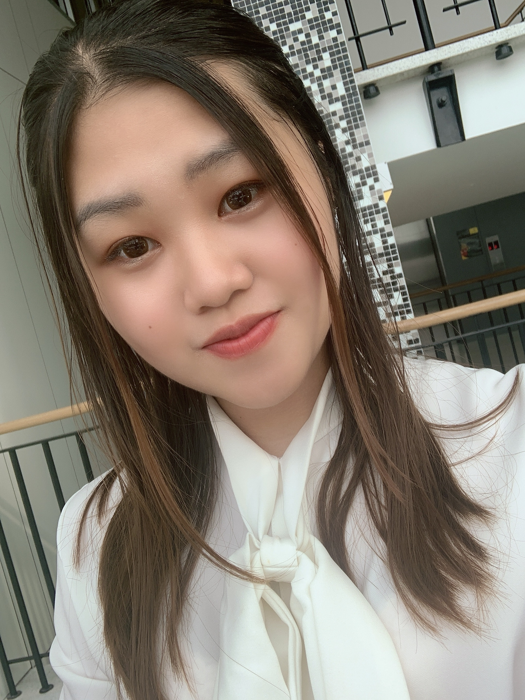
19423627
Daphne CHAN
Hi, it’s Daphne! I’m studying for a double degree in Bachelor of Law/ Bachelor of Business in my third year. It was a remarkable opportunity for me to gain positive values and experiences in UWS community, and I would love to utilize what I have learnt and maybe I could benefit my peers and help people. In my law unit, the legal sense was greatly enhanced, and probably I could give broader students a chance to understand their legal rights and potential issues. I consider myself to have a strong sense of responsibility, a pleasing personality and trustworthy. I also have a multicultural background: Hong Kong and Australia, which allows me to understand cultural differences and respect different cultures. Words are not enough to express myself, but actions do. I wish you could allow me an opportunity to contribute to my peers to achieve higher. Thanks

CHESTERS, Cameron
19836052
Cameron CHESTERS

My name is Cameron Chesters and I’m seeking to join the Student Representative Council!
I’m currently the founder and president of The WSU Fun Club and an executive for the WSU Law Society.
I’m very committed to making uni fun for every single student.
With me elected you can be sure any university social event you could dream of will be fought for by me.
If there is anything that has ever annoyed you about uni, I will also be very excited to fight for a solution.
Thank you for trusting me to be a part of the SRC!

CUPITT, Sarah
149760041
Sarah CUPITT
Hi! I'm Sarah Cupitt, an ambitious 3rd-year student studying a Bachelor of Communication (Journalism & PR), playing a vital role in student advocacy relating to university-wide issues, working on programs and services that offer a range of student opportunities. I want to continue representing student's rights and interests at WSU alongside my team, Strength & Integrity. I'm a creative young leader and have held various student positions such as; Director of Student Publications, SRC Vice-President, Multimedia Editor, SRC Online Rep, and NUS delegate since 2019. I founded WSU's first writing community Modern Ink, and am an exec of 7 other clubs and a recipient of various leadership awards from WSU and the local community. This year, my goal is to connect students in shaping the systems that affect their learning experiences. To ensure equity for students, transparency for SSAF, ongoing policy change, and more club funding, please vote for me!

DANG, Verbena
19869836
Verbena DANG
NO STATEMENT AVAILABLE

ESPINAS, Jonathan
19346029
Jonathan ESPINAS
I, Jonathan Espinas, a third year nursing student, would like to run for Student Representative Council. The position I would like to run for is National Union of Students (NUS), otherwise I am happy to run for any other positions. I have been participated in many activities across all campuses including social sports games, Pizza night at Campelltown Campus and I also am currently a Secretary for the student club WSU Nursing & Midwifery Student Society (NaMSS). Some things you might want to know about me, I love trying new things, exploring anything that is possible and always like a challenge. Throughout my life I participated in a range of activities including learning musical instruments (i.e. guitar, piano), dance (participated in Dance Championships Both Nationally and Internationally). But that’s enough about me. The reason why I would like to run for Student Representative Council, is I would like student’s voice

FERRER, Natasha
19795371 Natasha FERRER
As the founder and current president of the Nursing and Midwifery Student’s Society (NaMSS), I have cultivated a passion for student advocation and creation of student platforms. As a NUS representative for our school, I plan to focus on student voice towards education and important concepts. I will be surveying our students bodies and creating platforms for Western Sydney University students to voice their concerns and needs so that the NUS team can contribute to the national collective. Environmental concerns, uplifting women, ensuring quality and fair education and mental health is what I strive to advocate for as an NUS representative. As a student in her final months of university, I strive to make a positive change that future student generations will benefit from. Please vote for me

KAPOOR, Anushka
19925527
Anushka KAPOOR
NO STATEMENT AVAILABLE
MURAVU, Loore
19223865
Loore MURAVU
The Nation Union of Students (NUS) is an organisation, deeply in debt, that we pay annual fees to be a member of. Since 2019 your SRC has paid a total of $10,000 to be a part of this organisation. In return they have provided questionable returns to us as a student community. Once a year, your student fees fund students to booze it up at the NUS National Conference, where there have been many reports of bullying, threats and intimidation, and obtuse political stalwartly. If elected, I will hold this organisation to account and make sure that WSU students voice is heard. A set of key performance indicators (KPI’s) shall be formulated, and if this is not held to, a recommendation will be made to the SRC to hold a referendum on disaffiliating from this toxic organisation

PARKAR, Rameez
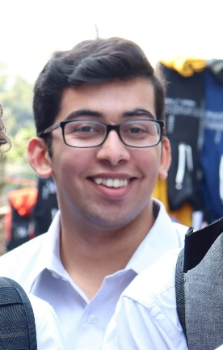
19290573
Rameez PARKAR

Hi I’m Rameez. I never thought I would ever run for the Western SRC but I don’t think I could sit by quietly any longer. That’s why I put my hand up to be a NUS Delegate. For too long now the students of Western Sydney University have had their interests ignored. Like many students, my “uni life” consists of coming to class and going home because there is not enough to do on campus. That is why I started a student club and that’s why I’ve run for the SRC. I think that so much can be done to serve the interests of students and that is what I have been doing over the last year as a representative. There has never been a more important time for strong progressive, principled and pragmatic students representatives fighting for us! Let’s make WSU even better! Vote [1] Rameez Parkar and JUMPSTART!

PREUSS-KEARNEY, Simon
18638811
Simon PREUSS-KEARNEY
Being a member of the NUS is representing all student of Western in the national student community. To achieve this a representative has the important responsibility to be a voice for all students alongside our 5 equal representatives. With experience in the SRC, I bring leadership and an understanding of the significance of this event. Importantly, this event uses SSAF fees. Consequently, representative must find a way to return value to all students. My goals for NUS are to advocate more support for our university. It is far too often overlooked and under-represented in the conference. Additionally, to weigh in on topics such as fee hikes for many units; the endless movement of education onto pre-recorded (often 5+ years old) lectures; and the insufficient ProctorU style exams many Universities use. It’s time we unite for students at NUS. Vote for strength and integrity as action starts with us

POLARA, Razin
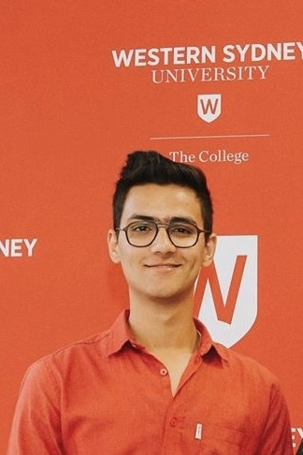
19668228
Razin POLARA

Hi, my name is Razin and I am the current SRC for the parramatta south campus. Apart from the representative role I have also been involved in many other activities in the university. This includes President of Western Sydney Hikers club, secretary of Western Shooters Football Club etc. and also a MATES mentor. In terms of study I am currently doing Bachelor of Nursing.
I have been in the representative role since 2 years. I have tried my best to involve in and participate in the university as a SRC. Due to my leadership skills and enough experience towards the university and its processes I would like to run for the Parramatta south representative position again and want to do much more activities and fun in the university. To help and students is still my number one priority.

Your vote to me will make a new change to the university.

RAM, Crystal
18702590
Crystal RAM
I'm a candidate at our student elections, and a CURRENT member of the SRC; I want to continue to JUMP START WSU. Currently on the executive of Student Clubs, I want to put my leadership experience to work for all of WSU.
This election is very important because our voice will be listened to. This will happen unless you do not vote. And other students’ ideas and thoughts will be heard. I’m the right person to do this job. In the first place, I’m a very responsible person and I love speaking before an audience. Second, if you vote for me, I will speak out for your complaints and problems that I’m sure you have on campus.
I have a plan for a series of fundraising events where all clubs and societies support one another and bring in new contributions.

Remember CRYSTAL and JUMPSTART when you vote.

REED, Robert
17277873
Robert REED
My name is Robert Reed, I am a current Undergraduate Student currently studying aBachelor of Podiatric Medicine.I have been involved in Student Representation at Western for 4 years as a representativefor Disability. During this time, I have learnt about the urgency and ongoing need foradvocacy for the rights of students from a policy level.If I am to be elected as NUS delegate for 2021, I will strive for sustained equitable policychange to ensure a holistic level of advocacy to students regardless of their identification toany particular equity groups. I am also of the belief that Western students require a strongdelegation within the NUS that supports the unified interests of students within the universityand does not play into party politics.

SANDHU, Angad
18993064
Angad SANDHU
As a second generation Indian Australian I feel a new perspective could be given to the Academic Senate. In my perspective for these University elections to represent the university there should be more voices of colour on the table. From my understanding diversity and inclusion is the gathering of people with different backgrounds, genders, political views, and cultures. However, more than just being gathered in a workplace, they each give their opinions and thoughts in the matter at hand to come up with the best possible result. All this being done with respect and without prejudice.

SANGER, Hari

NO IMAGE AVAILABLE

20400415 Hari SANGER
I have been and international student in Australia and now a local, I would like to think I have a very good understanding of issues students face, however trivial. University life can be equally enjoyable and stressful at the same time because of all the commitments and expectations students face. I would like to get involved and help my fellow student and represent them in any way possible and get recognised. I consider myself a very committed person, a good listener and a very open minded for people to have trust that they are being listened. Presently studying in trimesters, I study only three subjects per semester as compared to four so I am left with some spare time and I would like to utilise it for this purpose.

TATO, Elsie

NO IMAGE AVAILABLE

20514815

Elsie TATO

Hi my name is Elsie. I nominate myself for Vice president (undergraduate)! It's currently my first year in University and it has been a big change, in a good way. I believe I have the skills to be a great model for my peers. To be the voice of the needs of my peers. To listen to every opinion and try my best to cater to the needs of others and not just myself. I am reliable and am willing to take any risks and take time out of my day to do what is needed for this position. Thank you.

URIGWE, Timothy
18632125
Timothy URIGWE
The Nation Union of Students (NUS) is an organisation, deeply in debt, that we pay annual fees to be a member of. Since 2019 your SRC has paid a total of $10,000 to be a part of this organisation. In return they have provided questionable returns to us as a student community. Once a year, your student fees fund students to booze it up at the NUS National Conference, where there have been many reports of bullying, threats and intimidation, and obtuse political stalwartly. If elected, I will hold this organisation to account and make sure that WSU students voice is heard. A set of key performance indicators (KPI’s) shall be formulated, and if this is not held to, a recommendation will be made to the SRC to hold a referendum on disaffiliating from this toxic organisation

WEEKS, Sean

20143028

Sean Weeks

NO STATEMENT AVAILABLE

