Western Sydney University Student Elections Guide
Student Editors
2021

ABDELLATIF, Shayma
18754647
Shayma ABDELLATIF
My name is Shayma Abdellatif and I’m running for the role of student editor.

About me, I study Bachelor Communication/ Bachelor International Studies, majoring in Journalism, Indonesian and Asian Studies. I have a passion for human rights, social justice and culture, all of which is reflected in my writing. When I’m not writing for W’SUP I’m travelling, trying new foods and watching anime and movies.
Being part of W’SUP for the past year has been an awe-inspiring journey as I had the chance to meet amazing people and write about topics that relate to the student experience. I engaged with professionals discussing mental health, women’s rights, cultural diversity and entertainment. I would like to continue providing more great content, extending the platform for students to share their stories in the WSU community.

Vote for me and let’s work together to strengthen the student voice.

AYUSH, Ayush
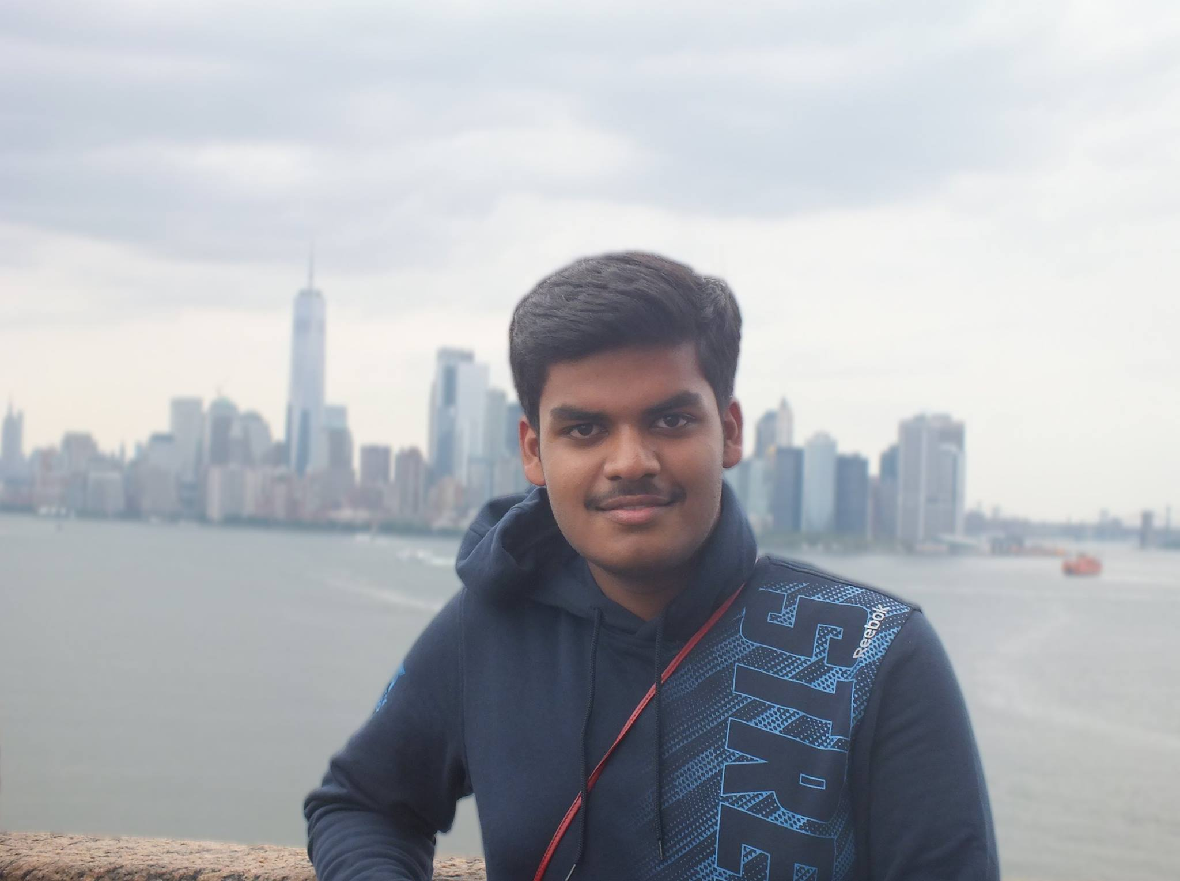

19876391
Ayush AYUSH
My name is Ayush, a second-year international student, studying Bachelor in Business with a major in sports management and photojournalism and photo-media as electives.
I am a published writer as I have few articles published in newspapers in Australia. I am also a professional sports and events photographer with experiences in covering musical gigs and sports, at the top-most level, like cricket, soccer, hockey, motorsports and equestrian for sports clubs, newspapers and agencies. I have also won quite a few contests at the international level for videomaking and editing.
My experiences with student clubs involve being the Founding President of WesSyd Media and Paintball 6 Siege, and Vice President of Western Sydney Sports Business Society. I believe my experiences in being involved with news and working media could be helpful to the student newspaper team – W’SUP.

Bekker, Fred
NO IMAGE AVAILABLE
19367402
Frederick BEKKER

Hi there! My name is Frederick W. Bekker and I am keen to be your next elected representative. We all know that although WSU is a great Uni, there are a lot of things that we can improve upon. We are coming together in 2021 to bring you a new and revamped platform which we are hoping will benefit every student. Having a student advisory group on academic school boards, free university supplies such as notebooks and pens for all students because finances should be no barrier to education, and large social events with other universities for increased social collaboration, are just some of the ideas that we want to bring to you this year. This 2021, make sure you vote dream team - not for us – but for your university experience.

BRUNNER, Katelyn
NO IMAGE AVAILABLE

19296584
Katelyn BRUNNER

Hi, my name is Katelyn Brunner, and I am studying a Bachelor of Arts (Creative Writing)/Bachelor of Creative Industries (Graphic Design). I have recently become a student editor for WSUP news, and I would like to reapply to stay after June 2021. I am passionate about words and writing. I believe that writing is the best way to make sense of a very confusing world and that it is an amazing way to get your voice heard. I will make sure that everything I do is done with punctuality and accuracy. This position is the work I would like to do once I graduate so this experience is incredibly valuable to me. I would be honoured to stay on the team and represent you, the students at Western Sydney University through WSUP news.

Cupitt, Sarah
19760041
Sarah CUPITT
Hi! I'm Sarah Cupitt, an ambitious 3rd-year student studying a Bachelor of Communication (Journalism & PR), playing a vital role in student advocacy relating to university-wide issues, working on programs and services that offer a range of student opportunities. I want to continue representing student's rights and interests at WSU alongside my team, Strength & Integrity. I'm a creative young leader and have held various student positions such as; Director of Student Publications, SRC Vice-President, Multimedia Editor, SRC Online Rep, and NUS delegate since 2019. I founded WSU's first writing community Modern Ink, and am an exec of 7 other clubs and a recipient of various leadership awards from WSU and the local community. This year, my goal is to connect students in shaping the systems that affect their learning experiences. To ensure equity for students, transparency for SSAF, ongoing policy change, and more club funding, please vote for me!

HAQUE, Ishmamul
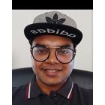
19478584
Ishmamul HAQUE
Hi, I am running for student editor and would love your support. I want to make W’SUP more student focused by including more articles on stress and health management because that is a growing concern for students. The website would include a “Positive Story of the Day” to balance all the negativity around us. I am also looking to produce an environmentally friendly digital magazine to reduce the paper in printing W’SUP. I would reach out to more students from disciplines such as business, psychology, education, nursing because these voices should also be heard alongside communications students. I want to take student concerns directly to University authorities and make sure our concerns are addressed. I would personally create a form where students can direct their concerns. Finally, I want to focus more on campus clubs and activities to
help students find their own communities and friends to grow with!

KAPOOR, Anushka
19925527
Anushka KAPOOR
Please accept this as my expression of interest to apply for the student editor role. I have been a student editor previously and I’m well aware of the roles and responsibilities, since it was for a very short amount of time and there was a lot to share and work on.
I hold experience in content writing and press releases. Currently, I am working as Media and Communications Officer with Council of Australian Postgrad Association (CAPA). Being involved in media activities to manage the overall digital image, working closely with senior members of the association, creating engaging content, strategic plans to increase student participation by integrating new media trends, managing digital presence, publishing newsletters etc. Having said this, makes me ideal for this role as I am passionate about writing &creating content.

MATIC, Nikodin
17236007 Nikodin MATIC

After playing sports at a national level, I returned to University to continue my Bachelor of Business/ Bachelor of Laws and have been heavily involved in all aspects of University including academically, sport and student clubs.

Last year, I ran on the promise to help our Student Clubs and increase the quality and variety of activities available. As the SRC Vice President – Activities, I have made SSAF bids for an eSports Lounge and an upgrade to the multi-purpose courts at Kingswood. I have made $10,000 of funding available to our Student Clubs to help them host better events. I organised the $1000 Kahoot with over 13 clubs and oversaw the purchase of several items to boost student engagement and make events and their University life more enjoyable. These include a professional outdoor laser tag set (12 units) that can fire accurately up to 200m away, 3 x racing simulators with

PARKAR, Rameez
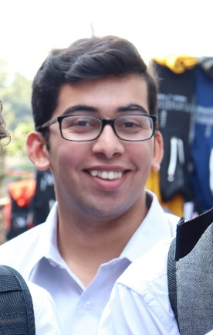
19290573
Rameez PARKAR

Hi I’m Rameez. I never thought I would ever run for the Western SRC but I don’t think I could sit by quietly any longer. That’s why I put my hand up to be a representative. For too long now the students of Western Sydney University have had their interests ignored. Like many students, my “uni life” consists of coming to class and going home because there is not enough to do on campus. That is why I started a student club and that’s why I’ve run for the SRC. I think that so much can be done to serve the interests of students and that is what I have been doing over the last year as a representative. There has never been a more important time for strong progressive, principled and pragmatic students representatives fighting for us! Let’s make WSU even better! Vote [1] Rameez Parkar and JUMPSTART!

SANDHU, Angad

18993064
Angad SANDHU
As a second generation Indian Australian I feel a new perspective could be given to the Academic Senate. In my perspective for these University elections to represent the university there should be more voices of colour on the table. From my understanding diversity and inclusion is the gathering of people with different backgrounds, genders, political views, and cultures. However, more than just being gathered in a workplace, they each give their opinions and thoughts in the matter at hand to come up with the best possible result. All this being done with respect and without prejudice.

