ANNUAL REPORT 2016

The Year in Review
Volume 2

STRA1725 Annual Report 2016_Vol 2_v1.indd 1 19/04/2017 3:05 PM

Financial Statements and Independent Audit Reports

Western Sydney University

UWS Enterprises Pty Limited trading as Western Sydney University The College

uwsconnect Limited

UWS Early Learning Limited

Whitlam Institute within Western Sydney University Limited Whitlam Institute within Western Sydney University Trust

Supporting data
Page

3

99

139

169

193

213

Budget and Performance Indicators 237

This page is intentionally blank

Western Sydney University

Consolidated Financial Statements

For the year ended 31 December 2016

Western Sydney University

Statement by the Members of the Board of Trustees
For the year ended 31 December 2016

In accordance with a resolution of the Board of Trustees of Western Sydney University dated 5 April 2017 and pursuant to Section 41C (1B) and (1C) of the Public Finance and Audit Act 1983, we state that to the best of our knowledge and belief:

- The financial statements present a true and fair view of the financial position of Western Sydney University and its controlled entities (the Group) at 31 December 2016 and the Income Statement and Statement of Comprehensive Income of the Group for the year then ended.

- The financial statements have been prepared in accordance with the provisions of the Public Finance and Audit Act 1983, the Public Finance and Audit Regulation 2015 and the Financial Statement Guidelines for the Australian Higher Education Providers for the 2016 Reporting Period issued by the Department of Education and Training.

- The financial statements have been prepared in accordance with applicable Australian Accounting Standards and other mandatory authoritative pronouncements and interpretations of the Australian Accounting Standards Board, some of which contain requirements specific to not-for-profit entities that are inconsistent with IFRS requirements.

- We are not aware of any circumstances which would render any particulars included in the financial statements to be misleading or inaccurate.

- There are reasonable grounds to believe that the Group will be able to pay its debts as and when they fall due.

........................................................................................... ............................................................................................
Professor Peter Shergold, AC Professor Barney Glover
Chancellor Vice Chancellor and President

Dated at Sydney 5 April 2017
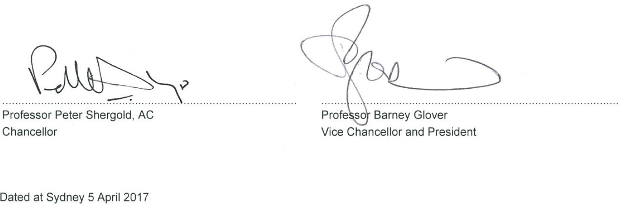

Responsible persons declaration
For the year ended 31 December 2016

The responsible persons declare that in the responsible person's opinion:

  - there are reasonable grounds to believe that the registered entity is able to pay all of its debts, as and when they become due and payable; and

  - the financial statements and notes satisfy the requirements of the Australian Charities and Not-for-profits Commission Act 2012.

Signed in accordance with subsection 60.15(2) of the Australian Charities and Not-for-profits Commission Regulation 2013.

............................................................................................
Professor Barney Glover
Vice Chancellor and President

Dated at Sydney 5 April 2017

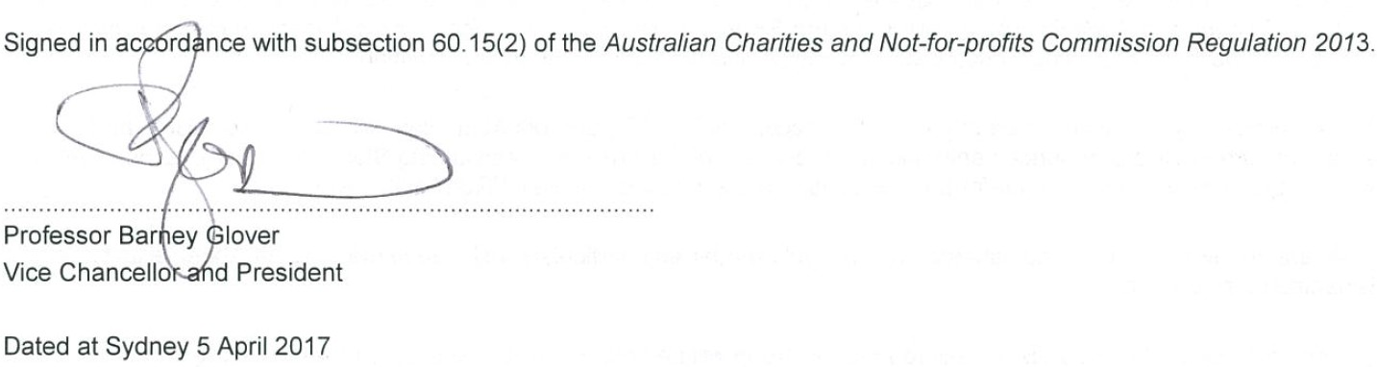

Certifications Statement
For the year ended 31 December 2016

The amount of Australian Government financial assistance expended during the period was for the purposes for which it was intended and Western Sydney University has complied with applicable legislation, contracts, agreements and program guidelines in making expenditure.

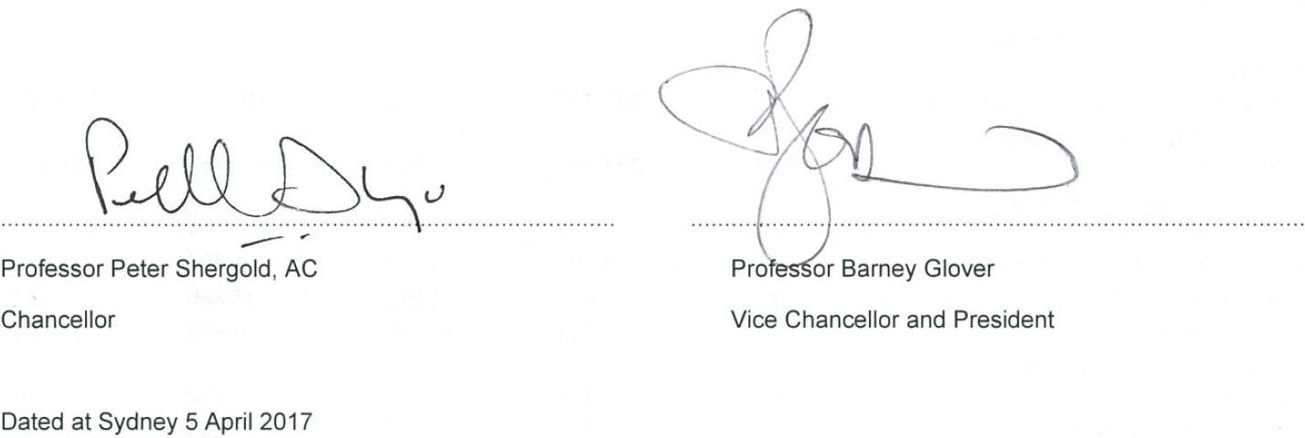
Western Sydney University charged Student Services and Amenities Fees strictly in accordance with the Higher Education Support Act 2003 (the Act) and the Administration Guidelines made under the Act. Revenue from the fees were spent strictly in accordance with the Act and only on services and amenities specified in subsection 19-38(4) of the Act.

........................................................................................... ...........................................................................................

Professor Peter Shergold, AC Professor Barney Glover

Chancellor Vice Chancellor and President

Dated at Sydney 5 April 2017

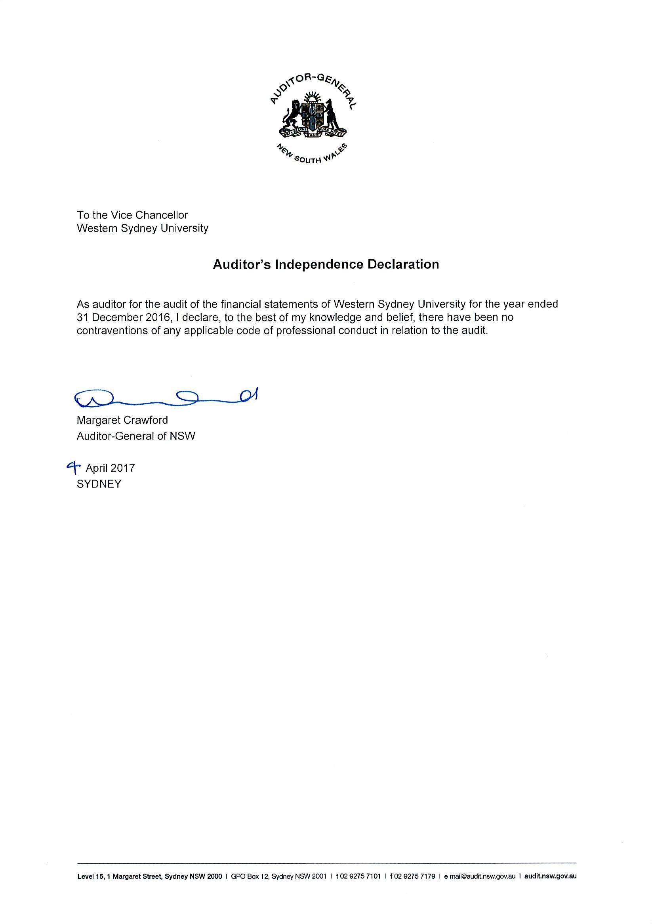

Start of Audited Financial Statements

Western Sydney University

Income Statement
For the Year Ended 31 December 2016

Consolidated Parent

Income from continuing operations
Australian Government financial assistance

Notes
2016
$'000
2015
$'000
2016
$'000
2015
$'000

Australian Government grants HELP - Australian Government | 2 | 345,493 | 342,114 | 345,493 | 341,954
payments | 2(b) | 223,757 | 221,292 | 223,757 | 221,316
State and Local Government financial assistance | 3 | 6 | - | 6 | -
HECS-HELP - student payments |  | 14,594 | 14,821 | 14,594 | 14,821
Fees and charges | 4 | 96,688 | 93,976 | 87,660 | 79,964
Investment revenue | 5 | 8,535 | 12,579 | 8,456 | 12,536
Royalties, Trademarks and Licences | 6 | 262 | 221 | 262 | 194
Consultancy and contracts | 7 | 17,927 | 14,156 | 17,923 | 14,171
Share of net profit or loss on investments accounted for using the equity method | 8 | (1,052) | (119) | - | -
Other income | 9 | 55,433 | 49,688 | 52,674 | 39,499
Gain on disposal of assets | 10 | 13,191 | 6,889 | 12,842 | 6,995
Total income from continuing
operations 774,834 755,617 763,667 731,450

Expenses from continuing operations
Employee related expenses | 11 | 466,003 | 442,407 | 420,814 | 389,684
Depreciation and amortisation | 12 | 43,874 | 39,637 | 42,580 | 38,921
Repairs and maintenance | 13 | 27,107 | 30,165 | 26,844 | 29,847
Borrowing costs | 14 | 2,558 | 1,735 | 2,689 | 1,956
Impairment of assets | 15 | (183) | 48 | (214) | (98)
Other expenses | 16 | 200,638 | 200,302 | 234,936 | 228,134
Total expenses from continuing
operations |  | 739,997 714,294 727,649 688,444
Net result from continuing operations |  | 34,837 41,323 36,018 43,006

Western Sydney University

Statement of Comprehensive Income
For the Year Ended 31 December 2016

Consolidated Parent
 | Notes | 2016  $'000 | 2015  $'000 | 2016  $'000 | 2015  $'000
Net result for the period |  | 34,837 | 41,323 | 36,018 | 43,006
Items that may be reclassified to Income Statement
Gain / (loss) on revaluation of available- for-sale financial assets | 29(b) | 4,724 | 855 | 4,724 | 855
Total |  | 4,724 | 855 | 4,724 | 855
Items that will not be reclassified to Income Statement
Gain / (loss) on revaluation of land and buildings | 29(b) | 18,900 | 110,168 | 18,879 | 110,168
Gain / (loss) on revaluation of art collection | 29(b) | 986 | - | 986 | -
Gain / (loss) on revaluation of livestock | 29(b) | (214) | 46 | (214) | 46
Gain / (loss) on revaluation of licenses | 29(b) | - | 250 | - | 250
Actuarial gains / (losses) recognised in respect of Defined Benefit Plans | 29(b) | (366) | (280) | (366) | (280)
Total |  | 19,306 | 110,184 | 19,285 | 110,184
Total other comprehensive income |  | 24,030 | 111,039 | 24,009 | 111,039
Total comprehensive income |  | 58,867 | 152,362 | 60,027 | 154,045
Total comprehensive income attributable to members of the University |  | 58,867 | 152,362 | 60,027 | 154,045

Statement of Financial Position
As at 31 December 2016

Consolidated Parent

Notes
2016
$'000
2015
$'000
2016
$'000
2015
$'000

ASSETS
Current assets
Cash and cash equivalents | 17 | 139,225 | 132,544 | 136,397 | 130,053
Receivables | 18 | 61,525 | 47,064 | 64,151 | 51,178
Inventories | 19 | 15 | 2,888 | - | -
Other non-financial assets | 24 | 244 | 154 | 244 | 154
Non-current assets held for sale | 20 | 85,460 | 69,513 | 85,330 | 69,300
Total current assets |  | 286,469 | 252,163 | 286,122 | 250,685
Non-current assets
Receivables | 18 | 353,345 | 353,868 | 353,345 | 353,868
Investments accounted for using the equity method | 8 | - | - | - | -
Property, plant and equipment | 21 | 1,600,066 | 1,523,368 | 1,593,034 | 1,516,756
Intangible assets | 22 | 10,294 | 5,334 | 10,140 | 5,061
Other financial assets | 23 | 98,175 | 85,536 | 98,175 | 85,536
Other non-financial assets | 24 | 1,002 | 622 | 1,002 | 622
Total non-current assets |  | 2,062,882 | 1,968,728 | 2,055,696 | 1,961,843
Total assets |  | 2,349,351 | 2,220,891 | 2,341,818 | 2,212,528
LIABILITIES
Current liabilities
Trade and other payables | 25 | 47,695 | 58,207 | 47,297 | 57,448
Borrowings | 26 | 72,000 | - | 79,228 | 7,681
Provisions | 27 | 68,421 | 69,721 | 65,819 | 67,135
Other liabilities | 28 | 48,850 | 42,769 | 47,052 | 41,357
Total current liabilities |  | 236,966 | 170,697 | 239,396 | 173,621
Non-current liabilities
Borrowings | 26 | 83,000 | 75,500 | 83,000 | 75,500
Provisions | 27 | 350,420 | 355,373 | 349,220 | 354,009
Other liabilities | 28 | 12,745 | 11,968 | 12,745 | 11,968
Total non-current liabilities |  | 446,165 | 442,841 | 444,965 | 441,477
Total liabilities |  | 683,131 | 613,538 | 684,361 | 615,098
Net assets |  | 1,666,220 | 1,607,353 | 1,657,457 | 1,597,430
EQUITY
Restricted funds |  | - | - | - | -
Reserves | 29 | 708,004 | 684,514 | 703,755 | 680,286
Retained earnings | 29 | 958,216 | 922,839 | 953,702 | 917,144
Total equity |  | 1,666,220 | 1,607,353 | 1,657,457 | 1,597,430

Statement of Changes in Equity
For the Year Ended 31 December 2016
 |  |  | Parent
 |  |  | Retained
 |  | Reserves | Earnings | Total
 | Notes | $'000 | $'000 | $'000
Balance at 1 January 2016 |  | 680,286 | 917,144 | 1,597,430
Net result | 29(c) | - | 36,018 | 36,018
Gain on revaluation of property, plant and equipment | 29(b) | 18,879 | - | 18,879
Gain on revaluation of available-for-sale financial assets | 29(b) | 4,724 | - | 4,724
Gain on revaluation of art collection | 29(b) | 986 | - | 986
Gain on revaluation of livestock | 29(b) | (214) | - | (214)
Net actuarial gains / (losses) recognised in respect of Defined Benefit Plans | 29(b) | (366) | - | (366)
Total comprehensive income |  | 704,295 | 953,162 | 1,657,457
Transfer from property plant and equipment reserve on disposal of assets | 29(c) | (540) | 540 | -
Balance at 31 December 2016 |  | 703,755 | 953,702 | 1,657,457
 |  |  | Parent
 |  |  | Retained
 |  | Reserves | Earnings | Total
 | Note | $'000 | $'000 | $'000
Balance at 1 January 2015 |  | 571,082 | 872,303 | 1,443,385
Net result | 29(c) | - | 43,006 | 43,006
Gain on revaluation of property, plant and equipment | 29(b) | 110,168 | - | 110,168
Gain on revaluation of available-for-sale financial assets | 29(b) | 855 | - | 855
Gain on revaluation of livestock | 29(b) | 46 | - | 46
Net actuarial gains / (losses) recognised in respect of Defined Benefit Plans | 29(b) | (280) | - | (280)
Gain on revaluation of licenses | 29(b) | 250 | - | 250
Total comprehensive income |  | 682,121 | 915,309 | 1,597,430
Transfer from property plant and equipment reserve on disposal of assets | 29(c) | (1,835) | 1,835 | -
Balance at 31 December 2015 |  | 680,286 | 917,144 | 1,597,430

 | Notes | $'000 | $'000 | $'000
Balance at 1 January 2016 |  | 684,514 | 922,839 | 1,607,353
Net result | 29(c) | - | 34,837 | 34,837
Gain on revaluation of property, plant and equipment | 29(b) | 18,900 | - | 18,900
Gain on revaluation of available-for-sale financial assets | 29(b) | 4,724 | - | 4,724
Gain on revaluation of art collection |  | 986 | - | 986
Gain on revaluation of livestock | 29(b) | (214) | - | (214)
Net actuarial gains / (losses) recognised in respect of Defined Benefit Plans | 29(b) | (366) | - | (366)
Total comprehensive income |  | 708,544 | 957,676 | 1,666,220
Transfer from property plant and equipment reserve on disposal of assets | 29(c) | (540) | 540 | -
Balance at 31 December 2016 |  | 708,004 | 958,216 | 1,666,220

Consolidated

 |  | Reserves | Retained Earnings | Total
 | Note | $'000 | $'000 | $'000
Balance at 1 January 2015 |  | 575,310 | 879,681 | 1,454,991
Net result | 29(c) | - | 41,323 | 41,323
Gain on revaluation of property, plant and equipment | 29(b) | 110,168 | - | 110,168
Gain on revaluation of available-for-sale financial assets | 29(b) | 855 | - | 855
Gain on revaluation of livestock | 29(b) | 46 | - | 46
Net actuarial gains / (losses) recognised in respect of Defined Benefit Plans | 29(b) | (280) | - | (280)
Gain on revaluation of licenses | 29(b) | 250 | - | 250
Total comprehensive income |  | 686,349 | 921,004 | 1,607,353
Transfer from property plant and equipment reserve on disposal of assets | 29(c) | (1,835) | 1,835 | -
Balance at 31 December 2015 |  | 684,514 | 922,839 | 1,607,353

Consolidated Parent

Notes
2016
$'000
2015
$'000
2016
$'000
2015
$'000

CASH FLOWS FROM OPERATING ACTIVITIES
Australian Government Grants |  | 567,636 | 562,552 | 567,636 | 562,416
State Government Grants |  | 6 | - | 6 | -
HECS-HELP - Student payments |  | 14,594 | 14,821 | 14,594 | 14,821
Receipts from student fees and other customers |  | 167,926 | 171,648 | 156,864 | 148,424
Interest received |  | 8,226 | 11,773 | 7,948 | 11,604
Payments to suppliers and employees |  | (740,153) | (681,349) | (730,058) | (658,667)
Interest and other costs of finance |  | (2,558) | (1,735) | (2,550) | (1,746)
GST recovered |  | 27,821 | 21,337 | 27,821 | 21,337
Net cash provided by operating activities | 39 | 43,498 | 99,047 | 42,261 | 98,189
CASH FLOWS FROM INVESTING ACTIVITIES
Proceeds from sale of property, plant and equipment |  | 25,796 | 31,939 | 25,306 | 31,866
Payments for property, plant and equipment |  | (134,198) | (93,893) | (132,566) | (91,586)
Payments for financial assets |  | (7,915) | (28,187) | (7,915) | (28,187)
Loans to related parties |  | - | - | (841) | (11,855)
Repayment of loans by related parties |  | - | - | 1,191 | 10,503
Net cash used by investing activities |  | (116,317) | (90,141) | (114,825) | (89,259)
CASH FLOWS FROM FINANCING ACTIVITIES
Proceeds from borrowings |  | 493,500 | 442,500 | 498,572 | 444,808
Repayment of borrowings |  | (414,000) | (443,000) | (419,664) | (446,700)
Net cash (used by) / provided by | 26
financing activities 79,500 (500) 78,908 (1,892)
Net increase in cash and cash equivalents held |  | 6,681 | 8,406 | 6,344 | 7,038
Cash and cash equivalents at beginning of the year |  | 132,544 | 124,138 | 130,053 | 123,015
Cash and cash equivalents at end of financial year | 17 | 139,225 | 132,544 | 136,397 | 130,053

1 Summary of Significant Accounting Policies

The principal accounting policies adopted in the preparation of these financial statements are set out below. These policies have been consistently applied to all the years reported, unless otherwise stated. The financial statements include the separate financial statements for Western Sydney University as the parent entity (the 'University') and the consolidated entity consisting of Western Sydney University and its subsidiaries (the 'Group').

The principal place of business for Western Sydney University is Great Western Highway Kingswood NSW 2747.

Basis of Preparation

The annual financial statements represent the audited general purpose financial statements of Western Sydney University. They have been prepared on an accrual basis in accordance with Australian Accounting Standards.

The University applies Tier 1 reporting requirements.

Additionally the statements have been prepared in accordance with the following statutory requirements:

- Public Finance and Audit Act 1983 and Public Finance and Audit Regulations 2015;

- Financial Statement Guidelines for Australian Higher Education Providers for the 2016 Reporting Period as issued by the Department of Education and Training;

- The Australian Charities and Not-for-profit Commission Regulation 2013; and

- Other State/Australian Government legislative requirements.

Western Sydney University is a not-for-profit entity and these statements have been prepared on that basis. Some of the Australian Accounting Standards requirements for not-for-profit entities are inconsistent with IFRS requirements.

Date of authorisation for issue

The financial statements were authorised for issue by the members of Western Sydney University on 5 April 2017.

Historical cost convention

These financial statements have been prepared under the historical cost convention, as modified by the revaluation of available-for-sale financial assets, financial assets and liabilities (including derivative instruments) at fair value through profit or loss, and certain classes of property, plant and equipment.

1 Summary of Significant Accounting Policies (continued)

- Basis of Preparation (continued)

Critical accounting estimates and significant judgements

The preparation of financial statements in conformity with Australian Accounting Standards requires the use of certain critical accounting estimates. It also requires management to exercise its judgement in the process of applying Western Sydney University’s accounting policies. The estimates and underlying assumptions are reviewed on an ongoing basis.The areas involving a higher degree of judgement or complexity, or areas where assumptions and estimates are significant to the financial statements, are disclosed below:

  - Management has elected to measure land and buildings at fair value as determined by licensed valuers being Global Valuation Services Pty Ltd who have performed an independent valuation as at 30 September 2016. Plant and equipment has been measured at the written down historical costs of these assets. The valuation of land, building, plant and equipment is shown in property, plant and equipment (note 21). For further details refer also note 1(p).

  - Trade debtors (note 18) would generally be measured at amortised cost which will be approximated by the related nominal value. Management has assumed that there are no significant receivables with fair value materially different from nominal value and that there will be no significant delays in collecting outstanding amounts.

  - The University has entered into a Joint Operation with Urban Growth (note 38). Cost of goods sold has been calculated on a percentage of completion basis, taking into account lot area sold and total costs to completion of the development.

Determining the carrying amount of provisions for employee long service leave entitlements (note 27), provision for annual leave entitlements (note 27), deferred superannuation (note 27), depreciation and useful life of buildings (note 21), and allowance for impaired receivables (note 18(a)) requires estimation of the uncertain future events on those assets and liabilities at the reporting date.

The assumptions made in the assessment of each of the financial assets and liabilities are shown in the relevant notes to the accounts and note 1(j), note 1(m), note 1(o), note 1(p) and note 1(x).

Basis of Consolidation

- Subsidiaries

The consolidated financial statements incorporate the assets and liabilities of all subsidiaries of Western Sydney University (''parent entity'') as at 31 December 2016 and the results of all subsidiaries for the year then ended. Western Sydney University and its subsidiaries together are referred to in these financial statements as the Group or the Consolidated Entity.

Subsidiaries are all those entities (including structured entities) over which the Group has control. The Group has control over an investee when it is exposed, or has rights to variable returns from its involvement with the investee and has the ability to affect those returns through its power over the investee. Power over the investee exists when the Group has existing rights that give it current ability to direct the relevant activities of the investee. The existence and effect of potential voting rights that are currently exercisable or convertible are considered when assessing whether the Group controls another entity. Returns are not necessarily monetary and can be only positive, only negative, or both positive and negative.

Subsidiaries are fully consolidated from the date on which control is transferred to the Group. They are de-consolidated from the date control ceases.

1 Summary of Significant Accounting Policies (continued)

- Basis of Consolidation (continued)

Intercompany transactions, balances and unrealised gains on transactions between Group entities are eliminated. Unrealised losses are also eliminated unless the transaction provides evidence of the impairment of the asset transferred. Accounting policies of subsidiaries have been changed where necessary to ensure consistency with the policies adopted by the Group.

The acquisition method of accounting is used to account for the acquisition of subsidiaries by the Group. The subsidiaries of the University as at 31 December 2016 are:
- UWS Enterprises Pty Limited trading as Western Sydney University The College

- uwsconnect Limited

- Whitlam Institute (within Western Sydney University) Limited and Trust

- UWS Early Learning Limited

Television Sydney (TVS) Limited ceased broadcasting on 20 December 2015 and finalised business operations on 31 December 2015, with no further transactions occuring in 2016. The Company was de-registered on 9 November 2016.

Separate financial statements are prepared by the University’s subsidiaries. The Audit Office of NSW audits these financial statements.

- Joint Arrangements

AASB 11 Joint Arrangements defines a joint arrangement as an arrangement of which two or more parties have joint control and classifies these arrangements as either joint ventures or joint operations.

Western Sydney University has determined that it has both joint venture and joint operations.

Joint operations:

The University's share of assets, liabilities, revenue and expenses of a joint operation have been incorporated in the financial statements under the appropriate headings. Details of the joint operation are set out in note 38.

Joint venture:

The interest in a joint venture entity is accounted for in the consolidated financial statements using the equity method and is carried at cost by the parent entity. Under the equity method, the share of the profits or losses of the entity is recognised in the income statement, and the share of movements in reserves is recognised in reserves in the statement of comprehensive income and the statement of changes in equity. If the venturer's share of losses of a joint venture equals or exceeds its interest in the joint venture, the venturer discontinues recognising its share of further losses.
Details relating to the entity are set out in note 8.

1 Summary of Significant Accounting Policies (continued)

- Foreign currency transactions and balances

Both the functional and presentation currency of the Group is Australian Dollars.

Transactions in foreign currencies are recorded in the functional currency at the exchange rates prevailing at the date of the transaction. Foreign exchange gains and losses resulting from the settlement of such transactions and from the translation at year-end exchange rates of monetary assets and liabilities denominated in foreign currencies are recognised in the income statement.

Revenue Recognition

Revenue is measured at the fair value of the consideration received or receivable. Amounts disclosed as revenue are net of returns, trade allowances, rebates and amounts collected on behalf of third parties.

The Group recognises revenue when the amount of revenue can be reliably measured, it is probable that future economic benefits will flow to the Group and specific criteria have been met for each of the Group’s activities as described below. The amount of revenue is not considered to be reliably measurable until all contingencies relating to the sale have been resolved. The Group bases its estimates on historical results, taking into consideration the type of customer, the type of transaction and the specifics of each arrangement.

Revenue is recognised for the major business activities as follows:

Government Grants

Western Sydney University treats operating grants received from Australian Government entities as income in the year of receipt, as required by AASB 1004 Contributions.

Grants from the Government are recognised at their fair value where the Group obtains control of the right to receive a grant, it is probable that economic benefits will flow to the Group and it can be reliably measured.

HELP Payments

Revenue from HELP is categorised into those received from the Australian Government and those received directly from students. Revenue is recognised and measured in accordance with the above disclosure.

Student fees and charges

Fees and charges are recognised as income in the year of receipt, except to the extent that fees and charges relate to courses to be held in future periods. Such income is treated as income in advance in liabilities. Conversely, fees and charges relating to debtors are recognised as revenue in the year to which the prescribed course relates.

Royalties, trademarks and licences

Revenue from royalties, trademarks and licences is recognised as income when earned.

Consulting and contracting

Contract revenue is recognised in accordance with the percentage of completion method. The stage of completion is measured by reference to labour hours incurred to date as a percentage of estimated total labour hours for each contract.

1 Summary of Significant Accounting Policies (continued)

- Revenue Recognition (continued)

- Lease income

Lease income from operating leases is recognised as income on a straight-line basis over the lease term.

Investment income

Revenue is recognised as the interest accrues using the effective interest method. All other material revenue is accounted for on an accrual basis.

Research grants and contracts

Private (Non Education) research grants and contracts are received by the University in advance of research services being provided and represent reciprocal transfers as specific research services are agreed between the University and the research contractee, with an acquittal process following the provision of the research service. The University treats unspent private research grants as a liability (note 28). In 2016 this amounted to $9.840M (2015: $7.649M). In the 2016 reporting period the $7.649M deferred in the prior year has been treated as income (2015: $9.846M). The net impact on income in 2016 was therefore an increase of $2.191M (2015: decrease of $2.197M).

Income Tax exemption

The Group is exempt from income tax under section 50-B of the Income Tax Assessment Act 1997.

Leases

Leases of property, plant and equipment where the Group, as lessee, has substantially all the risks and rewards of ownership are classified as finance leases. Finance leases are capitalised at the lease’s inception at the lower of the fair value of the leased property and the present value of the minimum lease payments. The corresponding rental obligations, net of finance charges, are included in other short term and long term payables. Each lease payment is allocated between the liability and finance cost. The finance cost is charged to the income statement over the lease period so as to produce a constant periodic rate of interest on the remaining balance of the liability for each period. The property, plant and equipment acquired under finance leases are depreciated over the shorter of the asset’s useful life and the lease term.

Leases in which a significant portion of the risks and rewards of ownership are retained by the lessor are classified as operating leases (note 33). Payments made under operating leases (net of any incentives received from the lessor) are charged to the income statement on a straight-line basis over the period of the lease.

Lease income from operating leases is recognised in income on a straight-line basis over the lease term.

Lease incentives under operating leases are recognised as a liability and amortised on a straight-line basis over the life of the lease term.

1 Summary of Significant Accounting Policies (continued)

- Impairment of assets

Intangible assets that have an indefinite useful life are not subject to amortisation and are tested annually for impairment. Other assets are reviewed for impairment wherever events or changes in circumstances indicate that the carrying amount may not be recoverable. The recoverable amount is the higher of the asset’s fair value less costs to sell and value in use.

An impairment loss is recognised for the amount by which the asset’s carrying amount exceeds its recoverable amount (note 15). For the purposes of assessing impairment, assets are grouped at the lowest levels for which there are separately identifiable cash flows which are largely independent of the cash inflows from other assets or groups of assets (cash generating unit).

Cash and cash equivalents

For statement of cash flows presentation purposes, cash and cash equivalents includes cash on hand, deposits held at call with financial institutions, other short term, highly liquid investments with original maturities of six months or less that are readily convertible to known amounts of cash and which are subject to an insignificant risk of changes in value.

Trade receivables

Trade receivables are recognised initially at fair value and subsequently measured at amortised cost using the effective interest method, less provision for impairment. The Group's standard terms of trade is 14 days from the date of recognition with the exception of the deferred government contribution for superannuation.

Collectability of trade receivables is reviewed on an ongoing basis. Debts which are known to be uncollectible are written off. A provision for impairment of receivables is established when there is objective evidence that the Group will not be able to collect all amounts due according to the original terms of receivables. Significant financial difficulties of the debtor, probability that the debtor will enter bankruptcy or financial reorganisation, and default or delinquency in payments are considered indicators that the trade receivable is impaired. The amount of the provision is the difference between the asset’s carrying amount and the present value of estimated future cash flows, discounted at the effective interest rate. The amount of the movement in the provision is recognised in the income statement.

When a trade receivable is uncollectable the amount of the loss is recognised in the income statement within ‘impairment of assets’. Subsequent recoveries of amounts previously written off are credited to ‘other revenue’ in the income statement.

Cash flows relating to short term receivables are not discounted if the effect of discounting is immaterial.

Prepayments

Payments for goods and services which are to be provided in future years are recognised as prepayments. Prepayments are recorded in trade and other receivables in the statement of financial position.

Inventories

A stocktake of inventories on hand at year end was performed. All inventories are measured at the lower of cost and net realisable value. Textbooks and retail stock are valued at a weighted average price and other stock is valued at last purchase price.

1 Summary of Significant Accounting Policies (continued)

- Investments and other financial assets Classification
The Group classifies its investments in the following categories:held to maturity investments, loans and receivables and available-for-sale financial assets. The classification depends on the purpose for which the investments were acquired. Management determines the classification of its investments at initial recognition and in the case of assets classified as held-to-maturity, re-evaluate this designation at each reporting date.

) Held-to-maturity investments

Held-to-maturity investments are non-derivative financial assets with fixed or determinable payments and fixed maturities that the Group's management has the positive intention and ability to hold to maturity.

The Group has designated as held-to-maturity investments its investment in a fixed income portfolio managed by JB Were Limited. The investments are included as non-current assets in the statement of financial position (note 23).

) Loans and receivables

Loans and receivables are non-derivative financial assets with fixed or determinable payments that are not quoted in an active market. They are included in current assets, except for those with maturities greater than 12 months after the reporting date which are classified as non-current assets. Loans and receivables are included in receivables in the statement of financial position.

Available-for-sale financial assets

Available-for-sale financial assets, comprising principally marketable equity securities, are non-derivatives that are designated in this category.

The Group has designated as available-for-sale:

- units held in Acadian Australian Equity High Yield Fund, a managed investment fund; and

- unlisted securities

The Acadian Australian Equity High Yield Fund units and unlisted securities are included as non-current assets in the statement of financial position (note 23).

Unrealised gains and losses arising from changes in the fair value of financial assets classified as available-for- sale are recognised in equity in the available-for-sale investments revaluation reserve (note 29(a)).

Recognition and derecognition of financial assets

Purchases and sales of investments are recognised on 'trade date' which is the date on which the Group commits to purchase or sell the asset. Investments are initially recognised at fair value plus transaction costs for all financial assets not carried at fair value through profit or loss. Financial assets carried at fair value through profit and loss are initially recognised at fair value and transaction costs are expensed in the income statement. Financial assets are derecognised when the rights to receive cash flows from the financial assets have expired or have been transferred and the Group has transferred substantially all the risks and rewards of ownership.

1 Summary of Significant Accounting Policies (continued)

- Investments and other financial assets (continued) Classification (continued)
When investments classified as available-for-sale are sold, the accumulated fair value adjustments recognised in other comprehensive income are included in the income statement as gains and losses from sale of available- for-sale financial assets (note 5 ).

Subsequent measurement

Available-for-sale financial assets are subsequently carried at fair value. Loans and receivables and held-to- maturity investments are carried at amortised cost using the effective interest method.

Fair value

The fair values of investments and other financial assets are based on quoted prices in an active market. If the market for a financial asset is not active (and for unlisted securities), the Group establishes fair value by using valuation techniques that maximise the use of relevant data. These include reference to the estimated price in an orderly transaction that would take place between market participants at the measurement date. Other valuation techniques used are the cost approach and the income approach based on characteristics of the asset and the assumptions made by market participants.

Impairment

The Group assesses at each balance date whether there is objective evidence that a financial asset or group of financial assets is impaired. In the case of equity securities classified as available-for-sale, a significant or prolonged decline in the fair value of a security below its cost is considered in determining whether the security is impaired. If any such evidence exists for available-for-sale financial assets, the cumulative loss - measured as the difference between the acquisition cost and the current fair value, less any impairment loss on that financial asset previously recognised in profit and loss - is removed from equity and recognised in the income statement. Impairment losses recognised in the income statement on equity instruments are not reversed through the income statement.

Non-current assets (or disposal groups) held for sale and discontinued operations

Non-current assets (or disposal groups) are classified as held for sale and stated at the lower of their carrying amount and fair value less costs of disposal, if their carrying amount will be recovered principally through a sale transaction rather than through continuing use.

An impairment loss is recognised for any initial or subsequent write down of the asset (or disposal group) to fair value less costs to sell. A gain is recognised for any subsequent increases in fair value less costs to sell of an asset (or disposal group), but not in excess of any cumulative impairment loss previously recognised. A gain or loss not previously recognised by the date of the sale of the non-current asset (or disposal group) is recognised at the date of derecognition.

Non-current assets (including those that are part of a disposal group) are not depreciated or amortised while they are classified as held for sale. Interest and other expenses attributable to the liabilities of a disposal group classified as held for sale continue to be recognised.

Non-current assets classified as held for sale and the assets of a disposal group classified as held for sale are presented separately from the other assets in the statement of financial position. The liabilities of a disposal group classified as held for sale are presented separately from other liabilities in the statement of financial position.

1 Summary of Significant Accounting Policies (continued)

- Fair value measurement

The fair value of assets and liabilities must be measured for recognition and disclosure purposes.

The Group classifies fair value measurements using a fair value hierarchy that reflects the significance of the inputs used in making the measurements.

The fair value of assets or liabilities traded in active markets (such as publicly traded derivatives, and trading and available-for-sale securities) is based on quoted market prices for identical assets or liabilities at the end of the reporting date (Level 1). The quoted market price used for assets held by the Group is the most representative of fair value in the circumstances within the bid-ask spread.

The fair value of assets or liabilities that are not traded in an active market are determined using valuation techniques. The Group uses a variety of methods and makes assumptions that are based on market conditions existing at each balance date. Quoted market prices or dealer quotes for similar instruments (Level 2) are used for long-term debt instruments held. Other techniques that are not based on observable market data (Level 3) such as estimated discounted cash flows, are used to determine fair value for the remaining assets and liabilities. The level in the fair value hierarchy shall be determined on the basis of the lowest level input that is significant to the fair value measurement in its entirety.

Fair value measurement of non-financial assets is based on the highest and best use of the asset. The Group considers market participants' use of, or purchase price, of the asset to be in a manner that would be highest and best use.

The carrying value less impairment provision of trade receivables and payables are assumed to approximate their fair values due to their short-term nature. The fair value of financial liabilities for disclosure purposes is estimated by discounting the future contractual cash flows at the current market interest rate that is available to the Group for similar financial instruments.

Property, Plant and Equipment

Land, buildings and the art collection are capitalised and shown at fair value, based on periodic, but at least triennial, valuations by external independent valuers, less subsequent depreciation for buildings. Any accumulated depreciation at the date of revaluation is eliminated against the gross carrying amount of the asset and the carrying amount is restated to the revalued amount of the asset.

Valuation for land and new or refurbished buildings was undertaken as at 30 September 2016 by Global Valuation Services Pty Ltd. Land and buildings were revalued on the basis of highest and best use.

For non completed assets, construction costs totalling $50.306M incurred up to the reporting date were capitalised subsequent to the buildings revaluation. The scope of the valuation did not include revaluation of these buildings. The value of these refurbished buildings is based on the 31 December 2015 revaluation by Global Valuation Services Pty Ltd plus the construction costs capitalised in late 2016.

The Group undertakes a regular review of its land holdings in light of the future academic footprint of the University. Re- evaluation may be undertaken from time to time on land originally designated for educational use with a view to realising monies to fund infrastructure requirements via sale and or joint development, following appropriate re zoning of the land to allow alternate uses.

1 Summary of Significant Accounting Policies (continued)

(p) Property, Plant and Equipment (continued)

The fair value of land is the amount for which the land could be exchanged between willing parties in an arms length transaction, based on market prices for similar properties, with similar zoning, in comparable locations and condition. The Group expects that the fair value of land already rezoned to allow for alternate use shall be different to land available for educational use only. Valuers engaged to determine the fair value of the land have taken into account the intended use and ultimate disposal of the land, as applicable.

Due to the specialised nature of buildings and the lack of directly comparable sales evidence, the 30 September 2016 valuation for new and refurbished buildings was undertaken utilising the Summation Valuation approach, whereby the cost to construct improvements as new is estimated and that amount depreciated, after taking into consideration the nature and design of the improvements, their age and the current condition. In determining the value for each building the exterior dimensions of each building were calculated from the detailed room specifications maintained by the University and extrapolated by the valuer's knowledge of current building rates on a square metre basis. The resultant value as at reporting date was then adjusted for the estimated remaining useful life of each building. The Depreciated Replacement Cost of the improvements was then added to the underlying land value, which was derived after analysis of comparable sales evidence.

In valuing the art collection, Adrienne Carlson, Valuer utilised certain historical facts and relevant market data available up to the date of the valuation. The most recent valuation was completed as at 31 December 2016.

All other plant and equipment is stated at historical cost less depreciation. Historical cost includes expenditure that is directly attributable to the acquisition of the items.

Subsequent costs are included in the asset’s carrying amount or recognised as a separate asset, as appropriate, only when it is probable that future economic benefits associated with the item will flow to the Group and the cost of the item can be measured reliably. All other repairs and maintenance are charged to the income statement during the financial period in which they are incurred.

Increases in the carrying amounts arising on revaluation of land and buildings are recognised in other comprehensive income and accumulated equity under the heading of revaluation surplus. To the extent that the increase reverses a decrease previously recognised in the income statement, the increase is first recognised in the income statement.
Decreases that reverse previous increases of the same class of asset are firstly recognised in other comprehensive income to the extent of the remaining reserve attributable to the asset. All other decreases are expensed in the income statement.

1 Summary of Significant Accounting Policies (continued)

- Property, Plant and Equipment (continued)

Land and the art collection are not depreciated. Depreciation on other assets is calculated using the straight line method to allocate their cost or revalued amounts, over their estimated useful lives, as follows:

Life | 2016 | 2015
Computing (Mainframe & Networking) | 4 years | 4 years
Computing (Other) | 3 years | 3 years
Vehicles | 6-7 years | 6-7 years
Scientific | 10 years | 10 years
Audio visual | 10 years | 10 years
Printing | 10 years | 10 years
Other | 10-20 years | 10-20 years
Buildings (except where a limit of useful life of a building has been identified) | 5-60 years | 5-60 years
Library Collection | 5 years | 5 years
Leasehold Improvements | 2-6 years | 2-6 years

Leasehold improvements are depreciated over the shorter of the unexpired period of the lease or the estimated life of the improvements.

The assets’ residual values and useful lives are reviewed, and adjusted if appropriate, at each reporting date.

An asset’s carrying amount is written down immediately to its recoverable amount if the asset’s carrying amount is greater than its estimated recoverable amount.

Gains and losses on disposals are determined by comparing proceeds with carrying amounts. These are included in the income statement. When revalued assets are sold, it is Group policy to transfer the amounts in reserves in respect of those assets to retained earnings.

Repairs and Maintenance

Repairs and maintenance costs are recognised as expenses as incurred, except where they relate to the replacement of a component of an asset, in which case, the costs are capitalised and depreciated. Other routine operating maintenance, repair and minor renewal costs are also recognised as expenses as incurred.

Livestock

The University maintains livestock for research, teaching and commercial purposes. Livestock is valued on the fair value basis based on current market price. A stocktake of livestock holdings was undertaken at year end.

Intangible Assets

- Licences

Licences have a finite useful life and are carried at cost less accumulated amortisation and impairment losses. Amortisation is calculated using the straight-line method to allocate the cost of licences across their estimated useful life of 5 years (note 22).

1 Summary of Significant Accounting Policies (continued)

- Intangible Assets (continued)

- Electronic materials

Electronic materials have a finite useful life and are carried at cost less accumulated amortisation and impairment losses. Amortisation is calculated using the straight-line method to allocate the cost of electronic materials across their estimated useful life of 5 years (note 22).

Trade and other payables

Trade and other payables are carried at amortised cost and due to their short term nature they are not discounted. They represent liabilities for goods and services provided to the Group prior to the end of the financial year, that are unpaid and arise when the Group becomes obliged to make future payments in respect of the purchase of these goods and services. The Group's standard terms of payment are 30 days from date of recognition.

Borrowings

Borrowings are initially recognised at fair value, net of transaction costs incurred. Borrowings are subsequently measured at amortised cost. Any difference between the proceeds (net of transaction costs) and the redemption amount is recognised in the income statement over the period of the borrowings using the effective interest method. Fees paid on the establishment of loan facilities, which are not an incremental cost relating to the actual draw-down of the facility, are recognised as prepayments and amortised on a straight-line basis over the term of the facility.

Borrowings are removed from the statement of financial position when the obligation specified in the contract is discharged, cancelled or expired. The difference between the carrying amount of a financial liability that has been extinguished or transferred to another party and the consideration paid, including any non-cash assets transferred or liabilities assumed, is recognised in other income or other expenses.

Borrowings are classified as current liabilities unless the Group has an unconditional right to defer settlement of the liability for at least 12 months after the end of the reporting period and does not expect to settle the liability for at least 12 months after the end of the reporting period.

Borrowing costs

Borrowing costs are expensed. Finance charges in respect of finance leases, and exchange differences arising from foreign currency borrowings to the extent that they are regarded as an adjustment to interest costs are included in the definition of borrowing costs.

Provisions

Provisions are recognised when the Group has a present legal or constructive obligation as a result of past events, it is probable that an outflow of resources will be required to settle the obligation and the amount can be reliably estimated.

Provisions are not recognised for future operating losses. Where there are a number of similar obligations, the likelihood that an outflow will be required in settlement is determined by considering the class of obligations as a whole. A provision is recognised even if the likelihood of an outflow with respect to any one item included in the same class of obligations may be small.

Provisions are measured at the present value of management’s best estimate of the expenditure required to settle the present obligation at the reporting date. The discount rate used to determine the present value reflects current market assessments of the time value of money and the risks specific to the liability. The increase in the provision due to the passage of time is recognised as a finance cost.

1 Summary of Significant Accounting Policies (continued)

- Employee benefits

Provision is made for benefits accruing to employees in respect of wages and salaries, annual leave and long service leave when it is probable that settlement will be required and they are capable of being measured reliably. The calculation of employee benefits includes all relevant on-costs and is calculated as follows at reporting date.

) Wages and salaries

Liabilities for short-term employee benefits including wages and salaries and non-monetary benefits are measured at the amount expected to be paid when the liability is settled, if it is expected to be settled wholly before twelve months after the end of the reporting period, and is recognised in other payables.

Annual leave and sick leave

The liability for annual leave is recognised in current provisions for employee benefits as it is due to be settled within 12 months after the end of the reporting period. It is measured at the amount expected to be paid when the liability is settled.

Sick leave is cumulative but not vesting and therefore is not recognised in employee provisions. Liabilities for sick leave are recognised when the leave is taken and measured at the rates paid or payable.

Long service leave

The liability for long service leave is recognised in the provision for employee benefits and measured at the present value of expected future payments to be made in respect of services provided by employees up to the reporting date using the projected unit credit method. Consideration is given to expected future wage and salary levels, experience of employee departures and periods of service. Expected future payments are discounted using market yields at the reporting date on national government bonds with terms to maturity and currency that match, as closely as possible, the estimated future cash outflows.

Regardless of the expected timing of settlements, provisions made in respect of employee benefits are classified as a current liability, unless there is an unconditional right to defer the settlement of the liability for at least twelve months after the reporting date, in which case it would be classified as a non-current liability.

obligations

Employees of the Group that are members of Unisuper are entitled to benefits on retirement, disability or death from the Group’s superannuation plan. The Group has a defined benefit section and defined contribution section within its plan. The defined benefit section provides defined lump sum benefits based on years of service and final average salary. The defined contribution section receives fixed contributions from Group companies and the Group’s legal or constructive obligation is limited to these contributions.

A liability or asset in respect of defined benefit superannuation plans is recognised in the statement of financial position, and is measured at the present value of the defined benefit obligation at the reporting date less the fair value of the superannuation fund’s assets at that date. The present value of the defined benefit obligation is based on expected future payments which arise from membership of the fund to the reporting date, calculated annually by independent actuaries using the projected unit credit method. Consideration is given to expected future wage and salary levels, experience of employee departures and periods of service.

Expected future payments are discounted using market yields at the reporting date on national government bonds with terms to maturity and currency that match, as closely as possible, the estimated future cash outflows.

1 Summary of Significant Accounting Policies (continued)

- Employee benefits (continued)

Remeasurement gains and losses arising from experience adjustments and changes in actuarial assumptions are recognised in the period in which they occur, directly in other comprehensive income. They are included in the retained earnings in the statement of changes in equity and in the statement of financial position.

Past service costs are recognised in profit or loss immediately.

Contributions to the defined contributions section of Western Sydney University's superannuation fund and other independent defined contribution superannuation funds are recognised as an expense as they become payable.

Deferred government benefit for superannuation

In accordance with the 1998 instructions issued by the Department of Education, Training and Youth Affairs (DETYA) now known as the Department of Education (Education), the effects of the unfunded superannuation liabilities of Western Sydney University and its controlled entities were recorded in the income statement and the statement of financial position for the first time in 1998. The prior years’ practice had been to disclose liabilities by way of a note to the financial statements.

The unfunded liabilities recorded in the statement of financial position under Provisions have been determined by Mercer Human Resource Consulting Ltd and relate to the State Superannuation Scheme, the State Authorities Superannuation Scheme and the State Authorities Non Contributory Scheme. This assessment was based on the full requirements of AASB 119.

Deferred government benefits for superannuation are the amounts recognised as reimbursement rights as they are the amounts expected to be received from the Australian Government for the emerging costs of the superannuation funds for the life of the liability.

Note 41 discloses specific treatment.

) Termination Benefits

Termination benefits are payable when employment is terminated before the normal retirement date, or when an employee accepts an offer of benefits in exchange for the termination of employment. The Group recognises the expense and liability for termination benefits either when it can no longer withdraw the offer of those benefits or when it has recognised costs for restructuring within the scope of AASB 137 that involves the payment of termination benefits. The expense and liability are recognised when the Group is demonstrably committed to either terminating the employment of current employees according to a detailed formal plan without possibility of withdrawal or providing termination benefits as a result of an offer made to encourage voluntary redundancy.

Termination benefits are measured on initial recognition and subsequent changes are measured and recognised in accordance with the nature of the employee benefit. Benefits expected to be settled wholly within twelve months are measured at the undiscounted amount expected to be paid. Benefits not expected to be settled before twelve months after the end of the reporting period are discounted to present value.

1 Summary of Significant Accounting Policies (continued)

- Financial guarantee contracts

Financial guarantee contracts are recognised as a liability at the time the guarantee is issued. The liability is initially measured at fair value, and subsequently at the higher of the amount determined in accordance with AASB 137 Provisions, Contingent Liabilities and Contingent Assets and the amount initially recognised less cumulative amortisation, where appropriate.

The fair value of financial guarantees is determined as the present value of the difference in net cash flows between the contractual payments under the debt instrument and the payments that would be required without the guarantee, or the estimated amount that would be payable to a third party for assuming the obligations.

Where guarantees in relation to loans or other payables of subsidiaries or associates are provided for no compensation, the fair values are accounted for as contributions and recognised as part of the cost of the investment.

Rounding of amounts

The University is of a kind referred to in Class order 98/0100 as amended by Class order 04/667, issued by the Australian Securities and Investments Commission, relating to the ''rounding off'' of amounts in the financial report. Amounts in the financial report have been rounded off in accordance with that Class Order to the nearest thousand dollars, or in certain cases, the nearest dollar.

(aa) Goods and Services Tax (GST)

Revenues, expenses and assets are recognised net of the amount of associated GST, unless the GST incurred is not recoverable from the taxation authority. In this case, it is recognised as part of the cost acquisition of the asset or as part of the expense.

Receivables and payables are stated inclusive of the amount of GST receivable or payable. The net amount of GST recoverable from, or payable to, the taxation authority is included with other receivables or payables in the statement of financial position.

Cash flows are presented on a gross basis. The GST components of cash flows arising from investing or financing activities which are recoverable from, or payable to the taxation authority, are presented as operating cash flows.

The Group, excluding uwsconnect Limited and UWS Early Learning Limited, is a Charitable Institution endorsed to access GST concessions on a range of transactions.

(ab) Insurance

Western Sydney University insures externally for all significant areas of risk exposure and accordingly is not a self insurer and makes no provision in its financial statements for internal coverage.

Workers’ Compensation insurance is currently held with Employers Mutual Insurance. Property and liability protections (including General and Products Liability, Professional Liability, Medical Malpractice, Clinical Trials and Directors and Officers) are arranged with Unimutual.

(ac) Foreign operations

Western Sydney University operates a small number of teaching programs in the Asia region. There are no University entities registered overseas.

1 Summary of Significant Accounting Policies (continued) (ad) New Accounting Standards and Interpretations
Certain new Accounting Standards and Interpretations have been published that are not mandatory for 31 December 2016 reporting periods. Western Sydney University's assessment of the impact of these new Standards and Interpretations is set out below:

Standard Application date Implications
AASB 124 Related Party
Disclosures 1 January 2017 The impact of adoption has not yet been determined.
AASB 15 Revenue from contracts
with customers 1 January 2019 The impact of adoption has not yet been determined. AASB 9 Financial instruments 1 January 2018 The impact of adoption has not yet been determined. AASB 16 Leases 1 January 2019 The impact of adoption has not yet been determined.

Summary of Significant Accounting Policies (continued) (ae) Comparative Amounts
When required by Accounting Standards, comparative figures have been adjusted to conform to changes in presentation for the current financial year.

When the Group applies an accounting policy retrospectively, makes a retrospective restatement or reclassifies items in the financial statements, a statement of financial position as at the beginning of the earliest comparative period will be presented.

During the preparation of the current year financial statements, the following items have been adjusted to conform with the current years presentation, resulting in more relevant reliable financial information and classification.

2015 | 2015 | 2015 | 2015
Reported | Revised | Reported | Revised
Consolidated | Consolidated | Parent | Parent
Note $'000 | $'000 | $'000 | $'000

Note 2(f) - Australian Research Councils
(i) Discovery  Projects | 2(f)(i) | 4,046 | 4,908 | 4,046 | 4,908
Fellowships | 2(f)(i) | 2,099 | 1,237 | 2,099 | 1,237
 |  | 6,145 | 6,145 | 6,145 | 6,145
Note 9 - Other revenue and income  Sales of goods | 9 | 9,798 | 16,916 | 1,011 | 1,011
Commercial leases and other rental income | 9 | 11,473 | 4,355 | 4,108 | 4,108
 |  | 21,271 | 21,271 | 5,119 | 5,119
Note 16 - Other expenses
Minimum lease payments on operating lease | 16 | 6,237 | 8,554 | 5,852 | 8,169
Other expenses | 16 | 11,777 | 9,460 | 10,853 | 8,536
 |  | 18,014 | 18,014 | 16,705 | 16,705

Note 24 - Other non-financial asset
Current assets
Other non-financial assets 24 - 154 - 154

Non-current assets
Other non-financial assets | 24 | 776 | 622 | 776 | 622
 |  | 776 | 776 | 776 | 776

Note 25 - Trade and other payables
Payables 25 59,024 58,771 58,012 58,012

Note 28 - Other liabilities
Other | 28 | 1,895 | 2,148 | 1,796 | 1,796
 |  | 60,919 | 60,919 | 59,808 | 59,808

- Australian Government financial assistance including HECS-HELP and other Australian Government loan programs

  - Commonwealth Grants Scheme and Other Grants

Consolidated Parent
 |  | Note | 2016  $'000 | 2015  $'000 | 2016  $'000 | 2015  $'000
 | Commonwealth Grants Scheme #1 |  | 297,511 | 287,365 | 297,511 | 287,365
 | Indigenous Support Program |  | 1,758 | 1,749 | 1,758 | 1,749
 | Higher Education Participation Program #2 |  | 11,625 | 13,074 | 11,625 | 13,074
 | Disability Support Program |  | 924 | 823 | 924 | 823
 | Promotion of Excellence in Learning and Teaching |  | 155 | 175 | 155 | 175
 | Total Commonwealth Grants Scheme and Other Grants | 40(a) | 311,973 | 303,186 | 311,973 | 303,186
(b) | Higher Education Loan Programs
 | HECS - HELP |  | 204,836 | 204,978 | 204,836 | 204,978
 | FEE - HELP #3 |  | 11,862 | 9,195 | 11,862 | 9,219
 | SA - HELP |  | 7,059 | 7,119 | 7,059 | 7,119
 | Total Higher Education Loan Programs | 40(b) | 223,757 | 221,292 | 223,757 | 221,316
(c) | Scholarships
 | Australian Postgraduate Awards |  | 3,361 | 3,227 | 3,361 | 3,227
 | International Postgraduate Research Scholarships |  | 274 | 270 | 274 | 270
 | Commonwealth Education Costs Scholarships #4 |  | 109 | 83 | 109 | 83
 | Commonwealth Accommodation Scholarships |  | 21 | 10 | 21 | 10
 | Indigenous Access Scholarships |  | 39 | 72 | 39 | 72
 | Total Scholarships | 40(c) | 3,804 | 3,662 | 3,804 | 3,662
(d) | Education Research
 | Joint Research Engagement Program |  | 3,813 | 3,730 | 3,813 | 3,730
 | Research Training Scheme |  | 7,070 | 6,884 | 7,070 | 6,884
 | Research Infrastructure Block Grants |  | 1,896 | 1,796 | 1,896 | 1,796
 | Sustainable Research Excellence in Universities |  | 1,753 | 1,497 | 1,753 | 1,497
 | Total Education Research | 40(d) | 14,532 | 13,907 | 14,532 | 13,907

2 Australian Government financial assistance including HECS-HELP and other Australian Government loan programs (continued)

(e) | Other Capital Funding |  | Consolidated |  | Parent
 |  |  | 2016 | 2015 | 2016 | 2015
 |  | Note | $'000 | $'000 | $'000 | $'000
 | Education Investment Fund |  | - | 100 | - | 100
 | Total Other Capital Funding | 40(e) | - | 100 | - | 100
(f) | Australian Research Council ('ARC')
 | (i) Discovery
 | Projects |  | 4,433 | 4,908 | 4,433 | 4,908
 | Fellowships #5 |  | 990 | 1,237 | 990 | 1,237
 | Indigenous Researchers Development |  | - | 256 | - | 256
 | Total Discovery | 40(f)(i) | 5,423 | 6,401 | 5,423 | 6,401
 | (ii) Linkages
 | Linkages - Infrastructure |  | - | 18 | - | 18
 | Projects |  | 1,146 | 716 | 1,146 | 716
 | Total Linkages | 40(f)(ii) | 1,146 | 734 | 1,146 | 734
 | (iii) Networks and Centres
 | Networks and Centres - Centres |  | 1,136 | 1,069 | 1,136 | 1,069
 | Total Networks and Centres |  | 1,136 | 1,069 | 1,136 | 1,069
Total Networks and Centres and
Special Research Initiatives 40(f)(iii) 1,136 1,069 1,136 1,069
Total ARC |  | 40(f) | 7,705 | 8,204 | 7,705 | 8,204

#1 Includes the basic CGS grant amount, CGS - Regional Loading, CGS - Enabling Loading, Maths and Science Transition Loading and Full Fee Places Transition Loading.
#2 Includes Equity Support Program
#3 Program is in respect of FEE-HELP for Higher Education only and excludes funds received in respect of VET FEE-HELP
#4 Includes Grandfathered Scholarships, National Priority and National Accommodation Priority Scholarships
#5 Includes Early Career Researcher Award

2 Australian Government financial assistance including HECS-HELP and other Australian Government loan programs (continued)

- Other Australian Government Financial Assistance

Consolidated Parent

2016
$'000
2015
$'000
2016
$'000
2015
$'000

Non-capital  Department of Health | 3,649 | 6,491 | 3,649 | 6,491
Away-from-base assistance | 404 | 389 | 404 | 389
Indigenous Tutorial Assistance Scheme | 480 | 372 | 480 | 372
Study overseas short term mobility project | 1,877 | 2,090 | 1,877 | 2,090
Structured Training and Employment Program | - | 52 | - | 52
Other | 319 | 611 | 319 | 451
Total | 6,729 | 10,005 | 6,729 | 9,845
Capital
Department of the Environment | - | 2,000 | - | 2,000
Horticulture Innovation Australia | 750 | 1,050 | 750 | 1,050
Total | 750 | 3,050 | 750 | 3,050
Total Other Australian Government Financial Assistance | 7,479 | 13,055 | 7,479 | 12,895

Total Australian Government Financial
Assistance | 569,250 | 563,406 | 569,250 | 563,270

2 Australian Government financial assistance including HECS-HELP and other Australian Government loan programs (continued)

Consolidated Parent

2016
$'000
2015
$'000
2016
$'000
2015
$'000

Reconciliation
Australian Government Grants
(Note 2: a + c + d + e + f +g ) | 345,493 | 342,114 | 345,493 | 341,954
Higher Education Loan Programs (2b) | 223,757 | 221,292 | 223,757 | 221,316
Total Australian Government Financial Assistance | 569,250 | 563,406 | 569,250 | 563,270

- Australian Government Grants received - cash basis

CGS and Other Education Grants Higher Education Loan | 40(a)  40(b) | 312,771 | 302,951 | 312,771 | 302,951
Programmes |  | 222,891 | 221,389 | 222,891 | 221,413
Scholarships | 40(c) | 3,804 | 3,662 | 3,804 | 3,662
Education Research | 40(d) | 12,954 | 13,907 | 12,954 | 13,907
Other Capital Funding | 40(e) | - | 100 | - | 100
ARC Grants - Discovery | 40(f) | 5,133 | 6,234 | 5,133 | 6,234
ARC Grants - Linkages | 40(f) | 1,146 | 749 | 1,146 | 749
ARC Grants - Networks and Centres | 40(f) | 1,136 | 1,069 | 1,136 | 1,069
Other Australian Government Grants | 2(g) | 7,479 | 13,055 | 7,479 | 12,895
Total Australian Government
Grants received - cash basis 567,314 563,116 567,314 562,980
OS-Help (Net) | 40(g) | 322 | (564) | 322 | (564)
Total Australian Government funding received - cash basis |  | 567,636 | 562,552 | 567,636 | 562,416

State and local government financial assistance

Government grants were received during the reporting period for the following purposes:

Consolidated Parent

Non-capital
2016
$'000
2015
$'000
2016
$'000
2015
$'000

NSW Department of Primary Industries 6 - 6 -

Total Non-capital 6 - 6 -

Total State and Local Government Financial
Assistance 6 - 6 -

- Fees and charges
Consolidated Parent

2016
$'000
2015
$'000
2016
$'000
2015
$'000

Course Fees and Charges  Fee-paying onshore overseas students | 79,643 | 75,228 | 77,728 | 70,928
Fee-paying offshore overseas students | 1,099 | 1,086 | 822 | 649
Fee-paying domestic postgraduate students | 2,771 | 2,674 | 2,771 | 2,674
Fee-paying domestic undergraduate students | 454 | 488 | 291 | 388
Fee-paying domestic non-award students | 868 | 960 | 730 | 801
Continuing education | 3,044 | 4,113 | 9 | -
Other domestic course fees and charges | (25) | 36 | (25) | 36
Total Course Fees and Charges | 87,854 | 84,585 | 82,326 | 75,476
Other Non-Course Fees and Charges  Student services fees from students | 2,781 | 2,512 | 2,781 | 2,512
Deferral fees | 144 | 149 | 144 | 149
Library fines | 215 | 200 | 215 | 200
Student accommodation | 824 | 330 | 824 | 330
Academic transcripts | 261 | 259 | 261 | 259
Graduation fees | 385 | 404 | 385 | 404
Academic dress hire | 367 | 374 | 367 | 374
Student test fees | 3,311 | 4,706 | - | -
Other | 546 | 457 | 357 | 260
Total Other Fees and Charges | 8,834 | 9,391 | 5,334 | 4,488
Total Fees and Charges | 96,688 | 93,976 | 87,660 | 79,964

- Investment revenue and other investment income
Consolidated Parent
 | 2016  $'000 | 2015  $'000 | 2016  $'000 | 2015  $'000
Interest income  Bank deposits | 3,634 | 3,732 | 3,555 | 3,689
Other loans and receivables | 438 | 440 | 438 | 440
Distribution from managed funds  Available-for-sale financial assets | 2,947 | 6,801 | 2,947 | 6,801
Held-to-maturity investments | 258 | 267 | 258 | 267
Dividends received | 1,258 | 1,339 | 1,258 | 1,339
Total investment income | 8,535 | 12,579 | 8,456 | 12,536

- Royalties, trademarks and licences
Consolidated Parent

2016
$'000
2015
$'000
2016
$'000
2015
$'000

Royalty and intellectual property 262 221 262 194

Total royalties, trademarks and
licences 262 221 262 194
- Consultancy and contracts
Consolidated Parent
Consultancy | 2016  $'000  4,230 | 2015  $'000  3,476 | 2016  $'000  4,226 | 2015  $'000  3,474
Contract research | 13,697 | 10,680 | 13,697 | 10,697
Total consultancy and contracts | 17,927 | 14,156 | 17,923 | 14,171

- Investments accounted for using the equity method

  - Restrictions

The Group has nil restrictions from the joint venture with Navitas Ltd.

  - Individually immaterial joint venture or associate

Aggregate carrying amount of interests in joint ventures and associates accounted for using the equity method that are not individually material in the consolidated financial statements:

Consolidated Joint Ventures
Profit/(loss) from continuing operations | 2016  $'000  (1,052) | 2015  $'000  (119)
Profit/(loss) from continuing operations after income tax | (1,052) | (119)
Other comprehensive income | - | -
Total comprehensive income | (1,052) | (119)

Capital commitments arising from the Group's interests in joint arrangements and contingent liabilities arising from the Group's interests in associates and joint arrangements are disclosed in notes 33 and 32 respectively.

9 | Other revenue and income | Consolidated |  | Parent
 |  | 2016 | 2015 | 2016 | 2015
 |  | $'000 | $'000 | $'000 | $'000
 | Sale of goods | 15,584 | 16,916 | 993 | 1,011
 | Parking fees | 4,048 | 4,467 | 4,049 | 4,467
 | Donations and bequests | 7,283 | 3,819 | 7,153 | 3,786
 | Commercial leases and other rental income | 5,778 | 4,355 | 5,536 | 4,108
 | Salary recoveries | 4,288 | 4,262 | 4,461 | 4,278
 | Childcare centre fees and grants | 5,972 | 5,913 | - | -
 | Non-salary recoveries | 4,200 | 2,221 | 4,186 | 2,288
 | Scholarships and prizes | 1,587 | 1,267 | 1,587 | 1,267
 | Commission income | 715 | 823 | 715 | 613
 | Service income | 651 | 599 | 20,170 | 14,153
 | Tied grants non-government | 260 | 328 | 260 | 328
 | Conference and seminar income | 604 | 352 | 604 | 321
 | Other | 4,463 | 4,366 | 2,960 | 2,879
 | Total other revenue and income | 55,433 | 49,688 | 52,674 | 39,499

10 Gain on disposal of assets
Consolidated Parent

2016
$'000
2015
$'000
2016
$'000
2015
$'000

Proceeds from sale | 25,771 | 31,939 | 25,306 | 31,866
Carrying amount of assets sold | (12,580) | (25,050) | (12,464) | (24,871)
Total gain on disposal of assets | 13,191 | 6,889 | 12,842 | 6,995

11 | Employee related expenses | Consolidated |  | Parent
 |  | 2016 | 2015 | 2016 | 2015
 |  | $'000 | $'000 | $'000 | $'000
 | Academic
 | Salaries | 191,081 | 178,054 | 170,181 | 156,647
 | Contribution to superannuation
 | & pension schemes - funded | 26,771 | 25,869 | 24,734 | 23,763
 | Payroll tax | 11,554 | 10,582 | 10,229 | 9,266
 | Worker's compensation | 783 | 681 | 699 | 620
 | Long service leave expense | 5,194 | 4,492 | 5,032 | 4,277
 | Annual leave | 1,012 | 922 | 949 | 718
Total academic 236,395 |  |  | 220,600 | 211,824 | 195,291
Non-academic
Salaries |  | 187,058 | 179,661 | 169,125 | 156,202
Contribution to superannuation
& pension schemes - funded |  | 25,359 | 25,539 | 23,821 | 23,428
Payroll tax |  | 10,363 | 9,812 | 9,993 | 9,231
Worker's compensation |  | 940 | 902 | 651 | 593
Long service leave expense |  | 5,391 | 4,687 | 5,158 | 4,444
Annual leave |  | 497 | 1,206 | 242 | 495
Total non-academic |  | 229,608 | 221,807 | 208,990 | 194,393
Total employee related
expenses |  | 466,003 | 442,407 | 420,814 | 389,684
Total employee related
expenses, including deferred
Government Employee Benefits
for Superannuation |  | 466,003 | 442,407 | 420,814 | 389,684

12 | Depreciation and amortisation | Consolidated |  | Parent
 |  | 2016 | 2015 | 2016 | 2015
 |  | $'000 | $'000 | $'000 | $'000
 | Depreciation  Buildings and Infrastructure | 25,924 | 24,050 | 25,924 | 24,050
 | Plant and equipment | 10,974 | 9,692 | 10,826 | 9,484
 | Library collection | 2,945 | 3,322 | 2,945 | 3,322
 | Total depreciation | 39,843 | 37,064 | 39,695 | 36,856
 | Amortisation  Leasehold property | 2,828 | 2,090 | 1,803 | 1,612
 | Intangible assets | 1,203 | 483 | 1,082 | 453
 | Total amortisation | 4,031 | 2,573 | 2,885 | 2,065
 | Total depreciation and amortisation | 43,874 | 39,637 | 42,580 | 38,921
13 | Repairs and maintenance
Consolidated Parent
 |  | 2016 | 2015 | 2016 | 2015
 |  | $'000 | $'000 | $'000 | $'000
 | Buildings | 21,692 | 24,905 | 21,616 | 24,801
 | Plant and equipment | 4,784 | 4,713 | 4,676 | 4,548
 | Information technology | 34 | 43 | 32 | 41
 | Motor vehicles | 597 | 504 | 520 | 457
 | Total repairs and maintenance | 27,107 | 30,165 | 26,844 | 29,847
14 | Borrowing costs
Consolidated Parent
 |  | 2016 2015 |  | 2016 | 2015
 |  | $'000 $'000 |  | $'000 | $'000
 | Interest expense | 2,558 1,735 |  | 2,689 | 1,956
 | Total borrowing costs expensed | 2,558 1,735 |  | 2,689 | 1,956
15 | Impairment of assets | Consolidated |  | Parent
 |  | 2016 2015 |  | 2016 | 2015
 |  | $'000 $'000 |  | $'000 | $'000
 | Bad debts | 127 456 |  | 112 | 431
 | Doubtful debts | (310) (410) |  | (326) | (531)
 | Library collection | - 2 |  | - | 2
 | Total impairment of assets | (183) 48 |  | (214) | (98)

16 | Other expenses | Consolidated |  | Parent
 |  | 2016 | 2015 | 2016 | 2015
 |  | $'000 | $'000 | $'000 | $'000
 | Fees for service #1 | 74,121 | 71,258 | 122,796 | 114,896
 | Consumables & supplies | 28,032 | 28,783 | 16,729 | 18,652
 | Scholarships, grants and prizes | 20,243 | 19,365 | 20,176 | 18,652
 | Overheads | 12,006 | 11,184 | 12,012 | 11,027
 | Advertising, marketing and promotional expenses | 13,708 | 12,283 | 13,737 | 11,700
 | Minimum lease payments on operating lease | 12,309 | 8,554 | 11,844 | 8,169
 | Non-capitalised equipment | 4,456 | 4,798 | 4,165 | 4,173
 | Travel and entertainment | 7,516 | 8,339 | 7,288 | 7,785
 | Cleaning and waste removal | 9,059 | 7,981 | 8,780 | 7,527
 | Student education support | 445 | 7,503 | 445 | 7,501
 | Communication costs | 3,370 | 3,695 | 3,169 | 3,551
 | Staff development | 2,703 | 2,668 | 2,509 | 2,466
 | Security costs | 3,570 | 3,559 | 3,524 | 3,488
 | Student service fees | 297 | 872 | 9 | 11
 | Other expenses | 8,803 | 9,460 | 7,753 | 8,536
 | Total other expenses | 200,638 | 200,302 | 234,936 | 228,134

#1 Audit remuneration included in amount and disclosed under note 31.

17 Cash and cash equivalents
Consolidated Parent

2016
$'000
2015
$'000
2016
$'000
2015
$'000

Cash at bank and on hand | 51,125 | 38,168 | 48,697 | 35,677
Short-term deposits | 88,100 | 94,376 | 87,700 | 94,376
Total cash and cash equivalents | 139,225 | 132,544 | 136,397 | 130,053

- Reconciliation to cash at the end of the year

The above figures are reconciled to cash at the end of the year as shown in the statement of cash flows as follows:
 | Balances as above | 139,225 | 132,544 | 136,397 | 130,053
 | Balance per statement of cash flows | 139,225 | 132,544 | 136,397 | 130,053
(b) | Cash at bank and on hand

The average interest rate during 2016 on bank accounts included in cash at bank and on hand was 2.11% (2015: 1.91%).

(c) Short term deposits

The deposits are at fixed interest rates ranging between 2.55% and 2.80%.

18 | Receivables |  | Consolidated |  | Parent
 |  |  | 2016 | 2015 | 2016 | 2015
 |  | Note | $'000 | $'000 | $'000 | $'000
 | Current
 | Student fees |  | 2,326 | 3,401 | 2,186 | 3,004
 | Other debtors |  | 21,494 | 15,336 | 24,284 | 19,760
 |  |  | 23,820 | 18,737 | 26,470 | 22,764
 | Less Provision for impaired receivables | 18(a) | (618) | (1,176) | (586) | (897)
 | Other |  | 14,624 | 13,463 | 14,624 | 13,441
 | Prepayments |  | 23,699 | 16,040 | 23,643 | 15,870
 | Total current receivables |  | 61,525 | 47,064 | 64,151 | 51,178
 | Non-current
 | Deferred government benefit for superannuation | 41 | 332,281 | 335,332 | 332,281 | 335,332
 | Finance lease receivables | 18(c) | 17,673 | 17,242 | 17,673 | 17,242
 | Prepayments |  | 3,391 | 1,294 | 3,391 | 1,294
 | Total non-current receivables |  | 353,345 | 353,868 | 353,345 | 353,868
 | Total receivables |  | 414,870 | 400,932 | 417,496 | 405,046

(a) Impaired receivables

As at 31 December 2016 current receivables of the Group with a nominal value of $0.618M (2015: $1.176M) were impaired. The amount of the provision was $0.618M (2015: $1.176M). The individually impaired receivables mainly relate to individual debtors with balances aged greater than 180 days.

The ageing of these receivables is as follows: | Consolidated | Parent
 | 2016 2015 | 2016 | 2015
 | $'000 $'000 | $'000 | $'000
0 to 3 months | - - | - | -
3 to 6 months | - - | - | -
Over 6 months | (618) (1,176) | (586) | (897)
Total current impaired
receivables (618) (1,176) (586) (897)

18 Receivables (continued)

- Impaired receivables (continued)

As at 31 December 2016 trade receivables of the Group totalling $10.575M (2015: $6.685M) were past due but not impaired. These relate to a number of individual customers for whom there is no recent history of default. The ageing analysis of these receivables is as follows:

Consolidated Parent

2016
$'000
2015
$'000
2016
$'000
2015
$'000

Trade Receivables  0 to 3 months | 7,554 | 5,032 | 7,118 | 4,827
3 to 6 months | 2,473 | 622 | 1,855 | 597
Over 6 months | 548 | 1,031 | 501 | 831
Total past due but not impaired
receivables 10,575 6,685 9,474 6,255

Consolidated Parent

2016
$'000
2015
$'000
2016
$'000
2015
$'000

Movements in the provision for impaired receivables are as follows:
At 1 January | 1,176 | 1,208 | 897 | 7,167
Provision for impairment recognised / (reversed) during the year | (685) | (488) | (423) | (601)
Receivables written off / (reversed) during the year as uncollectible | 127 | 456 | 112 | 431
Related party loan forgiven | - | - | - | (2,094)
Related party receivables forgiven | - | - | - | (4,006)
At 31 December | 618 | 1,176 | 586 | 897

The creation and release of the provision for impaired receivables has been included in ‘impairment of assets’ in the income statement. Amounts charged to the provision account are generally written off when there is no expectation of recovering additional cash.

The other amounts within receivables do not contain impaired assets and are not past due. Based on credit history, it is expected that these amounts will be received when due.

- Leasing Arrangements

The University, as lessor, has entered into a lease with Campus Living Villages Pty Limited to manage student residence accommodation for a period of 40 years.

18 Receivables (continued)

- Amounts receivable under finance leases

Minimum lease payments Present value of minimum lease
payments

2016
$'000
2015
$'000
2016
$'000
2015
$'000

Not later than 1 year - - - -
Later than 1 year and not later
than 5 years - - - - Later than 5 years 42,990 42,990 17,673 17,242

Amounts receivable under
finance leases 42,990 42,990 17,673 17,242
Less unearned finance income | (25,317) | (25,748) | - | -
Present value of minimum lease payments receivable | 17,673 | 17,242 | 17,673 | 17,242
Allowance for uncollectible lease payments | - | - | - | -
Finance lease receivable | 17,673 | 17,242 | 17,673 | 17,242

Unguaranteed residual values of assets leased under finance leases at the end of the reporting period are estimated at $42.990M (2015: $42.990M).

Contingent rents of $0.810M (2015: $0.329M) have been recognised as income in the year.

The finance lease receivables at the end of the reporting period are neither past due nor impaired.

Inventories
Consolidated Parent

2016
$'000
2015
$'000
2016
$'000
2015
$'000

Current
At cost:
Stock on hand | 15 | 2,888 | - -
Total inventories | 15 | 2,888 | - -

- Non-current assets classified as held for sale ('NCA')
Consolidated Parent

2016
$'000
2015
$'000
2016
$'000
2015
$'000

Current  Land | 85,330 | 69,300 | 85,330 | 69,300
Subway Franchise | 130 | 213 | - | -
Total non-current assets or disposal groups classified as held for sale | 85,460 | 69,513 | 85,330 | 69,300

NCAs (or disposal groups) held for sale are carried at the lower of the carrying amount or the fair value less costs to sell. For the fair value of the NCA (or disposal group) see note 36(b).

The University has entered into a sales agreement to sell land at its Westmead campus. Settlement is expected to occur by 31 October 2017, subject to the relocation of telecommunications towers on the current site. A gain of $8.0m has been recognised in 2016 (2015: $63.4m) in the statement of comprehensive income, under the heading gain on revaluation of land and buildings. This gain on revaluation is recognised in the property development reserve in note 29(b). This revaluation gain will be transferred to retained earnings on settlement when the asset is de-recognised.

Property, plant and equipment

 | Construction in Progress | Freehold Land | Crown Land | Buildings | Infrastructure | Buildings- Under Finance Lease | Plant and Equipment | Leasehold Improvements | Library Collection | Artwork | Total
Consolidated | $'000 | $'000 | $'000 | $'000 | $'000 | $'000 | $'000 | $'000 | $'000 | $'000 | $'000
At 1 January 2015
- Cost | 110,573 | - | - | 820 | 623 | 4,594 | 126,513 | 20,284 | 86,775 | - | 350,182
- Valuation | - | 187,336 | 162,335 | 826,809 | 81,397 | - | - | - | 1,651 | 3,041 | 1,262,569
Accumulated depreciation | - | - | - | (2,285) | (683) | (4,594) | (65,627) | (6,075) | (77,213) | - | (156,477)
Net Book Amount | 110,573 | 187,336 | 162,335 | 825,344 | 81,337 | - | 60,886 | 14,209 | 11,213 | 3,041 | 1,456,274
Year Ended 31 December 2015
Opening Net Book Amount | 110,573 | 187,336 | 162,335 | 825,344 | 81,337 | - | 60,886 | 14,209 | 11,213 | 3,041 | 1,456,274
Revaluation Surplus | - | 93,717 | - | 15,199 | 1,252 | - | - | - | - | - | 110,168
Additions | 77,251 | 1,150 | - | - | - | - | 9,928 | - | 2,235 | 64 | 90,628
Disposals | (18,620) | (250) | - | (4,998) | - | - | (726) | - | (453) | (3) | (25,050)
Depreciation Charge | - | - | - | (21,561) | (2,489) | - | (9,692) | (2,090) | (3,322) | - | (39,154)
Non-Cash Adjustments | - | - | - | (11) | - | - | (3) | 29 | - | - | 15
Transfers to Freehold Buildings and Plant & Equipment | (106,943) | - | - | - | - | - | - | - | - | - | (106,943)
Transfers from Construction in Progress | - | 1,943 | - | 96,688 | 5,295 | - | 39 | 2,928 | - | 50 | 106,943
Transfers to Held for Sale Assets | - | (69,300) | - | - | - | - | (213) | - | - | - | (69,513)
Closing Net Book Amount | 62,261 | 214,596 | 162,335 | 910,661 | 85,395 | - | 60,219 | 15,076 | 9,673 | 3,152 | 1,523,368
At 31 December 2015
- Cost | 62,261 | - | - | 7,929 | 1,637 | 4,594 | 132,831 | 23,242 | 82,713 | - | 315,207
- Valuation | - | 214,596 | 162,335 | 905,781 | 85,557 | - | - | - | 1,651 | 3,152 | 1,373,072
Accumulated depreciation | - | - | - | (3,049) | (1,799) | (4,594) | (72,612) | (8,166) | (74,691) | - | (164,911)
Net Book Amount | 62,261 | 214,596 | 162,335 | 910,661 | 85,395 | - | 60,219 | 15,076 | 9,673 | 3,152 | 1,523,368

21 Property, plant and equipment (continued) |  |  |  | Buildings-
Construction Freehold in Progress Land | Crown Land | Buildings | Infrastructure | Under Finance Lease | Plant and Equipment | Leasehold Improvements | Library Collection | Artwork | Total
Consolidated $'000 $'000 | $'000 | $'000 | $'000 | $'000 | $'000 | $'000 | $'000 | $'000 | $'000
Year Ended 31 December 2016
Opening Net Book Amount 62,261 214,596 | 162,335 | 910,661 | 85,395 | - | 60,219 | 15,076 | 9,673 | 3,152 | 1,523,368
Revaluation Surplus - (3,055) | - | 19,722 | 2,203 | - | - | - | 30 | 986 | 19,886
Additions 114,688 3,950 | - | - | - | - | 7,182 | - | 2,179 | 66 | 128,065
Disposals (11,310) - | - | (758) | - | - | (284) | - | (228) | - | (12,580)
Depreciation Charge - - | - | (23,172) | (2,752) | - | (10,974) | (2,828) | (2,945) | - | (42,671)
Non-Cash Adjustments - - | - | - | - | - | - | 28 | - | - | 28
Transfers to Freehold Buildings and  Plant & Equipment (80,595) - | - | - | - | - | - | - | - | - | (80,595)
Transfers from Construction in  Progress - - | - | 54,304 | 11,674 | - | 10,022 | 4,595 | - | - | 80,595
Transfers to Held for Sale Assets - (10,859) | - | - | (5,171) | - | - | - | - | - | (16,030)
Closing Net Book Amount 85,044 204,632 | 162,335 | 960,757 | 91,349 | - | 66,165 | 16,871 | 8,709 | 4,204 | 1,600,066
At 31 December 2016
- Cost 85,044 - | - | 47,788 | 2,518 | 4,594 | 148,577 | 27,865 | 81,139 | - | 397,525
- Valuation - 204,632 | 162,335 | 920,514 | 90,256 | - | - | - | 1,712 | 4,204 | 1,383,653
Accumulated depreciation - - | - | (7,545) | (1,425) | (4,594) | (82,412) | (10,994) | (74,142) | - | (181,112)
Net Book Amount 85,044 204,632 | 162,335 | 960,757 | 91,349 | - | 66,165 | 16,871 | 8,709 | 4,204 | 1,600,066

21 Property, plant and equipment (continued) |  |  |  |  | Buildings-
Construction | Freehold |  |  |  | Under Finance | Plant and | Leasehold | Library
in Progress | Land | Crown Land | Buildings | Infrastructure | Lease | Equipment | Improvements | Collection | Artwork | Total
Parent $'000 | $'000 | $'000 | $'000 | $'000 | $'000 | $'000 | $'000 | $'000 | $'000 | $'000
At 1 January 2015
- Cost 106,889 | - | - | 820 | 623 | 4,594 | 123,655 | 17,610 | 86,776 | - | 340,967
- Valuation - | 187,336 | 162,335 | 826,809 | 81,397 | - | - | - | 872 | 3,029 | 1,261,778
Accumulated depreciation - | - | - | (2,285) | (683) | (4,594) | (63,593) | (3,738) | (77,213) | - | (152,106)
Net Book Amount 106,889 | 187,336 | 162,335 | 825,344 | 81,337 | - | 60,062 | 13,872 | 10,435 | 3,029 | 1,450,639
Year Ended 31 December 2015
Opening Net Book Amount 106,889 | 187,336 | 162,335 | 825,344 | 81,337 | - | 60,062 | 13,872 | 10,435 | 3,029 | 1,450,639
Revaluation Surplus - | 93,717 | - | 15,199 | 1,252 | - | - | - | - | - | 110,168
Additions 75,308 | 1,150 | - | - | - | - | 9,823 | - | 2,234 | 64 | 88,579
Disposals (18,620) | (250) | - | (4,998) | - | - | (547) | - | (453) | (3) | (24,871)
Depreciation Charge - | - | - | (21,561) | (2,489) | - | (9,484) | (1,612) | (3,322) | - | (38,468)
Non-Cash Adjustments - | - | - | (11) | - | - | 2 | 18 | - | - | 9
Transfers to Freehold Buildings and  Plant & Equipment (104,799) | - | - | - | - | - | - | - | - | - | (104,799)
Transfers from Construction in  Progress - | 1,943 | - | 96,688 | 5,295 | - | 39 | 784 | - | 50 | 104,799
Transfers to Held for Sale Assets - | (69,300) | - | - | - | - | - | - | - | - | (69,300)
Closing Net Book Amount 58,778 | 214,596 | 162,335 | 910,661 | 85,395 | - | 59,895 | 13,062 | 8,894 | 3,140 | 1,516,756
At 31 December 2015
- Cost 58,778 | - | - | 7,929 | 1,637 | 4,594 | 131,471 | 18,412 | 82,713 | - | 305,534
- Valuation - | 214,596 | 162,335 | 905,781 | 85,557 | - | - | - | 872 | 3,140 | 1,372,281
Accumulated depreciation - | - | - | (3,049) | (1,799) | (4,594) | (71,576) | (5,350) | (74,691) | - | (161,059)
Net Book Amount 58,778 | 214,596 | 162,335 | 910,661 | 85,395 | - | 59,895 | 13,062 | 8,894 | 3,140 | 1,516,756

21 Property, plant and equipment (continued) |  |  |  |  | Buildings-
Construction | Freehold |  |  |  | Under Finance | Plant and | Leasehold | Library
in Progress | Land | Crown Land | Buildings | Infrastructure | Lease | Equipment | Improvements | Collection | Artwork | Total
Parent $'000 | $'000 | $'000 | $'000 | $'000 | $'000 | $'000 | $'000 | $'000 | $'000 | $'000
Year Ended 31 December 2016
Opening Net Book Amount 58,778 | 214,596 | 162,335 | 910,661 | 85,395 | - | 59,895 | 13,062 | 8,894 | 3,140 | 1,516,756
Revaluation Surplus - | (3,055) | - | 19,722 | 2,203 | - | - | - | 9 | 986 | 19,865
Additions 113,124 | 3,950 | - | - | - | - | 7,080 | - | 2,148 | 66 | 126,368
Disposals (11,310) | - | - | (758) | - | - | (168) | - | (228) | - | (12,464)
Depreciation Charge - | - | - | (23,172) | (2,752) | - | (10,826) | (1,803) | (2,945) | - | (41,498)
Non-Cash Adjustments - | - | - | - | - | - | 9 | 28 | - | - | 37
Transfers to Freehold Buildings and  Plant & Equipment (76,421) | - | - | - | - | - | - | - | - | - | (76,421)
Transfers from Construction in  Progress - | - | - | 54,304 | 11,674 | - | 9,760 | 683 | - | - | 76,421
Transfers to Held for Sale Assets - | (10,859) | - | - | (5,171) | - | - | - | - | - | (16,030)
Closing Net Book Amount 84,171 | 204,632 | 162,335 | 960,757 | 91,349 | - | 65,750 | 11,970 | 7,878 | 4,192 | 1,593,034
At 31 December 2016
- Cost 84,171 | - | - | 47,788 | 2,518 | 4,594 | 147,150 | 19,122 | 81,139 | - | 386,482
- Valuation - | 204,632 | 162,335 | 920,514 | 90,256 | - | - | - | 881 | 4,192 | 1,382,810
Accumulated depreciation - | - | - | (7,545) | (1,425) | (4,594) | (81,400) | (7,152) | (74,142) | - | (176,258)
Net Book Amount 84,171 | 204,632 | 162,335 | 960,757 | 91,349 | - | 65,750 | 11,970 | 7,878 | 4,192 | 1,593,034

22 | Intangible Assets  Parent | Development | Electronic
 |  | costs Licences | Materials | Total
 |  | $'000 $'000 | $'000 | $'000
 | At 1 January 2015
 | - Cost | - 275 | 2,266 | 2,541
 | - Accumulated amortisation and impairment | - (275) | - | (275)
 | Net book amount at 1 January 2015 | - - | 2,266 | 2,266
 | Year ended 31 December 2015
 | Opening net book value | - - | 2,266 | 2,266
 | Additions | - - | 2,998 | 2,998
 | Amortisation charge | - - | (453) | (453)
 | Revaluation increase recognised in equity | - 250 | - | 250
 | Net book amount at 31 December 2015 | - 250 | 4,811 | 5,061
 | At 31 December 2015
 | - Cost | - 250 | 5,264 | 5,514
 | - Accumulated amortisation and impairment | - - | (453) | (453)
 | Net book amount at 31 December 2015 | - 250 | 4,811 | 5,061
 | Year ended 31 December 2016
 | Opening net book amount | - 250 | 4,811 | 5,061
 | Additions | - - | 6,161 | 6,161
 | Amortisation charge | - (29) | (1,053) | (1,082)
 | Net book amount at 31 December 2016 | - 221 | 9,919 | 10,140
 | At 31 December 2016
 | - Cost | - 250 | 11,425 | 11,675
 | - Accumulated amortisation and impairment | - (29) | (1,506) | (1,535)
 | Net book amount at 31 December 2016 | - 221 | 9,919 | 10,140

Intangible Assets (continued)

Consolidated | Development  costs | Licences | Electronic  Materials | Total
 | $'000 | $'000 | $'000 | $'000
At 1 January 2015  - Cost | - | 756 | 2,266 | 3,022
- Accumulated amortisation and impairment | - | (705) | - | (705)
Net book amount amount at 1 January 2015 | - | 51 | 2,266 | 2,317
Year ended 31 December 2015  Opening net book amount | - | 51 | 2,266 | 2,317
Additions | 263 | - | 2,998 | 3,261
Amortisation charge | - | (30) | (453) | (483)
Revaluation surplus | - | 250 | - | 250
Non-Cash Adjustments | - | (11) | - | (11)
Net book amount at 31 December 2015 | 263 | 260 | 4,811 | 5,334
At 31 December 2015  - Cost | 263 | 330 | 5,264 | 5,857
- Accumulated amortisation and impairment | - | (70) | (453) | (523)
Net book amount at 31 December 2015 | 263 | 260 | 4,811 | 5,334
Year ended 31 December 2016  Opening net book amount | 263 | 260 | 4,811 | 5,334
Additions | - | - | 6,161 | 6,161
Amortisation charge | (110) | (40) | (1,053) | (1,203)
Non-Cash Adjustments | 1 | 1 | - | 2
Net book amount at 31 December 2016 | 154 | 221 | 9,919 | 10,294
At 31 December 2016  - Cost | 264 | 331 | 11,425 | 12,020
- Accumulated amortisation and impairment | (110) | (110) | (1,506) | (1,726)
Net book amount at 31 December 2016 | 154 | 221 | 9,919 | 10,294

23 | Other financial assets | Consolidated |  | Parent
 |  | 2016 | 2015 | 2016 | 2015
 |  | $'000 | $'000 | $'000 | $'000
 | Non-Current
 | Available for sale (Unlisted securities) | 11,330 | 9,500 | 11,330 | 9,500
 | Available for sale (Acadian) | 76,143 | 69,703 | 76,143 | 69,703
 | Held to maturity (Amortised cost) | 10,702 | 6,333 | 10,702 | 6,333
 | Total non-current other financial assets | 98,175 | 85,536 | 98,175 | 85,536

24 Other non-financial assets
Consolidated Parent

Current
2016
$'000
2015
$'000
2016
$'000
2015
$'000

Lease incentives 244 154 244 154
Total current other non-financial assets 244 154 244 154
Non-current
Livestock holdings 490 622 490 622
Lease incentives 512 - 512 -

Total non-current other non-financial
assets 1,002 622 1,002 622

Total other non-financial assets 1,246 776 1,246 776

25 | Trade and other payables | Consolidated | Parent
 |  | 2016 2015 | 2016 | 2015
 |  | $'000 $'000 | $'000 | $'000
 | Current  Payables | 47,373 58,771 | 46,975 | 58,012
 | OS-HELP liability to Australian Government | 322 (564) | 322 | (564)
 | Total current trade and other payables | 47,695 58,207 | 47,297 | 57,448

- Foreign currency risk

The carrying amounts of the Group's and parent entity's trade and other payables are denominated in the following currencies:

Consolidated Parent

2016
$'000
2015
$'000
2016
$'000
2015
$'000

Australian Dollars | 46,833 | 56,773 | 46,435 | 56,014
US Dollars | 396 | 1,032 | 396 | 1,032
Euro | 146 | 225 | 146 | 225
GB Pounds | 307 | 114 | 307 | 114
Other | 13 | 63 | 13 | 63
 | 47,695 | 58,207 | 47,297 | 57,448

For an analysis of the sensitivity of trade and other payables to foreign currency risk refer to note 35.

26 | Borrowings | Consolidated |  | Parent
 |  | 2016 | 2015 | 2016 | 2015
 |  | $'000 | $'000 | $'000 | $'000
 | Current  Unsecured bank loans (i) | 72,000 | - | 72,000 | -
 | Unsecured other financial liabilities (ii) | - | - | 7,228 | 7,681
 | Total current borrowings | 72,000 | - | 79,228 | 7,681
 | Non-Current
 | Unsecured bank loans (i) | 83,000 | 75,500 | 83,000 | 75,500
 | Total non-current borrowings | 83,000 | 75,500 | 83,000 | 75,500
 | Total borrowings | 155,000 | 75,500 | 162,228 | 83,181

- In October 2013 the University received approval from the Treasurer of New South Wales to increase its borrowing facilities by $70 million to a maximum of $198 million for the construction of new facilities and other infrastructure. Such approval was required under Section 22 (l)(e) of the Western Sydney University Act 1997.The additional facilities were finalised with the University's bank in September 2014.

In November 2016 the borrowing facilities were further increased by $100 million to a maximum $298 million and were finalised with the University's bank in November 2016.

The interest rate of the loan is variable being based on the BBSY bid rate plus a margin. The interest rate averaged 2.78% during 2016. The loan facilities are unsecured.

The balance of the loan outstanding as at 31 December 2016 was $155.0 million (2015: $75.5 million).

- Relates to the transfer of UWS Enterprises Pty Limited trading as Western Sydney University The College and UWS Early Learning Limited surplus funds to the University.

The fair value of borrowings equals their carrying amount, as the impact of discounting is not significant. For an analysis of the sensitivity of borrowings to interest rate risk refer to note 35.
The carrying amount of the Group's borrowings is denominated in AUD currency.

Borrowings (continued)

  - Financing arrangements

Unrestricted access was available at reporting date to the following lines of credit:

Consolidated Parent
 | 2016  $'000 | 2015  $'000 | 2016  $'000 | 2015  $'000
Credit standby arrangements
Total facilities
Bank guarantees | 825 | 575 | 825 | 575
Credit cards | 4,500 | 4,570 | 4,500 | 4,500
Leasing facilities | 26,000 | 28,011 | 26,000 | 26,000
Total credit standby arrangements | 31,325 | 33,156 | 31,325 | 31,075
Used at balance date
Bank guarantees | 708 | 200 | 708 | 200
Credit cards | 146 | 186 | 146 | 186
Leasing facilities | 15,221 | 13,688 | 15,221 | 13,677
Total used at balance date | 16,075 | 14,074 | 16,075 | 14,063
Unused at balance date
Bank guarantees | 117 | 375 | 117 | 375
Credit cards | 4,354 | 4,384 | 4,354 | 4,314
Leasing facilities | 10,779 | 14,323 | 10,779 | 12,323
Total unused at balance date | 15,250 | 19,082 | 15,250 | 17,012
Bank loan facilities
Total facilities | 298,000 | 198,000 | 298,000 | 198,000
Used at balance date | (155,000) | (75,500) | (155,000) | (75,500)
Total unused at balance date | 143,000 | 122,500 | 143,000 | 122,500

- Provisions
Consolidated Parent

Note
2016
$'000
2015
$'000
2016
$'000
2015
$'000

Current provisions expected to be settled within 12 months Employee benefits
Annual leave |  | 22,688 | 21,246 | 20,981 | 20,110
Long service leave |  | 6,798 | 6,069 | 6,512 | 5,896
 |  | 29,486 | 27,315 | 27,493 | 26,006
Current provisions expected to be settled after more than 12 months
Employee benefits
Annual leave |  | 5,576 | 6,187 | 5,286 | 5,217
Long service leave |  | 33,359 | 36,219 | 33,040 | 35,912
 |  | 38,935 | 42,406 | 38,326 | 41,129
Total current provisions 68,421 |  |  | 69,721 | 65,819 | 67,135
Non-current provisions
Employee benefits
Long service leave |  | 16,731 | 19,072 | 15,531 | 17,708
Deferred government benefits for superannuation | 41(d) | 332,982 | 335,855 | 332,982 | 335,855
Long-term provisions
Make good on leases |  | 707 | 446 | 707 | 446
Total non-current provisions |  | 350,420 | 355,373 | 349,220 | 354,009
Total provisions |  | 418,841 | 425,094 | 415,039 | 421,144

  - Annual leave

The following on costs have been used by management in calculating the provision for annual leave:

%
Superannuation | 16.75
Estimate of short term salary increase | 3.75
Payroll tax | 5.45
Workers compensation | 0.75

27 Provisions (continued)

  - Long service leave

In 2014 the University engaged Mercer Consulting (Australia) Pty Ltd to undertake a valuation of the University's long service leave liability. The University has used a shorthand measurement technique to value the long service leave liability at 31 December 2016. Assumptions used in this measurement included:

%
Estimate rate of long term inflation / salary increase 3.00
Discount for future investment earnings 2.75
  - Movements in provisions - Non Current
Movements in each class of provision during the financial year, other than employee benefits, are set out below:

 | Make good on leases | Total
 | $'000 | $'000
Parent
Non-current
Carrying amount at start of year | 446 |  | 446
Additional provisions | 261 |  | 261
Carrying amount at end of year | 707 |  | 707
 | Make good on leases | Total
 | $'000 | $'000
Consolidated
Non-current
Carrying amount at start of year | 446 |  | 446
Additional provisions | 261 |  | 261
Carrying amount at end of year | 707 |  | 707

The University has an obligation to make good on leased premises at the end of certain rental agreements. A provision has been made factoring in the cost of bringing the premises back to the conditions specified in the lease agreements.

28 | Other liabilities | Consolidated |  | Parent
 |  | 2016 | 2015 | 2016 | 2015
 |  | $'000 | $'000 | $'000 | $'000
 | Current
 | Deferred income | 27,411 | 23,759 | 27,285 | 23,759
 | Fees received in advance | 15,197 | 17,002 | 13,946 | 15,942
 | Australian Government Unspent Financial Assistance | - | (194) | - | (194)
 | Lease incentives | 588 | 54 | 588 | 54
 | Other | 5,654 | 2,148 | 5,233 | 1,796
 | Total current other liabilities | 48,850 | 42,769 | 47,052 | 41,357
 | Non-current
 | Deferred income | 2,793 | 2,968 | 2,793 | 2,968
 | Lease incentives | 9,952 | 9,000 | 9,952 | 9,000
 | Total non-current other liabilities | 12,745 | 11,968 | 12,745 | 11,968
 | Total other liabilities | 61,595 | 54,737 | 59,797 | 53,325
29 | Reserves and retained earnings
 | (a) Reserves
 |  | Consolidated |  | Parent
 |  | 2016 | 2015 | 2016 | 2015
 |  | $'000 | $'000 | $'000 | $'000
 | Deferred superannuation reserve | (646) | (280) | (646) | (280)
 | Property development revaluation reserve | 71,459 | 63,429 | 71,459 | 63,429
 | Property, plant and equipment revaluation surplus | 617,516 | 607,186 | 617,320 | 607,011
 | Investment revaluation reserve | 16,767 | 12,043 | 12,714 | 7,990
 | Art collection revaluation reserve | 2,420 | 1,434 | 2,420 | 1,434
 | Livestock revaluation reserve | 238 | 452 | 238 | 452
 | Licenses revaluation reserve | 250 | 250 | 250 | 250
 | Total Reserves | 708,004 | 684,514 | 703,755 | 680,286

29 Reserves and retained earnings (continued)

- Movements in Reserves

Consolidated Parent

2016
$'000
2015
$'000
2016
$'000
2015
$'000

Property development revaluation reserve
Balance at 1 January | 63,429 | - | 63,429 | -
Transfer from property, plant and equipment revaluation surplus | 8,030 | 63,429 | 8,030 | 63,429
Balance at 31 December | 71,459 | 63,429 | 71,459 | 63,429
Property, plant and equipment revaluation surplus
Balance at 1 January | 607,186 | 562,282 | 607,011 | 562,107
Revaluation - gross | 18,900 | 110,168 | 18,879 | 110,168
Write back on disposal of revalued assets | (540) | (1,835) | (540) | (1,835)
Transfer to assets-held-for-sale reserve | (8,030) | (63,429) | (8,030) | (63,429)
Balance at 31 December | 617,516 | 607,186 | 617,320 | 607,011
State superannuation funds revaluation reserve
Balance at 1 January | (280) | - | (280) | -
Revaluation - gross | (366) | (280) | (366) | (280)
Balance at 31 December | (646) | (280) | (646) | (280)
Investment revaluation reserve
Balance at 1 January | 12,043 | 11,188 | 7,990 | 7,135
Revaluation - gross | 4,724 | 855 | 4,724 | 855
Balance at 31 December | 16,767 | 12,043 | 12,714 | 7,990
Art work revaluation reserve
Balance at 1 January | 1,434 | 1,434 | 1,434 | 1,434
Revaluation - gross | 986 | - | 986 | -
Balance at 31 December | 2,420 | 1,434 | 2,420 | 1,434
Livestock revaluation reserve
Balance at 1 January | 452 | 406 | 452 | 406
Revaluation - gross | (214) | 46 | (214) | 46
Balance at 31 December | 238 | 452 | 238 | 452
Licenses revaluation reserve
Balance at 1 January | 250 | - | 250 | -
Revaluation - gross | - | 250 | - | 250
Balance at 31 December | 250 | 250 | 250 | 250
Total reserves | 708,004 | 684,514 | 703,755 | 680,286

29 Reserves and retained earnings (continued)

- Movements in retained earnings

Consolidated Parent

2016
$'000
2015
$'000
2016
$'000
2015
$'000

 | Retained earnings at 1 January | 922,839 | 879,681 | 917,144 | 872,303
 | Net result for the period | 34,837 | 41,323 | 36,018 | 43,006
 | Transfer from property, plant and equipment revaluation surplus | 540 | 1,835 | 540 | 1,835
 | Retained earnings at 31 December | 958,216 | 922,839 | 953,702 | 917,144
(d) | Nature and purpose of reserves

The property development revaluation reserve represents the gain on revaluation of land held for sale at date of transfer. The gain on revaluation will be transferred to retained earnings when the sale is completed, and the asset is de-recognised.

The asset revaluation reserve for property, plant and equipment reflects revaluation of all Group land, buildings and rare library collection. The reserve is the difference between the valuation and the book value as at valuation date.

The deferred superannuation reserve represents an emerging liability for the University in respect of any excess salary component relating to continuing members of SASS or SSS State Superannuation funds. Such a liability will arise where a continuing member of SASS or SSS has received a salary increase that causes their actual salary to be greater than their notional salary. The Commonwealth and State will guarantee to fund the State Superannuation Fund defined benefit obligation of each university, except to the extent that there is an excess salary component.

The investment revaluation reserve is equal to the unrealised gains / (losses) on investments with the University's Fund Managers and unlisted securities for 2016 together with accumulated prior years unrealised gains / (losses).

The asset revaluation reserve for art collection reflects the revaluation of all Group artworks. The reserve is the difference between the valuation and the book value at the valuation date.

The livestock revaluation reserve reflects the revaluation of Group livestock at fair (market) value. The reserve is the difference between the revaluation and the book value at the valuation date See note 1(r).

The licence revaluation reserve reflects the revaluation of the University's water licence. The reserve is the difference between the valuation and the book value at the valuation date.

30 Key Management Personnel Disclosures

- Names of responsible persons and executive officers

The following persons were responsible persons and executive officers of Western Sydney University during the financial year:

  - Names of Responsible Persons

'Responsible person' is defined to mean a member of the University's Board of Trustees who had authority and responsibility for planning, directing and controlling activities of the University in 2016 :

Peter Shergold, AC Barney Glover Paul Wormell
John Banks
MaryAnn Bin-Sallik - commenced 1 January 2016 Elizabeth Dibbs
Genevieve Gregor Vivienne James Ian Stone Christopher Brown
Peeyush Gupta - commenced 14 June 2016 Michael Pratt
Gillian Shadwick - ceased 4 April 2016 Gabrielle Trainor
Ben Etherington - commenced 1 January 2016 Tim Ferraro
Winnie Jobanputra - commenced 1 January 2016 Sophie Kobuch
Jenny Purcell

30 Key Management Personnel Disclosures (continued)

- Names of responsible persons and executive officers (continued)

  - Names of Executive Officers

'Executive' is defined to mean the Chief Executive Officer plus the members of the Executive Committee of the University. In 2016 these were:

Barney Glover Scott Holmes Denise Kirkpatrick Angelo Kourtis Peter Pickering Deborah Sweeney Linda Taylor
Lisa Jackson-Pulver
Simon Barrie - commenced 11 January 2016 Kevin Bell - commenced 11 July 2016
Michael Burgess - commenced 1 February 2016 Michael Adams
Rhonda Griffiths - ceased 30 September 2016 Annemarie Hennessy
Deborah Hatcher - commenced 1 August 2016 Kevin Dunn
Gregory Kolt Michele Simons Peter Hutchings Simeon Simoff Kerry Holling
Ellen Brackenreg - ceased 31 March 2016

- Remuneration of board members and executives

Consolidated Parent
 | 2016  Number |  | 2015  Number |  | 2016  Number |  | 2015  Number
Remuneration of Board Members
Nil to $14,999 |  | 3 |  | 2 |  | - |  | -
$15,000 to $29,999 |  | 1 |  | 2 |  | - |  | -
$30,000 to $39,999  $40,000 to $49,999 |  | 1  - |  | - 1 |  | 1  - |  | - 1
 |  | 5 |  | 5 |  | 1 |  | 1

30  (b) | Key Management Personnel Disclosures (continued)  Remuneration of board members and executives (continued)
 | Consolidated |  | Parent
 | 2016 2015 |  | 2016 | 2015
 | Number Number |  | Number | Number
 | Remuneration of executive officers
 | $130,000 to $139,999 - | 1 | - |  | -
 | $140,000 to $149,999 1 | - | - |  | -
 | $160,000 to $169,999 - | 1 | - |  | -
 | $170,000 to $179,999 1 | - | - |  | -
 | $180,000 to $189,999 - | 2 | - |  | 1
 | $190,000 to $199,999 - | 1 | - |  | -
 | $210,000 to $219,999 1 | - | - |  | -
 | $230,000 to $239,999 - | 1 | - |  | -
 | $240,000 to $249,999 1 | 1 | 1 |  | -
 | $250,000 to $259,999 1 | - | - |  | -
 | $260,000 to $269,999 - | 2 | - |  | 2
 | $270,000 to $279,999 2 | 1 | 1 |  | -
 | $280,000 to $289,999 1 | 5 | 1 |  | 5
 | $300,000 to $309,999 4 | - | 3 |  | -
 | $310,000 to $319,999 - | 1 | - |  | 1
 | $320,000 to $329,999 2 | 1 | 2 |  | 1
 | $330,000 to $339,999 3 | 2 | 3 |  | 2
 | $340,000 to $349,999 1 | 1 | 1 |  | 1
 | $350,000 to $359,999 1 | - | 1 |  | -
 | $370,000 to $379,999 - | 2 | - |  | 2
 | $380,000 to $389,999 2 | - | 2 |  | -
 | $390,000 to $399,999 1 | - | 1 |  | -
 | $420,000 to $429,999 - | 2 | - |  | 2
 | $440,000 to $449,999 1 | 1 | 1 |  | 1
 | $470,000 to $479,999 1 | - | 1 |  | -
 | $490,000 to $499,999 1 | 2 | 1 |  | 2
 | $520,000 to $529,999 1 | - | 1 |  | -
 | $570,000 to $579,999 1 | - | 1 |  | -
 | $830,000 to $839,999* - | 1 | - |  | 1
 | $870,000 to $879,999* 1 | - | 1 |  | -
 | 28 | 28 | 22 |  | 21

* The Vice-Chancellor's total remuneration included paid salary, PAYG withholding tax, expense-of-office allowance, employee and employer superannuation contributions, a salary-sacrificed motor vehicle, Fringe Benefits Tax and housing allowance. No additional bonus is payable.

Remuneration is reflected of an annualised total remuneration package for those key management personnel who were members of the Executive for a part of any year.

30 Key Management Personnel Disclosures (continued)

- Key management personnel compensation

Key management personnel include Board Members and Executives.

Consolidated Parent

2016
$'000
2015
$'000
2016
$'000
2015
$'000

 | Short-term employee benefits | 8,057 | 7,052 | 7,071 | 6,013
 | Post-employment benefits | 1,053 | 1,025 | 924 | 902
 | Termination benefits | - | 291 | - | 291
 | Total key management personnel compensation | 9,110 | 8,368 | 7,995 | 7,206
(d) | Loans to key management personnel

No loans were made to key management personnel during the financial year (2015: nil).

Remuneration of Auditors

During the year, the following fees were paid for services provided by the auditor of the entity:

Consolidated Parent

Audit and review of the Financial Statements
Fees paid to the Audit Office of New

2016
$'000
2015
$'000
2016
$'000
2015
$'000

South Wales 376 385 276 276

Total paid for audit and review 376 385 276 276
Fees shown are exclusive of Goods and Services Tax.

Contingencies

  - Contingent liabilities

The University currently has a jointly controlled operation with Urban Growth at the Campbelltown campus which may result in potential costs to the University from the removal of telecommunication equipment if the lease is terminated with the telecommunication company (costs associated with alternative site).

The University has entered into an Agreement for Lease for 169 Macquarie Street Parramatta with Leighton Properties Pty Limited as the developer.

The University has executed a Commercial Lease for an initial term of 15 years which is not immediately binding and is held in escrow pending practical completion under the Agreement for Lease as at 31 December 2016.
Subject to practical completion under the terms of the Agreement for Lease the Commercial Lease will then become binding on the later of the date of Practical Completion and 1 February 2017. Practical completion occured on 1 December 2016, and commencement of the Commercial Lease began on 1 February 2017 in line with the terms of the Agreement for Lease. No financial impact has occurred or is recorded in the University's Financial Statements relating to the Agreement for Lease or Commercial Lease for the 2016 period.

It is the University's current policy to provide uwsconnect Limited with such support and assistance as may be required to allow them to meet their financial obligations in conformity with generally accepted standards of commercial and financial prudence for the period 1 January 2017 up until approximately twelve months from the date of the signed financial statements to the expected date of the auditor's report for the next annual reporting period.

Commitments

(a) | Capital commitments  Capital expenditure contracted for at the reporting date but not recognised as liabilities are:
 | Consolidated Parent
 | 2016 2015 2016 | 2015
 | $'000 $'000 $'000 | $'000
 | Property, plant and equipment
 | Within one year 49,528 73,476 49,061 | 73,184
 | Total 49,528 73,476 49,061 | 73,184

The above amounts included commitments for capital expenditure on joint operations of $11.8M payable within one year.

33  (b) | Commitments (continued)  Lease commitments
 | (i) Operating Leases
 | The University leases computing equipment, printing equipment and building office space under operating leases.
 | Commitments for minimum lease payments in relation to non-cancellable operating leases are payable as follows:
 | Consolidated Parent
 | 2016 2015 2016 | 2015
 | $'000 $'000 $'000 | $'000
 | Within one year 10,731 10,827 10,209 | 10,530
 | Between one year and five years 11,911 6,603 11,683 | 6,479
 | Later than five years 1,358 280 1,358 | 280
 | Total future minimum lease payments 24,000 17,710 23,250 | 17,289

Related Parties

  - Parent entities

The ultimate parent entity within the Group is Western Sydney University.

  - Subsidiaries

Interests in subsidiaries are set out in note 37.

  - Key management personnel

Disclosures relating to directors and specified executives are set out in note 30

34 Related Parties (continued)

  - Transactions with related parties

The following transactions occurred with related parties:

Consolidated Parent

Sale of goods and services
2016
$'000
2015
$'000
2016
$'000
2015
$'000

Royalty payments to University - - 20,092 14,964

Total sales of goods and
services - - 20,092 14,964

Purchase of goods
Services to University - - 1,097 1,497
Funding to controlled entities - - 53,671 49,558

Total purchase of goods - - 54,768 51,055

  - Loans to/from related parties
 |  | Consolidated 2016 2015  $'000 $'000 | Parent  2016 2015  $'000 $'000
 | Loans to subsidiaries  Beginning of the year | - | - 5,011 5,627
 | Loans advanced | - | - 1,600 11,855
 | Loan repayment received | - | - (1,000) (10,370)
 | Interest charged | - | - 199 126
 | Interest received | - | - (191) (133)
 | Loans forgiven by Parent | - | - - (2,094)
End of year 25 - - 5,619 5,011

Consolidated Parent
 | 2016  $'000 | 2015  $'000 | 2016 2015  $'000 $'000
Loans from subsidiaries  Beginning of the year |  | - | - 7,681 8,863
Loans advanced |  | - | - 5,072 2,307
Loan repayments paid |  | - | - (5,664) (3,700)
Interest charged |  | - | - 139 210
End of year |  | - | - 7,228 7,680

34 Related Parties (continued)

(f) Outstanding balances

The following balances are outstanding at the reporting date in relation to transactions with related parties:

Consolidated Parent

Current receivables (sale of goods and services)

2016
$'000
2015
$'000
2016
$'000
2015
$'000

Subsidiaries - - 1 6
Current receivables (loans)
Subsidiaries - - 5,619 5,010 Current payables (purchase of
goods)
Subsidiaries - - 12 14
Current payables (loans)
Parent entity - - 6,583 7,681 No provision for doubtful debts has been raised in relation to outstanding balances from related parties.

35 Financial Risk Management

- Introduction

The Group's activities expose it to a variety of financial risks: market risk (including currency risk, fair value interest rate risk, cash flow interest rate risk and price risk), credit risk and liquidity risk. The Group's overall risk management program focuses on the unpredictability of financial markets and seeks to minimise potential adverse effects on the financial performance of the Group. The Group uses different methods to measure different types of risk to which it is exposed. These methods include sensitivity analysis in the case of interest rate, foreign exchange and other price risks and ageing analysis for credit risk.

The Group's principal financial instruments are investments in units in managed investment funds and held to maturity investments.

The main purposes of the managed investment funds and held to maturity investments are to:

  - earn an income stream and provide long term growth to support the Western Sydney University Foundation Fund's objectives, and the University's teaching, learning and research initiatives, and

  - provide long term capital growth so that the Group can provide sufficient funds to meet longer term liabilities including deferred employee benefits.

The Group also has various other financial instruments such as cash, receivables, payables and finance leases.

35 Financial Risk Management (continued)

- Introduction (continued)

Treasury Risk Management

The University only invests funds with fund managers that were approved by NSW Treasury under the previous requirements of the Western Sydney University Act or are now approved by the Finance and Investment Committee. Approved fund managers use a wide range of diversified strategic asset allocations. The performance of the fund managers is closely monitored by the University's Finance and Investment Committee. The Finance and Investment Committee has a number of external members with a high level of experience and expertise in funds management. The Committee provides written principles for overall risk management, as well as policies covering specific areas, such as investment of excess liquidity. The Finance and Investment Committee also evaluates Treasury management strategies in the context of the most recent economic conditions and forecasts and the Group’s activities. The Finance and Investment Committee reports regularly to the Board of Trustees.

- Market risk

Market risk is the risk that changes in market prices, such as foreign exchange rates, interest rates and equity prices will affect the Group's income or the value of its holdings of financial instruments. The objective of market risk management is to manage and control market risk exposures within acceptable parameters, while optimising return.

Foreign exchange risk

Foreign exchange risk is the risk that the value of a financial instrument will fluctuate because of changes in foreign exchange rates.The Group is primarily exposed to foreign exchange risk on purchases that are denominated in a currency other than the Australian dollar (AUD). The Group undertakes a minor level of hedging associated with regular purchases for the Library, and specific one off purchases. The Group also ensures that its exposure is kept to an acceptable level by buying foreign currencies at spot rates when necessary to address any short term imbalances. The Group has no overseas investment operations likely to affect its statement of financial position by movement in exchange rates.

Price risk

Price risk is risk that the value of a financial instrument will fluctuate as a result of changes in market prices. This arises from investments held by the University and classified on the Statement of Financial Position as available for sale and held-to-maturity. To manage price risk from investments in managed investment funds the University has contracted out the management of the portfolio to external fund managers. These fund managers are mandated to diversify investments of the portfolio under their management. The quantum of funds under management per external fund manager and the investment objectives of each external fund manager are in accordance with limits / policies set by the Finance and Investment Committee.

Cash flow and fair value interest rate risk

Fair value interest rate risk is the risk that the fair value of a financial instrument will fluctuate because of changes in interest rates. The Group's exposure to interest rate risk is relatively small, however this is likely to increase as additional debt is utilised in future years.

35 Financial Risk Management (continued)

- Market risk (continued)

Summarised sensitivity analysis

The following table summarises the sensitivity of the Group's financial assets and financial liabilities to interest rate risk, foreign exchange risk and other price risk.

31 December 2016
Carrying amount | Interest rate risk  -0.25% +0.25%  Result Equity Result Equity  $'000 $'000 $'000 $'000 |  |  |  | Foreign exchange risk  -10% +10%  Result Equity Result Equity  $'000 $'000 $'000 $'000 |  |  |  | Other price risk  -1% +1%  Result Equity Result Equity  $'000 $'000 $'000 $'000
139,225 | (348) | (348) | 348 | 348 | - | - | - | - | - | - | - | -
414,870 | - | - | - | - | - | - | - | - | - | - | - | -
87,473 | - | - | - | - | - | - | - | - | - | (875) | - | 875
10,702 | (27) | (27) | 27 | 27 | - | - | - | - | - | - | - | -
47,695 | - | - | - | - | 86 | 86 | (86) | (86) | - | - | - | -
155,000 | 388 | 388 | (388) | (388) | - | - | - | - | - | - | - | -
61,595 | - | - | - | - | - | - | - | - | - | - | - | -
 | 13 | 13 | (13) | (13) | 86 | 86 | (86) | (86) | - | (875) | - | 875

Financial assets
Cash and cash equivalents Receivables
Financial assets - available for sale
Financial assets - Held to maturity

Financial liabilities Trade and other payables Borrowings
Other liabilities
Total increase/(decrease)

31 December 2015
Carrying amount | Interest rate risk  -0.25% +0.25%  Result Equity Result Equity  $'000 $'000 $'000 $'000 |  |  |  | Foreign exchange risk  -10% +10%  Result Equity Result Equity  $'000 $'000 $'000 $'000 |  |  |  | Other price risk  -1% +1%  Result Equity Result Equity  $'000 $'000 $'000 $'000
132,544 | (331) | (331) | 331 | 331 | - | - | - | - | - | - | - | -
400,932 | - | - | - | - | - | - | - | - | - | - | - | -
79,203 | - | - | - | - | - | - | - | - | - | (792) | - | 792
6,333 | (16) | (16) | 16 | 16 | - | - | - | - | - | - | - | -
58,207 | - | - | - | - | 143 | 143 | (143) | (143) | - | - | - | -
75,500 | 189 | 189 | (189) | (189) | - | - | - | - | - | - | - | -
54,737 | - | - | - | - | - | - | - | - | - | - | - | -
 | (158) | (158) | 158 | 158 | 143 | 143 | (143) | (143) | - | (792) | - | 792

Financial assets
Cash and cash equivalents Receivables
Financial assets - available for sale
Financial assets - Held to maturity

Financial liabilities Trade and other payables Borrowings
Other liabilities
Total increase/(decrease)

35 Financial Risk Management (continued)

- Credit risk

Credit risk is the risk of financial loss to the Group if a customer or counterparty to a financial instrument fails to meet its contractual obligations and arises primarily from receivables from customers and investment securities.

Receivables

The Group’s exposure to credit risk is influenced mainly by the individual characteristics of each customer. Receivables are mainly attributable to sales transactions with a single customer. Apart from the Government deferred debtor, the Group does not have any material risk exposure to any other single debtor or group of debtors.

Investments

The Group limits its exposure to credit risk through its Credit Risk Policy which establishes eligible counterparties with credit limits based upon counterparty credit ratings and accessible shareholder funds. An eligible counterparty must be rated from Standard and Poors or Moodys at a minimum level equivalent to BBB+ (Standard and Poors long term) or Baa1(Moodys long term), and has accessible shareholder funds of at least
$100M. Given these high credit ratings, management does not expect any counterparty to fail to meet its obligations. Funds managers are closely monitored to ensure adherence to the Credit Risk policy.

- Liquidity risk

Liquidity risk is the risk that the Group will not be able to meets its financial obligations as they fall due. The Group’s approach to managing liquidity is to ensure, as far as possible, that it will have sufficient liquidity to meet its liabilities when due under both normal and stressed conditions, without incurring unacceptable losses or reputational risk.

The Group reviews its immediate and short term cash requirements on a daily basis with a three year rolling cash flow forecast regularly provided to management.

Western Sydney University

Notes to the Financial Statements
For the Year Ended 31 December 2016

Financial Risk Management (continued)

- Liquidity risk (continued)

The following table summarises the maturity of the Group’s financial assets and financial liabilities:

Average Interest
rate Variable interest rate Within 1 year 1 - 5 years 5+ years Non Interest Total
 | 2016  % | 2015  % | 2016  $'000 | 2015  $'000 | 2016  $'000 | 2015  $'000 | 2016  $'000 | 2015  $'000 | 2016  $'000 | 2015  $'000 | 2016  $'000 | 2015  $'000 | 2016  $'000 | 2015  $'000
Financial Assets:
Cash and cash equivalents 2.73 |  | 3.04 | 51,125 | 38,168 | 88,100 | 94,376 | - | - | - | - | - | - | 139,225 | 132,544
Receivables (a) -  Other Financial Assets: |  | - | - | - | - | - | - | - | - | - | 77,446 | 60,131 | 77,446 | 60,131
Available for sale (Unlisted  securities) - |  | - | - | - | - | - | - | - | - | - | 11,330 | 9,500 | 11,330 | 9,500
Available for sale (Acadian) 11.41 |  | 10.38 | 76,143 | 69,703 | - | - | - | - | - | - | - | - | 76,143 | 69,703
Held to maturity 3.50 |  | 4.04 | 152 | 292 | 501 | 498 | 8,540 | 3,541 | 1,509 | 2,002 | - | - | 10,702 | 6,333
Total Financial Assets |  |  | 127,420 | 108,163 | 88,601 | 94,874 | 8,540 | 3,541 | 1,509 | 2,002 | 88,776 | 69,631 | 314,846 | 278,211
Financial Liabilities:  Payables - |  | - | - | - | - | - | - | - | - | - | (43,995) | (54,418) | (43,995) | (54,418)
Borrowings 2.78 |  | 3.15 | - | - | (72,000) | - | (83,000) | (75,500) | - | - | - | - | (155,000) | (75,500)
Other financial liabilities - |  | - | - | - | - | - | - | - | - | - | (58,279) | (54,737) | (58,279) | (54,737)
Total Financial Liabilities |  |  | - | - | (72,000) | - | (83,000) | (75,500) | - | - | (102,274) | (109,155) | (257,274) | (184,655)

  - The University's deferred government contribution for superannuation included in note 18 is not included in the above analysis as the timing of the cash flows cannot be determined.

72

Fair Value Measurement

  - Fair value measurements

The fair value financial assets and financial liabilities must be estimated for recognition and measurement or for disclosure purposes.

Due to the short-term nature of the current receivables their carrying value is assumed to approximate their fair value and based on credit history it is expected that the receivables, that are neither past due nor impaired, will be received when due.

The carrying amounts and aggregate net fair values of financial assets and liabilities at balance date are:

Carrying Amount Fair Value
 | 2016  $'000 | 2015  $'000 | 2016  $'000 | 2015  $'000
Financial assets  Cash and cash equivalents | 139,225 | 132,544 | 139,225 | 132,544
Receivables | 414,870 | 400,932 | 414,870 | 400,932
Other financial assets  Available for sale (Unlisted securities) | 11,330 | 9,500 | 11,330 | 9,500
Available for sale (Acadian) | 76,143 | 69,703 | 76,143 | 69,703
Held-to-maturity investments | 10,702 | 6,333 | 10,767 | 6,285
Total financial assets | 652,270 | 619,012 | 652,335 | 618,964
Financial Liabilities  Payables | 47,695 | 58,207 | 47,695 | 58,207
Borrowings | 155,000 | 75,500 | 155,000 | 75,500
Other financial liabilities | 5,654 | 2,148 | 5,654 | 2,148
Total financial liabilities | 208,349 | 135,855 | 208,349 | 135,855

The Group measure and recognise the following assets at fair value on a recurring basis:
    - Available-for-sale financial assets
    - Land and buildings

The Group has also measured non-current assets held for sale at fair value on a non-recurring basis.

36 Fair Value Measurement (continued)

  - Fair value hierarchy

Western Sydney University categorises assets and liabilities measured at fair value into a hierarchy based on the level of inputs used in measurements.

Level 1 quoted prices (unadjusted) in active markets for identical assets or liabilities.
Level 2 inputs other than quoted prices included within Level 1 that are observable for the asset or liability, either directly or indirectly.
Level 3 inputs for the asset or liability that are not based on observable market data (unobservable inputs)

- Recognised fair value measurements

Fair value measurements recognised in the statement of financial position are categorised into the following levels at 31 December 2016.

Fair value measurements at 31 December 2016 | 2016 | Level 1 | Level 2 | Level 3
Note | $'000 | $'000 | $'000 | $'000
Recurring fair value measurements
Financial assets
Available-for-sale financial assets 23
Available for sale (Unlisted securities) | 11,330 | - | 11,027 | 303
Available for sale (Acadian) | 76,143 | 76,143 | - | -
Total financial assets | 87,473 | 76,143 | 11,027 | 303
Non-financial assets
Property, plant and equipment 21
Land | 366,967 | - | 366,967 | -
Buildings | 960,757 | - | - | 960,757
Infrastructure | 91,349 | - | - | 91,349
Artwork | 4,204 | - | 4,204 | -
Rare book collection | 1,712 | - | 1,712 | -
Total non-financial assets | 1,424,989 | - | 372,883 | 1,052,106
Non-recurring fair value measurements
Non-current assets held for sale 20 | 85,460 | - | 85,460 | -

36 Fair Value Measurement (continued)

(b) Fair value hierarchy (continued)

Fair value measurements at 31 December 2015

 | Note | 2015  $'000 | Level 1  $'000 | Level 2 Level 3  $'000 $'000
Recurring fair value measurements
Financial assets
Available-for-sale financial assets | 23
Available for sale (Unlisted securities) |  | 9,500 | - | - 9,500
Available for sale (Acadian) |  | 69,703 | 69,703 | - -
Total financial assets |  | 79,203 | 69,703 | - 9,500
Non-financial assets
Property, plant and equipment | 21
Land |  | 376,931 | - | 376,931 -
Buildings |  | 910,661 | - | - 910,661
Infrastructure |  | 85,395 | - | - 85,395
Artwork |  | 3,152 | - | 3,152 -
Rare book collection |  | 1,651 | 1,651 | - -
Total non-financial assets |  | 1,377,790 | 1,651 | 380,083 996,056
Non-recurring fair value measurements
Non-current assets held for sale |  | 69,513 | - | 69,513 -
Total non-recurring fair value measurements |  | 69,513 | - | 69,513 -

There were no transfers between levels 1, 2 and 3 for recurring fair value measurements during the year.

Western Sydney University's policy is to recognise transfers into and transfers out of fair value hierarchy levels as at the end of the reporting period.

- Disclosed fair values

The fair value of assets or liabilities traded in active markets (such as available-for-sale securities) is based on quoted market prices for identical assets or liabilities at the reporting date (level 1). This is the most representative of fair value in the circumstances. The fair value of held-to-maturity investments were determined by reference to published price quotations in an active market.

The carrying value less impairment provision of trade receivables and payables is a reasonable approximation of their fair values due to the short-term nature of trade receivables. The fair value of financial liabilities for disclosure purposes is estimated by discounting the future contractual cash flows at the current market interest rate that is available to the Group for similar financial instruments (level 3).

36 Fair Value Measurement (continued)

- Fair value hierarchy (continued)

The fair value of non-current borrowings disclosed in note 26 is estimated by discounting the future contractual cash flows at the current market interest rates that are available to the Group for similar financial instruments. For the period ending 31 December 2016, the borrowing rates averaged 2.78% during the year. The fair value of current borrowings approximates the carrying amount, as the impact of discounting is not significant (level 2).

- Valuation techniques used to derive level 2 and level 3 fair values

  - Recurring fair value measurements

The fair value of financial instruments that are not traded in an active market are determined using valuation techniques. These valuation techniques maximise the use of observable market data where it is available and rely as little as possible on entity specific estimates. If all significant inputs required to fair value an instrument are observable, the instrument is included in level 2.

If one or more of the significant inputs is not based on observable market data, the instrument is included in level
3. This is the case for unlisted equity securities.

The Group uses a variety of methods and makes assumptions that are based on market conditions existing at each balance date. Specific valuation techniques used to value financial instruments include the use of quoted market prices or dealer quotes for similar instruments.

All of the resulting fair value estimates are included in level 2 except for unlisted equity securities, explained in
- below.

Land and buildings (classified as property, plant and equipment) are calculated independently, at least every three years. At the end of each reporting period, the Group updates their assessment of the fair value of each property, taking into account the most recent independent valuations. The Group determines the property's value within a range of reasonable fair value estimates.

The best evidence of fair value is current prices in an active market for similar properties. Where such information is not available, the Group considers information from a variety of sources, including discounted replacement cost - the cost to construct improvements as new is estimated and that amount depreciated, after taking into consideration the nature and design of the improvements, their age and current condition.

All resulting fair value estimates for properties are included in level 3 except for vacant land. The level 2 fair value of vacant land has been derived using the sales comparison approach. Sale prices of comparable land in close proximity are adjusted for differences in key attributes such as property size. The most significant input into this valuation approach is price per square metre.

(ii) Non-recurring fair value measurement

Land classified as held for sale during the reporting period was measured at the lower of its carrying amount and fair value less cost to sell at the time of the reclassification. The fair value of the land was also determined using the sales comparison approach as described in (i) above.

36 Fair Value Measurement (continued)

- Fair value measurements using significant unobservable inputs (level 3)

The following table is a reconciliation of level 3 items for the periods ended 31 December 2016 and 2015.

Unlisted equity

Level 3 Fair Value  Measurement 2016 | securities  $'000 | Buildings Infrastructure  $'000 $'000 |  | Total  $'000
Opening balance | 9,500 | 910,661 | 85,395 | 1,005,556
Acquisitions | - | 54,304 | 11,674 | 65,978
Transfers out of level 3 | (11,027) | - | - | (11,027)
Transfer to held for sale assets | - | - | (5,171) | (5,171)
Disposals | - | (758) | - | (758)
Recognised in profit or loss* | - | (23,172) | (2,752) | (25,924)
Recognised in other comprehensive income | 1,830 | 19,722 | 2,203 | 23,755
Closing balance | 303 | 960,757 | 91,349 | 1,052,409

Level 3 Fair Value Measurement 2015
Unlisted equity securities
$'000

Buildings
$'000

Infrastructure
$'000

Total
$'000

Opening balance | 5,196 | 825,344 | 81,337 | 911,877
Acquisitions | - | 96,688 | 5,295 | 101,983
Disposals | - | (4,998) | - | (4,998)
Sales | - | (11) | - | (11)
Recognised in profit or loss* | - | (21,561) | (2,489) | (24,050)
Recognised in other comprehensive income | 4,304 | 15,199 | 1,252 | 20,755
Closing balance | 9,500 | 910,661 | 85,395 | 1,005,556

* This includes nil gains / (losses) (2015: Nil) attributable to the change in unrealised gains / (losses) recognised in profit or loss attributable to unlisted securities, and $25.924M (2015: $21.005M) attributable to depreciation recognised in profit or loss.

  - Transfers between levels 2 and 3 and changes in valuation techniques

Due to the availability of observable market data, the University has transferred the value of one of its investments in unlisted securities from level 3 to level 2 at the end of the year.

36 Fair Value Measurement (continued)

(d) Fair value measurements using significant unobservable inputs (level 3) (continued)

  - Valuation inputs and relationships to fair value

The following table summarises the quantitative information about the significant unobservable inputs used in level 3 fair value measurements. See (c) above for the valuation techniques adopted.

Unlisted equity

Fair value at 31
December 2016
$'000
Unobservable inputs*
Range of inputs (probability weighted average)
Relationship of unobservable inputs to fair value

securities 303 * * * Buildings 960,757
Infrastructure 91,349

*There were no significant inter-relationship between unobservable inputs that materially affects fair value.

Subsidiaries

The consolidated financial statements incorporate the assets, liabilities and results of the following subsidiaries in accordance with the accounting policy described in note 1(b).

Ownership interest

Name of Entity | Principal place of  business | 2016  % |  | 2015  %
Television Sydney Limited | Australia |  | - |  | 75
UWS Enterprises Pty Limited trading as Western Sydney University The College | Australia |  | 100 |  | 100
UWS Early Learning Limited | Australia |  | 100 |  | 100
uwsconnect Limited | Australia |  | 100 |  | 100
Whitlam Institute (within Western Sydney University) Limited and Trust | Australia |  | 100 |  | 100

Television Sydney (TVS) Limited received notice from the Federal Minister for Communications advising that the broadcast license would expire effective 31 December 2015. The Board of TVS decided to cease broadcasting on 20 December 2015, and finalise business operations on 31 December 2015. Television Sydney (TVS) Limited was
de-registered on 9 November 2016.

There are no significant restrictions on the group's ability to access or use the assets and settle the liabilities of the group.

Joint Operations

Joint operation with Urban Growth at Campbelltown

The project is for the development of a residential subdivision comprising 966 lots over 122 hectares located on the south west portion of the Campbelltown property. Land sales commenced in 2014 and extend through a number of stages through 2017, subject to market demand. The development is located in a desirable south western portion of Campbelltown's Macarthur region, adjacent to the University campus, suburban shopping facilities, parks, and in close proximity to both a railway station and the Hume Highway. The infrastructure being built will also improve access to the University campus with a much needed second major entry road as part of the development.

The University and Urban Growth each have a 50% interest in the operation, and share equally in the costs of development, and proceeds from sale of the developed lots. Due to decision making being shared equally, and the equal sharing of costs and output, the University has determined this to be a jointly controlled operation.

Ownership interest/ voting rights held

Name of joint operation Nature of relationship
Jointly controlled operation with Urban Growth for the

Principal place of business
2016
%
2015
%

Campbelltown residential development
residential subdivision of
land. Australia 50 50

38 Joint Operations (continued)

Joint operation with Urban Growth at Campbelltown (continued)

The assets and liabilities employed in the above jointly controlled operation, including Western Sydney University's share of any assets and liabilities held jointly, are detailed below. The amounts are included in the financial statements under their respective categories.

Consolidated Parent

2016
$'000
2015
$'000
2016
$'000
2015
$'000

Statement of Financial Position  Other receivables | 2,083 | 1,528 | 2,083 | 1,528
Construction in Progress | 9,461 | 12,079 | 9,461 | 12,079
Deferred income | (480) | (495) | (480) | (495)
Trade and other payables | (1,562) | (1,744) | (1,562) | (1,744)
Statement of Comprehensive Income  Proceeds from sale of assets | 25,173 | 31,350 | 25,173 | 31,350
Carrying amount of assets sold | (11,310) | (18,620) | (11,310) | (18,620)
Gain on disposal of assets | 13,863 | 12,730 | 13,863 | 12,730
Other expenses | 7 | (644) | 7 | (644)
Interest revenue | (500) | 13 | (500) | 13

- Reconciliation of Net Results to Net Cash Flows From Operating Activities

Consolidated Parent

2016
$'000
2015
$'000
2016
$'000
2015
$'000

Net result for the period  Net (gain)/loss on disposal of | 34,837 | 41,323 | 36,018 | 43,006
property, plant and equipment | (13,191) | (6,889) | (12,842) | (6,995)
Superannuation adjustments | 2,685 | (15,929) | 2,685 | (15,929)
Depreciation and amortisation | 43,874 | 39,637 | 42,580 | 38,921
Impairment of receivables | (558) | (32) | (311) | (6,270)
Cost of goods sold - livestock | (82) | 21 | (82) | 21
(Increase)/decrease in trade debtors | (16,431) | (14,249) | (15,540) | (9,614)
Increase/(decrease) in other operating liabilities | 7,111 | 14,211 | 6,611 | 15,581
(Increase)/decrease in inventories | 2,873 | 1,008 | - | -
(Increase)/decrease in other non- financial assets | (602) | (154) | (602) | (154)
Increase/(decrease) in trade creditors | (10,765) | 20,154 | (10,151) | 20,048
Increase/(decrease) in other provisions | (6,253) | 19,946 | (6,105) | 19,574
Net cash provided by operating
activities 43,498 99,047 42,261 98,189

Acquittal of Australian Government Financial Assistance

  - Education - CGS and other Education grants

Commonwealth Grants Scheme#1

Indigenous Support Program

Higher Education Participation Program #2

Disability Support Program

Diversity and Structural Adjustment Fund #3

Promo of Exc in Learning and Teaching

Parent Entity (University) Only | Note | 2016  $'000 | 2015  $'000 | 2016  $'000 | 2015  $'000 | 2016  $'000 | 2015  $'000 | 2016  $'000 | 2015  $'000 | 2016  $'000 | 2015  $'000 | 2016  $'000 | 2015  $'000
Financial assistance received in CASH during the reporting period (total cash received from Australian Government for the program) |  | 298,324 | 287,130 | 1,758 | 1,749 | 11,625 | 13,074 | 924 | 823 | - | - | 140 | 175
Net accrual adjustments |  | (813) | 235 | - | - | - | - | - | - | - | - | 15 | -
Revenue for the period | 2(a) | 297,511 | 287,365 | 1,758 | 1,749 | 11,625 | 13,074 | 924 | 823 | - | - | 155 | 175
Surplus/(deficit) from the previous year |  | - | - | - | - | 6,811 | 4,850 | 787 | 476 | 306 | 537 | 461 | 980
Total revenue including accrued revenue |  | 297,511 | 287,365 | 1,758 | 1,749 | 18,436 | 17,924 | 1,711 | 1,299 | 306 | 537 | 616 | 1,155
Less expenses including accrued expenses |  | (297,511) | (287,365) | (1,758) | (1,749) | (9,104) | (11,113) | (1,109) | (512) | (306) | (231) | (462) | (694)
Surplus/(deficit) for the reporting period |  | - | - | - | - | 9,332 | 6,811 | 602 | 787 | - | 306 | 154 | 461

Total
Parent Entity (University) Only | Note | 2016  $'000 | 2015  $'000
Financial assistance received in CASH during the reporting period (total cash received from Australian Government for the program) |  | 312,771 | 302,951
Net accrual adjustments |  | (798) | 235
Revenue for the period | 2(a) | 311,973 | 303,186
Surplus/(deficit) from the previous year |  | 8,365 | 6,843
Total revenue including accrued revenue |  | 320,338 | 310,029
Less expenses including accrued expenses |  | (310,250) | (301,664)
Surplus/(deficit) for the reporting period |  | 10,088 | 8,365

#1 Basic CGS grant amount, CGS – Regional Loading, CGS – Enabling Loading, Maths and Science Transition Loading and Full Fee Places Transition Loading.
#2 Includes Equity Support Program.
#3 Includes Collaboration and Structural Adjustments Program

40 Acquittal of Australian Government Financial Assistance (continued)
  - Higher education loan programmes (excl OS-HELP)

HECS-HELP (Aust.
Government payments
only) FEE-HELP #4 SA-HELP Total

Parent Entity (University) Only Note
Cash Payable/(Receivable) at the beginning of the
2016
$'000
2015
$'000
2016
$'000
2015
$'000
2016
$'000
2015
$'000
2016
$'000
2015
$'000

year  Financial assistance received in cash during the |  | 916 | 889 | (461) | (224) | 44 | (263) | 499 | 402
reporting period |  | 205,336 | 205,005 | 11,060 | 8,982 | 6,495 | 7,426 | 222,891 | 221,413
Cash available for the period |  | 206,252 | 205,894 | 10,599 | 8,758 | 6,539 | 7,163 | 223,390 | 221,815
Revenue earned | 2(b) | 204,836 | 204,978 | 11,862 | 9,219 | 7,059 | 7,119 | 223,757 | 221,316
Cash Payable/(Receivable) at the end of the year |  | 1,416 | 916 | (1,263) | (461) | (520) | 44 | (367) | 499

#4 Program is in respect of FEE-HELP for Higher Education only and excludes funds received in respect of VET FEE-HELP

40 Acquittal of Australian Government Financial Assistance (continued)

  - Scholarships

International Australian Postgraduate Postgraduate Research

Commonwealth Education Cost

Commonwealth Accommodation

Indigenous Access

Awards
Scholarships
Scholarships #5
Scholarships #5
Scholarship Total

Parent Entity (University) Only | Note | 2016  $'000 | 2015  $'000 | 2016  $'000 | 2015  $'000 | 2016  $'000 | 2015  $'000 | 2016  $'000 |  | 2015  $'000 |  | 2016  $'000 | 2015  $'000 | 2016  $'000 | 2015  $'000
Financial assistance received in CASH during the reporting period (total cash received from Australian Government for the program) |  | 3,361 | 3,227 | 274 | 270 | 109 | 83 |  | 21 |  | 10 | 39 | 72 | 3,804 | 3,662
Revenue for the period | 2(c) | 3,361 | 3,227 | 274 | 270 | 109 | 83 |  | 21 |  | 10 | 39 | 72 | 3,804 | 3,662
Surplus/(deficit) from the previous year |  | - | - | - | 134 | 17 | 57 |  | 10 |  | - | - | - | 27 | 191
Total revenue including accrued revenue |  | 3,361 | 3,227 | 274 | 404 | 126 | 140 |  | 31 |  | 10 | 39 | 72 | 3,831 | 3,853
Less expenses including accrued expenses |  | (3,361) | (3,227) | (274) | (404) | (126) | (123) |  | - |  | - | (39) | (72) | (3,800) | (3,826)
Surplus/(deficit) for the reporting period |  | - | - | - | - | - | 17 |  | 31 |  | 10 | - | - | 31 | 27

#5 Includes Grandfathered Scholarships, National Priority and National Accommodation Priority Scholarships respectively.

40 Acquittal of Australian Government Financial Assistance (continued)

  - Education Research

Joint Research Engagement

Research Training Scheme

Research Infrastructure Block Grants

Sustainable Research Excellence in
Universities Total

Parent Entity (University) Only Note
2016
$'000
2015
$'000
2016
$'000
2015
$'000
2016
$'000
2015
$'000
2016
$'000
2015
$'000
2016
$'000
2015
$'000

Financial assistance received in CASH during the reporting period (total cash received from the Australian Government for the program) |  | 3,813 | 3,730 | 7,070 | 6,884 | 1,896 | 1,796 | 175 | 1,497 | 12,954 | 13,907
Net accrual adjustments |  | - | - | - | - | - | - | 1,578 | - | 1,578 | -
Revenue for the period | 2(d) | 3,813 | 3,730 | 7,070 | 6,884 | 1,896 | 1,796 | 1,753 | 1,497 | 14,532 | 13,907
Surplus/(deficit) from the previous year |  | - | - | - | - | - | - | - | 41 | - | 41
Total revenue including accrued revenue |  | 3,813 | 3,730 | 7,070 | 6,884 | 1,896 | 1,796 | 1,753 | 1,538 | 14,532 | 13,948
Less expenses including accrued expenses |  | (3,813) | (3,730) | (7,070) | (6,884) | (1,896) | (1,796) | (1,753) | (1,538) | (14,532) | (13,948)
Surplus/(deficit) for reporting period |  | - | - | - | - | - | - | - | - | - | -

Western Sydney University

Notes to the Financial Statements
For the Year Ended 31 December 2016

40 Acquittal of Australian Government Financial Assistance (continued)

  - Other Capital Funding

Education Investment
Fund Total

Parent Entity (University) Only Note
2016
$'000
2015
$'000
2016
$'000
2015
$'000

Financial assistance received in CASH during the reporting period (total cash received from Australian Government for the program) |  | - 100 | - 100
Revenue for the period | 2(e) | - 100 | - 100
Surplus/(deficit) from the previous year |  | - 24 | - 24
Total revenue including accrued revenue |  | - 124 | - 124
Less expenses including accrued expenses |  | - (124) | - (124)
Surplus/(deficit) for the reporting period |  | - - | - -

86

40  (f) | Acquittal of Australian Government Financial Assistance (continued)  Australian Research Council Grants
 |  |  | Projects | Fellowships | Indigenous Researchers Development | Total Discovery
 | (i) Discovery |  | 2016 2015 | 2016 2015 | 2016 2015 | 2016 2015
 | Parent Entity (University) Only | Note | $'000 $'000 | $'000 $'000 | $'000 $'000 | $'000 $'000
 | Financial assistance received in CASH during the reporting period (total cash received from the Australian Government for the program) |  | 4,143 4,775 | 990 1,237 | - 222 | 5,133 6,234
 | Net accrual adjustments |  | 290 133 | - - | - 34 | 290 167
 | Revenue for the period | 2(f)(i) | 4,433 4,908 | 990 1,237 | - 256 | 5,423 6,401
 | Surplus/(deficit) from the previous year |  | 4,018 3,071 | 988 1,724 | 66 81 | 5,072 4,876
 | Total revenue including accrued revenue |  | 8,451 7,979 | 1,978 2,961 | 66 337 | 10,495 11,277
 | Less expenses including accrued expenses |  | (4,873) (3,961) | (1,333) (1,973) | (50) (271) | (6,256) (6,205)
 | Surplus/(deficit) for reporting period |  | 3,578 4,018 | 645 988 | 16 66 | 4,239 5,072

Infrastructure International Projects Total Linkages
(ii) Linkages  Parent Entity (University) Only | Note | 2016  $'000 |  | 2015  $'000 | 2016  $'000 | 2015  $'000 | 2016  $'000 | 2015  $'000 | 2016  $'000 | 2015  $'000
Financial assistance received in CASH during the reporting period (total cash received from the Australian Government for the program) |  |  | - | - |  | - - | 1,146 | 749 | 1,146 | 749
Net accrual adjustments |  |  | - | 18 |  | - - | - | (33) | - | (15)
Revenue for the period | 2(f)(ii) |  | - | 18 |  | - - | 1,146 | 716 | 1,146 | 734
Surplus/(deficit) from the previous year |  |  | 1 | 199 |  | - 9 | 1,057 | 1,264 | 1,058 | 1,472
Total revenue including accrued revenue |  |  | 1 | 217 |  | - 9 | 2,203 | 1,980 | 2,204 | 2,206
Less expenses including accrued expenses |  |  | (1) | (216) |  | - (9) | (882) | (923) | (883) | (1,148)
Surplus/(deficit) for reporting period |  |  | - | 1 |  | - - | 1,321 | 1,057 | 1,321 | 1,058

Acquittal of Australian Government Financial Assistance (continued)

  - Australian Research Council Grants (continued)

(iii) Networks and Centres and Special Research

Centres

Total Networks and Centres

Special Research
Initiatives Total

Initiatives
Parent Entity (University) Only Note
2016
$'000
2015
$'000
2016
$'000
2015
$'000
2016
$'000
2015
$'000
2016
$'000
2015
$'000

Financial assistance received in CASH during the reporting period (total cash received from the Australian Government for the program) |  | 1,136 | 1,069 | 1,136 | 1,069 | - | - | 1,136 | 1,069
Revenue for the period | 2(f)(iii) | 1,136 | 1,069 | 1,136 | 1,069 | - | - | 1,136 | 1,069
Surplus/(deficit) from the previous year |  | 1,052 | 848 | 1,052 | 848 | 20 | 20 | 1,072 | 868
Total revenue including accrued revenue |  | 2,188 | 1,917 | 2,188 | 1,917 | 20 | 20 | 2,208 | 1,937
Less expenses including accrued expenses |  | (1,270) | (865) | (1,270) | (865) | - | - | (1,270) | (865)
Surplus/(deficit) for reporting period |  | 918 | 1,052 | 918 | 1,052 | 20 | 20 | 938 | 1,072

40  (g) | Acquittal of Australian Government Financial Assistance (continued)  OS-HELP
 |  |  | 2016 | 2015
 | Parent Entity (University) Only | Note | $'000 | $'000
 | Cash received during the reporting period | 2(h) | 2,658 | 483
 | Cash spent during the reporting period |  | (1,772) | (1,901)
 | Net cash received |  | 886 | (1,418)
 | Cash surplus / (deficit) from the previous period |  | (564) | 854
 | Cash surplus/(deficit) for reporting period | 25 | 322 | (564)

(h) Student Services and Amenities Fee |  | 2016 | 2015
Parent Entity (University) Only | Note | $'000 | $'000
Unspent/(overspent) revenue from previous period SA-HELP revenue earned | 2(b) | - 7,059 | - 7,119
Student Services and Amenities Fees direct from students | 4 | 2,781 | 2,512
Total revenue expendable in period |  | 9,840 | 9,631
Student services expenses during period |  | (9,840) | (9,631)
Unspent/(overspent) student services revenue |  | - | -

Defined Benefits Plans

  - Fund specific disclosure

The Pooled Fund holds in trust the investments of the closed NSW public sector superannuation schemes, namely State Authorities Superannuation Scheme (SASS), State Superannuation Scheme (SSS) and State Authorities Non Contributory Superannuation Scheme (SANCS), which are State schemes and subject to reimbursement rights. These three schemes are all defined benefit schemes - at least a component of the final benefit is derived from a multiple of member salary and years of membership.

These unfunded liabilities recorded in the Statement of Financial Position under provisions have been determined by independent actuaries.

During 2015, University of Sydney on behalf of the NSW Universities, led a project to finalise the negotiation of an agreement between the Commonwealth and New South Wales Governments to provide certainty in respect to the funding of the defined benefits superannuation funds managed by the State Authorities Superannuation Trustees Corporation (STC). These discussions have now culminated in a memorandum of understanding being reached between the Commonwealth and the State Governments. This memorandum has now been executed with the effect that the Commonwealth and New South Wales Governments are taking on all of the risk of the liabilities of the three funds (SASS, SANCS and SSS) for the next seventy years.

The significant elements of the agreement are that:

- the agreement allows for funding of the SANCS accounts that were previously not eligible under the scheme

- in future, the Commonwealth will not contribute to costs associated with excess salary increases. Future fund liabilities deemed to be the result of excess salary increases will be recouped from each relevant university in the form of 'top-up' payments.

The amount receivable from the Commonwealth or State in respect of the three funds as at 31 December 2016 was $332.281M (2015: $335.332M) and this is reflected in Note 18 as Non-current receivables. This receivable is net of the University's accrued and forecasted excess salary liability as at 31 December 2016 totalling
$0.701M (2015: $0.523M) as the liability is treated as a reduction of the Commonwealth and State reimbursement right. The amount owing to members of the three funds as at 31 December 2016 was
$332.982M (2015: $335.855M), including the University's accrued and forecasted excess salary liability, is recognised in the statement of financial position under provisions.

The University expects to make a contribution of $1.48 million (2015: $1.80 million) to the defined benefit plan during the next financial year.

The weighted average duration of the defined benefit obligation is 11.9 years (2015: 12.1 years). The expected maturity analysis of undiscounted benefit obligations is as follows:

 | Less than 1 year | Between 1  and 2 years | Between 2  and 5 years | Over 5 years | Total
 | $'000 | $'000 | $'000 | $'000 | $'000
Defined benefit obligations  - 31 December 2016 | 24,435 | 24,643 | 74,836 | 467,758 | 591,672
Defined benefit obligations  - 31 December 2015 | 24,326 | 24,707 | 75,728 | 472,141 | 596,902

41 Defined Benefits Plans (continued)

  - Categories of plan assets

The analysis of the plan assets and the expected rate of return at the reporting date is as follows:

2016 (%) 2015 (%)
No Active No Active
Equity instruments | Active Market  66 | Market | 3 | Active Market  69 | Market | 3
Property | 4 |  | 5 | 4 |  | 4
Alternatives | 12 |  | 10 | 10 |  | 10
Total | 82 |  | 18 | 83 |  | 17

The principal assumptions used for the purposes of the actuarial valuations were as follows (expressed as weighted averages):
 | Discount rate(s) | 2016  %  2.78 | 2015  % | 2.90
 | Expected return on plan assets | 7.40 |  | 7.80
 | Expected return on reimbursement rights | 2.97 |  | 2.95
 | Expected rate(s) of salary increase | 2.50 |  | 2.50
 | Expected rate of CPI increase | 2.50 |  | 2.50
(c) | Actuarial assumptions and sensitivity

The sensitivity of the defined benefit obligation to change in the significant assumptions is:

Change in
assumption Impact on defined benefit obligation
Discount rate | %  1.00 | Increase in assumption  Decrease by 10.7% | Decrease in assumption  Increase by 12.9%
Salary growth rate | 0.50 | Increase by 0.2% | Decrease by 0.2%

The above sensitivity analyses are based on a change in an assumption while holding all the other assumptions constant. In practice this is unlikely to occur, and changes in some of the assumptions may be correlated. When calculating the sensitivity of the defined benefit obligation to significant actuarial assumptions the same method has been applied as when calculating the defined benefit liability recognised in the statement of financial position.

The methods and types of assumptions used in the preparation of the sensitivity analysis did not change compared to the prior period.

41 Defined Benefits Plans (continued)

(d) Statement of financial position amounts

Amounts recognised in the statement
of financial position - 2016 Note
$'000
SASS
$'000
SANCS
$'000
SSS
$'000
Total

Liabilities
Provision for deferred government 27
benefits for superannuation |  | 11,140 | 3,843 | 317,999 | 332,982
Total liabilities recognised in the
statement of financial position |  | 11,140 | 3,843 | 317,999 | 332,982
Assets
Receivables for deferred government | 18
contribution for superannuation |  | 10,605 | 3,718 | 317,958 | 332,281
Total assets recognised in the
statement of financial position |  | 10,605 | 3,718 | 317,958 | 332,281
Net liability recognised in the
statement of financial position |  | 535 | 125 | 41 | 701

Net liability reconciliation - 2016  Defined benefit obligation |  | 38,794 | 6,058 | 409,418 | 454,270
Fair value of plan assets |  | (27,654) | (2,215) | (91,419) | (121,288)
Net liability |  | 11,140 | 3,843 | 317,999 | 332,982
Reimbursement right | 18 | (10,605) | (3,718) | (317,958) | (332,281)
Total net liability/(asset) |  | 535 | 125 | 41 | 701

Reimbursement rights - 2016  Opening value of reimbursement right | 10,895 | 3,387 | 321,573 | 335,855
Excess salary expense through profit and loss | (8) | (5) | (42) | (55)
Emerging liability for excess salaries | (527) | (119) | - | (646)
Return on reimbursement rights | 617 | 112 | 8,877 | 9,606
Remeasurements | (372) | 343 | (12,450) | (12,479)
Closing value of reimbursement right 18 | 10,605 | 3,718 | 317,958 | 332,281

41  (d) | Defined Benefits Plans (continued)  Statement of financial position amounts (continued)
 |  | $'000 | $'000 | $'000 | $'000
 | Present value obligations - 2016 | SASS | SANCS | SSS | Total
 | Opening defined benefit obligation | 43,556 | 6,897 | 422,251 | 472,704
 | Current service cost | 1,330 | 283 | 258 | 1,871
 | Interest expense | 1,193 | 185 | 11,986 | 13,364
 |  | 46,079 | 7,365 | 434,495 | 487,939
 | Remeasurements
 | Actuarial losses/(gains) arising from changes in financial assumptions | 170 | 42 | 1,350 | 1,562
 | Experience (gains)/losses | 100 | 318 | (12,665) | (12,247)
 |  | 270 | 360 | (11,315) | (10,685)
 | Contributions
 | Plan participants | 571 | - | 178 | 749
 | Payments from plan
 | Benefits paid | (8,008) | (1,609) | (16,157) | (25,774)
 | Taxes, premiums and expenses paid | (118) | (58) | 2,217 | 2,041
 |  | (8,126) | (1,667) | (13,940) | (23,733)
 | Closing defined benefit obligation | 38,794 | 6,058 | 409,418 | 454,270

Present value of plan assets - 2016  Opening fair value of plan assets | 32,661 | 3,510 | 100,679 | 136,850
Interest expense / (income) | 892 | 91 | 2,670 | 3,653
 | 33,553 | 3,601 | 103,349 | 140,503
Remeasurements
Return on plan assets, excluding amounts included in net interest expense | 642 | 16 | 1,135 | 1,793
Contributions
Employers | 1,013 | 265 | 697 | 1,975
Plan participants | 572 | - | 178 | 750
 | 1,585 | 265 | 875 | 2,725
Payments from plan
Benefits paid | (8,008) | (1,609) | (16,157) | (25,774)
Taxes, premiums and expenses paid | (118) | (58) | 2,217 | 2,041
 | (8,126) | (1,667) | (13,940) | (23,733)
Closing fair value of plans assets | 27,654 | 2,215 | 91,419 | 121,288

41 Defined Benefits Plans (continued)

(d) Statement of financial position amounts (continued)

Amounts recognised in the statement
of financial position - 2015 Note
$'000
SASS
$'000
SANCS
$'000
SSS
$'000
Total

Liabilities
Provision for deferred government 27
benefits for superannuation |  | 10,895 3,387 321,573 335,855
Total liabilities recognised in the statement of financial position |  | 10,895 3,387 321,573 335,855
Assets
Receivables for deferred government contribution for superannuation | 18 | 10,641 3,311 321,380 335,332
Total assets recognised in the statement of financial position | 18 | 10,641 3,311 321,380 335,332
Net liability recognised in the statement of financial position |  | 254 76 193 523

Net liability reconciliation - 2015  Defined benefit obligation |  | 43,556 | 6,897 | 422,251 | 472,704
Fair value of plan assets |  | (32,661) | (3,510) | (100,678) | (136,849)
Net liability | 27 | 10,895 | 3,387 | 321,573 | 335,855
Reimbursement right | 18 | (10,641) | (3,311) | (321,380) | (335,332)
Total net liability/(asset) |  | 254 | 76 | 193 | 523

Reimbursement rights - 2015  Opening value of reimbursement right | 10,161 | 3,506 | 306,014 | 319,681
Excess salary expense through profit and loss | (29) | (22) | (192) | (243)
Emerging liability for excess salaries | (226) | (54) | - | (280)
Return on reimbursement rights | 588 | 258 | 8,788 | 9,634
Remeasurements | 147 | (377) | 6,770 | 6,540
Closing value of reimbursement right 18 | 10,641 | 3,311 | 321,380 | 335,332

41  (d) | Defined Benefits Plans (continued)  Statement of financial position amounts (continued)
 |  | $'000 | $'000 | $'000 | $'000
 |  | SASS | SANCS | SSS | Total
 | Present value obligations - 2015
 | Opening defined benefit obligation | 45,840 | 7,829 | 417,591 | 471,260
 | Current service cost | 1,526 | 337 | 365 | 2,228
 | Interest expense | 1,215 | 210 | 11,574 | 12,999
 |  | 48,581 | 8,376 | 429,530 | 486,487
 | Remeasurements
 | Actuarial losses/(gains) arising from changes in demographic assumptions | 666 | (74) | 13,453 | 14,045
 | Actuarial losses/(gains) arising from changes in financial assumptions | (24) | - | (3,887) | (3,911)
 | Experience (gains)/losses | 123 | (275) | (2,029) | (2,181)
 |  | 765 | (349) | 7,537 | 7,953
 | Contributions
 | Plan participants | 607 | - | 348 | 955
 | Payments from plan
 | Benefits paid | (6,218) | (1,268) | (16,749) | (24,235)
 | Taxes, premiums and expenses paid | (179) | 138 | 1,585 | 1,544
 |  | (6,397) | (1,130) | (15,164) | (22,691)
 | Closing defined benefit obligation | 43,556 | 6,897 | 422,251 | 472,704

Present value of plan assets - 2015  Opening fair value of plan assets | 35,679 | 4,323 | 111,577 | 151,579
Interest expense / (income) | 945 | 113 | 2,917 | 3,975
 | 36,624 | 4,436 | 114,494 | 155,554
Remeasurements
Return on plan assets, excluding amounts included in net interest expense | 617 | 29 | 766 | 1,412
 | 617 | 29 | 766 | 1,412
Contributions
Employers | 1,210 | 175 | 234 | 1,619
Plan participants | 607 | - | 348 | 955
 | 1,817 | 175 | 582 | 2,574
Payments from plan
Benefits paid | (6,218) | (1,268) | (16,749) | (24,235)
Taxes, premiums and expenses paid | (179) | 138 | 1,585 | 1,544
 | (6,397) | (1,130) | (15,164) | (22,691)
Closing fair value of plans assets | 32,661 | 3,510 | 100,678 | 136,849

Events Occurring After the Reporting Date

There are no events identified after the Statement of Financial Position date that would have a material impact on the financial statements.

End of Audited Financial Statements.

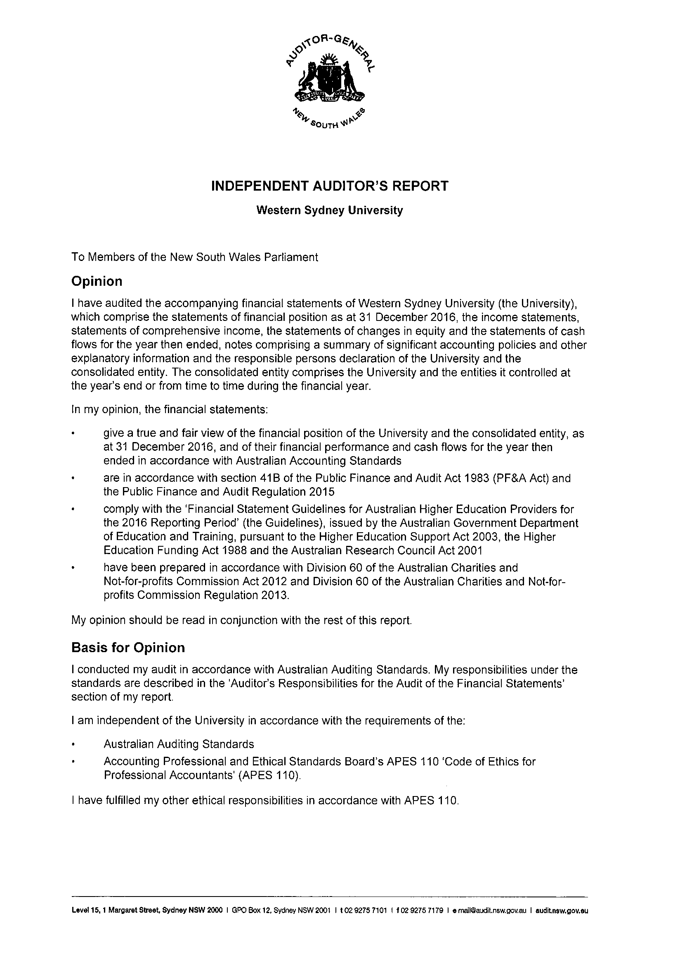

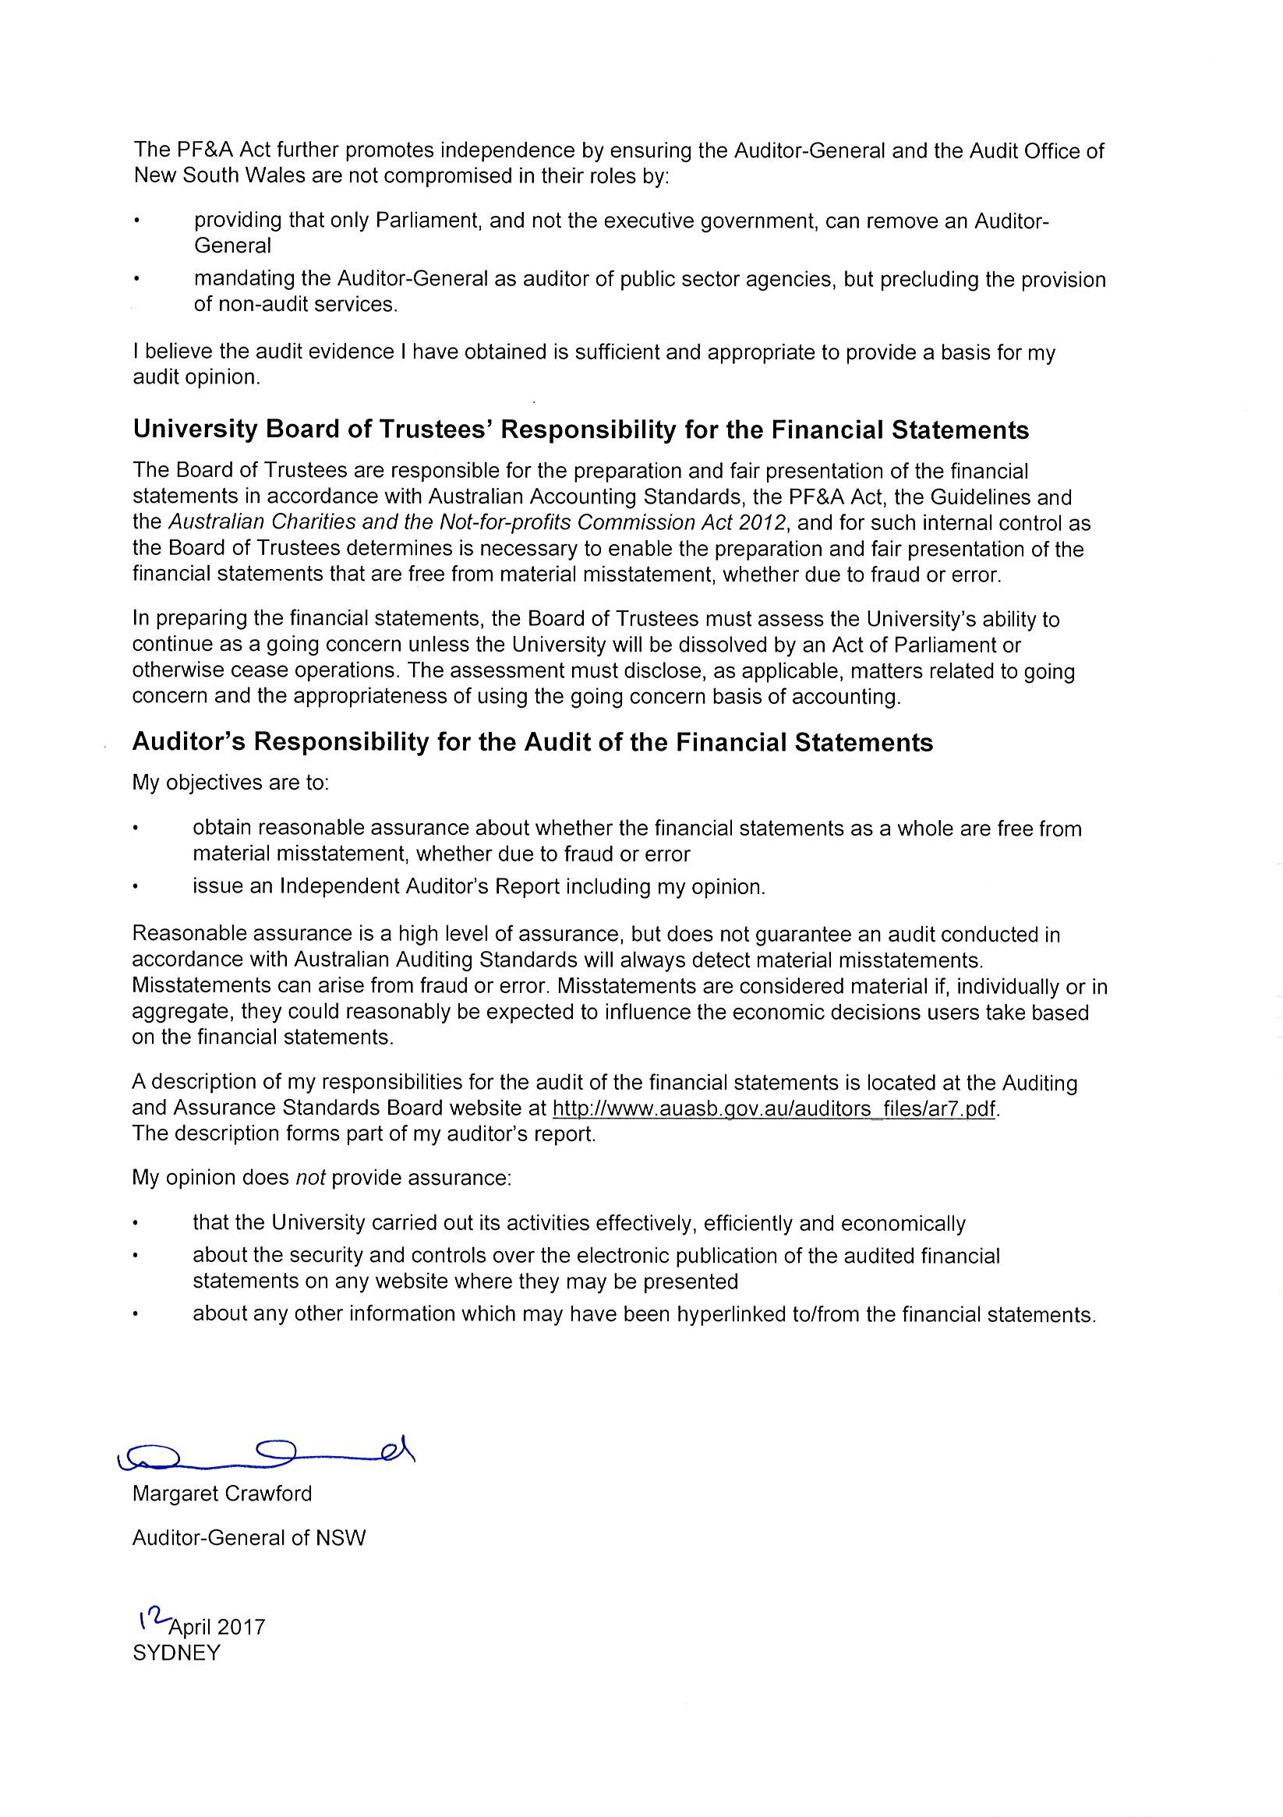

UWS Enterprises Pty Limited Trading as Western Sydney University The College
ABN: 44 003 474 468

Financial Statements
For the Year Ended 31 December 2016

These financial statements are of UWS Enterprises Pty Limited as an individual entity. The financial statements are presented in the Australian currency.
UWS Enterprises Pty Limited (the Company) is a company limited by shares, incorporated and domiciled in Australia. Its registered office and principal place of business is:
Nirimba Education Precinct
Eastern Road, Quakers Hill NSW 2763
A description of the nature of the Company's operations and its principal activities is included in the directors' report on pages 100 to 103, which is not part of these financial statements.
The financial statements were authorised for issue by the directors on 15 March 2017. The directors have the power to amend and reissue the financial statements.

Directors' Report

31 December 2016

The directors present their report on the Company for the financial year ended 31 December 2016.

General information Information on directors
The name and qualification of each person who has been a director during the year and to the date of this report are:

Mr Ramy Aziz B.Bus, CPA, FGIA

Associate Professor Craig Ellis BBus, BComms (Hons), PhD, SA Fin (Resigned 16 February 2016) Ms Jackie Kelly B.Law (Resigned 20 October 2016)
Professor Denise Kirkpatrick Doctor of Philosophy (PhD), Education (Chair)

Mr Angelo Kourtis BA

Professor Simon Barrie Doctor of Philosophy (PhD), B.App Sci (Appointed 19 April 2016) Ms Caroline Hutchinson B Economics, B Laws (Appointed 01 January 2017)
Directors have been in office since the start of the financial year to the date of this report unless otherwise stated.

Principal activities and significant changes in nature of activities

The principal activities of the Company during the financial year were:

  - Provision of educational services

There were no significant changes in the nature of the Company's principal activities during the financial year.

Directors' Report

31 December 2016

Operating results and review of operations for the year

The net result of the Company for the year ended 31 December 2016 amounted to NIL (2015: NIL) which included a royalty payment to the parent entity of $20,092,238 (2015: $14,083,420).

Other items

Significant changes in state of affairs

No significant changes in the nature of the Company's activities occurred during the year.

Events after the reporting date

No matters or circumstances have arisen since the end of the financial year which significantly affected or could significantly affect the operations of the Company, the results of those operations or the state of affairs of the Company in future financial years.

Future developments and results

Likely developments in the operations of the Company and the expected results of those operations in future financial years have not been included in this report as the inclusion of such information is likely to result in unreasonable prejudice to the Company.

Environmental issues

The Company's operations are not regulated by any significant environmental regulations under a law of the Commonwealth or of a state or territory of Australia.

Dividends paid or recommended

No dividend was paid or payable since the commencement of the financial year and up to and including the date of signing the report (2015: nil).

Company secretary

Ms Wendy Barker and Mr Ian Londish held the position of Company Secretary for the whole of the financial year and to the date of this report.

Directors' Report

31 December 2016

Meetings of directors

During the financial year ended 31 December 2016, 6 meetings of directors were held. Attendances by each director during the year were as follows:

 | Directors' Meetings
 | Number eligible to attend | Number attended
Mr Ramy Aziz | 6 | 6
Associate Professor Craig Ellis | - | -
Ms Jackie Kelly | 5 | 4
Professor Denise Kirkpatrick | 6 | 5
Mr Angelo Kourtis | 6 | 5
Professor Simon Barrie | 5 | 3
Ms Caroline Hutchinson | - | -

Indemnification and insurance of officers and auditors

The Company is insured externally and in line with the parent entity's policies for all significant areas of risk exposure and accordingly, is not a self-insurer and makes no provision in its financial statements for internal coverage.

Proceedings on behalf of company

No person has applied for leave of court to bring proceedings on behalf of the Company or intervene in any proceedings to which the Company is a party for the purpose of taking responsibility on behalf of the Company for all or any part of those proceedings.

The Company was not a party to any such proceedings during the year.

Auditor's independence declaration

The auditor's independence declaration in accordance with section 307C of the Corporations Act 2001, for the year ended 31 December 2016 has been received and can be found on page 105 of the financial statements.

The Audit Office of New South Wales GPO Box 12 Sydney NSW 2001

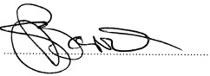This report is made in accordance with a resolution of the Board of Directors.

................................................................

Profesor Simon Barrie

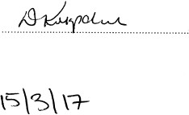Director: Director:

...............................................................

Professor Denise Kirkpatrick

Dated:

Directors' Declaration

In the directors' opinion:

- the financial statements and notes, as set out on pages 106 to 136, are in accordance with the Corporations Act 2001, including:
  - complying with Accounting Standards, the Corporations Regulations 2001, Public Finance and Audit Act 1983,
Public Finance and Audit Regulation 2015 and other mandatory professional reporting requirements, and

  - giving a true and fair view of the company's financial position as at 31 December 2016 and of its performance for the financial year ended on that date, and;

- there are reasonable grounds to believe that the company will be able to pay its debts as and when they become due and payable,

This declaration is made in accordance with a resolution of the Board of Directors.

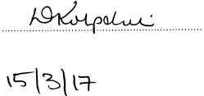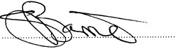Director Director

..................................................................

..................................................................

Professor Denise Kirkpatrick

Professor Simon Barrie

Dated

Responsible Entities Declaration - per section 60.15 of the Australian Charities and Not-for-profits Commission Regulation 2013

The responsible entities declare that in the responsible entities' opinion:

- there are reasonable grounds to believe that the registered entity is able to pay all of its debts, as and when they become due and payable; and

- the financial statements and notes satisfy the requirements of the Australian Charities and Not-for-profits Commission Act 2012.

Signed in accordance with subsection 60.15(2) of the Australian Charities and Not-for-profits Commission Regulation 2013.

..................................................................
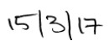
Director
Date

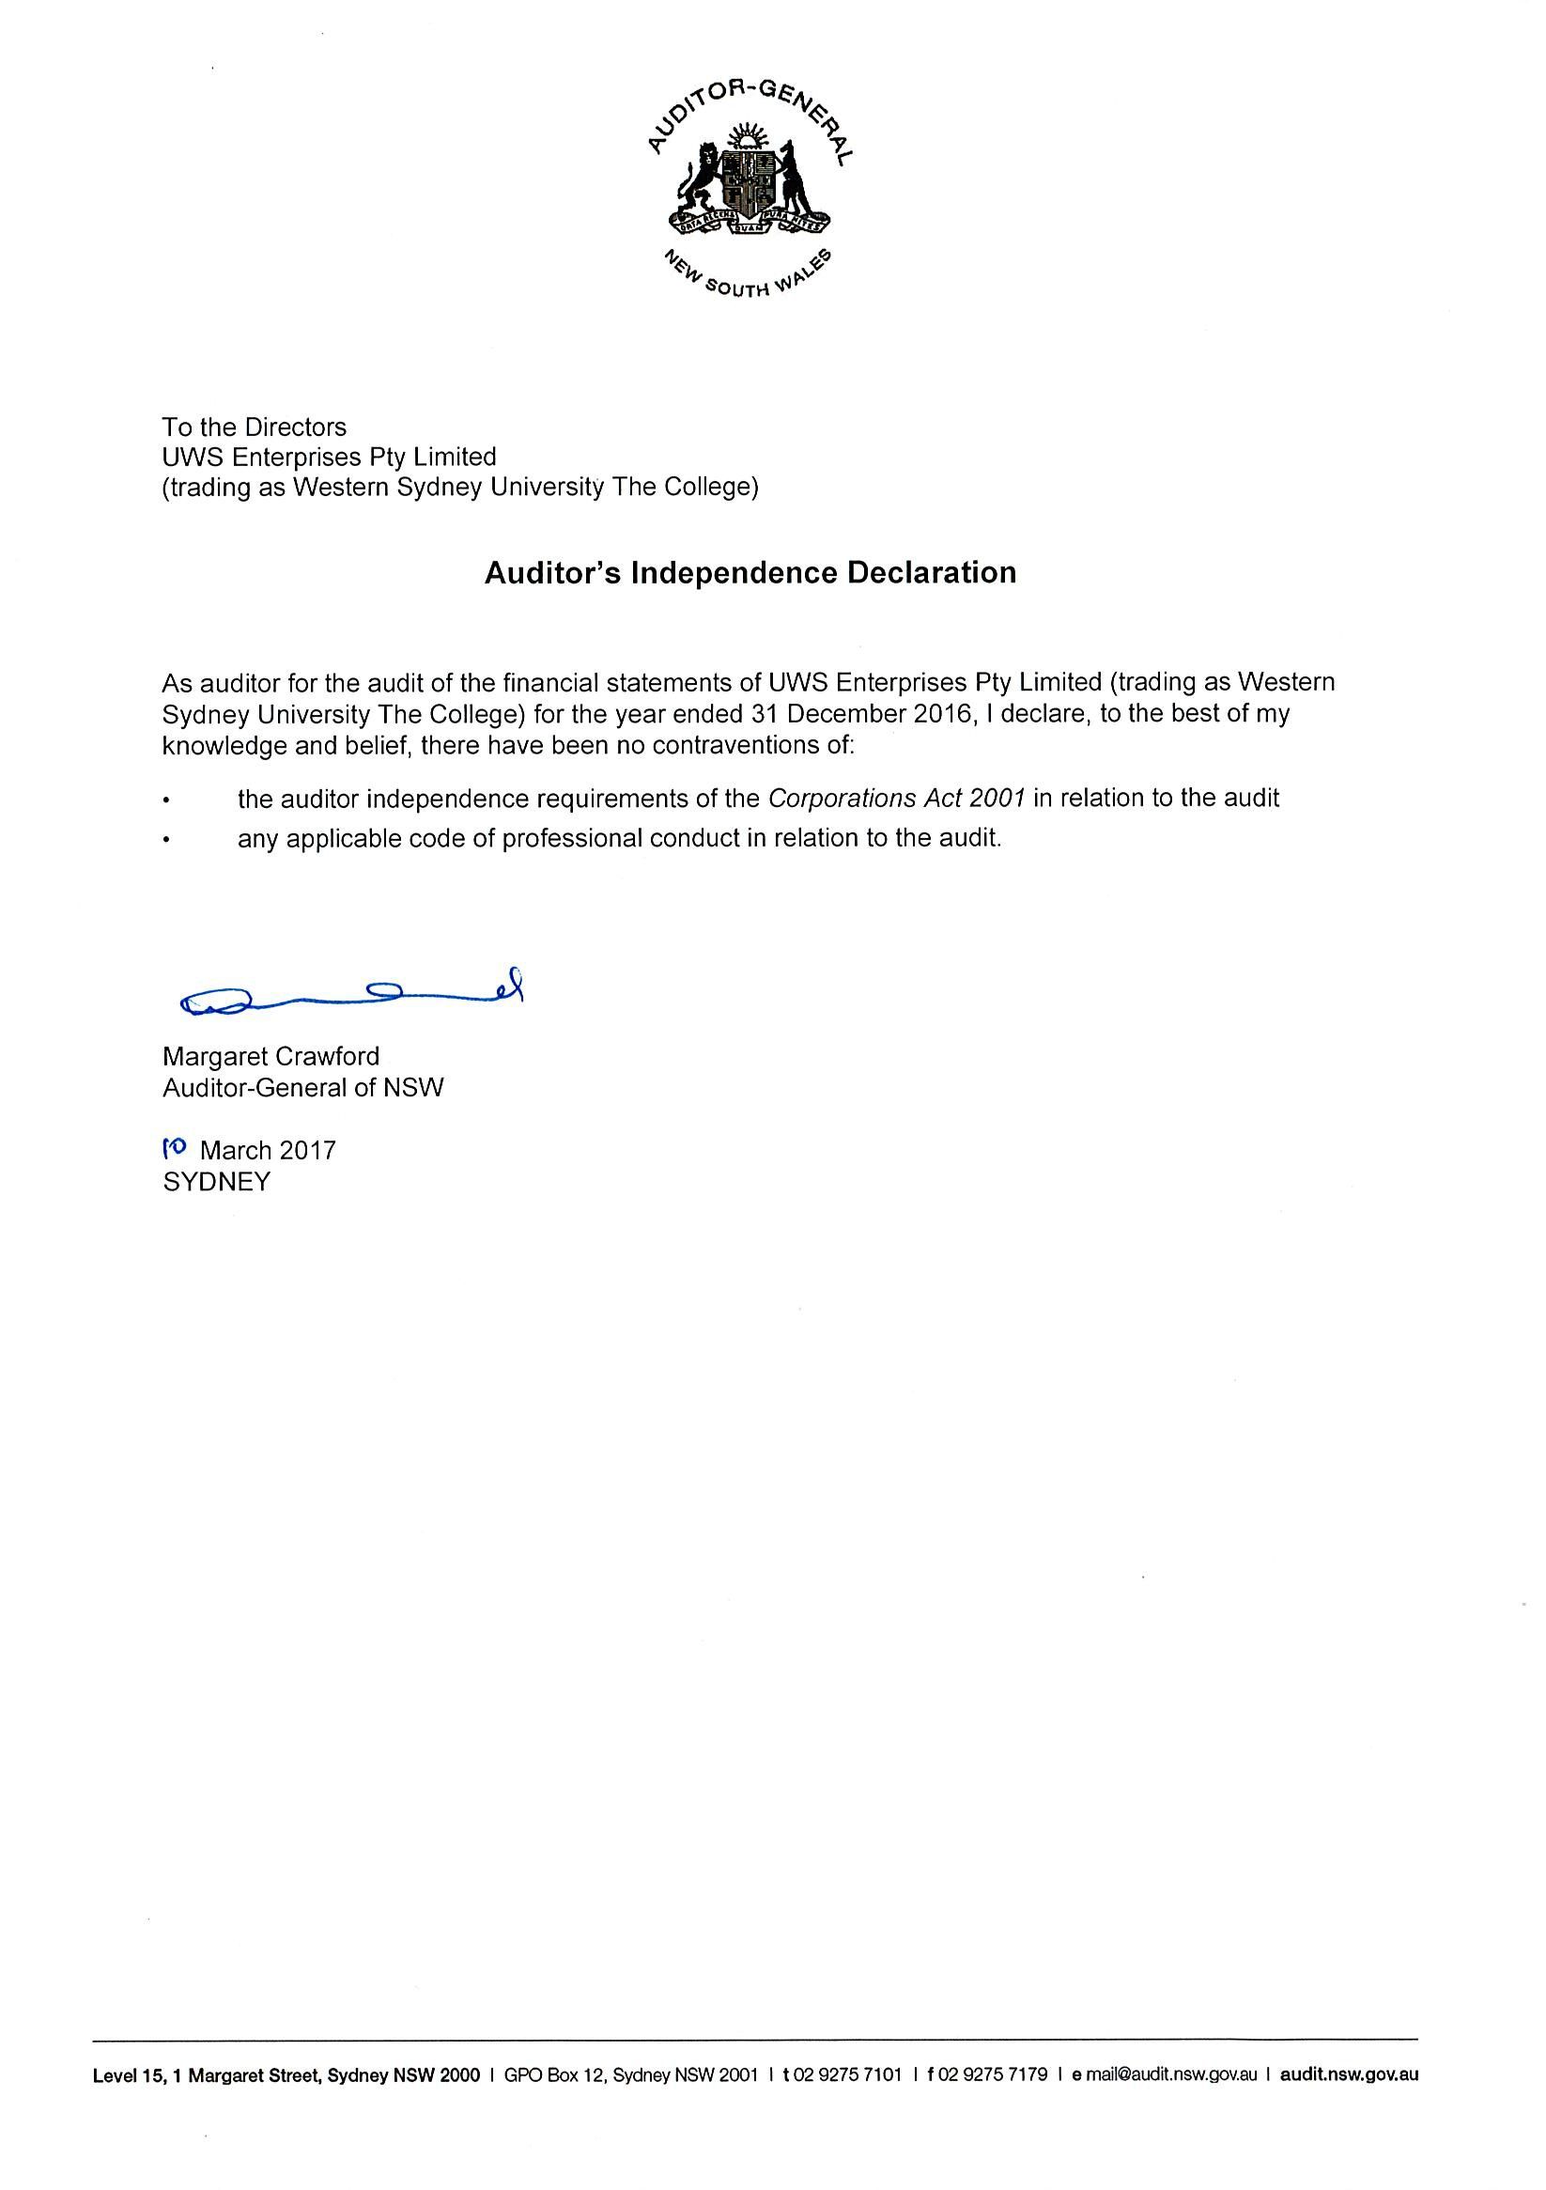

Statement of Comprehensive Income
For the Year Ended 31 December 2016
 |  | 2016 | 2015
 | Notes | $ | $
Revenue
Rendering of services | 14(a) | 60,565,646 | 61,068,828
Interest revenue |  | 149,633 | 195,466
Share of net profit or loss on investments accounted for using the equity method | 7 | (1,052,110) | (119,417)
Other revenue | 14(b) | 329,105 | 307,378
Total revenue |  | 59,992,274 | 61,452,255
Net loss on disposal of assets |  | - | (9,122)
Expenses
Employee benefits expense | 15 | (31,835,140) | (36,982,679)
Fees for service | 15 | (3,696,121) | (5,562,708)
Occupancy expenses | 15 | (339,947) | (183,692)
Royalty to parent | 16 | (20,092,238) | (14,083,420)
Depreciation and amortisation expense | 15 | (1,235,440) | (570,772)
Consumables and supplies |  | (302,139) | (538,517)
Advertising, marketing and promotional expenses |  | (132,018) | (506,123)
Student expenses |  | (491,411) | (618,110)
Other expenses | 15 | (1,867,820) | (2,397,112)
Total Expenses |  | (59,992,274) | (61,443,133)
Other comprehensive income |  | - | -
Total comprehensive income for the year |  | - | -
Comprehensive income for the year attributable to
Non - controlling interest |  | - | -
Western Sydney University (The Parent) |  | - | -
Total comprehensive income for the year |  | - | -

Statement of Financial Position
As At 31 December 2016
 |  | 2016 | 2015
 | Notes | $ | $
ASSETS
Current Assets
Cash and cash equivalents | 2 | 1,109,058 | 696,371
Loans to parent entity |  | 5,651,726 | 6,560,759
Trade and other receivables | 3 | 401,737 | 369,087
Receivables from related parties | 20(d) | 585,588 | 86,250
Prepayments | 4 | 879,154 | 3,451,055
Total Current Assets |  | 8,627,263 | 11,163,522
Non-Current Assets
Loans to joint venture |  | 247,890 | -
Property, plant and equipment | 5 | 5,262,295 | 2,359,451
Intangible assets | 6 | 153,658 | 263,414
Total Non-Current Assets 5,663,843 2,622,865
Total Assets |  | 14,291,106 | 13,786,387
LIABILITIES
Current Liabilities
Trade payables |  | 139,066 | 491,163
Tuition fees advance receipts |  | 776,051 | 779,699
Amounts due to related parties | 20(d) | 684,058 | 78,698
Accrued expenses | 8 | 2,210,500 | 2,142,802
Provisions | 9 | 1,838,997 | 1,885,873
Other liabilities | 10 | 1,113,673 | 731,071
Total Current Liabilities |  | 6,762,345 | 6,109,306
Non-Current Liabilities
Provisions | 9 | 763,312 | 911,632
Total Non-Current Liabilities |  | 763,312 | 911,632
Total Liabilities |  | 7,525,657 | 7,020,938
Net Assets |  | 6,765,449 | 6,765,449
EQUITY  Issued capital | 11 | 1 | 1
Retained earnings |  | 6,765,448 | 6,765,448
Total Equity |  | 6,765,449 | 6,765,449

Statement of Changes in Equity

For the Year Ended 31 December 2016

Issued Capital
$
Retained Earnings
$

Total
$

Balance at 1 January 2016 1 6,765,448 6,765,449
Total comprehensive income for the year
Surplus / (deficit) for the year - - -
Other comprehensive income - - - Balance at 31 December 2016 1 6,765,448 6,765,449

Issued Capital
$
Retained Earnings
$

Total
$

Balance at 1 January 2015 1 6,765,448 6,765,449

Total comprehensive income for the year
Surplus / (deficit) for the year - - -
Other comprehensive income - - -
Balance at 31 December 2015 1 6,765,448 6,765,449

Statement of Cash Flows
For the Year Ended 31 December 2016
 |  | 2016 | 2015
 | Notes | $ | $
CASH FLOWS FROM OPERATING ACTIVITIES:  Receipts from customers |  | 60,604,124 | 61,405,545
Payments to suppliers and employees |  | (58,698,091) | (60,022,386)
Interest received |  | 49,502 | 17,661
Australian Government Grants |  | - | 160,000
Other receipts / (payments) |  | 329,105 | 222,744
Net cash provided by operating activities | 21 | 2,284,640 | 1,783,564
CASH FLOWS FROM INVESTING ACTIVITIES:  Proceeds from sale of plant and equipment |  | - | 30,100
Purchase of property, plant and equipment |  | (1,581,117) | (2,055,703)
Payment for intangible asset |  | - | (263,414)
Payments for operations of joint venture |  | (1,300,000) | (119,417)
Repayments received from the parent entity |  | 7,978,278 | 8,080,191
Advances made to the parent entity |  | (6,969,114) | (7,556,296)
Net cash used in investing activities |  | (1,871,953) | (1,884,539)
CASH FLOWS FROM FINANCING ACTIVITIES:
Net cash provided by financing activities - -
Net increase / (decrease) in cash and cash equivalents held |  | 412,687 | (100,975)
Cash and cash equivalents at beginning of year |  | 696,371 | 797,346

Cash and cash equivalents at end of financial year 2 1,109,058 696,371

Notes to the Financial Statements
For the Year Ended 31 December 2016

The principal accounting policies adopted in the preparation of these financial statements are set out below. These policies have been consistently applied to all the years reported, unless otherwise stated.

1 Summary of Significant Accounting Policies

- Basis of Preparation

The financial statements are general purpose financial statements which have been prepared in accordance with Australian Accounting Standards, Australian Accounting Interpretations, the Corporations Act 2001, Section 41B(1) of the Public Finance & Audit Act 1983, Public Finance & Audit Regulation 2015, the Australian Charities and Not-for profits Commission Act 2012 and Regulation 2013 and other legislative requirements.

Australian Accounting Standards set out accounting policies that the AASB has concluded would result in the financial statements containing relevant and reliable information about transactions, events and conditions.

The financial statements and notes of the Company comply with Australian Accounting Standards, some of which contain requirements specific to not-for-profit entities that are inconsistent with IFRS requirements.

Material accounting policies adopted in the preparation of these financial statements are presented below and have been consistently applied unless otherwise stated.

The financial statements have been prepared on an accruals basis and are based on historical costs, modified, where applicable, by the measurement at fair value of selected non-current assets, financial assets and financial liabilities.

Principles of Consolidation

Joint Arrangements

The Company determined that the Joint Arrangement with Navitas Ltd for the establishment of the Western Sydney University International College Pty Ltd ("the International College") is a Joint Venture equally controlled by the Company and Navitas Ltd.

The Company's share of assets, liabilities, revenue and expenses of the Joint Venture has been incorporated by using the equity method in accordance with AASB 11 Joint Arrangements.

Under the equity method of accounting, the Company recognises its share of the profit and net assets in the International College as a one line item in the income statement and statement of financial position, respectively.

The initial recognition of the investment in joint venture is recognised at cost, which includes the purchase price and any directly attributable expenditures necessary to obtain it.

The carrying amount is adjusted to recognise the company's share of the profit or loss of the International College after the date of acquisition.

Any shareholder loans, in substance, could form a part of the company's net investment in the joint venture and are taken into account when assessing the amount of any losses recognised by the Company relating to its interest in the International College and distributions received from the International College reduce the carrying amount of the investment.

Notes to the Financial Statements

For the Year Ended 31 December 2016

1 Summary of Significant Accounting Policies continued

- Foreign currency transactions and balances

The functional currency of the Company is measured using the currency of the primary economic environment which is Australian dollars. The financial statements are presented in Australian dollars which is the parent entity's functional and presentation currency.

Comparative Amounts

When required by Accounting Standards, comparative figures have been adjusted to conform to changes in presentation for the current financial year.

When the Company applies an accounting policy retrospectively, makes a retrospective restatement or reclassifies items in its financial statements, a statement of financial position as at the beginning of the earliest comparative period will be presented.

The following items have been adjusted to conform with the current year's presentation.

 | Note | 2015  Reported  $ | 2015  Revised  $
Current assets  Trade and other receivables | 3 | 455,337 | 369,087
Receivables from related parties | 20(d) | - | 86,250
 |  | 455,337 | 455,337
Cash flows from investing activities  Repayments received from the parent entity |  | - | 8,080,191
Advances made to the parent entity |  | - | (7,556,296)
 |  | - | 523,895
Cash flows from financing activities  Repayments received from the parent entity |  | 8,080,191 | -
Advances made to the parent entity |  | (7,556,296) | -
 |  | 523,895 | -
Note 9 - Employee Benefits  Long service leave obligations expected to be settled after 12 months | 9 | - | 173,206
Note 13 - Financial Risk Management  Trade and other receivables | 13 | 448,392 | 362,142
Receivables from related parties | 13 | - | 86,250
 |  | 448,392 | 448,392

Notes to the Financial Statements

For the Year Ended 31 December 2016

1 Summary of Significant Accounting Policies continued

- Financial assets Classification
The Company classifies its financial assets as loans and receivables.

  - Loans and receivables

Loans and receivables are non-derivative financial assets with fixed or determinable payments that are not quoted in an active market and are subsequently measured at amortised cost .

Loans and receivables are included in current assets, except for those which are not expected to be realised within 12 months after the end of the reporting period.

Trade receivables

Trade receivables are recognised initially at fair value and subsequently measured at amortised cost less provision for impairment. The Company's standard terms of trade for trade receivables is 14 days from the date of recognition. They are presented as current assets unless collection is not expected for more than 12 months after the reporting date.

Collectability of trade receivables is reviewed on an ongoing basis. Debts which are known to be uncollectable are written off. A provision for impairment of receivables is established when there is objective evidence that the Company will not be able to collect all amounts due according to the original terms of receivables. Significant financial difficulties of the debtor, probability that the debtor will enter bankruptcy or financial reorganisation and default or delinquency in payments are considered indicators that the trade receivable is impaired.

The amount of the provision is the difference between the book value and the amount expected to be recovered from the debtor. The amount of the movement in the provision is recognised in the income statement.

When a trade receivable is uncollectable the amount of the loss is recognised in the income statement within ‘Other Expenses’. Subsequent recoveries of amounts previously written off are credited to ‘other revenue’ in the income statement.

Cash and cash equivalents

Cash and cash equivalents include cash on hand, deposits held at call with banks, other short-term highly liquid investments with original maturities of three months or less which are convertible to a known amount of cash and subject to an insignificant risk of change in value. Bank overdrafts are shown within short-term borrowings in current liabilities on the statement of financial position.

Employee benefits

The Company's liability for employee benefits arises from services rendered by employees are up to the end of the reporting period. Employee benefits that are expected to be settled within one year have been measured at the amounts expected to be paid when the liability is settled, plus related on-costs.

Employee benefits payable later than one year have been measured as the present value of expected future payments to be made in respect of services provided by employees up to the reporting date using the projected unit credit method. Those cashflows are discounted using market yields on national government bonds with terms to maturity that match the expected timing of cashflows.

Notes to the Financial Statements

For the Year Ended 31 December 2016

1 Summary of Significant Accounting Policies continued

- Provisions

Provisions are recognised when the Company has a legal or constructive obligation, as a result of past events, for which it is probable that an outflow of economic benefits will result and that outflow can be reliably measured.

Termination benefits are payable when employment is terminated before the normal retirement date, or when an employee accepts voluntary redundancy in exchange for these benefits. The Company recognises termination benefits when it is demonstrably committed to either terminating the employment of current employees according to a detailed formal plan without possibility of withdrawal or to providing termination benefits as a result of an offer made to encourage voluntary redundancy. Benefits falling due more than 12 months after the end of the reporting period are discounted to present value.

Provisions are measured at the present value of management's best estimate of the outflow required to settle the obligation at the end of the reporting period. The discount rate used is a pre-tax rate that reflects current market assessments of the time value of money and the risks specific to the liability. The increase in the provision due to the unwinding of the discount is taken to finance costs in the statement of comprehensive income.

Regardless of the expected timing of settlement, provisions made in respect of employee benefits are classified as a current liability, unless there is an unconditional right to defer the settlement of the liability for at least 12 months after the reporting date, in which case it would be classified as a non-current liability.

Trade and other payables

Trade and other payables represent the liability outstanding at the end of the reporting period for goods and services received by the Company during the reporting period which remain unpaid. The balance is recognised as a current liability in the statement of financial position with the amounts normally paid within 30 days of recognition of the liability.

Leases

Lease payments for operating leases, where substantially all of the risks and benefits remain with the lessor, are charged as expenses on a straight-line basis over the life of the lease term.

Leased assets are depreciated on a straight-line basis over their estimated useful lives where it is likely that the Company will obtain ownership of the asset or over the term of the lease.

Revenue and other income

The Company recognises revenue when the amount of revenue can be reliably measured, it is probable that future economic benefits will flow to the Company and specific criteria have been met for each of the Company's activities as discussed below.

Revenue is measured at the fair value of the consideration received or receivable after taking into account any trade discounts and volume rebates allowed. Any consideration deferred is treated as the provision of finance and is discounted at a rate of interest that is generally accepted in the market for similar arrangements. The difference between the amount initially recognised and the amount ultimately received is interest revenue.

All revenue is stated net of the amount of goods and services tax (GST).

Notes to the Financial Statements

For the Year Ended 31 December 2016

1 Summary of Significant Accounting Policies continued

- Revenue and other income continued Rendering of services
Revenue recognition relating to the rendering of services is determined with reference to the stage of completion of the transaction at the end of the reporting period and where the outcome of the contract can be estimated reliably. Stage of completion is determined with reference to the services performed to date as a percentage of total anticipated services to be performed. Where the outcome cannot be estimated reliably, revenue is recognised only to the extent that related expenditure is recoverable.

Goods and Services Tax (GST)

Revenues, expenses and assets are recognised net of the amount of GST, except where the amount of GST incurred is not recoverable from the Australian Tax Office. In these circumstances the GST is recognised as part of the cost of acquisition of the asset or as part of an item of the expense. Receivables and payables in the statement of financial position are shown inclusive of GST.

Cash flows are presented in the statement of cash flows on a gross basis, except for the GST component of investing and financing activities, which are disclosed as operating cash flows.

The Company is grouped with the parent entity for GST purposes and therefore the net GST receivable or GST payable is not reflected within these statements.

Critical accounting estimates and judgements

The below areas involve a high degree of judgement where assumptions and estimates are significant to the financial statements of the Company.

Key judgements - provision for impairment of receivables

The value of the provision for impairment of receivables is estimated by considering the ageing of receivables, communication with the debtors and prior history.

Key judgements - provision for long service leave

The value of the provision for long service leave is measured as the present value of expected future payments to be made in respect of services provided by employees up to the reporting date using the projected unit credit method.

New and revised accounting standards

Certain new accounting standards and interpretations have been published that are not mandatory for 31 December 2016 reporting periods and have not yet been applied to the financial statements. The Company’s assessment of the impact of the new standards and interpretations is that they will not materially affect any of the amounts recognised in the financial statements or significantly impact the disclosures in relation to the Company.

Notes to the Financial Statements

For the Year Ended 31 December 2016

1 Summary of Significant Accounting Policies continued

- Property, Plant and Equipment

Each class of property, plant and equipment is carried at cost as indicated less, where applicable, any accumulated depreciation and impairment losses.

Plant and equipment

Plant and equipment are measured on a cost basis (cost less depreciation and impairment losses). Cost includes expenditure that is directly attributable to the asset.

Artwork

Artwork is measured on a cost basis. Cost includes expenditure that is directly attributable to the asset. Art is a non-depreciable asset.

Leasehold Improvements

Leasehold improvements are measured on a cost basis. Cost includes expenditure that is directly attributable to the asset.

Depreciation

The depreciable amount of all fixed assets including capitalised leased assets, is depreciated on a straight-line basis over the asset's useful life to the Company commencing from the time the asset is held ready for use.
Leasehold improvements are depreciated over the shorter of either the unexpired period of the lease or the estimated useful lives of the improvements.

The estimated useful lives/depreciation rates used for each class of depreciable assets are:

Class of Fixed Asset Depreciation Rate / Useful Life

Computer Equipment 3-4 years
Leasehold improvements 2-6 years
Motor Vehicles 6-7 years
Other Equipment 10-20 years

The assets' residual values, depreciation methods and useful lives are reviewed, and adjusted if appropriate, at the end of each reporting period.

An asset's carrying amount is written down immediately to its recoverable amount if the asset's carrying amount is greater than its estimated recoverable amount.

Notes to the Financial Statements

For the Year Ended 31 December 2016

1 Summary of Significant Accounting Policies continued

- Property, Plant and Equipment continued

Gains and losses on disposals are determined by comparing proceeds with the carrying amount. These gains and losses are included in the statement of comprehensive income. When revalued assets are sold, amounts included in the revaluation reserve relating to that asset are transferred to retained earnings.

Intangible Assets

Development costs of Online Teaching Units

Costs directly attributable to the development of online teaching units are capitalised as intangible assets only when technical feasibility of the project is demonstrated, the Company has the intention and ability to complete and use the online units and the costs can be measured reliably. Such costs include the purchases of materials and services and payroll-related costs of employees directly involved in the project. Research costs are recognised as an expense when incurred.

Costs associated with the development of online teaching units are captured initially as Work in Progress (WIP).

Amortisation

Total costs captured for the units will be transferred from WIP to Intangible Asset upon completion of the development.

Amortisation will commence when teaching of the units commences. Amortisation period will be two years on a straight line basis.

Royalties

Royalties are due by the Company for its access to the parent entity's intellectual property, infrastructure, premises and business services. Royalty is accrued on a monthly basis based on budgeted and forecasted total revenue for the related period and is effected by an intercompany transfer. Adjustment is made at the end of each financial year to reflect the agreed final contribution for the year.

Income Tax

The Company is exempt from the payment of tax by virtue of section 50-5 of the Income Tax Assessment Act 1997. Accordingly, no provision for income tax liability or future income tax benefit has been included in the accounts.

Notes to the Financial Statements

For the Year Ended 31 December 2016

2 | Cash and cash equivalents | 2016 | 2015
 |  | $ | $
 | Cash at bank and in hand | 886,197 | 283,509
 | TCorp Hour-Glass Investment Facility | 222,861 | 412,862
 | Total cash and cash equivalents | 1,109,058 | 696,371
 | Reconciliation of cash

Cash at the end of the financial year as shown in the statement of cash flows is reconciled to items in the statement of financial position as follows:
Cash and cash equivalents | 2016  $ 1,109,058 | 2015  $  696,371
Balance as per statement of cash flows | 1,109,058 | 696,371
The Company's exposure to interest rate risk is discussed in Note 13.

Notes to the Financial Statements

For the Year Ended 31 December 2016

3 | Trade and other receivables |  | 2016 | 2015
 |  | Note | $ | $
 | Student receivables |  | 121,248 | 397,242
 | Trade receivables |  | 304,953 | 213,292
 | Provision for doubtful receivables | 3(a) | (26,379) | (258,905)
 | Accrued interest |  | 344 | 311
 | Other receivables |  | 1,571 | 17,147
 | Total current trade and other receivables |  | 401,737 | 369,087
 | (a) Provision for impairment of receivables
 | Movement in provision for impairment of receivables is as follows: |  | 2016 | 2015
 |  |  | $ | $
 | Opening balance as at 1 January |  | 258,905 | 137,882
 | Doubtful debt provision |  | 16,137 | 121,023
 | Bad debts written off |  | (248,663) | -
 | Balance as at 31 December |  | 26,379 | 258,905
 | Credit risk

The Company has no significant concentration of credit risk with respect to any single counterparty or group of counterparties. The class of assets described as 'trade and other receivables' is considered to be the main source of credit risk related to the Company.

On a geographical basis, the Company has credit risk exposures in Australia only as all transactions are conducted in Australian dollars.

The following table details the Company's trade and other receivables exposure to credit risk (prior to collateral and other credit enhancements) with ageing analysis and impairment provided for thereon. Amounts are considered as 'past due' when the debt has not been settled, within the terms and conditions agreed between the Company and the customer or counter party to the transaction. Receivables that are past due are assessed for impairment by ascertaining solvency of the debtors and are provided for where there is objective evidence indicating that the debt may not be fully repaid to the Company.

Notes to the Financial Statements

For the Year Ended 31 December 2016

3 Trade and other receivables continued

The balances of receivables that remain within initial trade terms (as detailed in the table) are considered to be of high credit quality.
(Days overdue)
 | 0-30 | 30-60 | 60-90 | 90-180 | > 180 | Total
 | $ | $ | $ | $ | $ | $
2016  Trade and student receivables | 159,805 | 176,871 | 4,893 | 40,633 | 43,999 | 426,201
Other receivables | 1,571 | - | - | - | - | 1,571
Accrued interest | 344 | - - - |  |  | - | 344
Provision for doubtful receivables | - | - - (200) |  |  | (26,179) | (26,379)
Total | 161,720 | 176,871 | 4,893 | 40,433 | 17,820 | 401,737
2015  Trade and student receivables | 94,242 | 160,674 | 12,968 | 61,148 | 281,503 | 610,534
Other receivables | 11,101 | - | 15 | 4,831 | 1,200 | 17,147
Accrued interest | 311 | - | - | - | - | 311
Provision for doubtful receivables | - | - | - | - | (258,905) | (258,905)
Total | 105,654 | 160,674 | 12,983 | 65,979 | 23,798 | 369,087

The Company does not hold any financial assets with renegotiated terms. The other class of receivables do not contain impaired assets. It is expected that these balances will be received when due.

4 | Prepayments | 2016 | 2015
 |  | $ | $
 | Prepayments | 6,754 | 131,242
 | Internal capital funding for capital projects | 872,400 | 3,319,813
 | Total Prepayments | 879,154 | 3,451,055

Notes to the Financial Statements

For the Year Ended 31 December 2016

5 | Property, plant and equipment | 2016 | 2015
 |  | $ | $
 | Leasehold Improvements  Leasehold improvements | 8,742,040 | 4,993,196
 | Accumulated depreciation | (3,841,451) | (2,815,932)
 | Total leasehold improvements | 4,900,589 | 2,177,264
 | Plant and equipment  Property, Plant and Equipment | 901,463 | 628,318
 | Accumulated depreciation | (551,666) | (458,040)
 | Total plant and equipment | 349,797 | 170,278
 | Artwork  At cost | 11,909 | 11,909
 | Total artwork | 11,909 | 11,909
 | Total property, plant and equipment | 5,262,295 | 2,359,451

Movements in Carrying Amounts

Movement in the carrying amounts for each class of property, plant and equipment between the beginning and the end of the financial year:

Leasehold Property, Plant

improvements and Equipment
Artwork
Total

$ $ $ $

2016  Balance at the beginning of year | 2,177,264 | 170,278 | 11,909 | 2,359,451
Additions | 3,748,843 | 279,685 | - | 4,028,528
Disposals Depreciation expense | - (1,025,518) | - (100,166) | -  - | - (1,125,684)
Balance at 31 December 2016 | 4,900,589 | 349,797 | 11,909 | 5,262,295
2015  Balance at the beginning of year | 337,247 | 199,962 | 11,909 | 549,118
Additions | 2,318,362 | 101,964 | - | 2,420,326
Disposals | - | (39,221) | - | (39,221)
Depreciation expense (478,345) |  | (92,427) | - | (570,772)
Balance at 31 December 2015 2,177,264 |  | 170,278 | 11,909 | 2,359,451

6 | Intangible assets | 2016 | 2015
 |  | $ | $
 | Online teaching units  Online teaching units - at cost | 263,414 | 263,414
 | Accumulated amortisation | (109,756) | -
 | Net carrying value | 153,658 | 263,414
 | Total Intangibles | 153,658 | 263,414

(a) Movements in carrying amounts of intangible assets

 | Online Teaching Units | Total
 | $ | $
2016  Balance at the beginning of the year | 263,414 | 263,414
Amortisation | (109,756) | (109,756)
Closing value at 31 December 2016 | 153,658 | 153,658

2015
Balance at the beginning of the year - -
Additions 263,414 263,414
Amortisation - -
Closing value at 31 December 2015 263,414 263,414

Investments accounted for using the equity method

  - Restrictions

The Company has nil restrictions from the joint venture with Navitas Ltd.

Individually immaterial joint venture

Aggregate carrying amount of interests in joint venture accounted for using the equity method that are not individually material in the financial statements:

Joint Venture
Profit/(loss) from continuing operations | 2016  $ (1,052,110) | 2015  $  (119,417)
Profit/(loss) from continuing operations after income tax | (1,052,110) | (119,417)
Other comprehensive income | - | -
Total comprehensive income | (1,052,110) | (119,417)

Capital commitments and contingent liabilities arising from the Company's interests in joint venture are disclosed in notes 12 and 18, respectively.

The Western Sydney University International College Pty Ltd has a reporting date of 30 June.

Unrecognised share of losses of joint venture or associate

The Company has no unrecognised share of losses from the joint venture with Navitas Ltd (2015: $67,068).

Events Occurring After the Reporting Date

There are no events identified after the reporting date that would have a material impact on the financial statements.

Accrued expenses

2016
$

2015
$

Current  Salary | 329,858 | 319,283
Non-salary overheads | 391,568 | 315,628
Agents' commissions | 1,371,074 | 1,118,007
Provision for staff redundancy | 118,000 | 389,884
 | 2,210,500 | 2,142,802

- Employee Benefits

Current

2016
$

2015
$

Employee benefits - annual leave 1,396,560 1,565,400
Employee benefits - long service leave 442,437 320,473
1,838,997 1,885,873

Amounts not expected to be settled within the next 12 months

The current provision for employee benefits includes accrued annual leave. The entire amount of the provision is presented as current, since the Company does not have an unconditional right to defer settlement of any of these obligations. However, based on past experience, the Company does not expect all employees to take the full amount of accrued leave or require payment within the next 12 months. The following amounts reflect leave that is not expected to be taken or paid within the next 12 months.
 | Annual leave obligations expected to be settled after 12 months | 2016  $ 140,585 | 2015  $  272,214
 | Long service leave obligations expected to be settled after 12 months | 228,962 | 173,206
 |  | 369,547 | 445,420
 |  | 2016 | 2015
 |  | $ | $
 | Non-Current
 | Employee benefits - long service leave | 763,312 | 911,632
10 | Other liabilities | 2016 | 2015
 |  | $ | $
 | Unearned IELTS revenue * | 160,710 | 191,064
 | Payroll tax | 245,554 | 202,720
 | Fringe benefits tax | 18,587 | 74,776
 | Unallocated student receipts | - | 35,748
 | Other liabilities | 688,822 | 226,763
 |  | 1,113,673 | 731,071
 | *Represents IELTS test fees paid in advance.
11 | Issued Capital | 2016 | 2015
 |  | $ | $
 | Ordinary shares | 1 | 1
 | Total contributed equity | 1 | 1

Capital and Leasing Commitments

  - Operating lease commitments

The Company leases plant and office equipment and building teaching space under non-cancellable operating leases contracted for but not capitalised in the financial statements. The leases have renewal rights, whereby the terms of the lease are renegotiated.

2016 2015
Payable - minimum lease payments: | $ | $
- no later than 1 year | 496,600 | 310,571
- between 1 year and 5 years | 194,769 | 102,467
- greater than 5 years | - | -
 | 691,369 | 413,038

  - Capital commitments

 | 2016  $ | 2015  $
Capital expenditure commitments contracted for:  - no later than 1 year | 365,312 | 288,763
- between 1 year and 5 years | - | -
- greater than 5 years | - | -
 | 365,312 | 288,763

(c) Expenditure commitments from joint venture entities | 2016 | 2015
 | $ | $
Capital expenditure commitments contracted for:  - no later than 1 year | 101,408 | -
- between 1 year and 5 years | - | -
- greater than 5 years | - | -
 | 101,408 | -

- Financial Risk Management

The main risks the Company is exposed to through its financial instruments are credit risk, liquidity risk and market risk consisting of interest rate risk.

The Company's financial instruments consist mainly of deposits with banks and local money market instruments.

The totals for each category of financial instruments, measured in accordance with AASB 139 as detailed in the accounting policies to these financial statements, are as follows:

Weighted average
interest rate Balance

2016
%
2015
%
2016
$
2015
$

 | Financial Assets  Cash and cash equivalents | 1.73 | 2.09 | 1,109,058 | 696,371
 | Loans to parent entity | 2.40 | 2.47 | 5,651,726 | 6,560,759
 | Trade and other receivables (1) |  |  | 401,737 | 362,142
 | Receivables from related parties |  |  | 585,588 | 86,250
 | Loans to joint venture | 4.67 | - | 247,890 | -
 | Total financial assets |  |  | 7,995,999 | 7,705,522
 | Financial Liabilities  Trade payables (2) |  |  | 139,066 | 491,164
 | Amounts due to related parties |  |  | 684,058 | 78,698
 | Accrued expenses |  |  | 2,210,500 | 2,148,802
 | Other liabilities (2) |  |  | 380,756 | 224,836
 | Total financial liabilities |  |  | 3,414,380 | 2,943,500
Notes:

- Excludes statutory receivable and prepayments (not within the scope of AASB 7).

- Excludes statutory payables and unearned revenue (not within the scope of AASB 7).

13 Financial Risk Management continued Financial risk management policies
The Board of Directors has overall responsibility for the establishment of the Company’s financial risk management framework.

Risk management policies and systems are reviewed regularly to reflect changes in market conditions and the Company's activities.

The Company does not actively engage in the trading of financial assets for speculative purposes nor does it write or buy options.

Mitigation strategies for specific risks faced are described below:

Credit risk

Exposure to credit risk relating to financial assets arises from the potential non-performance by counterparties of contract obligations that could lead to a financial loss to the Company and arises principally from the Company's receivables and cash deposits.

Services are sold subject to retention of title clauses, so that in the event of non-payment the Company may have a secured claim.

There are no material differences between the carrying amount and fair value of financial assets and liabilities and hence the carry amount represents fair value.

Liquidity risk

Liquidity risk arises from the possibility that the Company might encounter difficulty in settling its debts or otherwise meeting its obligations related to financial liabilities. The Company manages this risk through the following mechanisms:

  - preparing forward-looking cash flow analysis in relation to its operational, investing and financial activities which are monitored on a weekly basis, and reported monthly; and

  - only investing surplus cash with licensed banks covered by Australian Government Deposit Guarantee, NSW - Treasury Corporation or with the parent entity;

The timing of expected outflows is not expected to be materially different from contracted cashflows. The tables below reflect an undiscounted contractual maturity analysis for financial liabilities.
Financial guarantee liabilities are treated as payable on demand since the Company has no control over the timing of any potential settlement of the liabilities.

The timing of cash flows presented in the table to settle financial liabilities reflects the earliest contractual settlement dates and does not reflect management's expectations that banking facilities will be rolled forward. The amounts disclosed in the table are the undiscounted contracted cash flows and therefore the balances in the table may not equal the balances in the statement of financial position due to the effect of discounting.

UWS Enterprises Pty Limited Trading as Western Sydney University The College
ABN: 44 003 474 468

Notes to the Financial Statements

For the Year Ended 31 December 2016

13 Financial Risk Management continued

Financial asset and liability maturity analysis - Non-derivative

Within 1 Year 1 to 5 Years Over 5 Years Total
 | 2016  $ | 2015  $ | 2016  $ | 2015 2016 2015 2016  $ $ $ $ | 2015  $
Financial assets due for receipt  Cash and cash equivalents | 1,109,058 | 696,371 | - | - - - 1,109,058 | 696,371
Loans to parent entity | 5,651,726 | 6,560,759 | - | - - - 5,651,726 | 6,560,759
Trade and other receivables | 401,737 | 362,142 | - | - - - 401,737 | 362,142
Receivables from related parties | 585,588 | 86,250 | - | - - - 585,588 | 86,250
Loans to joint venture | - | - | 247,890 | - - - 247,890 | -
 | 7,748,109 | 7,705,522 | 247,890 | - - - 7,995,999 | 7,705,522
Financial liabilities due for payment  Trade payables | 139,066 | 491,164 | - | - - - 139,066 | 491,164
Amounts due to related parties | 684,058 | 78,698 | - | - - - 684,058 | 78,698
Accrued expenses | 2,210,500 | 2,148,802 | - | - - - 2,210,500 | 2,148,802
Other liabilities | 380,756 | 224,836 | - | - - - 380,756 | 224,836
 | 3,414,380 | 2,943,500 | - | - - - 3,414,380 | 2,943,500

The timing of expected outflows is not expected to be materially different from contracted cashflows.

127

UWS Enterprises Pty Limited Trading as Western Sydney University The College
ABN: 44 003 474 468

Notes to the Financial Statements

For the Year Ended 31 December 2016

13 Financial Risk Management continued

Financial assets pledged as collateral

No financial assets have been pledged as security for any financial liability.

Market risk

Market risk is the risk that the fair value or future cash flows of a financial instrument will fluctuate because of changes in market prices.

- Interest rate risk

Exposure to interest rate risk arises on financial assets and financial liabilities recognised at the end of the reporting period, whereby a future change in interest rates will affect future cash flows or the fair value of fixed rate financial instruments.

- Price risk

Price risk relates to the risk that the fair value or future cash flows of a financial instrument will fluctuate because of changes in market prices of securities held being available-for-sale or fair value through profit and loss.

To manage price risk in managed investment funds the Company has contracted out the management of portfolio to external managers. These fund managers are mandated to diversify investments of the portfolio under their management.

Sensitivity analysis

The following table illustrates sensitivities to the Company's exposures to changes in the interest rate risk.

Interest Rate Risk - Sensitivity Analysis

The following sensitivity analysis is based on the interest rate risk exposures in existence at the end of the reporting period.

An increase of 100 basis points or a decrease of 100 basis points would have increased equity and surplus or deficit by the amounts shown below. This analysis assumes that other variables are held constant.

The movements in surplus / (deficit) are due to higher interest costs from variable rate debt and cash balances.

The net exposure at the end of the reporting period is representative of what the Company was and is expecting to be exposed to at the end of the next twelve months. The sensitivity analysis is performed on the same basis as in 2015.

128

UWS Enterprises Pty Limited Trading as Western Sydney University The College
ABN: 44 003 474 468

Notes to the Financial Statements

For the Year Ended 31 December 2016

13 Financial Risk Management continued

Interest Rate Risk - Sensitivity Analysis continued
 | Carrying | Surplus / deficit 100 basis points | Surplus / deficit 100 basis points | Equity  100 basis points | Equity  100 basis points
 | amount | increase | decrease | increase | decrease
 | $ | $ | $ | $ | $
2016
Financial assets
Cash and cash equivalents | 1,109,058 | 11,091 | (11,091) | 11,091 | (11,091)
Loans to parent entity | 5,651,726 | 56,517 | (56,517) | 56,517 | (56,517)
Loans to joint venture | 247,890 | 2,479 | (2,479) | 2,479 | (2,479)
Total increase / (decrease) in financial assets | 7,008,674 | 70,087 | (70,087) | 70,087 | (70,087)
Financial liabilities
Amounts due to related parties | 684,058 | - | - | - | -
Net increase / (decrease) in financial assets | 6,324,616 | 70,087 | (70,087) | 70,087 | (70,087)
2015
Financial assets
Cash and cash equivalents | 696,371 | 6,964 | (6,964) | 6,964 | (6,964)
Loans to parent entity | 6,560,759 | 65,608 | (65,608) | 65,608 | (65,608)
Total increase / (decrease) in financial assets | 7,257,130 | 72,572 | (72,572) | 72,572 | (72,572)
Financial liabilities
Amounts due to related parties | 78,698 | 787 | (787) | 787 | (787)
Net increase / (decrease) in financial assets | 7,335,828 | 73,359 | (73,359) | 73,359 | (73,359)

129

Notes to the Financial Statements

For the Year Ended 31 December 2016

14 Revenue

(a) | Revenue from rendering of services | 2016 | 2015
 |  | $ | $
 | Tuition income | 57,062,410 | 56,158,675
 | Student test fees | 3,310,884 | 4,706,130
 | Student charges | 192,352 | 204,023
 | Total revenue from rendering of services | 60,565,646 | 61,068,828
(b) | Other revenue | 2016 | 2015
 |  | $ | $
 | Salary recoveries | 23,304 | 8,968
 | Government grants | - | 160,000
 | Other income | 305,801 | 138,410
 | Total other revenue | 329,105 | 307,378

Notes to the Financial Statements
For the Year Ended 31 December 2016

15 | Expenses | 2016 | 2015
 |  | $ | $
 | Depreciation and Amortisation  Leasehold improvements | 1,025,518 | 478,345
 | Office equipment | 100,166 | 92,427
 | Intangible assets | 109,756 | -
 | Total depreciation and amortisation | 1,235,440 | 570,772
 | Employee benefits expense (including academic and non academic)  Salaries and wages | 25,416,923 | 29,018,179
 | Leave | 1,554,063 | 2,435,997
 | Superannuation | 2,561,789 | 3,013,317
 | Payroll tax | 1,691,369 | 1,896,970
 | Workers compensation | 106,206 | 89,186
 | Redundancies | 504,790 | 529,030
 |  | 31,835,140 | 36,982,679
 | Fees for service
 | Services from Parent | 192,161 | 574,221
 | Agent's commission | 865,336 | 1,393,483
 | Study tours | 65,957 | 14,860
 | Temporary contract staff | 317,097 | 291,468
 | Consultants | 275,877 | 674,075
 | Other | 1,979,693 | 2,614,601
 |  | 3,696,121 | 5,562,708
 | Occupancy expenses  Lease of building teaching space | 250,000 | -
 | Cleaning | 33,227 | 100,484
 | Other | 56,720 | 83,208
 |  | 339,947 | 183,692
 | Other expenses  Minor Equipment | 149,466 | 313,900
 | Staff recruitment | 71,240 | 45,806
 | Training and seminars | 38,050 | 94,793
 | Conference fees | 19,077 | 40,628
 | Other expenses (See (a) below) | 1,589,987 | 1,901,985
 |  | 1,867,820 | 2,397,112

Notes to the Financial Statements
For the Year Ended 31 December 2016

15 | Expenses continued  (a) Other Expenses
 |  | 2016 | 2015
 |  | $ | $
 | Staff travel | 125,605 | 307,755
 | Motor vehicle expenses | 139,435 | 184,139
 | Repairs & maintenance | 68,907 | 112,778
 | FBT on motor vehicles | 2,544 | 22,856
 | Postage, printing, telephone & internet | 673,734 | 757,310
 | Furniture | 67,508 | 85,179
 | Equipment lease | 388,355 | 288,929
 | Doubtful debt provision | 16,137 | 121,023
 | Sundry expenses | 107,762 | 22,016
 | Total other expenses | 1,589,987 | 1,901,985
16 | Royalty to parent

The Company pays a Royalty to the parent entity for access to the parent entity's intellectual property, infrastructure, premises and business services. The Royalty is determined as 100% of the operating surplus of the Company.

Remuneration of Auditors

The Audit Office of New South Wales

2016
$

2015
$

- Audit of financial statements 34,440 38,800

- Total remuneration for audit 34,440 38,800

- Contingencies

  - Contingent Liabilities

Claims

The Directors of the Company are not aware of the existence of any legal claims as at 31 December 2016 (2015: nil).

Guarantees

The Directors of the Company are not aware of any guarantees that are in place as at 31 December 2016 (2015: nil).

Notes to the Financial Statements

For the Year Ended 31 December 2016

19 | Remuneration of the Board  Total remuneration to external independent Board members of the Company during the year are as follows:
 | 2016 | 2015
 | $ | $
 | Independent Directors fees 12,500 | 45,000
 | Other key management personnel transactions
 | For details of other transactions with key management personnel, refer to Note 20: Related Party Transactions.
20 | Related Parties

The Company's main related parties are as follows:

  - Entities exercising control over the Company:

The parent entity, which exercises control over the Company, is Western Sydney University which wholly owns the Company.

  - Joint Venture with Navitas Ltd:

In April 2015, the Company entered into a Joint Venture Agreement with Navitas Ltd to form Western Sydney University International College Pty Ltd to operate an international college at Parramatta, New South Wales. The Company owns 50% of the entity.

Transactions with related parties

Transactions between related parties are on normal commercial terms and conditions no more favourable than those available to other parties unless otherwise stated.

The following transactions occurred with related parties:

2016
$

2015
$

Purchase of goods and services  Purchase of capital works from parent entity | 3,748,844 | 2,155,156
Purchase of catering services from other related parties | 115,782 | 119,562
Total | 3,864,626 | 2,274,718
Other transactions  Royalty to parent entity* | 20,092,238 | 14,083,420
Share of loss of joint venture | (1,052,110) | (119,417)
Interest received on loan to joint venture | 33,239 | -
Total | 19,073,367 | 13,964,003

*Royalty was paid for the use of the parent entity's services, infrastructure, premises and intellectual property during the year.

Notes to the Financial Statements

For the Year Ended 31 December 2016

20 Related Parties continued

(c) | Loans to/from related parties | 2016 | 2015
 |  | $ | $
 | Loans to Parent  Beginning of the year | 6,560,759 | 6,906,850
 | Loans advanced | 6,969,114 | 7,556,296
 | Loan repayment received | (7,978,277) | (8,080,191)
 | Interest charged | 100,130 | 177,804
 | End of year | 5,651,726 | 6,560,759
 | Loans to Joint Venture  Beginning of the year | - | -
 | Loans advanced | 1,300,000 | -
 | Share of loss of joint venture | (1,052,110) | -
 | Interest charged | - | -
 | End of year | 247,890 | -

No provisions for doubtful debts have been raised in relation to any outstanding balances, and no expense has been recognised in respect of bad or doubtful debts due from related parties.

Notes to the Financial Statements

For the Year Ended 31 December 2016

Related Parties continued

(d) Outstanding balances

The following balances are outstanding at the reporting date in relation to transactions with related parties:

 | 2016  $ | 2015  $
Current receivables (loans)
Western Sydney University | 5,651,726 | 6,560,759
Current receivables (provision of services)
Western Sydney University International College Pty Ltd | 585,588 | 86,250
Total current receivables | 6,237,314 | 6,647,009
Non-current receivables (loans)
Western Sydney University International College Pty Ltd | 247,890 | -
Total non-current receivables | 247,890 | -
Current payables (purchase of services)
Western Sydney University International College Pty Ltd | 684,058 | -
Total current payables | 684,058 | -

No provisions for doubtful debts have been raised in relation to any outstanding balances, and no expense has been recognised in respect of bad or doubtful debts due from related parties.

Notes to the Financial Statements

For the Year Ended 31 December 2016

Reconciliation of Surplus to Net Cash Flows From Operating Activities

Surplus for the year |  | 2016  $  - | 2015  $  -
Non-cash flows in surplus
Depreciation and amortisation |  | 1,235,440 | 570,772
Western Sydney University Loan Interest non cash |  | (100,130) | (177,804)
Net loss on sale of non-current assets |  | - | 9,122
Doubtful debt provision |  | 16,137 | -
Share of joint venture entity net profit after income tax and dividends |  | 1,052,110 | 119,417
Changes in assets and liabilities
 | (increase)/decrease in trade and other receivables | (48,787) | (259,653)
 | (increase)/decrease in prepayments | 124,488 | 191,101
 | increase/(decrease) in related party account balances | 106,021 | 75,367
 | increase/(decrease) in accruals | 67,698 | 444,694
 | increase/(decrease) in trade and other payables | (352,097) | 414,512
 | increase/(decrease) in other operating liabilities | 378,956 | (25,000)
 | increase/(decrease) in employee benefits | (195,196) | 421,036
 | Net cash flows from operating activities | 2,284,640 | 1,783,564
22 | Events Occurring After the Reporting Date

No matters or circumstances have arisen since the end of the financial year which significantly affected or may significantly affect the operations of the Company, the results of those operations, or the state of affairs of the Company in future financial years.

23 Company Details

The registered office of the Company
UWS Enterprises Pty Limited Trading as Western Sydney University The College Nirimba Education Precinct
Eastern Road, Quakers Hill NSW 2763

End of Audited Financial Statements

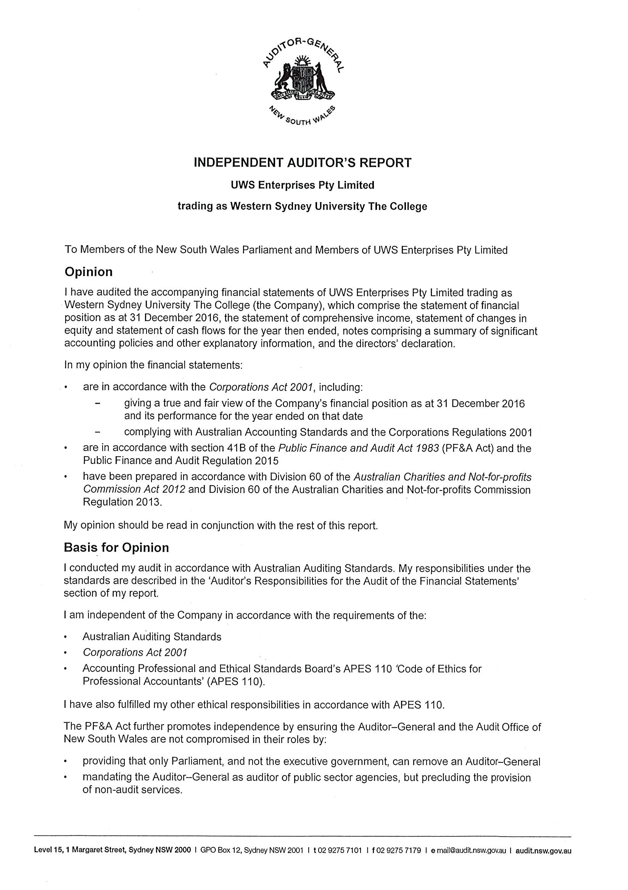

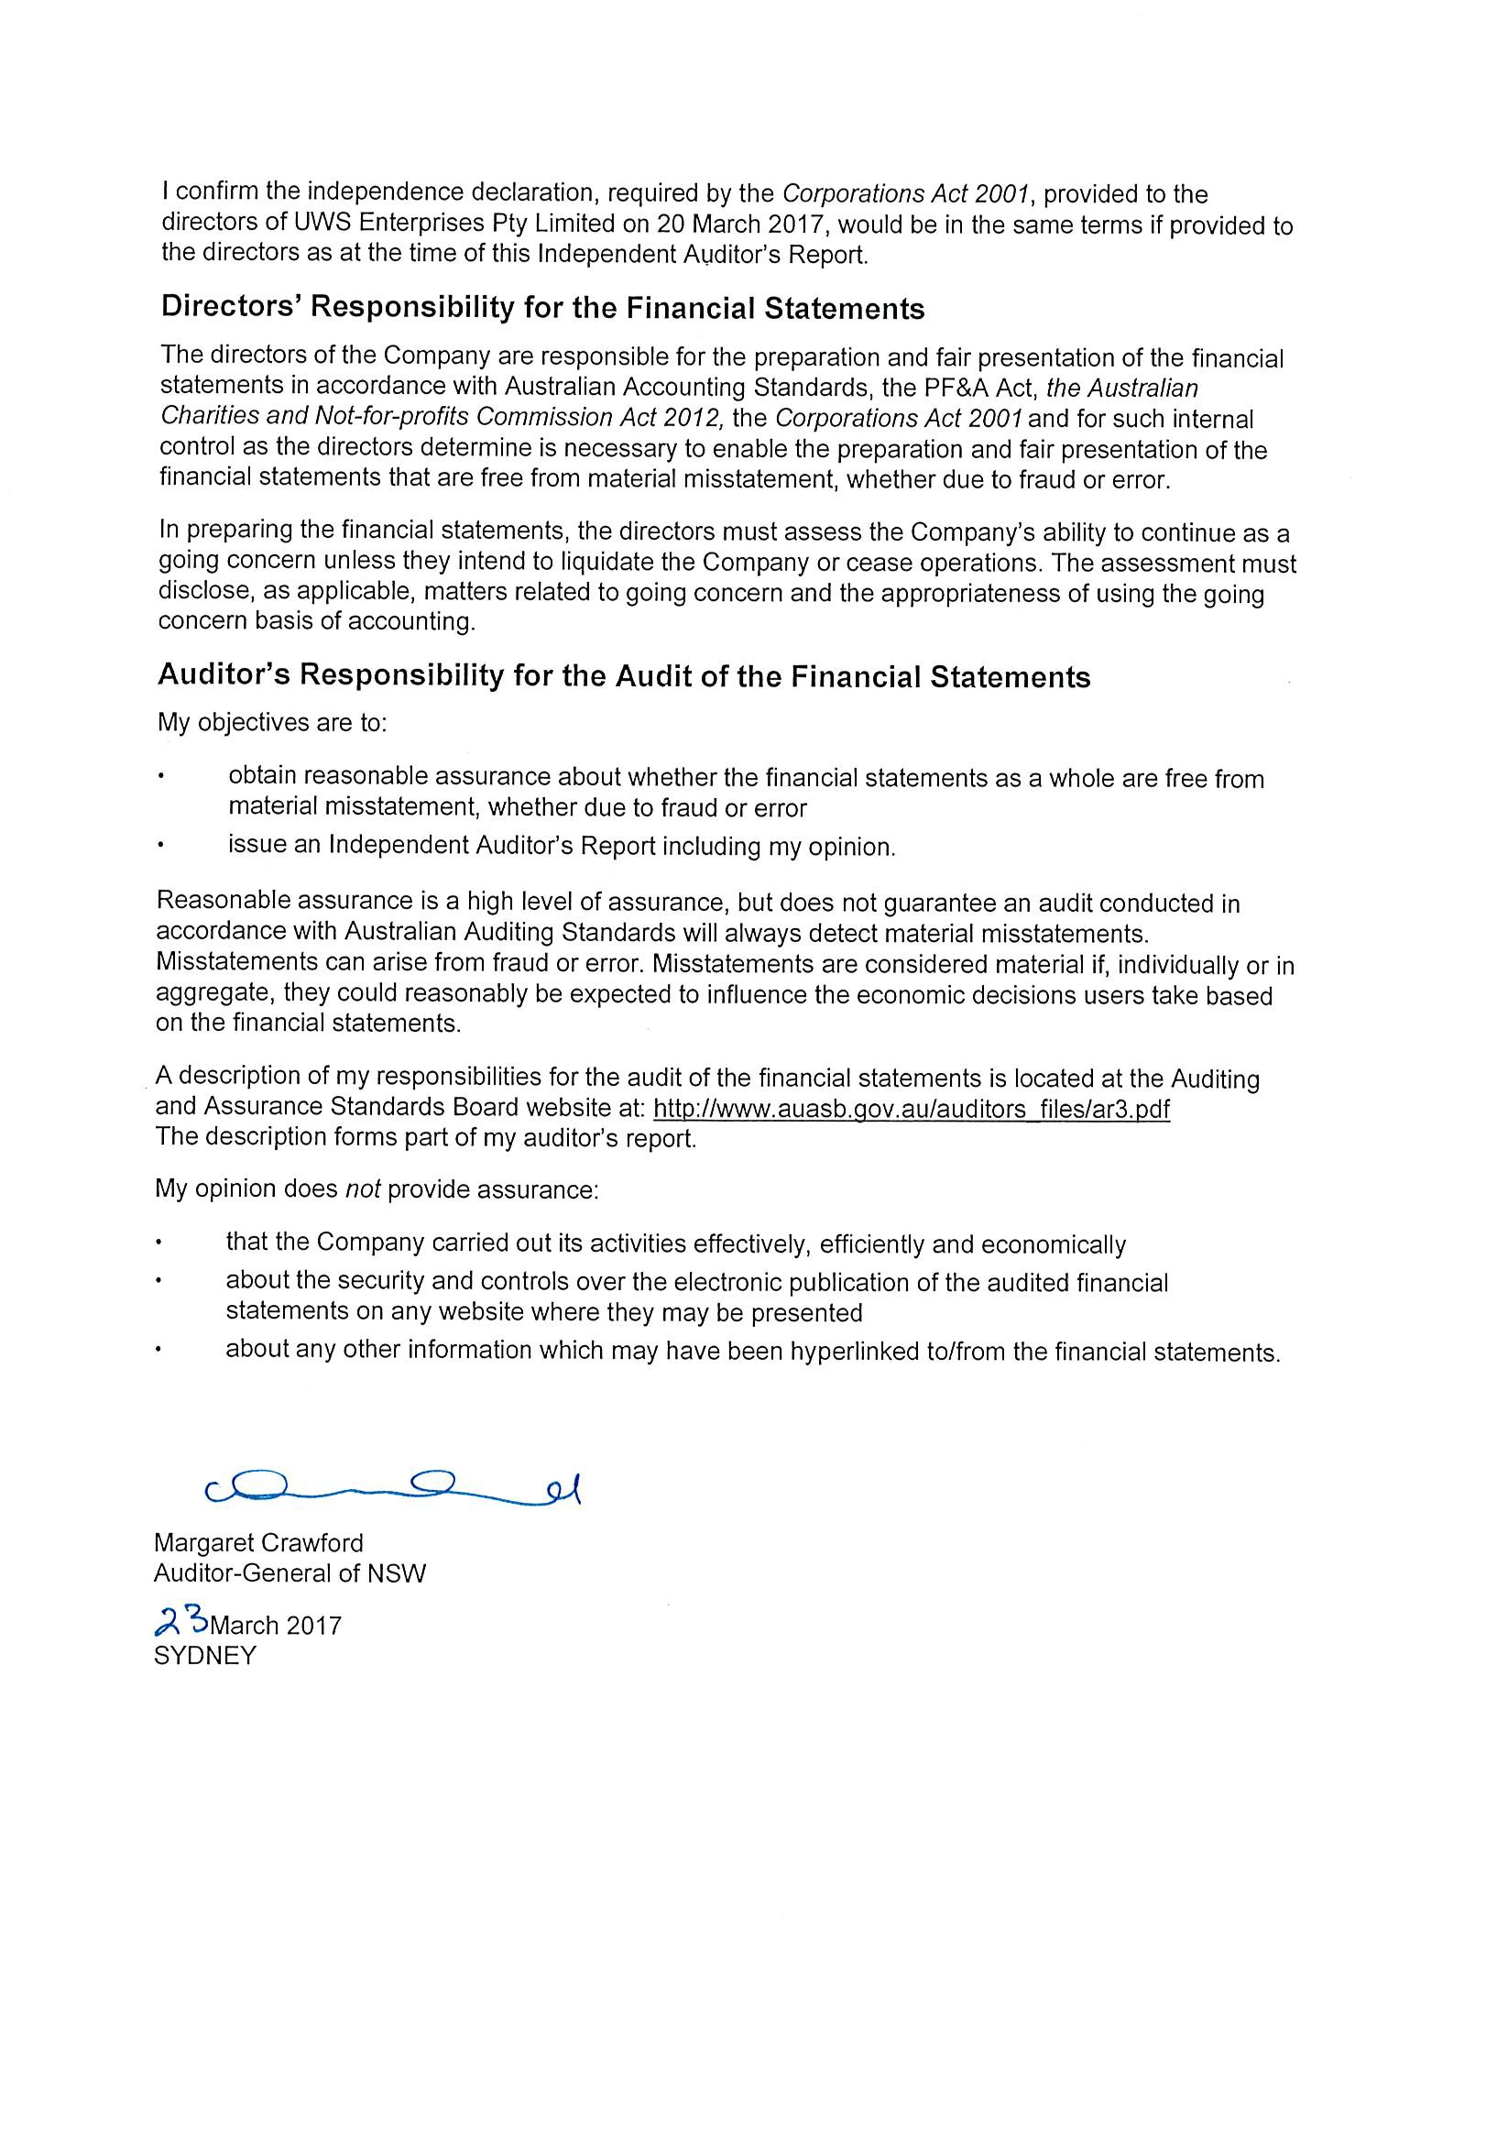

uwsconnect Limited
ABN 45 107 759 197

Financial Statements
For the Year Ended 31 December 2016

These financial statements are the individual entity statements of uwsconnect Limited (the Company). The financial statements are presented in the Australian currency.
The Company is limited by guarantee, incorporated and domiciled in Australia. Its registered office is: Western Sydney University
Great Western Highway Werrington NSW 2747
The financial statements were authorised for issue by the directors on 21 March 2017. The directors have the power to amend and reissue the financial statements.

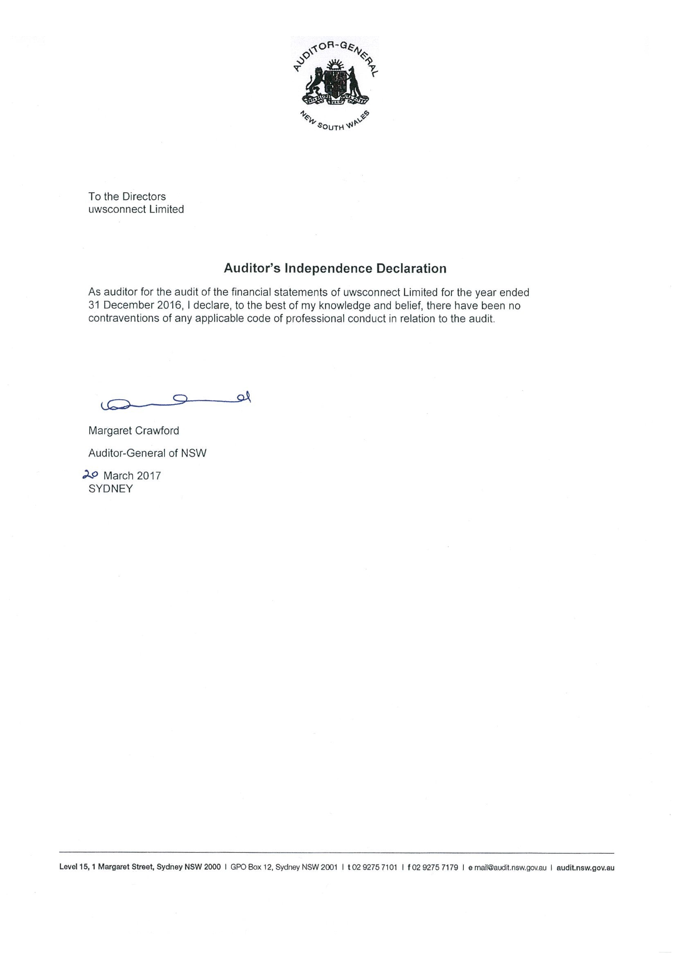

Statement of Comprehensive Income
For the Year Ended 31 December 2016
 |  | 2016 | 2015
 | Note | $ | $
Revenue
Sale of goods | 3 | 17,257,788 | 18,049,009
Rendering of services | 3 | 999,279 | 885,979
University funding | 3 | 1,994,063 | 2,542,005
Other revenue | 3 | 799,781 | 1,034,105
Total revenue from operations |  | 21,050,911 | 22,511,098
Gain on disposal of assets | 4 | 374,111 | 14,409
Total income |  | 21,425,022 | 22,525,507
Expenses
Raw materials and consumables used |  | (11,838,685) | (10,828,464)
Employee benefits expense | 5 | (8,389,159) | (9,955,207)
Depreciation and amortisation expense | 5 | (58,966) | (99,317)
Occupancy expenses | 5 | (348,390) | (552,709)
Minor equipment |  | (98,906) | (263,105)
Other expenses | 5 | (2,046,091) | (2,620,495)
Finance costs |  | (199,317) | (125,903)
Total expenses |  | (22,979,514) | (24,445,200)
Deficit for the year |  | (1,554,492) | (1,919,693)
Other comprehensive income for the year |  | - | -
Total comprehensive income for the year |  | (1,554,492) | (1,919,693)
Comprehensive income for the year attributable to:  Non-controlling interests |  | - | -
Parent |  | (1,554,492) | (1,919,693)
Total comprehensive income for the year |  | (1,554,492) | (1,919,693)

The accompanying notes form part of these financial statements.

Statement of Financial Position
As at 31 December 2016
 |  | 2016 | 2015
 | Note | $ | $
ASSETS
Current assets
Cash and cash equivalents | 7 | 496,008 | 502,541
Trade and other receivables | 8 | 2,746,448 | 1,131,602
Inventories | 9 | 14,753 | 2,888,192
Other assets |  | 41,055 | 94,469
Non-current assets held for sale | 10 | 130,266 | 212,761
Total current assets |  | 3,428,530 | 4,829,565
Non-current assets
Property, plant and equipment | 11 | 66,143 | 154,411
Intangible assets | 12 | - | 10,942
Total non-current assets 66,143 |  |  | 165,353
Total assets |  | 3,494,673 | 4,994,918
LIABILITIES
Current liabilities
Trade and other payables | 13 | 1,497,736 | 1,872,219
Borrowings from the parent | 14 | 5,618,407 | 5,010,493
Provisions | 15 | 448,673 | 457,471
Other liabilities | 16 | 104,985 | 229,061
Total current liabilities |  | 7,669,801 | 7,569,244
Non-current liabilities
Provisions | 15 | 164,116 | 210,426
Total non-current liabilities |  | 164,116 | 210,426
Total liabilities |  | 7,833,917 | 7,779,670
Net assets |  | (4,339,244) | (2,784,752)

EQUITY
Retained earnings
17 | (4,339,244) | (2,784,752)
 | (4,339,244) | (2,784,752)

Total equity

The accompanying notes form part of these financial statements.

Statement of Changes in Equity
For the Year Ended 31 December 2016
 | Retained Earnings | Total equity
 | $ | $
Balance 1 January 2016 | (2,784,752) | (2,784,752)
Total comprehensive income for the year
Deficit for the year | (1,554,492) | (1,554,492)
Balance at 31 December 2016 17 | (4,339,244) | (4,339,244)
 | Retained Earnings | Total equity
 | $ | $
Balance at 1 January 2015 | (865,059) | (865,059)
Total comprehensive income for the year
Deficit for the year | (1,919,693) | (1,919,693)
Balance at 31 December 2015 17 | (2,784,752) | (2,784,752)

The accompanying notes form part of these financial statements.

Statement of Cash Flows
For the Year Ended 31 December 2016
 |  | 2016 | 2015
 | Note | $ | $
CASH FLOWS FROM OPERATING ACTIVITIES  Receipts from customers |  | 21,333,696 | 24,246,149
Payments to suppliers and employees |  | (21,832,076) | (25,550,529)
Interest received |  | 16,400 | 11,663
Interest paid |  | (199,317) | -
Net cash flows used in operating activities | 24 | (681,297) | (1,292,717)
CASH FLOWS FROM INVESTING ACTIVITIES  Proceeds from sale of plant and equipment |  | 66,850 | 36,370
Net cash provided by investing activities |  | 66,850 | 36,370
CASH FLOWS FROM FINANCING ACTIVITIES  Proceeds from borrowings |  | 1,599,713 | 11,855,000
Payment of borrowings |  | (991,799) | (10,502,763)

Net cash flows provided by financing activities 607,914 1,352,237

Net (decrease) / increase in cash and cash equivalents held | (6,533) | 95,890
Cash and cash equivalents at beginning of the year | 502,541 | 406,651
Cash and cash equivalents at end of financial year 7 496,008 502,541

The accompanying notes form part of these financial statements.

Notes to the Financial Statements

For the Year Ended 31 December 2016

1 Summary of Significant Accounting Policies

The principal accounting policies adopted in the preparation of these financial statements is set out below. These policies have been consistently applied for all years reported unless otherwise stated.
The principal place of business for uwsconnect Limited is: Western Sydney University
Great Western Highway Werrington NSW 2747

Basis of Preparation

These financial statements are prepared on an accruals basis and in accordance with Australian Accounting Standards, Public Finance & Audit Act 1983, Public Finance and Audit Regulation 2015, Australian Charities and Not- for-profits Commission Act 2012 (ACNC Act) and Regulation 2013, other authoritative pronouncements of the Australian Accounting Standards Board and Urgent Issues Group Interpretations.
The financial statements of uwsconnect Limited (the Company) comply with Australian Accounting Standards, some of which contain requirements specific to not for profit entities that are inconsistent with International Financial Reporting Standards (IFRS) requirements.
Material accounting policies adopted in the preparation of these financial statements are presented below and have been consistently applied unless otherwise stated.

Critical accounting estimates

The preparation of financial statements requires the use of certain critical accounting estimates. It also requires management to exercise its judgement in the process of applying the Company's accounting policies. Estimates and judgements are continually evaluated and are based on historic experience and other factors, including expectations of future events that may have a financial impact on the Company and that are believed to be reasonable under the circumstances. Actual results may differ from the estimates.

These accounting policies have been consistently applied to all periods in the financial statements. The estimates and assumptions are reviewed on an ongoing basis. Revisions to any estimates are recognised in the period in which the estimate is reviewed, if the revision affects only that period or in a period of the revision and the future periods if the revision affects both current and future periods.

The financial statements have been prepared on an accruals basis and are based on historic costs, modified, where applicable, by the measurement at fair value of selected non-current assets, financial assets and financial liabilities.

Revenue recognition
The Company recognises revenue when the amount can be reliably measured, it is probable that future economic benefits will flow to the entity and specific criteria have been met for each of the Company's activities as described below. The Company bases its estimates on historical results, taking into consideration the type of customer, the type of transaction and the specifics of each arrangement.
Revenue is measured at the fair value of the consideration received or receivable. Amounts disclosed as revenue are net of returns, trade allowances, rebates and amounts collected on behalf of third parties.

Notes to the Financial Statements

For the Year Ended 31 December 2016

1 Summary of Significant Accounting Policies
- Revenue recognition
Revenue is recognised for the major business activities as follows:

Sale of goods and rendering of services
A sale is recorded when goods have been delivered to the customer, the customer has accepted the goods and collectability of the related receivables is probable. Revenue from rendering of services is recognised when that service has been provided.

Other revenue
All other material revenue is accounted for on an accrual basis. Funding from the parent entity is received quarterly in advance. Only the revenue pertaining to the month is accounted as revenue with the balance shown as income earned in advance (Note 14).

Finance costs
Finance costs relating to the Western Sydney University loan facilities are expensed.

Income Tax
The Company is exempt from the payment of tax by virtue of section 50-B of the Income Tax Assessment Act 1997. Accordingly, no provision for income tax liability or future income income tax benefit has been included in the accounts.

Cash and cash equivalents
For the purpose of presentation in the statement of cash flows, cash and cash equivalents include cash on hand and cash at bank.

Trade receivables
Trade receivables are recognised initially at fair value and subsequently measured at amortised cost using the effective interest method, less provision for impairment. The amount of the provision is recognised in the income statement. This is recognised as the difference between the assets carrying amount and the present value of estimated future cash flows, discounted at the effective interest rate. Collectability of trade receivables is reviewed on an ongoing basis at board level. Individual debts that are known to be uncollectable are written off when identified.
Short term receivables, with no stated interest rates, are measured at the original invoice amount where the effect of discounting is immaterial.

Inventories
All inventories are measured at the lower of cost and net realisable value. All stock is valued at a weighted average cost.

Financial assets Classification
The Company classifies its investments as loans and receivables.

Loans and receivables
Loans and receivables are non-derivative financial assets with fixed or determinable payments that are not quoted in an active market. They are included in current assets, except for those with maturities greater than 12 months after the reporting period which are classified as non current assets. Loans and receivables are included in trade and other receivables (note 8) in the Statement of Financial Position. The assets residual values are reviewed and adjusted if appropriate at each balance sheet date.

Notes to the Financial Statements

For the Year Ended 31 December 2016

1 Summary of Significant Accounting Policies
- Financial assets

Measurement
Details on how the fair value of financial instruments is determined are disclosed in note 2.

Assets carried at amortised cost
For loans and receivables, the amount of the loss is measured as the difference between the asset's carrying amount and the present value of estimated future cash flows (excluding future credit losses that have not been incurred) discounted at the financial asset's original effective interest rate. The carrying amount of the asset is reduced and the amount of the loss is recognised in the Statement of Comprehensive Income. If the loan has a variable interest rate, the discount rate for measuring any impairment loss is the current effective interest rate determined under the contract. As a practical expedient, when deriving fair values where the observable market price are not available also requires significant assumption and judgement.
If, in a subsequent period, the amount of the impairment loss decreases and the decrease can be related objectively to an event occurring after the impairment was recognised (such as an improvement in the debtor's credit rating), the reversal of the previously recognised impairment loss is recognised in the income statement.
Impairment testing of trade receivables is described in note 1(f).

Property, Plant and Equipment
Property, plant and equipment are stated at cost less accumulated depreciation.
Subsequent costs are included in the asset's carrying amount or recognised as a separate asset, as appropriate, only when it is probable that future economic benefits associated with the item will flow to the company and the cost of the item can be measured reliably. All other repairs and maintenance are charged to the statement of comprehensive income during the reporting period in which they are incurred.
Depreciation on assets is calculated using the straight line method to allocate their cost or re-valued amounts, net of their residual values, over their estimated useful lives or, in the case of leasehold improvements and certain leased plant and equipment, the shorter lease term as follows:

Class of Assets Useful Life
Plant and Equipment 3-10 years
Motor Vehicles 6-7 years
Computer Equipment 3-4 years
Leasehold Improvements 2-6 years
Other Property, Plant and Equipment 10-20 years
An asset's carrying amount is written down immediately to its recoverable amount if the asset's carrying amount is greater than its estimated recoverable amount.
Gains and losses on disposals are determined by comparing proceeds with carrying amount. These are included in the statement of comprehensive income.

Intangible Assets
  - IT development and software
Costs incurred in developing products or systems and costs incurred in acquiring software and licences that contribute to future financial benefits through revenue generation and/or cost reduction, are capitalised to software and systems. Costs capitalised include external direct costs of materials and service and direct payroll and payroll related costs to employee's time spent on the project. Amortisation is calculated on a straight line basis over periods generally ranging from 3 to 5 years.
  - Franchise Fees
Cost incurred to acquire Subway Franchise fees are amortised over a period of 20 years on a straight line basis.

Notes to the Financial Statements

For the Year Ended 31 December 2016

1 Summary of Significant Accounting Policies

- Trade and other payables

These amounts represent liabilities for goods and services provided to the Company prior to the end of the financial year which are unpaid. The amounts are unsecured and are usually paid according to the credit terms agreed with the suppliers. Trade and other payables are presented as current liabilities unless payment is not due within 12 months from the reporting date.

Employee benefits

Liabilities for wages and salaries, including non-monetary benefits, expected to be settled within 12 months after the end of each reporting period are measured at the amounts expected to be paid when the liabilities are settled and recognised in other payables. The liability for annual leave is recognised in the provision for employee benefits.

  - Provisions

The liability for long service leave and annual leave, which is not expected to be settled within 12 months after the end of the reporting period in which the employees render the related service, is recognised in the provision for employee benefits and measured at the present value of expected future payments to be made when the liability is settled. Consideration is given to expected future wage and salary levels, experience of employee departures and periods of service. Expected future payments are discontinued using market yields at the end of the reporting period on national government bonds with terms to maturity and currency that match, as closely as possible, the estimated future cash outflow.

Regardless of the expected timing of settlements, provisions made in respect of employee benefits are classified as a current liability, unless there is an unconditional right to defer the settlement of the liability for at least 12 months after the reporting date, in which case, it would be classified as a non-current liability.

Contributions to the defined fund are recognised as an expense as they become payable. Prepaid contributions are recognised as an asset to the extent that a cash refund or a reduction in the future payment is available.

Termination benefits are payable when employment is terminated before the normal retirement date, or where an employee accepts voluntary redundancy in exchange for these benefits. The Company recognises termination benefits when it is demonstrably committed to either terminating the employment of current employees according to a detailed formal plan without possibility of withdrawal or to providing termination benefits as a result of an offer made to encourage voluntary redundancy. Benefits falling due more than 12 months after the end of the reporting period are discounted to present value.

Borrowings
Borrowings are initially recognised at fair value, net of transaction costs incurred. Borrowings are subsequently measured at amortised cost. Any difference between the proceeds (net of transaction costs) and the redemption amount is recognised in the Statement of Comprehensive Income over the period of the borrowings using the effective interest method. Fees paid on the establishment of loan facilities are recognised as transaction costs of the loan to the extent that it is probable that some or all of the facility will be drawn down. In this case, the fee is deferred until the draw down occurs. To the extent there is no evidence that it is probable that some or all of the facility will be drawn down, the fee is capitalised as a prepayment for liquidity services and amortised over the period of the facility to which it relates.
Borrowings are removed from the statement of financial position when the obligation specified in the contract is discharged, cancelled or expired.
Borrowings are classified as current liabilities unless the Company has an unconditional right to defer settlement of the liability for at least 12 months after the reporting period.

Notes to the Financial Statements

For the Year Ended 31 December 2016

Summary of Significant Accounting Policies

- Goods and Services Tax (GST)
Revenues, expenses and assets are recognised net of the amount of associated GST, unless the GST incurred is not recoverable from the Australian Taxation Office. In this case it is recognised as part of the cost of acquisition of the asset or as part of the expense.
Receivables and payables are stated inclusive of the amount of GST receivable or payable. The net amount of GST recoverable from, or payable to, the taxation authority is included with other receivables or payables in the statement of financial position.
Cash flows are presented on a gross basis. The GST components of cash flows arising from investing or financing activities which are recoverable from, or payable to the taxation authority, are presented as operating cash flows.

New Accounting Standards and Interpretations
Certain new accounting standards and interpretations have been published that are not mandatory for 31 December 2016 reporting periods and have not yet been applied to the financial statements. The Company's assessment of the impact of these new standards and interpretations is that they will not materially affect any of the amounts recognised in the financial statements or significantly impact the disclosures in relation to the Company.

Comparative amounts
When required by Accounting Standards, comparative figures have been adjusted to conform to changes in presentation for the current year. No Comparative adjustments were made in 2016.

Financial Risk Management

The Company's activities expose it to a variety of financial risks: market risk (including interest rate risk), credit risk and liquidity risk. The Company's overall risk management program focuses on the unpredictability of financial markets and seeks to minimise potential adverse effects on the financial performance of the Company. The Company uses different methods to measure different types of risk to which it is exposed. These methods include sensitivity analysis in the case of interest rate and aging analysis for credit risk to determine market risk.

The Company holds the following financial instruments:

 | 2016  $ | 2015  $
Financial Assets  Cash and cash equivalents | 496,008 | 502,541
Trade and other receivables* | 2,746,448 | 1,131,602
Total Financial Assets | 3,242,456 | 1,634,143
Financial Liabilities  Trade and other payables* | 1,446,162 | 1,856,084
Borrowings from the parent | 5,618,407 | 5,010,493
Total Financial Liabilities | 7,064,569 | 6,866,577
* Excludes statutory receivables and payables

Notes to the Financial Statements

For the Year Ended 31 December 2016

2 Financial Risk Management

- Market risk

- Cash flow and fair value interest rate risk

The Company's main interest rate risk arises from short term borrowings. Borrowings issued at variable rates expose the Company to cash flow interest rate risk.

As at the end of the reporting period, the Company had the following variable rate borrowings:

2016  Weighted average |  | 2015  Weighted average
interest rate | Balance | interest rate | Balance
% | $ | % | $
4 | 5,618,407 | 5 | 5,010,493
Net exposure to cash flow interest rate risk 4 | 5,618,407 | 5 | 5,010,493

- Summarised sensitivity analysis

The following table summarises the sensitivity of the Company's financial assets and financial liabilities to interest rate risk, foreign exchange risk and other price risk.

 | Carrying amount | -1%  Surplus/(Deficit) | -1%  Equity | +1%  Surplus/(Deficit) | +1%  Equity
31 December 2016 | $ | $ | $ | $ | $
Financial Assets  Cash and cash equivalents | 496,008 | (4,960) | (4,960) | 4,960 | 4,960
Receivables | 2,746,448 | (27,464) | (27,464) | 27,464 | 27,464
Financial Liabilities  Borrowings | 5,618,407 | 56,184 | 56,184 | (56,184) | (56,184)
Trade and other payables | 1,446,162 | 14,461 | 14,461 | (14,461) | (14,461)
 | 10,307,025 | 38,221 | 38,221 | (38,221) | (38,221)

Notes to the Financial Statements

For the Year Ended 31 December 2016

2 Financial Risk Management

 | Carrying amount | -1%  Surplus/(Deficit) | -1%  Equity | +1%  Surplus/(Deficit) | +1%  Equity
31 December 2015 | $ | $ | $ | $ | $
Financial Assets  Cash and cash equivalents | 502,541 | (5,025) | (5,025) | 5,025 | 5,025
Receivables | 1,131,602 | (11,316) | (11,316) | 11,316 | 11,316
Financial Liabilities  Borrowings | (5,010,493) | 50,105 | 50,105 | (50,105) | (50,105)
Trade and other payables | (1,856,084) | 18,561 | 18,561 | (18,561) | (18,561)
 | (5,232,434) | 52,325 | 52,325 | (52,325) | (52,325)

- Credit risk

The credit risk on financial assets of the Company which have been recognised on the statement of financial position is generally the carrying amount, net of provision for loss. Credit risk arises where there is a possibility of the Company's debtors defaulting on their contractual obligation, resulting in financial loss to the Company. The Company does not have any significant exposure to any unrelated customer.

Liquidity risk

Prudent liquidity risk management implies maintaining sufficient cash and the availability of funding through an adequate amount of committed credit facilities to meet obligations when due.

Maturities of financial liabilities:

The tables below analyse the Company's financial liabilities into relevant maturity groupings based on their contractual maturities for all non- derivative financial liabilities.

The amounts disclosed in the table are the contractual undiscounted cash flows. Balances due within 12 months equal their carrying balances as the impact of discounting is not significant.

Contractual maturities of financial assets and liabilities

 | Less than 1 year | Between 1 and  5 years Over 5 years Non interest | Carrying amount | Average interest rate
2016  Cash and cash equivalents | $  496,008 | $ $ $  - - - | $  496,008 | % | 2
Trade and other receivables | 2,746,448 | - - 2,746,448 | 2,746,448 | -
Trade and other payables | (1,446,162) | - - (1,446,162) | (1,446,162) | -
Borrowings | (5,618,407) | - - - | (5,618,407) |  | 4
Total non derivatives (3,822,113) - - 1,300,286 (3,822,113)

Notes to the Financial Statements

For the Year Ended 31 December 2016

2 | Financial Risk Management  (c) Liquidity risk
 |  | Less than 1 year | Between 1 and  5 years Over 5 years Non interest | Carrying amount | Average interest rate
 | 2015 | $ | $ $ $ | $ | %
 | Cash and cash equivalents | 502,541 | - - - | 502,541 |  | 2
 | Trade and other receivables | 1,131,602 | - - 1,131,602 | 1,131,602 | -
 | Trade and other payables | (1,856,084) | - - (1,856,084) | (1,856,084) | -
 | Borrowings | (5,010,493) | - - - | (5,010,493) |  | 5
 | Total non derivatives | (5,232,434) | - - (724,482) | (5,232,434)
 | (d) Fair value measurements

The fair value of financial assets and financial liabilities must be estimated for recognition and measurement or for disclosure purposes.

As the Company's financial instruments are short term in nature, their carrying values recognised in the statement of financial position approximates their fair value.

The carrying amount and aggregate net fair values of financial assets and financial liabilities at balance date are:

 | Carrying amount | Fair value
 | $ | $
Financial assets  Cash and cash equivalents | 496,008 | 496,008
Trade and other receivables | 2,746,448 | 2,746,448
Total | 3,242,456 | 3,242,456
Financial Liabilities  Borrowings | 5,618,407 | 5,618,407
Trade and other payables | 1,446,162 | 1,446,162
Total | 7,064,569 | 7,064,569

Notes to the Financial Statements

For the Year Ended 31 December 2016

3 | Revenue  Revenue from operating activities
 |  | 2016 | 2015
 |  | $ | $
 | Sale of goods  Books | 10,020,803 | 8,782,499
 | Food and beverage | 6,990,275 | 8,751,331
 | Retail | 246,710 | 515,179
 | Total sale of goods | 17,257,788 | 18,049,009
 | Rendering of services  Sports | 989,201 | 882,708
 | Venue hire | 10,078 | 3,271
 | Total rendering of services | 999,279 | 885,979
 | University funding  University funding - general | 1,200,000 | 1,200,000
 | University funding - community services | 171,433 | 650,746
 | University funding - clubs | 350,000 | 401,459
 | University funding - sport | 272,630 | 289,800
 | Total University Funding | 1,994,063 | 2,542,005
 | Other revenue  Bank interest | 16,400 | 11,663
 | Other revenue | 783,381 | 1,022,442
 | Total other revenue | 799,781 | 1,034,105
 | Total revenue from operating activities | 21,050,911 | 22,511,098
4 | Gain on disposal of assets
 |  | 2016 | 2015
 |  | $ | $
 | Proceeds from sale | 490,100 | 14,409
 | Carrying amount of assets sold | (115,989) | -
 | Total gain on disposal of assets | 374,111 | 14,409

Notes to the Financial Statements
For the Year Ended 31 December 2016

5 | Expenses | 2016 | 2015
 |  | $ | $
 | Employee benefits expense  Salaries and wages | 6,770,007 | 8,333,768
 | Superannuation | 605,151 | 751,161
 | Annual leave | 274,348 | 346,931
 | Long service leave | 61,609 | 30,687
 | Workers compensation | 189,655 | 212,707
 | Termination benefits | 257,012 | 159,553
 | Other | 231,377 | 120,400
 | Total | 8,389,159 | 9,955,207
 | Depreciation  Plant and equipment | 15,646 | 50,945
 | Motor vehicles | 32,378 | 47,623
 |  | 48,024 | 98,568
 | Amortisation  Franchise fees | 10,942 | 750
 | Total depreciation and amortisation | 58,966 | 99,318
 | Occupancy expenses*  Minimum lease payments on operating leases | 76,442 | 96,356
 | Repairs and maintenance | 116,899 | 140,141
 | Utilities | 57,451 | 63,170
 | Cleaning and waste removal | 69,162 | 193,199
 | Security | 28,436 | 59,843
 |  | 348,390 | 552,709

* uwsconnect Limited currently resides in facilities owned by the University in which there is no charge. The value of this accomodation cannot be reliably measured or quantified due to the specialised nature of the premises, therefore no expense has been recognised in financial statements.

Other expenses
Consultancy, agency and service provider fees | 111,322 | 67,002
Advertising, promotions and events | 674,046 | 1,235,209
Equipment hire | 133,405 | 100,657
Motor vehicle | 128,001 | 120,384
Consumables and supplies | 532,418 | 441,088
Other | 466,899 | 656,155
 | 2,046,091 | 2,620,495

Notes to the Financial Statements
For the Year Ended 31 December 2016

- Discontinued Operations
On 22nd November 2016, uwsconnect Limited entered into an agreement with University Co-operative Bookshop Limited to dispose of its Retail business. The University Co-operative Bookshop Limited purchased all of the remaining inventory, fixtures and fittings of the outlets. The University Co-operative Bookshop Limited took over Retail operations, commencing trading from 15 December 2016.

Total Revenues for uwsconnect Limited's retail operation for the year ending 31 December 2016 were $10,360,475 (2015: $9,721,372). Expenditures for the Retail operation cannot be reliably measured or quantified.

Cash and cash equivalents

2016
$

2015
$

Cash at bank and on hand 496,008 502,541

Total cash at bank and on hand 496,008 502,541

  - Reconciliation to cash at the end of the year

The above figures are reconciled to cash at the end of the financial year as shown in the statement of cash flows as follows:
Balance as above | 2016  $ 496,008 | 2015  $  502,541
Balance as per statement of cash flows | 496,008 | 502,541

The Company's exposure to interest rate risk is discussed in note 2. The maximum exposure to credit risk at the end of each reporting period is the carrying amount of each class of cash and cash equivalents mentioned above.

Cash at bank and on hand are interest bearing.

Notes to the Financial Statements

For the Year Ended 31 December 2016

8 | Trade and other receivables | 2016 | 2015
 |  | $ | $
 | Trade receivables | 2,696,450 | 1,082,275
 | Sundry debtors and accruals | - | 21,763
 | Net trade receivables | 2,696,450 | 1,104,038
 | Prepayments | 49,998 | 27,564
 | Total current trade and other receivables | 2,746,448 | 1,131,602
 | Trade and other receivables are non-interest bearing.

At 31 December 2016,current receivables of uwsconnect Limited with a nominal value of $Nil (2015 Nil) were impaired. The amount of the provision was $Nil (2015 Nil).

As at 31 December 2016 trade receivables of $75,172 (2015:$145,578) were past due but not impaired. These relate to Western Sydney University. The ageing of these receivables is as follows:
 | 2016  $ | 2015  $
Up to 3 months | 22,002 | 129,522
3 to 6 months | 7,339 | 12,718
Over 6 months | 45,831 | 3,338
Total | 75,172 | 145,578

The other amounts within receivables do not contain impaired assets that are not past due. Based on the credit history, it is expected that these amounts will be received when due.

(a) Fair value and credit risk

Due to the short term nature of these receivables, their carrying amount is assumed to approximate their fair value.

The maximum exposure to credit risk at the end of each reporting period is the carrying amount of each class of receivables mentioned above. Refer to note 2 for more information on the risk management policy of the Company and the credit quality of the entity's trade receivables.

Notes to the Financial Statements

For the Year Ended 31 December 2016

Inventories

Finished goods

2016
$

2015
$

At net realisable value 14,753 2,954,192
Provision for impairment - (66,000)
14,753 2,888,192

Provision for impairment

Provision for impairment of inventories to net realisable value recognised as an expense during the year ended 31 December 2016 amounted to $NIL (2015: $66,000).

Movement in the allowance for impairment

2016
$

2015
$

At 1 January 66,000 -
Provision used during the year (66,000) -
Allowance for stock obsolescence recognised during the year - 66,000

At 31 December - 66,000

Disposal group classified as held for sale ('NCA')

Current

2016
$

2015
$

Disposal group relating to franchised Subway outlets 130,266 212,761

130,266 212,761

NCAs (or disposal groups) held for sale are carried at the lower of the carrying amount or the fair value less costs to sell.

uwsconnect Limited entered into sales agreements to sell both its Parramatta and Kingswood Subway outlets. Settlement of the Parramatta Subway outlet occured on 21 December 2016. A gain of $347,505 has been recognised in the statement of comprehensive income, under the heading Gain on disposal of assets.

Settlement for the sale of the Kingswood Subway outlet is expected to occur by 31 December 2017.

Notes to the Financial Statements

For the Year Ended 31 December 2016

11 | Property, plant and equipment | 2016 | 2015
 |  | $ | $
 | Plant and equipment  At cost | 225,782 | 244,997
 | Accumulated depreciation | (191,601) | (187,195)
 | Total plant and equipment | 34,181 | 57,802
 | Motor vehicles  At cost | 285,038 | 487,579
 | Accumulated depreciation | (253,076) | (390,970)
 | Total motor vehicles | 31,962 | 96,609
 | Total property, plant and equipment | 66,143 | 154,411

Movements in carrying amounts of property, plant and equipment

Movement in the carrying amounts for each class of property, plant and equipment between the beginning and the end of the current financial year:

Furniture,
 | Plant and  Equipment | Fixtures and  Fittings | Motor  Vehicles | Total
 | $ | $ | $ | $
Year ended 31 December 2016  Balance at the begining of the year | 57,802 | - | 96,609 | 154,411
Additions | - | - | - | -
Disposals - written down value | (1,224) | - (39,020) |  | (40,244)
Depreciation charge | (15,646) | - (32,378) |  | (48,024)
Balance at the end of the year | 40,932 | - 25,211 |  | 66,143

 | Plant and Equipment | Furniture, Fixtures and Fittings | Motor Vehicles | Total
 | $ | $ | $ | $
Year ended 31 December 2015  Balance at the beginning of year | 80,993 | 254,550 | 152,161 | 487,704
Disposals | (14,036) | - | (7,929) | (21,965)
Transfers | 254,550 | (254,550) | - | -
Transfers to held for sale | (212,761) | - | - | (212,761)
Depreciation charge | (50,944) | - | (47,623) | (98,567)
Balance at the end of the year | 57,802 | - | 96,609 | 154,411

Notes to the Financial Statements
For the Year Ended 31 December 2016

12 Intangible assets |  | Franchise
 | Software | fees | Total
At 1 January 2016 | $ | $ | $
Cost | 65,500 | 15,000 | 80,500
Accumulated amortisation | (65,500) | (15,000) | (80,500)
Net book amount - - -

Year ended 31 December 2016  Opening net book amount | - 10,942 | 10,942
Amortisation | - (10,942) | (10,942)
Closing net book amount | - - | -
At 31 December 2016
Cost | 65,500 15,000 | 80,500
Accumulated amortisation | (65,500) (15,000) | (80,500)
Net book amount | - - | -
At 1 January 2015
Cost | 65,500 15,000 | 80,500
Accumulated amortisation | (65,500) (3,308) | (68,808)
Net book amount | - 11,692 | 11,692
Year ended 31 December 2015
Opening net book amount | - 11,692 | 11,692
Amortisation charge | - (750) | (750)
Closing net book amount | - 10,942 | 10,942
At 31 December 2015
Cost | 65,500 15,000 | 80,500
Accumulated amortisation | (65,500) (4,058) | (69,558)
Net book amount | - 10,942 | 10,942

13 | Trade and other payables | 2016 | 2015
 |  | $ | $
 | Trade payables | 200,065 | 1,255,736
 | Accrued expenses | 786,383 | 416,142
 | Other payables | 511,288 | 200,341
 |  | 1,497,736 | 1,872,219

Notes to the Financial Statements
For the Year Ended 31 December 2016

14 Borrowings from the Parent | 2016 | 2015
Unsecured - current | $ | $
Loans from related parties | 5,618,407 | 5,010,493
Total current borrowings | 5,618,407 | 5,010,493
uwsconnect Limited has an unused borrowing facility to the value of $0.382M.
15 Provisions
Current provisions expected to be settled within 12 months. | 2016 | 2015
 | $ | $
Annual leave | 136,730 | 118,821
Long service leave | 72,597 | 140,446
 | 209,327 | 259,267
Current provisions expected to be settled after more than 12 months | 2016 | 2015
 | $ | $
Annual leave | 149,420 | 133,990
Long service leave | 89,926 | 64,213
 | 239,346 | 198,203
Total current provisions | 448,673 | 457,470
Non-current provisions
 | 2016 | 2015
 | $ | $
Employee benefits - long service leave | 164,116 | 210,426
Total non-current provisions | 164,116 | 210,426
16 Other liabilities | 2016 | 2015
 | $ | $
Voucher liability | 104,985 | 228,522
Deposit on hand | - | 539
 | 104,985 | 229,061

Notes to the Financial Statements
For the Year Ended 31 December 2016

17 | Retained earnings  Movements in retained earnings were as follows:
 |  | 2016 | 2015
 |  | $ | $
 | Opening balance | (2,784,752) | (865,059)
 | Deficit for the year | (1,554,492) | (1,919,693)
 | Closing Balance | (4,339,244) | (2,784,752)
18 | Remuneration of Auditors
 |  | 2016 | 2015
 |  | $ | $
 | Audit of financial statements | 35,200 | 40,893
 | Total remuneration for audit and other assurance services (inclusive of GST) | 35,200 | 40,893
19 | Contingencies
 | The Company had no contingent liabilities at 31 December 2016 (2015: $nil).
20 | Commitments
 | (a) Operating lease commitments
 |  | 2016 | 2015
 |  | $ | $
 | Commitments for minimum lease payments in relation to non- cancellable operating leases are payable as follows:
 | Within one year | 24,566 | 40,423
 | Between one year and five years | 33,964 | 6,019
 |  | 58,530 | 46,442
 | (b) Capital expenditure commitments

There are no capital expenditure commitments as at the end of the 2016 reporting period (2015: $nil).

Notes to the Financial Statements

For the Year Ended 31 December 2016

Related party transactions

  - Parent entity

The ultimate parent entity of the Company is Western Sydney University.

  - Transactions with related parties

The following transactions occurred with related parties:

Sale of goods and services
2016
$
2015
$

Sale of goods and services to the ultimate parent entity 1,092,728 1,367,512 Sale of goods and services to other related parties 62,276 99,700
1,155,004 1,467,212

Other transactions
 | 2016  $ | 2015  $
Funding from the ultimate parent entity | 1,994,063 | 2,542,005
Total | 1,994,063 | 2,542,005

  - Outstanding balances arising from sales or purchases of goods and services

The following balances are outstanding at the end of the reporting period in relation to transactions with related parties:

Current receivables
2016
$
2015
$

Ultimate parent entity - 978,500
Other related parties - 12,438

- 990,938
Current payables  Ultimate parent entity | 102,936 | 712,978
Other related parties | - | 2,013
102,936 714,991

Notes to the Financial Statements

For the Year Ended 31 December 2016
 |  | 2016  $ | 2015  $
(d) | Loans from the ultimate parent entity
 | Beginning of the year | 5,010,493 | 3,532,365
 | Loans advanced | 1,599,712 | 11,855,000
 | Interest charged | 199,317 | (10,502,763)
 | Loan repayment | (1,191,115) | 125,891
 | End of the year | 5,618,407 | 5,010,493

Economic dependency

The Company is economically dependant on Western Sydney University for the provision of office accommodation and support activities.

The Company, as a wholly owned entity of Western Sydney University, received $1,994,063 in direct funding in 2016 for University services.

Funding for 2017 has been approved for $2,215,600 for the purpose of providing food, beverages, health awareness services, campus life activities and events.

In addition there is support and funding for community services and clubs from the parent entity Western Sydney University (refer to Note 3).

Further all borrowings are from the Parent Entity as mentioned in Note 21 (d), with funding limited to day to day working capital.

Therefore management believes that the Company will continue as a going concern and a Letter of Support has been provided by Western Sydney University.

Events occurring after the reporting period

There are no events after the balance sheet date of which the Directors are aware of (2015 $Nil).

Notes to the Financial Statements

For the Year Ended 31 December 2016

Reconciliation of operating surplus/(deficit) to net cash flows from operating activities

Operating deficit for the year | 2016  $ (1,554,492) | 2015  $  (1,919,693)
Depreciation and amortisation | 58,966 | 99,317
Interest accrual | - | 125,891
Net (gain)/loss on sale of non-current assets | (374,111) | (14,409)
Changes in operating assets and liabilities
(Increase)/decrease in trade debtors | (1,184,846) | 52,953
(Increase)/decrease in inventories | 2,873,439 | 1,007,805
(Increase)/decrease in other operating assets | 53,415 | (94,473)
Increase/(decrease) in trade creditors | (374,483) | 27,168
Increase/(decrease) in other operating liabilities | (124,076) | (541,734)
Increase/(decrease) in other provisions | (55,109) | (35,542)
Net cash flows used in operating activities (681,297) (1,292,717)

End of the audited financial statements

Statement by Directors

The directors of uwsconnect Limited declare that:

- Under s41C (1b) of the Public Finance & Audit Act 1983 we state to the best of our knowledge and belief the financial statements and notes, as set out on pages 141 to 164 :

  - comply with Australian Accounting Standards, the Public Finance and Audit Act 1983, the Public Finance and Audit Regulation 2015 and the mandatory professional reporting requirements, and

  - give a true and fair view of the financial position as at 31 December 2016 and of the performance for the year ended on that date of uwsconnect Limited.

- In the directors' opinion, there are reasonable grounds to believe that uwsconnect Limited will be able to pay its debts as and when they become due and payable.

- We are not aware of any circumstances which would render any particulars included in the financial statements to be misleading or inaccurate.

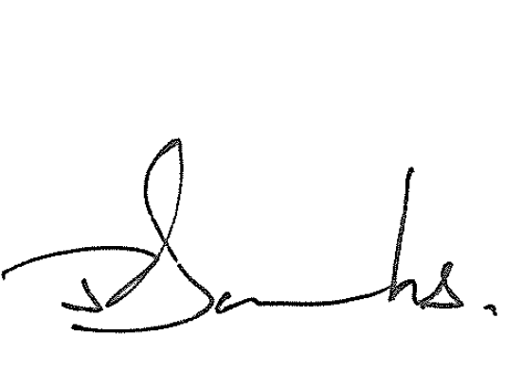
This declaration is made in accordance with a resolution of the Board of Directors.
John Banks Director

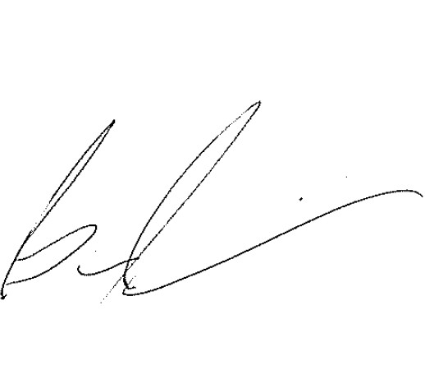
Bill Parasiris Director
21 March 2017

ABN 45 107 759 197

Responsible Entities Declaration - per section 60.15 of the Australian Charities and Not-for-profits Commision Regulation 2013

The responsible entities declare that in the responsible entities opinion:

- there are reasonable grounds to believe that the registered entity is able to pay all of its debts, as and when they become due and payable; and

- the financial statements and notes satisfy the requirements of the Australian Charities and Not-for-profits Commission Act 2012.

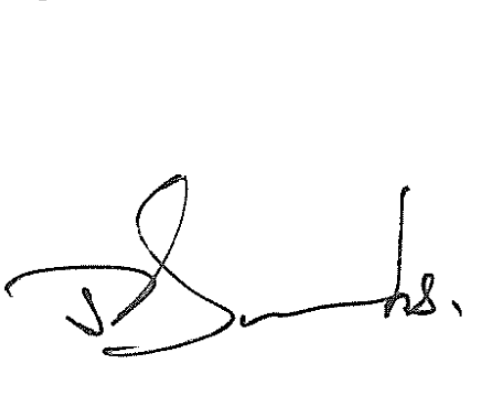
Signed in accordance with subsection 60.15(2) of the Australian Charities and Not-for-profits Commission Regulation 2013.
John Banks Director
21 March 2017

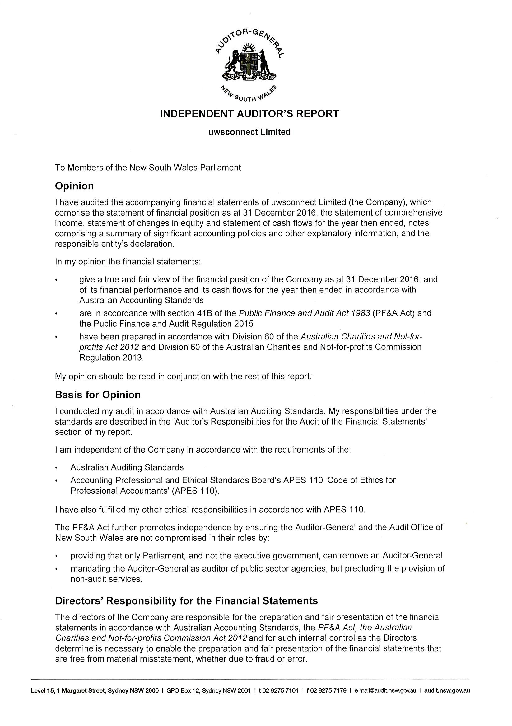

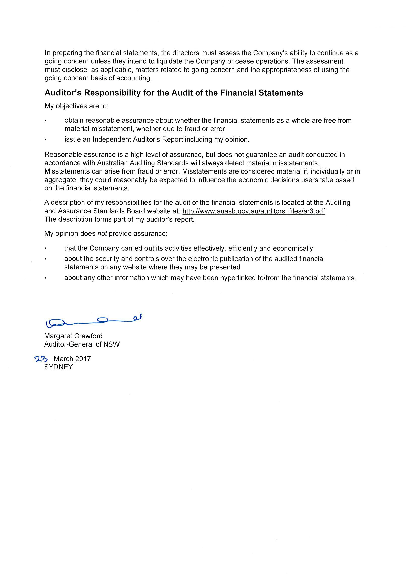

UWS Early Learning Limited
ABN 39155993445

Financial Statements
For the Year Ended 31 December 2016

These financial statements are the individual entity statements of UWS Early Learning Limited (the Company).

The Company is a company limited by guarantee, incorporated and domiciled in Australia. The financial statements are presented in Australian currency.

Its registered office is:

UWS Early Learning Limited

WSU Company Secretary, Entities, Finance Office Building M16 College Drive
Richmond NSW 2753 The principal place of business is:
Western Sydney University Building P18 College Drive Richmond NSW 2753

The financial statements were authorised for issue by the Directors on 6 March 2017. The Directors have the power to amend and reissue the financial statements.

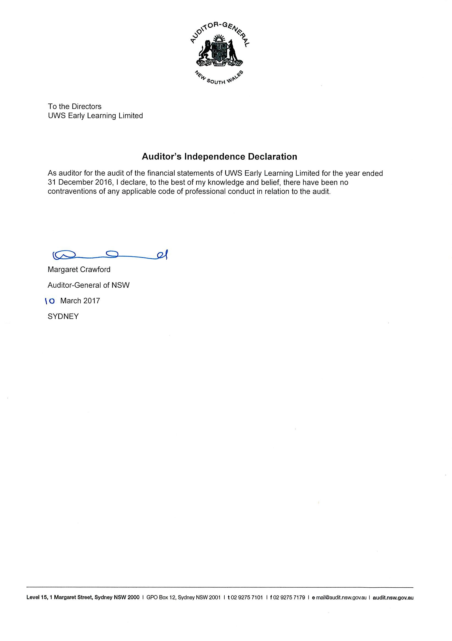

Statement of Comprehensive Income
For the year ended 31 December 2016
 |  | 2016 | 2015
 | Notes | $ | $
Revenue  Child Care Services | 2 | 6,397,816 | 6,010,368
Interest |  | 37,479 | 32,537
Other Revenue | 2 | 123,284 | 162,741
Total Revenue |  | 6,558,579 | 6,205,646
Expenses  Employee Benefits Expense | 3 | (5,551,480) | (5,333,351)
Provision for Doubtful Debts |  | (4,141) | (14,818)
Other Expenses | 3 | (770,037) | (640,823)
Total Expenses |  | (6,325,658) | (5,988,992)
Surplus (Deficit) for the year |  | 232,921 | 216,654

Other Comprehensive Income for the year - -
Total Comprehensive Income for the year 232,921 216,654

Statement of Financial Position
For the year ended 31 December 2016
 |  | 2016 | 2015
 | Note | $ | $
ASSETS
Current Assets  Cash and Cash Equivalents | 4 | 647,363 | 555,260
Receivables | 5 | 120,843 | 84,918
Prepayment |  | - | 11,562
Total Current Assets |  | 768,206 | 651,740
Non-Current Assets  Loan Receivable | 5 | 1,576,133 | 1,187,436
Total Non-Current Assets 1,576,133 1,187,436
Total Assets |  | 2,344,339 | 1,839,176
LIABILITIES
Current Liabilities  Trade and Other Payables | 6 | 574,994 | 472,567
Deferred Income |  | 129,031 | 61,136
Provisions | 7 | 504,415 | 429,810
Total Current Liabilities |  | 1,208,440 | 963,513
Non-Current Liabilities  Provisions | 7 | 81,844 | 54,529
Total Non-Current Liabilities |  | 81,844 | 54,529
Total Liabilities |  | 1,290,284 | 1,018,042
Net Assets |  | 1,054,055 | 821,134
EQUITY  Retained Earnings | 8 | 1,054,055 | 821,134
Total Equity |  | 1,054,055 | 821,134

 | Retained earnings | Total equity
 | $ | $
Balance at 1 January 2016 | 821,134 | 821,134
Comprehensive income for the year  Surplus for the year | 232,921 | 232,921
Other comprehensive income for the year | - | -
Total comprehensive income for the year | 232,921 | 232,921
Balance at 31 December 2016 | 1,054,055 | 1,054,055

 | Retained earnings | Total equity
 | $ | $
Balance at 1 January 2015 | 604,480 | 604,480
Comprehensive income for the year  Surplus for the year | 216,654 | 216,654
Other comprehensive income for the year | - | -
Total comprehensive income for the year | 216,654 | 216,654
Balance at 31 December 2015 | 821,134 | 821,134

 | Note | 2016  $ | 2015  $
CASH FLOWS FROM OPERATING ACTIVITIES  Receipts from fees |  | 3,287,955 | 2,998,772
Payments to suppliers and employees |  | (6,126,092) | (5,809,200)
Receipts from Australian Government child care benefits |  | 2,814,217 | 2,676,518
Subsidies received |  | 467,240 | 564,496
Interest received |  | 37,479 | 32,537
Net cash inflow/(outflow) from operating activities | 14 | 480,799 | 463,123
CASH FLOWS FROM INVESTING ACTIVITIES  Loans to related parties |  | (388,696) | (212,538)
Net cash (outflow) from investing activities |  | (388,696) | (212,538)
CASH FLOWS FROM FINANCING ACTIVITIES
Net cash provided by / (used in) financing activities - -
Net increase / (decrease) in cash and cash equivalents held |  | 92,103 | 250,585
Cash and cash equivalents at the beginning of the year |  | 555,260 | 304,675

Cash and cash equivalents at the end of the year 4 647,363 555,260

1 Summary of significant accounting policies

UWS Early Learning Limited (the Company) is a not-for-profit company limited by guarantee incorporated on 2nd March 2012 and domiciled in Australia.

The principal accounting policies adopted in the preparation of these financial statements are set out below. These policies have been consistently applied to all years reported, unless otherwise stated.

The financial statements for the year ended 31 December 2016 are authorised for issue in accordance with a resolution of the Board of Directors on 6 March 2017.

Basis of preparation

The financial statements are general purpose financial statements that have been prepared in accordance with Australian Accounting Standards, Australian Accounting Interpretations and other authoritative pronouncements of the Australian Accounting Standards Board.

Material accounting policies adopted in the preparation of these financial statements are presented below and have been consistently applied unless otherwise stated.

The financial statements have been prepared on an accruals basis and are based on historical costs modified, where applicable, by the measurement at fair value of selected non-current assets, financial assets and financial liabilities.

Additionally the statements have been prepared in accordance with the following statutory requirements:

- Public Finance and Audit Act 1983 and Public Finance and Audit Regulations 2015

The Company is a not-for-profit entity and these statements have been prepared on a going concern basis. The preparation of financial statements requires the use of certain critical accounting estimates. It also requires management to exercise its judgement in the process of applying the Company's accounting policies. Estimates and judgements are continually evaluated and are based on historical experience and other factors, including expectations of future events that may have a financial impact on the Company and that are believed to be reasonable under the circumstances.

There are no areas which involve a high degree of judgement or complexity, or areas where assumptions and estimates are significant to the financial statements of the Company.

Functional and presentation currency

The financial statements are presented in Australian dollars.

Revenue recognition

The Company recognises revenue when the amount of revenue can be reliably measured, it is probable that future economic benefits will flow to the Company and specific criteria have been met for each of the Company's activities as discussed below. The Company bases its estimates on historical results, taking into consideration the type of customer, the type of transaction and the specifics of each arrangement.

- Revenue recognition continued

Revenue is recognised for the major business activities as follows:

  - Child care services

Revenue from child care services is recognised when services have been provided to the customer, the customer has accepted the services and collectability of the related receivables is probable.

  - Government grants

UWS Early Learning Limited treats operating grants received from Australian Government entities as income in the year of receipt.

Grants from the government are recognised at their fair value where UWS Early Learning Limited obtains control of the right to receive the grant, it is probable that economic benefits will flow to UWS Early Learning Limited and it can be reliably measured.

  - Investment income

Interest income is recognised using the effective interest method.

Income tax exemption

The Company is exempt from the payment of tax by virtue of section 50-B of the Income Tax Assessment Act 1997. Accordingly, no provision for income tax liability or future income tax benefit has been included in the financial statements.

Cash and cash equivalents

Cash and cash equivalents includes cash at bank and on hand.

Trade receivables

Trade receivables are recognised initially at fair value and subsequently measured at amortised cost using the effective interest method, less provision for impairment. Trade receivables are due for settlement no more than 30 days for debtors. They are presented as current assets unless collection is not expected for more than 12 months after reporting date.

Collectability of trade receivables is reviewed on an ongoing basis. Debts which are known to be uncollectable are written off. A provision for impairment of receivables is established when there is objective evidence that the Company will not be able to collect all amounts due according to the original terms of receivables. Significant financial difficulties of debtor, probability that the debtor will enter bankruptcy or financial reorganisation, and default or delinquency in payments (more than 30 days overdue) are considered indicators that the trade receivable is impaired. The amount of the impairment allowance is the difference between the asset's carrying amount and the present value of estimated future cash flows, discounted at the effective interest rate. Cash flows relating to short-term receivables are not discounted if the effect of discounting is immaterial. The amount of movement in the impairment allowance is recognised in the statement of comprehensive income.

Financial assets

The UWS Early Learning Limited did not hold financial assets at fair value through profit or loss either in the current or comparative financial years.

  - Loans and receivables

Loans and receivables are non-derivative financial assets with fixed or determinable payments that are not quoted in an active market. They are included in current assets, except for those with maturities greater than 12 months after the statement of financial position date which are classified as non-current assets. Loans and receivables are included in receivables in the statement of financial position.

Loans and receivables are carried at amortised cost using the effective interest method.

  - Assets carried at amortised cost.

For loans and receivables, the amount of the loss is measured as the difference between the assets carrying amount and the present value of estimated future cash flows (excluding future credit losses that have not been incurred) discounted at the financial assets original effective interest rate. The carrying amount of the asset is reduced and the amount of the loss is recognised in the statement of comprehensive income. The loan has a variable interest rate, the discount rate for measuring any impairment loss is the current effective interest rate determined under the contract. As a practical expedient, the Company may measure impairment on the basis of an instruments fair value using an observable market price.

If, in a subsequent period, the amount of the impairment loss decreases and the decrease can be related objectively to an event occurring after the impairment was recognised (such as an improvement in the debtor's credit rating), the reversal of the previously recognised impairment loss is recognised in the statement of comprehensive income.

Trade and other payables

These amounts represent liabilities for goods and services provided to the Company prior to the end of the financial period, which are unpaid. The amounts are unsecured and are usually paid within 30 days of recognition.

Employee benefits

Provision is made for the UWS Early Learning Limited's liability for employee benefits arising from services rendered by employees to the end of the reporting period. Employee benefits that are expected to be settled within one year have been measured at the amounts expected to be paid when the liability is settled.

Employee benefits expected to be settled more than twelve months after the end of the reporting period have been measured at the present value of the estimated future cash outflows to be made for those benefits. In determining the liability, consideration is given to employee wage increases and the probability that the employee may satisfy vesting requirements. Cashflows are discounted using market yields on national government bonds with terms to maturity that match the expected timing of cashflows. Changes in the measurement of the liability are recognised in the statement of comprehensive income.

Employee benefits are presented as current liabilities in the statement of financial position if the UWS Early Learning Limited does not have an unconditional right to defer settlement of the liability for at least 12 months after the reporting date regardless of the classification of the liability for measurement purposes under AASB 119.

Goods and Services Tax (GST)

Revenues, expenses and assets are recognised net of the amount of associated GST, unless the GST incurred is not recoverable from the taxation authority. In this case, it is recognised as part of the cost of acquisition of the asset or as part of the expense.

Receivables and payables are stated inclusive of the amount of GST receivable or payable. The net amount of GST recoverable from, or payable to, the taxation authority is included with other receivables or payables in the statement of financial position.

Cash flows are presented on a gross basis. The GST components of cash flows arising from investing or financing activities which are recoverable from, or payable to, the taxation authority, are presented as operating cash flows.

New and Revised Accounting Standards

Certain new accounting standards and Interpretations have been published that are not mandatory for 31 December 2016 reporting periods and have not yet been applied to the financial statements. The Company's assessment of the impact of these new standards and interpretations is that they will not materially affect any of the amounts recognised in the financial statements or significantly impact the disclosures in relation to the Company.

2 | Revenue | 2016 | 2015
 |  | $ | $
 | Child care services  Family fee income | 3,178,328 | 2,890,223
 | Australian Government Childcare Benefits | 2,705,330 | 2,532,803
 | Subsidies | 514,158 | 587,342
 | Total child care services | 6,397,816 | 6,010,368
 | Other revenue  Australian Government Traineeship Funding | 13,864 | 37,100
 | Long Day Care Development Grants | 98,318 | 113,546
 | Other Income | 11,102 | 12,095
 | Total other revenue | 123,284 | 162,741
3 | Expenses
 | The result for the year includes the following specific expenses:
 |  | 2016 | 2015
 |  | $ | $
 | Employee benefits expense
 | Salaries and Wages | 4,954,641 | 4,777,730
 | Superannuation Expense | 407,725 | 414,596
 | Annual and Long Service Leave | 101,920 | 72,745
 | Worker's Compensation | 77,460 | 64,928
 | Other | 9,734 | 3,352
 | Total employee benefit expense | 5,551,480 | 5,333,351
 | Other expenses
 | Catering | 153,679 | 169,814
 | Cleaning | 151,442 | 157,131
 | Legal Expenses | 7,870 | 7,172
 | Non-capitalised Equipment | 115,299 | 59,290
 | Centre resources and supplies | 81,616 | 66,902
 | Repairs and Maintenance | 5,939 | 4,286
 | Staff Development | 118,613 | 53,470
 | Printing | 27,690 | 22,781
 | Sundry expenses | 107,889 | 99,977
 | Total other expenses | 770,037 | 640,823

Cash and cash equivalents

Note

2016
$

2015
$

Cash at bank 14 647,363 555,260
The Company's exposure to interest rate risk is discussed in note 15. The maximum exposure to credit risk at the end of each reporting period is the carrying amount of each class of cash and cash equivalents mentioned above. Cash at bank is interest bearing.

5 | Trade and other receivables | 2016 | 2015
 |  | $ | $
 | CURRENT  Trade receivables | 23,107 | 47,024
 | Receivable from Parent | 65,682 | 30,071
 | less: Provision for impairment | (5,874) | (16,818)
 |  | 82,915 | 60,277
 | GST receivable | 37,928 | 24,641
 | Total current receivables | 120,843 | 84,918
 | NON-CURRENT  Loan to Parent Entity | 1,576,133 | 1,187,436
 | Total non-current receivable | 1,576,133 | 1,187,436
 | Total trade and other receivables | 1,696,976 | 1,272,354

  - Trade and other receivables

As at 31 December 2016, trade receivable of $23,107 (2015: $47,024) and receivable from parent entity of $65,682 (2015: $30,071).

The ageing of total current receivables (excluding GST receivable) is as follows: | 2016 | 2015
 | $ | $
Up to 3 months | 86,512 | 60,277
3 to 6 months | 1,931 | 12,268
Over 6 months | 346 | 4,550
 | 88,789 | 77,095

Trade and other receivables continued
(b) Credit risk

The Company has no significant concentration of credit risk with respect to any single counter party or group or counterparties. The class of assets described as "trade and other receivables" is considered to be the main source of credit risk related to the Company.

The amounts within receivables do not contain impaired assets and are not significantly overdue. Based on credit history, it is expected that these amounts will be received in a timely manner and do not represent any material risk.

6 | Trade and other payables | 2016 | 2015
 |  | $ | $
 | CURRENT  Trade and other payables | 120,796 | 29,642
 | Enrolment Deposits | 233,877 | 224,326
 | Accrued Expenses | 35,226 | 30,952
 | Other payables | 185,095 | 187,647
 | Total trade and other payables | 574,994 | 472,567

7 Provisions

CURRENT
Employee benefits

2016
$

2015
$

Annual Leave | 313,966 | 287,131
Long Service Leave | 190,449 | 142,679
Total current provisions 504,415 429,810

NON-CURRENT
Employee benefits
Long Service Leave 81,844 54,529

Total non-current provisions 81,844 54,529

Total provisions 586,259 484,339

8 | Retained earnings  Movements in Retained Earnings
 |  | 2016 | 2015
 |  | $ | $
 | Retained Earnings at 1 January | 821,134 | 604,480
 | Surplus/(Deficit) for the year | 232,921 | 216,654
 | Balance at 31 December | 1,054,055 | 821,134

Key management personnel disclosures

  - Responsible persons and executive officers

The following persons were responsible persons and executive officers of UWS Early Learning Limited during the financial period.

Responsible Persons and Executive Officers: Mrs Angie Atkinson - General Manager
All responsible persons and executive officers are employees of UWS Early Learning Ltd and are remunerated directly by the entity.

Board of Directors

The following persons were Non-Executive Directors of UWS Early Learning Ltd during the financial period: Ms Susan Hudson - Chair
Mrs Susan Benzie Mrs Ellen Brackenreg Mrs Denise Fraser Mr Darren Greentree
Professor Michele Simons (appointed 10 October 2016) No Board Member is remunerated for their services.

Remuneration of auditors
During the period, the following fees were paid for services provided by the auditor of UWS Early Learning Limited:

2016
$
2015
$

Audit and review of the financial statements 29,600 24,000

Total fees paid to auditors 29,600 24,000

- Contingencies

The Company had no contingent liabilities at 31 December 2016.

Commitments

The Company had no commitments at 31 December 2016.

Related Parties

  - Entities exercising control over the Company

The ultimate parent entity of the Company is Western Sydney University.

(b) Transactions with related parties
The following transactions occurred with related parties:
 | 2016 | 2015
 | $ | $
Subsidies  Parent entity | 514,158 | 587,342
Total subsidies received | 514,158 | 587,342

Related Party Receivables
2016
$
2015
$

Parent entity subsidies | 65,682 | 30,071
Loan to Parent Entity | 1,576,133 | 1,187,436
Total related party receivables 1,641,815 1,217,507

14 | Reconciliation of operating surplus/(deficit) to net cash inflow/(outflow) from operating activities  2016 | 2015
 | $  Surplus/(Deficit) for the year 232,921 | $  216,654
 | Change in operating assets and liabilities:
(Increase) / decrease in trade debtors (35,926) 58,799
(increase)/decrease in prepayments 11,562 24,328
Increase/(decrease) in income in advance 67,895 (3,635)
Increase / (decrease) in trade creditors 91,154 12,646
Increase / (decrease) in other operating liabilities 11,273 82,997
Increase / (decrease) in other provisions 101,920 71,334

Net cash inflow/(outflow) from operating activities 480,799 463,123

- Financial risk management

The Company's activities expose it to a variety of financial risks: market risk (including fair value interest rate risk), credit risk and liquidity risk. The Company's overall risk management program focuses on the unpredictability of financial markets and seeks to minimise potential adverse effects on the financial performance of the Company. The Company uses different methods to measure different types of risk to which it is exposed. These methods include sensitivity analysis in the case of interest rate and aging analysis for credit risk to determine market risk.
The Company holds the following financial instruments:
Note: Excludes GST receivable, prepayment, deferred income, income in advance and provision payable (not within scope of AASB 7).
 | 2016  $ | 2015  $
Financial Assets  Cash and Cash Equivalents | 647,363 | 555,260
Trade Receivables | 82,915 | 60,277
Loan to Parent Entity | 1,576,133 | 1,187,436
Total financial assets | 2,306,411 | 1,802,973
Financial Liabilities  Trade and other payables | 305,891 | 217,289
Total financial liabilities | 305,891 | 217,289

  - Market risk

- Cash flow and fair value interest rate risk

The Company's exposure to interest rate risk is minimal as it has no borrowings.

- Sensitivity analysis

The following table summarises the sensitivity of the Company's financial assets to interest rate risk.

31 December 2016 Interest rate risk
-1% +1%

Carrying amount
$

Result
$

Equity
$

Result
$

Equity
$

Financial assets  Cash and Cash Equivalents | 647,363 | (6,474) | (6,474) | 6,474 | 6,474
Loan Receivable - Parent Entity | 1,576,133 | (15,761) | (15,761) | 15,761 | 15,761

Total increase/(decrease) (22,235) (22,235) 22,235 22,235

31 December 2015 Interest rate risk
-1% +1%

Financial assets
Carrying amount
$

Result
$

Equity
$

Result
$

Equity
$

Cash and Cash Equivalents | 555,260 | (5,553) | (5,553) | 5,553 | 5,553
Loan Receivable - Parent Entity | 1,187,436 | (11,874) | (11,874) | 11,874 | 11,874

Total increase/(decrease) (17,427) (17,427) 17,427 17,427

None of the Company's financial liabilities are subject to interest rate risk.

Credit risk

The credit risk on financial assets of the Company which have been recognised on the statement of financial position is generally the carrying amount, net of provision for loss. Credit risk arises when there is the possibility of the Company's debtors defaulting on their contractual obligations, resulting in financial loss to the Company. The Company does not have any significant exposure to any unrelated customer.

Liquidity risk

Liquidity risk arises from the possibility that the Company might encounter difficulty in settling its debts or otherwise meeting its obligations related to financial liabilities. The Company manages this risk through the following mechanisms:

- preparing forward-looking cash flow analysis in relation to its operational, investing and financial activities which are monitored on a monthly basis;
- obtaining funding from a variety of sources;
- maintaining a reputable credit profile;
- managing credit risk related to financial assets;
- only investing surplus cash with major financial institutions; and
- comparing the maturity profile of financial liabilities with the realisation profile of financial assets.

Typically, the Company ensures that it has sufficient cash on hand to meet expected operational expenses for a period of 30 days. Therefore the liquidity risk is considered to be minimal.

The following tables summarise the maturity of the UWS Early Learning Limited’s financial assets and financial liabilities:

Average
Interest rate Less than 1 year 1 to 5 years 5+ years Total
 | 2016  % | 2015  % | 2016  $ | 2015  $ | 2016  $ | 2015  $ | 2016  $ | 2015 2016  $ $ | 2015  $
Financial Assets:
Receivables | 2.9% | 2.9% | 82,915 | 60,277 | 1,576,133 | 1,187,436 |  | - - 1,659,048 | 1,247,713
Total Financial Assets |  |  | 82,915 | 60,277 | 1,576,133 | 1,187,436 |  | - - 1,659,048 | 1,247,713
Financial Liabilities:
Payables |  |  | 305,891 | 217,289 | - | - |  | - - 305,891 | 217,289
Total Financial Liabilities |  |  | 305,891 | 217,289 | - | - |  | - - 305,891 | 217,289

  - Fair value estimation
The fair value of financial assets and financial liabilities must be estimated for recognition and measurement or for disclosure purposes.
Due to the Company's financial instruments short-term nature, the carrying value of all financial instruments recognised in the statement of financial position approximates their fair value.

Economic dependency

The Company is economically dependent on Western Sydney University for the provision of accommodation for each centre and operational support activities.

Events occurring after the reporting date

No matters or circumstances have arisen since the end of the financial period which significantly affected or may significantly affect the operations of the Company, the results of those operations, or the state of affairs of the Company in future financial years.

Statement by Directors

The directors of the UWS Early Learning Limited declare that:

- Under s41C (1b) of the Public Finance & Audit Act 1983 we state to the best of our knowledge and belief the financial statements and notes, as set out on pages 171 to 187:

  - comply with Australian Accounting Standards, the Public Finance and Audit Act 1983, the Public Finance and Audit Regulation 2015 and the mandatory professional reporting requirements, and

  - give a true and fair view of the financial position as at 31 December 2016 and of the performance for the year ended on that date of the UWS Early Learning Limited.

- In the directors' opinion, there are reasonable grounds to believe that the UWS Early Learning Limited will be able to pay its debts as and when they become due and payable.

- We are not aware of any circumstances which would render any particulars included in the financial statements to be misleading or inaccurate.

This declaration is made in accordance with a resolution of the Board of Directors.

Director ................................................................................................................................................

Director ................................................................................................................................................

Dated this ..................................... day of .................................... 2017

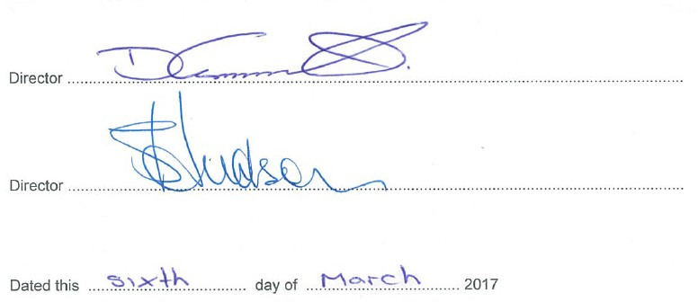

Responsible entities declaration per section 60.15 of Australian Charities and Not-for-profits Commission Regulation 2013

The responsible entity declares that in the responsible entity's opinion:

- there are reasonable grounds to believe that the registered entity is able to pay all of its debts, as and when they become due and payable; and

- the financial statements and notes satisfy the requirements of Australian Charities and Not-for-profit Commission Act 2012.

Signed in accordance with subsection 60.15(2) of the Australian Charities and not-for-profits Commission Regulation 2013.

.............................................................

Darren Greentree Director
6 March 2017

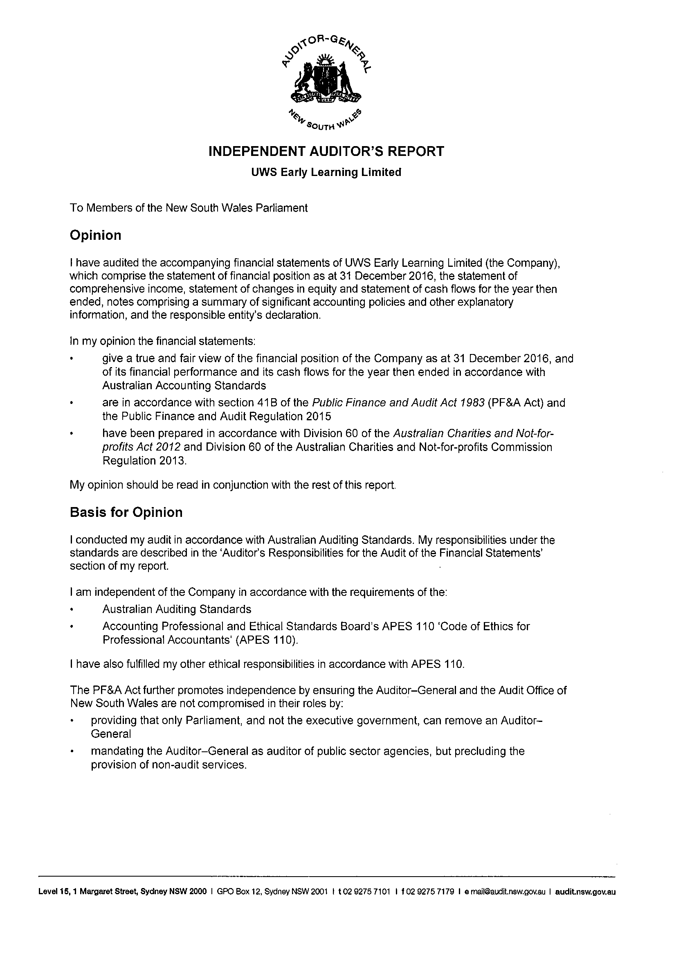

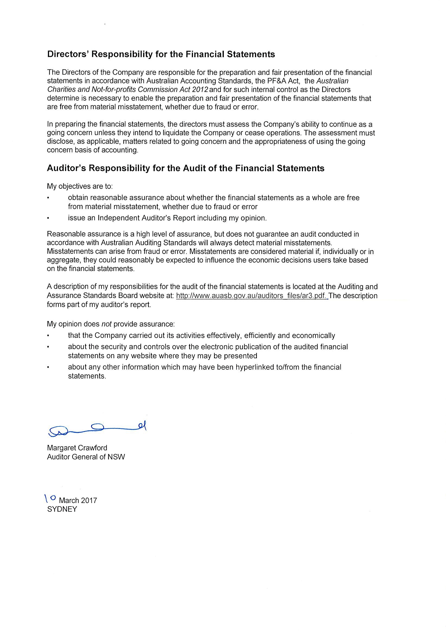

This page is intentionally blank

Whitlam Institute within Western Sydney University Limited
ABN: 50 100 342 309

Financial statements
For the year ended 31 December 2016

These financial statements of the Whitlam Institute within Western Sydney University Limited (the Company) are presented as an individual entity. The financial statements are presented in Australian currency.

The registered office and principal place of business of the Company is: Whitlam Institute within Western Sydney University Limited
Western Sydney University Building EZ, Parramatta Campus Cnr James Ruse Dr & Victoria Rd Rydalmere NSW 2116

Registered postal address is:
Whitlam Institute within Western Sydney University Limited Locked Bag 1797
Penrith NSW 2751

A description of the nature of the Company's operations and it principal activities is included in the director's report which is not part of these financial statements.

These financial statements were authorised for issue by the directors on 17 February 2017. The directors have the power to amend and reissue the financial statements.

Director's report

For the year ended 31 December 2016
Your directors present their report on the Company for the financial year ended 31 December 2016.

Directors
The names of each person who has been a director during the year and to the date of this report are: The Hon. John Faulkner
Ms Patricia Amphlett OAM Prof. Barney Glover
Ms Gabrielle Trainor Mr John Wells
Mr Talal Yassine OAM Ms Catherine Dovey
Mr Cameron Clyne Appointed 6 September 2016
Mr Geoffrey Roberson Resigned 25 November 2016
Dr Kerry Schott AO Resigned 20 May 2016

Directors have been in office since the start of the financial year to the date of this report unless otherwise stated.

Company secretary
Ms Sandra Stevenson held the position of Company Secretary for the whole of the financial year and to the date of this report.

Principal activities
The principal activity of the Company is to manage the Company and to act as Trustee of the Trust. The main function of the Company is fundraising in support of the University, and the effective management control of all Trust funds held within the Whitlam Institute Trust account.
The Whitlam Institute works as an educator, policy influencer and research institute. The Institute bridges the historical legacy of the late Gough Whitlam's years in public life and the contemporary relevance of the Whitlam Program to public discourse and policy. It links policies with people - connecting communities with the decisions and policies that affect their lives. The Whitlam Institute is guided by the 'three great aims' that drove the Whitlam Program of 1972. They are to promote equality, to involve the people of Australia in the decision-making processes of our land, and to liberate the talents and uplift the horizons of the Australian people.
The Whitlam Institute supports Western Sydney University development by working with schools to bring knowledge to life in the community. In a range of practical ways we make scholarship relevant to everyday lives. We are inspired by the E.G Whitlam Prime Ministerial Collection which represents the life's work of an Australian statesmen who has pursued his convictions with a constant commitment to community engagement and a determination to put words into action.
No significant changes in the nature of the Company's activity occurred during the financial year.

Review of operations
The surplus of the Company amounted to $ NIL (2015: $ NIL).

Dividends
No dividend is paid or payable since the commencement of the financial year and up to and including the date of signing this report (2015: $nil).

Events after the reporting date
No matters or circumstances have arisen since the end of the financial year which significantly affected or could significantly affect the operations of the Company, the results of those operations or the state of affairs of the Company in future financial years.

Future developments
Future developments are not expected to significantly affect the future operations of the Company.

Environmental matters
The Company's operations are not regulated by any significant environmental regulations under a law of the Commonwealth or of a state or territory.

Director's report

For the year ended 31 December 2016

Auditors independence declaration
The Audit Office of New South Wales continues in office in accordance with section 327 of the Corporations Act 2001.
The lead auditors independence declaration for the year e nded 31 December 2016 h as been received and can be found on page 200 of the financial statements.

Information on directors

The Hon. John Faulkner BA, DipEd (Macquarie). Chair.
Experience Appointed as Director 8 March 2011. Senator the Hon. John Faulkner was a Labor Senator for New South Wales from 1989 to 2015. Since his election to the Senate in 1989, Senator Faulkner has held a number of ministries, serving as Minister for Veterans' Affairs, Minister for Defence Science and Personnel, Minister for the Environment, Sport and Territories, Cabinet Secretary, Special Minister of State and Minister for Defence. He served as Leader of the Opposition in the Senate from 1996 to 2004. He has also held a range of senior positions within the Australian Labor Party, including National President of the party, twenty years as a member of its National Executive and nine years as Assistant General Secretary of the New South Wales Branch. Senator Faulkner is well versed in, and passionate about the history of the Australian Labor Party. Prior to his political career, Senator Faulkner worked as a teacher of children with severe disabilities.
Ms Patricia Amphlett OAM Non-Executive.
Experience Appointed as Director 29 June 2010. Ms Patricia Amphlett OAM is the Federal President of the Media, Entertainment and Arts Alliance, a position she has held since 2002. With a succession of hits and as a long standing member of the Bandstand Family, she established herself as a prominent force in the Australian music industry. Her musical talents are credited with many industry awards including Best Female Singer, Most Popular Female Performer, TV Logie for Best Teenage Personality and a succession of Gold Records. A definite 'all rounder' in the music and entertainment industry, Ms Amphlett’s talent spans a broad spectrum from writing, producing and performing shows for children, and hosting charity and corporate events. She maintains a high profile in the music industry, with many live performances at Festivals, Corporate Events, Clubs and Television shows. Ms Amphlett has a strong commitment to music education. She is a consultant for the NSW Government’s Talent Development Project. She is a member of the Board of the National Film & Sound Archives.

Director's report

For the year ended 31 December 2016

Information on directors (continued)
Prof. Barney Glover PhD (Applied Mathematics), MSc, BSc (Honours), Dip Ed (Melbourne),
MAICD. Non-Executive.
Experience Appointed as Director 1 Jan 2014. Professor Barney Glover has been the Vice-Chancellor and President of the Western Sydney University since he commenced in this role on 1 January 2014. Professor Glover is an accomplished academic leader and experienced Vice-Chancellor. Previously Vice-Chancellor at Charles Darwin University from 2009 to 2013, he has a long record of success in university management and leadership, particularly in research, intellectual property management and major capital development projects.Before relocating to the Northern Territory in 2009 Professor Glover was the Deputy Vice-Chancellor, Research at the University of Newcastle.
Prior to this, he held several positions at Perth's Curtin University of Technology including Pro Vice-Chancellor, Research and Development. He has a strong research publication record and has co-authored four texts in mathematics education. Before his appointment at Curtin Professor Glover held a number of positions at the University of Ballarat in Victoria. Professor Glover holds a PhD in Applied Mathematics and has worked on both the east and west coasts of Australia.
Ms Gabrielle Trainor LLB (Melb). Non-Executive.
Experience Appointed as Director 29 June 2010. Ms Gabrielle Trainor is a non-executive director and advisor. Her chair and director roles have spanned organisations in urban development, transport, education, public interest law, tourism, culture and sport. She was a founding partner and co-owner of specialist consultancy John Connolly & Partners and over 25 years advised large listed companies on the management of major transactions and significant issues across stakeholder groups including in capital markets, government, NGO’s and other influencers. Ms Trainor is a member of the board of Leighton Contractors (advisory board), a director of the Barangaroo Delivery Authority, Business Events Sydney, Cape York Group, the Aurora Education Foundation and is a trustee of the Charlie Perkins Education Trust. She is a member of the board of trustees of the Western Sydney University. She is Chair of the National Film and Sound Archive and Chair of Barnardo’s Australia. She co- chaired the 2012 Federal Government review of the Australia Council for the Arts. She has had a long term involvement in indigenous affairs, including as director of Cape York Partnerships and a member of the Victorian Government’s Aboriginal Economic Development Group which reported in 2010. Ms Trainor was educated as Ll.B at the University of Melbourne and was awarded a 1986 Churchill Fellowship. She studied in the USA and UK, including as a visiting scholar at Stanford University. She is an Honorary Associate in the Graduate School of Government at Sydney University and a Fellow of the Australian Institute of Company Directors.
Mr John Wells Non-Executive.
Experience Appointed as Director 15 June 2005. Mr John Wells is Chairman of Wells Haslem Pty Ltd. His career has embraced journalism at the most senior levels in Australia and overseas, senior media involvement in newspapers, television and radio, policy advice to Federal political leaders and public affairs consulting. His major interests are in government and media and the operational elements of strategic communication campaigns. He works for all of Wells Haslem’s major clients in these and many other roles.

Director's report

For the year ended 31 December 2016

Information on directors (continued)
Mr Talal Yassine OAM BA Lib (Macquarie), Master of Laws (Sydney), MBA (Deakin). Non-Executive.
Experience Appointed as Director 8 October 2010. Mr Talal Yassine OAM is an experienced lawyer, banker and Non-Executive Director. After 10 years at PricewaterhouseCoopers as a Director and strategist, he joined investment firm Babcock & Brown Ltd in the Corporate Finance Group and later in the Technical Real Estate Division. Later he held leadership positions in Better Place Australia and is currently the Managing Director of Crescent Wealth. Mr Yassine currently serves on the Board of Australia Post, Sydney Ports, the Whitlam Institute, The Australian Multicultural Council and as Deputy Chairman of the Gulf Australia Business Council. He has also served on the Board of Macquarie University; and as the Deputy Chairman of a government regulator, and as Chairman as Platinum Sound Pty Ltd. Mr Yassine holds a Master of Laws, a Master of Business Administration which was focused on international business strategy, as well as holding degrees in law and diplomas from the AICD and UNE in directorship. In November 2012, he was appointed as a Professorial Fellow at the Crawford School of Public Policy, at the Australian National University. On Australia Day 2010, he was awarded a Medal of the Order of Australia (OAM) for his service to business and to the community through a range of education.
Ms Catherine Dovey BA (UNSW), Dip Ed (Sydney Teacher College). Non-Executive.
Experience Catherine Dovey worked in the New South Wales public service in public policy formulation and administration. Her roles include an early period as a probation and parole officer with the NSW Corrections system and later as a member of the parole Board of NSW. In the interim she served in a variety of positions at Sydney Water. Catherine graduated from the University of New South Wales as a Bachelor of Arts and with a Diploma of Education from the then Sydney Teachers’ College. Catherine has always reflected a spirited engagement with community and education issues which included serving a decade as a Board member of the International Grammar School.
Mr Cameron Clyne BA (Sydney). Non-Executive.
Experience Cameron Clyne is currently Chairman of Camel Partners, a private advisory firm and the Camel Foundation. He is Chairman of the Australian Rugby Union; a director of SANZAAR Pty Ltd; the Western Sydney University Foundation; Camp Quality; a Patron of the Western Sydney Leadership Dialogue, and an Adjunct Professor at the WSU Business School. Cameron was Group Chief Executive Officer of National Australia Bank (NAB) from January 2009 until August 2014. He was also Chairman of Clydesdale Bank in the United Kingdom and a Director of the Bank of New Zealand. Prior to NAB Cameron was a Partner at PriceWaterhouseCoopers (PwC). He worked in their Sydney, Melbourne, San Francisco and New York offices. In 2008 he was named a Young Global Leader by the World Economic Forum.
Mr Geoffrey Roberson HonDLitt (WSU). Non-Executive.
Experience Serving as Director from 26 April 2002 until 25 November 2016. Mr Geoffrey Roberson is a solicitor, an Accredited Specialist in Commercial Litigation and he is a former President of the Law Society of New South Wales and former Deputy Chancellor of Western Sydney University. Currently the Chairman of Champion Legal Pty Limited, a Sydney-based law firm he also chairs and serves on a number of company Boards.

Director's report

For the year ended 31 December 2016

Information on directors (continued)
Dr Kerry Schott AO BA (Hons) (UNE), MA (British Columbia), DPhil (Oxon). Non-Executive. Experience Serving as Director from 11 September 2009 until 20 May 2016. Dr Kerry
Schott AO is Chairman of the Moorebank Intermodal Company Ltd, a Director of NBN Co, a Director of the TCorp Board in NSW, a member of the Infrastructure Australia Board, Patron and Board member of Infrastructure Partnerships Australia and a member of the Whitlam Institute Board. Dr Schott was the Project Director for the NSW Treasury managing the sales of the government owned electricity generating plants. She was previously the Project Director of the successful sale and lease of the Sydney desalination plant. She completed her role as CEO of the Commission of Audit for the NSW Government early in 2012. Previously she was Managing Director and CEO of Sydney Water from 2006 to 2011. Dr Schott spent 15 years as an investment banker, including as Managing Director of Deutsche Bank and Executive Vice President of Bankers Trust Australia. During this time she specialised in privatisation, restructuring, and infrastructure provision. Dr Schott holds a doctorate from Oxford University (Nuffield College), a Master of Arts from the University of British Columbia, Vancouver and a Bachelor of Arts (first class Honours) from the University of New England.

Director's report

For the year ended 31 December 2016

Meetings of directors
During the financial year, 4 meetings of directors (including committees of directors) were held. Attendances by each director during the year were as follows:

 | Directors' Meetings
 | Number eligible to attend | Number attended
The Hon. John Faulkner | 4 | 4
Ms Patricia Amphlett OAM | 4 | 3
Prof. Barney Glover | 4 | 4
Ms Gabrielle Trainor | 4 | 4
Mr John Wells | 4 | 3
Mr Talal Yassine OAM | 4 | 3
Ms Catherine Dovey | 4 | 4
Mr Cameron Clyne | 1 | 1
Mr Geoffrey Roberson | 4 | 3
Dr Kerry Schott AO | 2 | 2

Indemnification of Directors and Officers
Whitlam Institute within Western Sydney University Limited is insured externally and in line with the Western Sydney University policies for all significant areas of risk exposure and accordingly, is not a self-insurer and makes no provision in its financial statements for internal coverage.

Proceedings on behalf of company
No person has applied to the Court under section 237 of the Corporations Act 2001 for leave to bring proceedings on behalf of the Company or to intervene in any proceedings to which the Company is a party, for the purpose of taking responsibility on behalf of the Company for all or any part of those proceedings.

Signed in accordance with a resolution of the Board of Directors'.

Director: ......................................................................... Director: ..........................................................................
The Hon. John Faulkner Ms Gabrielle Trainor

Dated 17 February 2017
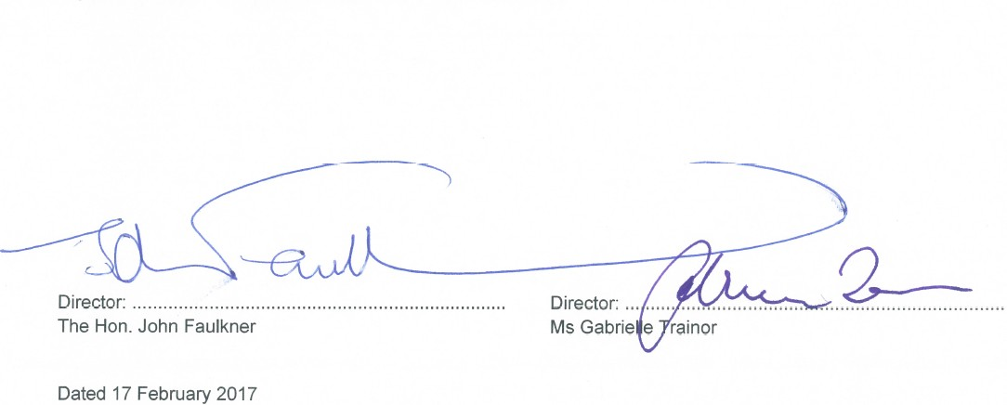

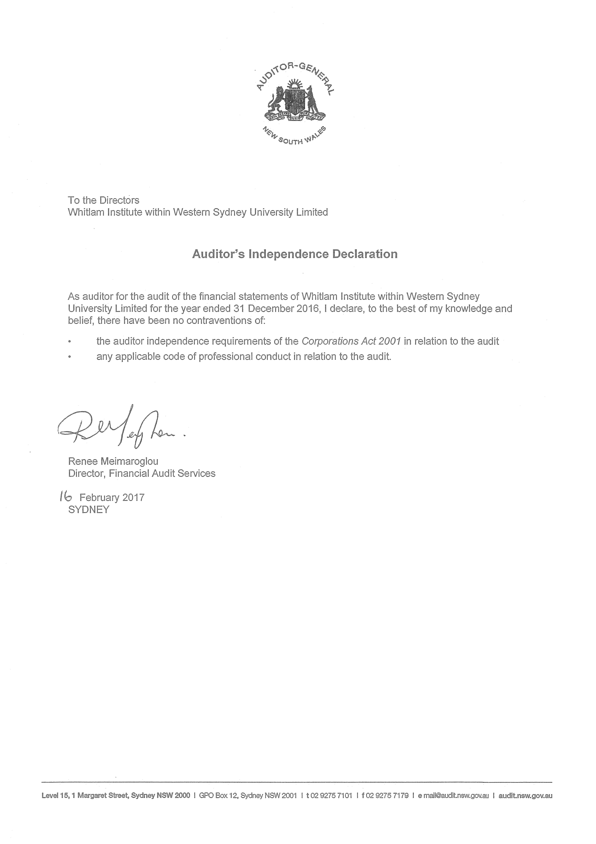

Statement of comprehensive income

For the year ended 31 December 2016

Revenue
2016
$
2015
$

Other revenue - -

Total revenue - -

Total income - -

Expenses
Finance costs - -

Total expenses - -

Surplus/(deficit) for the year - -

Other comprehensive income for the year - -

Total comprehensive income for the year - -

Statement of financial position
As at 31 December 2016
 |  | 2016 2015
 | Note | $ $
ASSETS  Current assets  Cash and cash equivalents | 6 | 1 1
Total current assets |  | 1 1
Total assets |  | 1 1
LIABILITIES  Current liabilities  Trade and other payables |  | - -
Total current liabilities |  | - -
Total liabilities |  | - -
Net assets |  | 1 1
EQUITY  Contributed equity |  | 1 1
Retained earnings  Total equity |  | - -  1 1

Statement of changes in equity
For the year ended 31 December 2016
 | Contributed equity | Retained Earnings | Total equity
 | $ | $ | $
Balance at 1 January 2016 | 1 |  | - 1
Total comprehensive income for the year | - |  | - -
Balance at 31 December 2016 | 1 |  | - 1
 | Contributed equity | Retained Earnings | Total equity
 | $ | $ | $
Balance at 1 January 2015 | 1 |  | - 1
Total comprehensive income for the year | - |  | - -
Balance at 31 December 2015 | 1 |  | - 1

Statement of cash flows
For the year ended 31 December 2016
 |  | 2016 2015
 | Note | $ $
Cash flows from operating activities  Payments to suppliers and employees |  | - -
Net cash inflow/(outflow) from operating activities | 14 | - -
Cash flows from investing activities
Net cash (outflow)/inflow from investing activities |  | - -
Cash flows from financing activities
Net cash inflow/(outflow) from financing activities |  | - -
Net increase/(decrease) in cash and cash equivalents  Cash and cash equivalents at beginning of year |  | - -  1 1
Cash and cash equivalents at end of year | 6 | 1 1

Notes to the financial statements

For the year ended 31 December 2016

1 Summary of Significant Accounting Policies

- Basis of Preparation
These financial statements are general purpose financial statements that have been prepared in accordance with Australian Accounting Standards (including Australian Accounting Interpretations) adopted by the AASB, the Corporations Act 2001, the requirements of the Public Finance & Audit Act 1983, Public Finance and Audit Regulation 2015 and other authoritative pronouncements of the Australian Accounting Standards Board (AASB).
These financial statements of the Company comply with Australian Accounting Standards some of which contain requirements specific to not-for-profit entities that are inconsistent with International Financial Reporting Standards (IFRS) requirements.
Material accounting policies adopted in the preparation of these financial statements are presented below and have been consistently applied unless otherwise stated.
The financial statements have been prepared on an accruals basis and are based on historical costs, modified, where applicable, by the measurement at fair value of selected non-current assets, financial assets and financial liabilities.

Revenue recognition
The Company recognises revenue when the amount of revenue can be reliably measured, it is probable that future economic benefits will flow to the entity and specific criteria have been met for each of the Company's activities. The Company bases its estimates on historical results, taking into consideration the type of customer, the type of transaction and the specifics of each arrangement.

Cash and cash equivalents
Cash and cash equivalents includes cash on hand, deposits held at call with financial institutions, other short term, highly liquid investments with original maturities of three months or less that are readily convertible to known amounts of cash and which are subject to an insignificant risk of changes in value.

Income tax exemption

The Company is exempt from the payment of tax by virtue of section 50 B of the Income Tax Assessment Act 1997.

Foreign currency transactions and balances

The functional currency of the Company is measured using the currency of the primary economic environment which is Australian dollars. The financial statements are presented in Australian dollars which is the ultimate parent entity's functional and presentation currency.

Goods and Services Tax (GST)
Revenues, expenses and assets are recognised net of the amount of associated GST, unless the GST incurred is not recoverable from the Australian Taxation Office. In this case, it is recognised as part of the cost of acquisition of the asset or as part of the expense.
Receivables and payables are stated inclusive of the amount of GST receivable or payable. The net amount of GST recoverable from, or payable to, the Australian Taxation Office is included with other receivables or payables in the statement of financial position.
Cash flows are presented on a gross basis. The GST components of cash flows arising from investing or financing activities which are recoverable from, or payable to the Australian Taxation Office, are presented as operating cash flows.

Notes to the financial statements

For the year ended 31 December 2016

Summary of Significant Accounting Policies (continued)

- Comparative amounts
Comparative figures have been reclassified and repositioned in the financial statements, where necessary, to conform with the basis of preparation and classification used in the current year.

New accounting standards and interpretations
Certain new accounting standards and interpretations have been published that are not mandatory for 31 December 2016 reporting periods and have not yet been applied in the financial statements. The Company's assessment of the impact of these new standards and interpretations is that they will not materially affect any of the amounts recognised in the financial statements or significantly impact the disclosures in relation to the Company.

Critical accounting estimates and judgments
The preparation of financial statements requires the use of certain critical accounting estimates. It also requires Management to exercise its judgement in the process of applying the Company's accounting policies. Estimates and judgements are continually evaluated and are based on historic experience and other factors, including expectations of future events that may have a financial impact on the Company and that are believed to be reasonable under the circumstances.
There are no areas which involve a high degree of judgement or complexity or where assumptions and estimates are significant to the financial statements of the Company.

Financial Risk Management
The main risks the Company is exposed to through its financial instruments are credit risk, liquidity risk and market risk (interest rate risk). The Company's overall risk management program focuses on the unpredictability of financial markets and seeks to minimise potential adverse effects on the financial performance of the Company. The Company uses different methods to measure different types of risk to which it is exposed. These methods include sensitivity analysis in the case of interest rate and ageing analysis for credit risk.
The totals for each category of financial instruments, measured in accordance with AASB 139 as detailed in the accounting policies to these financial statements, are as follows:

Financial Assets
2016
$
2015
$

Cash and cash equivalents 1 1
1 1

Credit risk
The credit risk on financial assets of the Company (which have been recognised in the statement of financial position) is generally the carrying amount, net of provision for loss. Credit risk arises when there is the possibility of the Company's debtors defaulting on their contractual obligations, resulting in financial loss to the Company. The Company does not have any significant exposure to any unrelated debtor.

Liquidity risk
Prudent liquidity risk management implies maintaining sufficient cash and the availability of funding through an adequate amount of committed credit facilities to meet obligations when due. At the end of the reporting period the Company held deposits at call of $1 (2015: $1) that are expected to readily generate cash inflows for managing liquidity risk.

Notes to the financial statements

For the year ended 31 December 2016

Financial Risk Management (continued)

  - Market risk
Market risk is the risk that the fair value or future cash flows of a financial instrument will fluctuate because of changes in market prices.
    - Cash flow and fair value interest rate
The Company's exposure to interest rate risk is minimal as it has no borrowings.

Expenses
No expenses were paid by the ultimate parent entity on behalf of the Company during 2016 (2015: NIL).

Remuneration of Auditors
Full audit fees for 2016 are reflected in the books of the Whitlam Institute within Western Sydney University Trust and will be paid by the ultimate parent entity (2015: NIL).

Fair Value Measurement

Fair value measurements of balance sheet items are not categorised given the lack of any assets or liabilities as at 31 December 2016.

Cash and cash equivalents

2016
$

2015
$

Cash at bank and in hand 1 1
1 1

Risk exposure
The Company's exposure to interest rate risk is discussed in note 2. The maximum exposure to credit risk at the end of each reporting period is the carrying amount of each class of cash and cash equivalents mentioned above.

Cash at bank and on hand
These are non-interest bearing.

Fair value
The carrying amount for cash and cash equivalents equals the fair value.

Contributed equity

Shares Total

Ordinary shares
2016
$
2015
$
2016
$
2015
$

Fully paid 1 1 1 1

Total contributed equity 1 1 1 1

  - Movements in ordinary share capital
There were no movements in contributed equity during the financial year.

Notes to the financial statements

For the year ended 31 December 2016

Commitments
The Company had no commitments at 31 December 2016 (31 December 2015: nil).

Contingencies
In the opinion of the Directors, the Company did not have any contingencies as at 31 December 2016 (31 December 2015: nil).

Key Management Personnel Disclosures
No remuneration has been paid to the key management personnel of Whitlam Institute within Western Sydney University Limited during the year (2015: nil).

Related party transactions
  - Parent entity
The ultimate parent entity of the Trust is Western Sydney University.

Transactions with related parties
There were no transactions with related parties in 2016 (2015: nil).

Economic dependency
The Company is economically dependent on the Western Sydney University for the provision of office accommodation and support activities.

Events occurring after the reporting date
No matters or circumstances have arisen since the end of the financial year which significantly affected or may significantly affect the operations of the Company, the results of those operations, or the state of affairs of the Company in future financial years (2015: nil).

Reconciliation of result for the year to cashflows from operating activities

2016
$

2015
$

Surplus for the year - -

Changes in assets and liabilities:
- (increase)/decrease in trade and other receivables - -
- (increase)/decrease in assets - -
- increase/(decrease) in trade and other payables - - Cashflow from operations - -

END OF AUDITED FINANCIAL STATEMENTS

Director's declaration

In the Director's opinion:

- The financial statements and notes are in accordance with the Corporations Act 2001 and:

  - comply with Australian Accounting Standards and other interpretations, the Corporations Regulations 2001, Public Finance and Audit Act 1983 the Public Finance and Audit Regulation 2015 and other mandatory professional reporting requirements; and

  - give a true and fair view of the financial position as at 31 December 2016 and of the performance for the year ended on that date of the Company.

- There are reasonable grounds to believe that the Company will be able to pay its debts as and when they become due and payable.

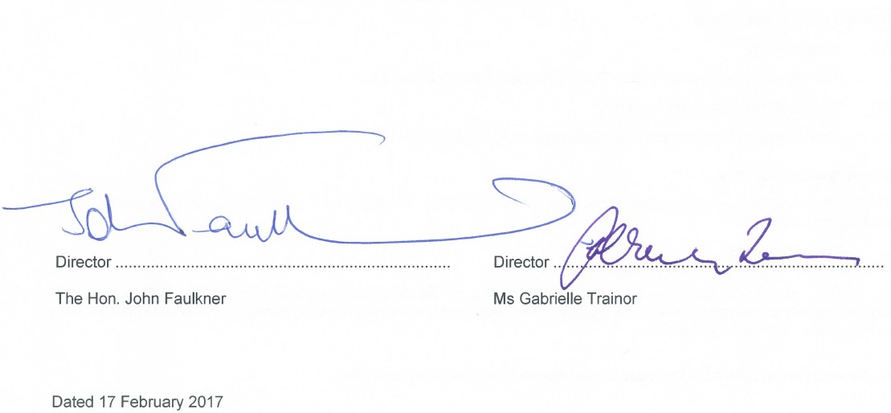
This declaration is made in accordance with a resolution of the Directors.

Director ............................................................................ Director ...........................................................................

The Hon. John Faulkner Ms Gabrielle Trainor

Dated 17 February 2017

INDEPENDENT AUDITOR’S REPORT
Whitlam Institute within Western Sydney University Limited

To Members of the New South Wales Parliament and Members of Whitlam Institute within Western Sydney University Limited
Opinion
I have audited the accompanying financial statements of Whitlam Institute within Western Sydney University Limited (the Company), which comprise the statement of financial position as at 31 December 2016, the statement of comprehensive income, statement of changes in equity and statement of cash flows for the year then ended, notes comprising a summary of significant accounting policies and other explanatory information, and the directors’ declaration.
In my opinion the financial statements:

- are in accordance with the Corporations Act 2001, including:
giving a true and fair view of the Company’s financial position as at 31 December 2016 and its performance for the year ended on that date
complying with Australian Accounting Standards and the Corporations Regulations 2001
- are in accordance with section 41B of the Public Finance and Audit Act 1983 (PF&A Act) and the Public Finance and Audit Regulation 2015.

My opinion should be read in conjunction with the rest of this report.
Basis for Opinion
I conducted my audit in accordance with Australian Auditing Standards. My responsibilities under the standards are described in the ‘Auditor’s Responsibilities for the Audit of the Financial Statements’ section of my report.
I am independent of the Company in accordance with the requirements of the:

- Australian Auditing Standards
- Corporations Act 2001
- Accounting Professional and Ethical Standards Board’s APES 110 ‘Code of Ethics for Professional Accountants’ (APES 110).

I have also fulfilled my other ethical responsibilities in accordance with APES 110.

The PF&A Act further promotes independence by ensuring the Auditor–General and the Audit Office of New South Wales are not compromised in their roles by:
- providing that only Parliament, and not the executive government, can remove an Auditor–General
- mandating the Auditor–General as auditor of public sector agencies, but precluding the provision of non-audit services.

I confirm the independence declaration, required by the Corporations Act 2001, provided to the directors of the Company on 16 February 2017, would be in the same terms if provided to the directors as at the time of this Independent Auditor’s Report.

Directors’ Responsibility for the Financial Statements
The directors of the Company are responsible for the preparation and fair presentation of the financial statements in accordance with Australian Accounting Standards, the PF&A Act and the Corporations Act 2001 and for such internal control as the directors determine is necessary to enable the preparation and fair presentation of the financial statements that are free from material misstatement, whether due to fraud or error.
In preparing the financial statements, the directors must assess the Company’s ability to continue as a going concern unless they intend to liquidate the Company or cease operations. The assessment must disclose, as applicable, matters related to going concern and the appropriateness of using the going concern basis of accounting.
Auditor’s Responsibility for the Audit of the Financial Statements
My objectives are to:

- obtain reasonable assurance about whether the financial statements as a whole are free from material misstatement, whether due to fraud or error
- issue an Independent Auditor’s Report including my opinion.

Reasonable assurance is a high level of assurance, but does not guarantee an audit conducted in accordance with Australian Auditing Standards will always detect material misstatements.
Misstatements can arise from fraud or error. Misstatements are considered material if, individually or in aggregate, they could reasonably be expected to influence the economic decisions users take based on the financial statements.
A description of my responsibilities for the audit of the financial statements is located at the Auditing and Assurance Standards Board website at: http://www.auasb.gov.au/auditors_files/ar3.pdf
The description forms part of my auditor’s report. My opinion does not provide assurance:
- that the Company carried out its activities effectively, efficiently and economically
- about the security and controls over the electronic publication of the audited financial statements on any website where they may be presented
- about any other information which may have been hyperlinked to/from the financial statements.
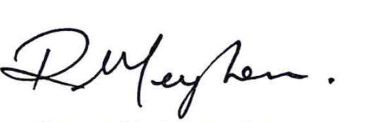
Renee Meimaroglou
Director, Financial Audit Services

21 February 2017 SYDNEY

This page is intentionally blank

Whitlam Institute Within Western Sydney University Trust
ABN: 42 247 216 279

Financial Statements
For the Year Ended 31 December 2016
These financial statements of the Whitlam Institute Within Western Sydney University Trust (the Trust) are presented as an individual entity. The financial statements are presented in Australian currency.
The registered office and principal place of business of the Whitlam Institute Within Western Sydney University Trust is:
Whitlam Institute Within Western Sydney University Trust Western Sydney University
Building EZ, Parramatta Campus Cnr James Ruse Dr & Victoria Rd Rydalmere NSW 2116 Registered postal address is:
Whitlam Institute Within Western Sydney University Trust Locked Bag 1797
Penrith NSW 2751
A description of the nature of the Trust's operations and it principal activities is included in the Trustees' report which is not part of these financial statements.
These financial statements were authorised for issue by the Trustees' on 17 February 2017. The Trustees have the power to amend and reissue the financial statements.

Trustees' report

For the year ended 31 December 2016

The Trustees present their report on Whitlam Institute Within Western Sydney University Trust for the financial year ended 31 December 2016.

Trustees

The Whitlam Institute Within Western Sydney University Limited (referred to hereafter as the Trustee Company) has been appointed as the Trustee of the Trust. The following persons have been directors of the Trustee Company during the whole of the financial year and to the date of this report:

The Hon. John Faulkner Ms Patricia Amphlett OAM Prof. Barney Glover
Ms Gabrielle Trainor Mr John Wells
Mr Talal Yassine OAM Ms Catherine Dovey
Mr Cameron Clyne Appointed 6 September 2016
Mr Geoffrey Roberson Resigned 25 November 2016
Dr Kerry Schott AO Resigned 20 May 2016

Directors have been in office since the start of the financial year to the date of this report unless otherwise stated.

Principal Activities

There were no significant changes in the nature of the Trust's activities during the year.

The Whitlam Institute Within Western Sydney University Trust exists to support (through the provision of money, property or benefits) Western Sydney University, specifically the work of the Whitlam Institute with respect to the Whitlam Prime Ministerial Collection and the Institute's research, educational and policy activity.

Trustees' report

For the year ended 31 December 2016

Meetings of trustees

During the financial year, 4 meetings of trustees (including committees of trustees) were held. Attendances by each trustee during the year were as follows:

 | Trustees Meetings
 | Number eligible to attend | Number attended
The Hon. John Faulkner | 4 | 4
Ms Patricia Amphlett OAM | 4 | 3
Prof. Barney Glover | 4 | 4
Ms Gabrielle Trainor | 4 | 4
Mr John Wells | 4 | 3
Mr Talal Yassine OAM | 4 | 3
Ms Catherine Dovey | 4 | 4
Mr Cameron Clyne | 1 | 1
Mr Geoffrey Roberson | 4 | 3
Dr Kerry Schott AO | 2 | 2

This report is made in accordance with a resolution of the Trustee.

Director: ............................................................................... Director: ..............................................................................
The Hon. John Faulkner Ms Gabrielle Trainor

Dated 17 February 2017
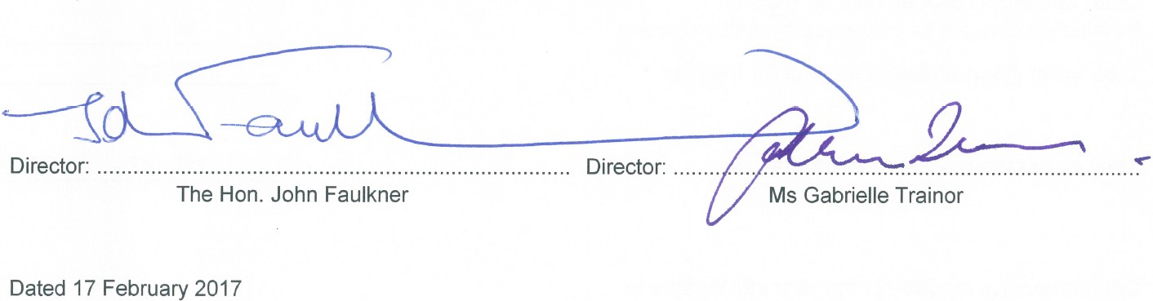

Statement of comprehensive income
For the Year Ended 31 December 2016
 |  | 2016 | 2015
 | Notes | $ | $
Revenue | 3
Services | 3 | 150,725 | 79,328
Other revenue | 3 | 14,079 | 11,341
Contribution of assets |  | 31,575 | -
Total revenue |  | 196,379 | 90,669
Expenses
Contribution to Ultimate Parent Entity | 4 | (55,870) | (55,000)
Event expenses | 4 | (1,191) | -
Bank charges | 4 | (197) | (194)
Total expenses |  | (57,258) | (55,194)
Surplus for the year |  | 139,121 | 35,475
Other comprehensive income for the year  Revaluation changes for property, plant and equipment |  | 20,040 | -
Total other comprehensive income for the year |  | 20,040 | -
Total comprehensive income for the year |  | 159,161 | 35,475
Comprehensive income for the year attributable to
Non - controlling interest |  | - | -
The parent |  | 159,161 | 35,475
Total comprehensive income for the year |  | 159,161 | 35,475

Statement of financial position
As at 31 December 2016
 |  | 2016 2015
 | Notes | $ $
ASSETS  Current assets  Cash and cash equivalents | 7 | 575,222 471,976
Trade and other receivables |  | 3,700 -
Total current assets |  | 578,922 471,976
Non-current assets  Property, plant and equipment | 8 | 830,442 778,827
Total non-current assets |  | 830,442 778,827
Total assets |  | 1,409,364 1,250,803
LIABILITIES
Current liabilities
Other liabilities |  | - 600
Total current liabilities |  | - 600
Total liabilities |  | - 600
Net assets |  | 1,409,364 1,250,203
TRUST FUNDS  Settled fund |  | 1 1
Reserves | 9 | 195,247 175,207
Retained earnings | 10 | 1,214,116 1,074,995
Total trust funds |  | 1,409,364 1,250,203

Statement of changes in equity
For the Year Ended 31 December 2016
 | Settled fund | Retained Earnings | Reserves | Total Equity
 | $ | $ | $ | $
Balance at 1 January 2016 | 1 | 1,074,995 | 175,207 | 1,250,203
Revaluation of property, plant and equipment | - | - | 20,040 | 20,040
Surplus for the year | - | 139,121 | - | 139,121
Total comprehensive income for the year | - | 139,121 | 20,040 | 159,161
Balance at 31 December 2016 | 1 | 1,214,116 | 195,247 | 1,409,364
 | Settled fund | Retained Earnings | Reserves | Total Equity
 | $ | $ | $ | $
Balance at 1 January 2015 | 1 | 1,039,520 | 175,207 | 1,214,728
Revaluation of property, plant and equipment | - | - | - | -
Surplus for the year | - | 35,475 | - | 35,475
Total comprehensive income for the year | - | 35,475 | - | 35,475
Balance at 31 December 2015 | 1 | 1,074,995 | 175,207 | 1,250,203

Statement of cash flows

For the Year Ended 31 December 2016

Notes
2016
$
2015
$

Cash flows from operating activities
Receipts from customers 150,125 79,328
Payments to suppliers and employees (57,258) (55,194)
Investment income 10,379 11,341

Net cash inflow/(outflow) from operating activities 16 103,246 35,475

Cash flows from investing activities

Net cash inflow/(outflow) from investing activities - -

Cash flows from financing activities

Net cash inflow/(outflow) from financing activities - -

Net increase/(decrease) in cash and cash equivalents 103,246 35,475
Cash and cash equivalents at beginning of year 471,976 436,501

Cash and cash equivalents at end of year 7 575,222 471,976

Notes to the financial statements

For the Year Ended 31 December 2016

1 Summary of Significant Accounting Policies

- Basis of Preparation

These financial statements are general purpose financial statements that have been prepared in accordance with Australian Accounting Standards (including Australian Accounting Interpretations) adopted by the AASB, the requirements of the Public Finance & Audit Act 1983, Public Finance and Audit Regulation 2015 and other authoritative pronouncements of the Australian Accounting Standards Board (AASB).

These financial statements of the Whitlam Institute Within Western Sydney University Trust comply with Australian Accounting Standards some of which contains requirements specific to not for profit entities that are inconsistent with International Financial Reporting Standards (IFRS) requirements.

Material accounting policies adopted in the preparation of these financial statements are presented below and have been consistently applied unless otherwise stated.

The financial statements have been prepared on an accruals basis and are based on historical costs, modified, where applicable, by the measurement at fair value of selected non-current assets, financial assets and financial liabilities.

Revenue recognition

The Trust recognises revenue when the amount of revenue can be reliably measured, it is probable that future economic benefits will flow to the entity and specific criteria have been met for each of the Trust's activities as described below. The Trust bases its estimates on historical results, taking into consideration the type of customer, the type of transaction and the specifics of each arrangement.

Revenue is recognised for the major business activities as follows:

- Donations, Scholarships and Prizes

Donations, scholarships and prizes are recognised when they are received.

A sale is recorded when goods have been delivered to the customer, the customer has accepted the goods and collectability of the related receivables is probable.

- Rendering of services

Revenue is recognised when the service is provided or by reference to the stage of completion (based on labour hours incurred to date).

- Event income

Event income is only recognised when the economic benefits associated with the transaction flows to the entity.

- Investment income

Investment income is recognised as it accrues using the effective interest method. All other material revenue is accounted for on an accrual basis.

Notes to the financial statements

For the Year Ended 31 December 2016

1 Summary of Significant Accounting Policies (continued)

- Cash and cash equivalents

Cash and cash equivalents includes cash on hand, deposits held at call with financial institutions, other short term, highly liquid investments with original maturities of three months or less that are readily convertible to known amounts of cash and which are subject to an insignificant risk of changes in value.

Income tax exemption

The Trust is exempt from the payment of tax by virtue of section 50 B of the Income Tax Assessment Act 1997. Accordingly no provision for income tax liability or future income tax benefit has been included in the accounts.

Government grants

Grants from the government are recognised at their fair value where there is a reasonable assurance that the grant will be received and the Trust will comply with all attached conditions.

Government grants relating to costs are deferred and recognised in the surplus or deficit over the period necessary to match them with the costs that they are intended to compensate.

Trade receivables

Trade receivables are recognised initially at fair value and subsequently measured at amortised cost using the effective interest method, less provision for impairment. Trade receivables are generally due for settlement within 30 days. They are presented as current assets unless collection is not expected for more than 12 months after the reporting date.

Collectability of trade receivables is reviewed on an ongoing basis. Debts which are known to be uncollectable are written off by reducing the carrying amount directly. An allowance account (provision for impairment of trade receivables) is used when there is objective evidence that the Trust will not be able to collect all amounts due according to the original terms of the receivables. Significant financial difficulties of the debtor, probability that the debtor will enter bankruptcy or financial reorganisation, and default or delinquency in payments (more than 30 days overdue) are considered indicators that the trade receivable is impaired. The amount of the impairment is the difference between the book value and the amount determined to be collectable.

The amount of the impairment loss is recognised in surplus/(deficit) within other expenses. When a trade receivable for which an impairment allowance had been recognised becomes uncollectable in a subsequent period, it is written off against the allowance account. Subsequent recoveries of amounts previously written off are credited against other expenses in surplus/(deficit).

Fair value estimation

The fair value of financial assets and financial liabilities must be estimated for recognition and measurement or for disclosure purposes.

The carrying value less impairment provision of trade receivables and payables are assumed to approximate their fair values due to their short term nature.

Property, plant and equipment

Property, plant and equipment is stated at historical cost less depreciation. Historical cost includes expenditure that is directly attributable to the acquisition of the items. Cost may also include transfers from equity of any gains/losses on qualifying cash flow hedges of foreign currency purchases of property, plant and equipment.

Notes to the financial statements

For the Year Ended 31 December 2016

1 Summary of Significant Accounting Policies (continued)

- Property, plant and equipment (continued)

Subsequent costs are included in the asset's carrying amount or recognised as a separate asset, as appropriate, only when it is probable that future economic benefits associated with the item will flow to the Trust and the cost of the item can be measured reliably. The carrying amount of any component accounted for as a separate asset is derecognised when replaced. All other repairs and maintenance are charged to surplus or deficit during the reporting period in which they are incurred.

Property, plant and equipment consists only of the Whitlam Collection and is not depreciated given the nature of its contents.

The assets' residual values and useful lives are reviewed, and adjusted if appropriate, at the end of each reporting period.

Gains and losses on disposals are determined by comparing proceeds with carrying amount. These are included in the statement of comprehensive income.

Whitlam Collection

Assets comprising the Whitlam Collection have been donated to the Trust. Market valuations have been obtained from a valuer to determine the fair value of the contribution in accordance with AASB 13 and AASB116 Fair value measurement. The Whitlam Collection was revalued in 2016 in accordance with the ultimate parent entity three year revaluation cycle however previously the Whitlam Collection was revalued at the end of 2014 following the passing of the Hon Gough Whitlam AC QC.

Goods and Services Tax (GST)

Revenues, expenses and assets are recognised net of the amount of associated GST, unless the GST incurred is not recoverable from the Australian Taxation Office. In this case it is recognised as part of the cost of acquisition of the asset or as part of the expense.

Receivables and payables are stated inclusive of the amount of GST receivable or payable. The net amount of GST recoverable from, or payable to, the Australian Taxation Office is included with other receivables or payables in the statement of financial position.

Cash flows are presented on a gross basis. The GST components of cash flows arising from investing or financing activities which are recoverable from, or payable to the Australian Taxation Office, are presented as operating cash flows.

Comparative amounts

No comparatives were restated in the financial statements.

New accounting standards and interpretations

Certain new accounting standards and interpretations have been published that are not mandatory for 31 December 2016 reporting periods and have not yet been applied in the financial report. The Trust's assessment of the impact of these new standards and interpretations is that they will not materially affect any of the amounts recognised in the financial statements or significantly impact the disclosures in relation to the Trust.

Notes to the financial statements

For the Year Ended 31 December 2016

Summary of Significant Accounting Policies (continued)

- Critical accounting estimates and judgments

The preparation of financial statements requires the use of certain critical accounting estimates. It also requires management to exercise its judgement in the process of applying the Trust's accounting policies. Estimates and judgements are continually evaluated and are based on historic experience and other factors, including expectations of future events that may have a financial impact on the Trust and that are believed to be reasonable under the circumstances.

The valuation of assets and the estimate of useful life uses estimates and judgments.

The valuation of the Whitlam Collection within Property Plant and Equipment has been signed by an independent expert valuer Peter Tinslay, Valuer on the basis of a fair value for accounting purposes.

Notes to the financial statements

For the Year Ended 31 December 2016

Financial Risk Management

The main risks Whitlam Institute Within Western Sydney University Trust is exposed to through its financial instruments are liquidity risk and market risk (interest rate risk). The Trust's overall risk management program focuses on the unpredictability of financial markets and seeks to minimise potential adverse effects on the financial performance of the Trust. The Trust uses different methods to measure different types of risk to which it is exposed. These methods include sensitivity analysis in the case of interest rate and ageing analysis for credit risk.

The totals for each category of financial instruments, measured in accordance with AASB 139 as detailed in the accounting policies to these financial statements, are as follows:

Financial Assets

Notes
2016
$
2015
$

Cash and cash equivalents 7 575,222 471,976
Trade and other receivables 3,700 -
578,922 471,976

Financial Liabilities
Other liabilities - 600
- 600

Credit risk

The credit risk on financial assets of the Trust which have been recognised on the statement of financial position is generally the carrying amount, net of provision for loss. Credit risk arises when there is the possibility of the Trust's debtors defaulting on their contractual obligations, resulting in financial loss to the Trust. The Trust does not have any significant exposure to any unrelated debtor.

The following table details the Trust's trade and other receivables exposure to credit risk with ageing analysis.

2016
$
2015
$

Up to 3 months 2,645 -
3 to 6 months 1,055 -

Total 3,700 -

  - Liquidity risk

Prudent liquidity risk management implies maintaining sufficient cash and the availability of funding through an adequate amount of committed credit facilities to meet obligations when due. At the end of the reporting period the Trust held deposits at call of $575,222 (2015: $471,976) that are expected to readily generate cash inflows for managing liquidity risk.

Notes to the financial statements

For the Year Ended 31 December 2016

2 Financial Risk Management (continued)

  - Market risk

Market risk is the risk that the fair value or future cash flows of a financial instrument will fluctuate because of changes in market prices.

- Cash flow and fair value interest rate

The Trust's exposure to interest rate risk is minimal as it has no borrowings.

- Summarised sensitivity analysis

The following table summarises the sensitivity of the Trust's financial assets and financial liabilities to interest rate risk. The Trust's financial assets and financial liabilities are not subject to foreign exchange risk and other price risk.
Carrying | -100bps  Surplus/ |  | +100bps  Surplus/
amount | (deficit) | Trust funds | (deficit) | Trust funds
$ | $ | $ | $ | $

31 December 2016

Financial assets
Cash and cash equivalents 575,222 (5,752) (5,752) 5,752 5,752
Trade receivables (a) 3,700 (37) (37) 37 37
Total increase/(decrease) in financial assets (5,789) (5,789) 5,789 5,789

Financial liabilities
Other liabilities (a) - - - - -
Total increase/(decrease) in financial
liabilities - - - -
Total increase/(decrease) (5,789) (5,789) 5,789 5,789

31 December 2015
Carrying | -100bps  Surplus/ |  | +100bps  Surplus/
amount | (deficit) | Trust funds | (deficit) | Trust funds
$ | $ | $ | $ | $

Financial assets
Cash and cash equivalents 471,976 (4,720) (4,720) 4,720 4,720
Total increase/(decrease) in financial assets  Financial liabilities | (4,720) (4,720) 4,720 4,720
Other liabilities (a) | 600 (6) (6) 6 6
Total increase/(decrease) in financial
liabilities | (6) (6) 6 6
Total increase/(decrease) | (4,726) (4,726) 4,726 4,726

- These amounts exclude all statutory payables and receivables.

Notes to the financial statements

For the Year Ended 31 December 2016

3 Revenue | 2016 2015
 | $ $
Services  Donations (a) | 150,725 55,778
Royalty and intellectual property | - 23,550
Total services | 150,725 79,328
Other revenue
Interest | 4,114 607
Distributions from managed funds | 9,965 10,734
Total other revenue | 14,079 11,341
Total revenue | 164,804 90,669
(a) Donations

In 2016 the Trust received donations of $150,725. This has increased significantly from 2015 following the establishment of the EG Whitlam Centenary Endowment Fund along with a fund raising dinner to mark the centenary of the Hon Gough Whitlam AC QC .

4 Expenses | 2016  $ | 2015  $
Contribution to Ultimate Parent Entity | 55,870 | 55,000
Event expenses | 1,191 | -
Bank charges | 197 | 194
Total expenses | 57,258 | 55,194
5 Remuneration of Auditors

Audit fees of $9,635 for 2016 (2015: $9,404) will be paid by the ultimate parent entity.

Notes to the financial statements

For the Year Ended 31 December 2016

6 Fair Value Measurement Fair value hierarchy
Whitlam Institute Within Western Sydney University Trust categorises assets and liabilities measured at fair value into a hierarchy based on the level of inputs used in measurements as follows:

Level 1 Unadjusted quoted prices in active markets for identical assets or liabilities that the entity can access at the measurement date.
Level 2 Inputs other than quoted prices included within Level 1 that are observable for the asset or liability, either directly or indirectly.
Level 3 Unobservable inputs for the asset or liability.

The table below shows the assigned level for each asset and liability held at fair value by the Trust:

31 December 2016 | Level 1  $ | Level 2  $ | Level 3  $ | Total  $
Non-financial assets  Property, plant and equipment |  | - 830,442 |  | - 830,442
Total non-financial assets |  | - 830,442 |  | - 830,442
Total assets |  | - 830,442 |  | - 830,442

31 December 2015 | Level 1  $ | Level 2  $ | Level 3 Total  $ $
Non-financial assets  Property, plant and equipment | 13,575 | 765,252 | - 778,827
Total non-financial assets | 13,575 | 765,252 | - 778,827
Total assets | 13,575 | 765,252 | - 778,827

Notes to the financial statements

For the Year Ended 31 December 2016

6 Fair Value Measurement (continued)

- Fair value measurements

Due to the short-term nature of the current receivable their carrying value is assumed to approximate their fair value and based on credit history it is expected that the receivable that are neither past due nor impaired will be received when due.

The carrying amounts and aggregate net fair values of financial assets and liabilities at balance date are:

Carrying Amount Fair Value

2016
$
2015
$
2016
$
2015
$

Financial assets  Cash and cash equivalents | 575,222 471,976 575,222 471,976
Trade and other receivables | 3,700 - 3,700 -
Total financial assets | 578,922 471,976 578,922 471,976
Financial Liabilities  Other liabilities | - 600 - 600
Total financial liabilities | - 600 - 600

The Trust measures and recognises the following assets and liabilities at fair value on a recurring basis:

- Property, plant and equipment

Valuation techniques used to derive level 1, level 2 and level 3 fair values

- Recurring fair value measurements

The fair value of assets that are not traded in an active market is determined using valuation techniques. These valuation techniques maximise the use of observable market data where it is available and rely as little as possible on entity specific estimates. If all significant inputs required to fair value an instrument are observable, the instrument is included in level 2.

If one or more of the significant inputs is not based on observable market data, the instrument is included in level 3.

The Trust uses a variety of methods and makes assumptions that are based on market conditions existing at each balance date.

Due to the short-term nature of the current receivable their carrying value is assumed to approximate their fair value and based on credit history it is expected that the receivable that are neither past due nor impaired will be received when due.

Property, plant and equipment is valued using current observable market values. All of the resulting fair value estimates are included in level 1 and level 2.

Notes to the financial statements

For the Year Ended 31 December 2016

Fair Value Measurement (continued)

(b) Valuation techniques used to derive level 1, level 2 and level 3 fair values (continued)

- Non-recurring fair value measurement

The Trust does not hold assets that use non-recurring fair value measurements during the current or prior periods.

Cash and cash equivalents

2016
$

2015
$

Cash at bank and on hand | 27,196 23,915
Term deposits | 400,000 -
T-Corp investments | 148,026 448,061
 | 575,222 471,976

  - Risk exposure

The Trust's exposure to interest rate risk is discussed in note 2. The maximum exposure to credit risk at the end of each reporting period is the carrying amount of each class of cash and cash equivalents mentioned above.

Cash at bank and on hand

These are non-interest bearing.

Fair value

The carrying amount for cash and cash equivalents equals the fair value.

Notes to the financial statements

For the Year Ended 31 December 2016

8 Property, plant and equipment | Library Total
 | $ $
At 1 January 2015
Valuation | 778,827 778,827
Net book amount | 778,827 778,827
Year ended 31 December 2015
Opening net book amount | 778,827 778,827
Revaluation | - -
Additions | - -
Closing net book amount | 778,827 778,827
At 31 December 2015
Valuation | 778,827 778,827
Net book amount | 778,827 778,827
Year ended 31 December 2016
Opening net book amount | 778,827 778,827
Revaluation | 20,040 20,040
Additions | 31,575 31,575
Closing net book amount | 830,442 830,442
At 31 December 2016
Valuation | 830,442 830,442
Net book amount | 830,442 830,442
9 Reserves
 | 2016 2015
 | $ $
Revaluation surplus - property, plant and equipment 195,247 175,207
195,247 175,207

Movements

Revaluation surplus - property, plant and equipment

2016
$

2015
$

Balance 1 January 175,207 175,207
Revaluation - gross 20,040 -
Balance 31 December 195,247 175,207

(a) Nature and purpose of reserves

(i) Revaluation surplus - property, plant and equipment

The property, plant and equipment revaluation reserve is used to record increments and decrements on the revaluation of non-current assets, as described in note 1(h).

Notes to the financial statements
For the Year Ended 31 December 2016
10 Retained surplus
Movements in retained surplus were as follows: | 2016 | 2015
Balance as at 1 January | $ 1,074,995 | $  1,039,520
Surplus for the year | 139,121 | 35,475
Trust distributions for the year - -
Balance as at 31 December 1,214,116 1,074,995

Commitments

The Trust had no commitments at 31 December 2016 (31 December 2015: nil).

Contingencies

The Trust did not have any contingencies at 31 December 2016 (31 December 2015: nil).

Key Management Personnel Disclosures

No remuneration has been paid to the key management personnel of Whitlam Institute Within Western Sydney University Trust during the year (2015: nil).

Related party transactions

  - Parent entity

The ultimate parent entity of the Trust is Western Sydney University.

(b) Transactions with related parties | 2016 | 2015
 | $ | $
Matched Donations from the Ultimate Parent Entity | (10,804) | (17,717)
Payments to the Ultimate Parent Entity | 55,870 | 55,000
15 Economic dependency

The Trust is economically dependent on the Western Sydney University for the provision of office accommodation and support activities.

Notes to the financial statements
For the Year Ended 31 December 2016
16 Reconciliation of surplus/(deficit) to net cash inflow from operating activities
Reconciliation of net income to net cash provided by operating activities: | 2016 | 2015
Surplus for the year | $ 139,121 | $  35,475
Changes in assets and liabilities:  - (increase)/decrease in trade and other receivables | (3,700) | -
- (increase)/decrease in assets | (31,575) | -
- increase/(decrease) in other liabilities | (600) | -
Cashflow from operations | 103,246 | 35,475

17 Events occurring after the reporting date

No matters or circumstances have arisen since the end of the financial year which significantly affected or may significantly affect the operations of the Trust, the results of those operations, or the state of affairs of the Trust in future financial years (2015: nil).

END OF AUDITED FINANCIAL STATEMENTS

Trustees' declaration

In the Trustee's opinion:

- the financial statements and notes, as set out on pages 216 to 232

  - comply with Australian Accounting Standards and other interpretations, the Public Finance and Audit Act 1983, the Public Finance and Audit Regulation 2015 and other mandatory professional reporting requirements; and

  - give a true and fair view of the financial position as at 31 December 2016 and of the performance for the year ended on that date of the Trust;

- There are reasonable grounds to believe that the Trust will be able to pay its debts as and when they become due and payable.

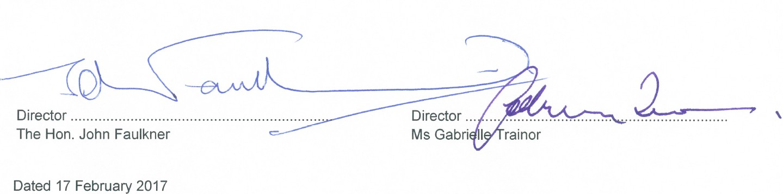
This declaration is made in accordance with a resolution of the Trustee Company, the Whitlam Institute with Western Sydney University Limited.

Director .................................................................. Director ..................................................................
The Hon. John Faulkner Ms Gabrielle Trainor

Dated 17 February 2017

INDEPENDENT AUDITOR’S REPORT
Whitlam Institute within Western Sydney University Trust

To Members of the New South Wales Parliament
Opinion
I have audited the accompanying financial statements of Whitlam Institute within Western Sydney University Trust (the Trust), which comprise the statement of financial position as at 31 December 2016, the statement of comprehensive income, statement of changes in equity and statement of cash flows for the year then ended, notes comprising a summary of significant accounting policies and other explanatory information.
In my opinion, the financial statements:

- give a true and fair view of the financial position of the Trust as at 31 December 2016, and of its financial performance and its cash flows for the year then ended
- in accordance with Australian Accounting Standards
- are in accordance with section 41B of the Public Finance and Audit Act 1983 (PF&A Act) and the Public Finance and Audit Regulation 2015.

My opinion should be read in conjunction with the rest of this report.
Basis for Opinion
I conducted my audit in accordance with Australian Auditing Standards. My responsibilities under the standards are described in the ‘Auditor’s Responsibilities for the Audit of the Financial Statements’ section of my report.
I am independent of the Trust in accordance with the requirements of the:

- Australian Auditing Standards
- Accounting Professional and Ethical Standards Board’s APES 110 ‘Code of Ethics for Professional Accountants’ (APES 110).

I have also fulfilled my other ethical responsibilities in accordance with APES 110.

The PF&A Act further promotes independence by ensuring the Auditor–General and the Audit Office of New South Wales are not compromised in their roles by:
- providing that only Parliament, and not the executive government, can remove an Auditor– General
- mandating the Auditor–General as auditor of public sector agencies, but precluding the provision of non-audit services.

I believe the audit evidence I have obtained is sufficient and appropriate to provide a basis for my audit opinion.

Director’s Responsibility for the Financial Statements
The Directors are responsible for the preparation and fair presentation of the financial statements in accordance with Australian Accounting Standards and the PF&A Act, and for such internal control as the Directors determine is necessary to enable the preparation and fair presentation of the financial statements that are free from material misstatement, whether due to fraud or error.
In preparing the financial statements, the Directors must assess the Trust’s ability to continue as a going concern unless the Trust will be dissolved by an Act of Parliament or otherwise cease operations. The assessment must disclose, as applicable, matters related to going concern and the appropriateness of using the going concern basis of accounting.
Auditor’s Responsibility for the Audit of the Financial Statements
My objectives are to:

- obtain reasonable assurance about whether the financial statements as a whole are free from material misstatement, whether due to fraud or error
- issue an Independent Auditor’s Report including my opinion.

Reasonable assurance is a high level of assurance, but does not guarantee an audit conducted in accordance with Australian Auditing Standards will always detect material misstatements. Misstatements can arise from fraud or error. Misstatements are considered material if, individually or in aggregate, they could reasonably be expected to influence the economic decisions users take based on the financial statements.
A description of my responsibilities for the audit of the financial statements is located at the Auditing and Assurance Standards Board website at: http://www.auasb.gov.au/auditors_files/ar3.pdf..
The description forms part of my auditor’s report. My opinion does not provide assurance:
- that the Trust carried out its activities effectively, efficiently and economically
- about the security and controls over the electronic publication of the audited financial statements on any website where they may be presented
- about any other information which may have been hyperlinked to/from the financial statements
Renee Meimaroglou
Director, Financial Audit Services

21 February 2017 SYDNEY

This page is intentionally blank

Western Sydney University and Controlled Entities

Budget and Performance Indicators

2016 Actual to Budget Comparative Analysis

2016 | 2016 | 2016 | 2016
BUDGET | ACTUAL | VARIANCE | VARIANCE
$'000 | $'000 | $'000 | %

INCOME FROM CONTINUING OPERATIONS
GOVERNMENT  ACADEMIC ACTIVITIES |  | 559,247 | 553,490 | (5,757) | -1.0%
International Onshore |  | 80,569 | 77,728 | (2,841) | -3.5%
International Offshore |  | 699 | 822 | 123 | 17.6%
Local fee-paying |  | 15,322 | 15,643 | 321 | 2.1%
External Research Grants |  | 29,800 | 26,378 | (3,422) | -11.5%
Consulting, Contracting & Royalties |  | 1,705 | 4,209 | 2,504 | 146.9%
Other Academic |  | 42,764 | 43,116 | 352 | 0.8%
 | Sub Total | 170,859 | 167,896 | (2,963) | -1.7%
OTHER INCOME ACTIVITIES  Leases & Other Commercial |  | 5,903 | 5,034 | (869) | -14.7%
Investment Income |  | 10,163 | 8,649 | (1,514) | -14.9%
Land/Property Development Projects |  | 162,676 | 25,083 | (137,593) | -84.6%
Other Incidental |  | 12,266 | 16,099 | 3,833 | 31.2%
WSU ENTITIES | Sub Total | 191,008 | 54,865 | (136,143) | -71.3%
WSU College |  | 65,112 | 59,992 | (5,120) | -7.9%
Whitlam Institute |  | 62 | 197 | 135 | 217.7%
UWSELL |  | 6,294 | 6,559 | 265 | 4.2%
uwsconnect  Adjustments on Consolidation |  | 19,999 | 21,541 | 1,542 | 7.7%
Sub Total |  | 91,467 | 88,289 | (3,178) | -3.5%
TOTAL SELF-GENERATED INCOME |  | 453,334 | 311,050 | (142,284) | -31.4%
TOTAL INCOME |  | 1,012,581 | 864,540 | (148,041) | -14.6%
EXPENSES FROM CONTINUING OPERATIONS  Schools 228,216 |  |  | 220,668 | 7,548 | 3.3%
Research | 86,400 |  | 79,266 | 7,134 | 8.3%
Divisions | 159,626 |  | 156,013 | 3,613 | 2.3%
WSU Entities | 90,678 |  | 89,471 | 1,207 | 1.3%
Consulting & Innovation | 2,443 |  | 3,648 | (1,205) | -49.3%
WSU Wide | 131,908 |  | 149,384 | (17,476) | -13.2%
Strategic Initiatives | 58,502 |  | 48,231 | 10,271 | 17.6%
Minor Works (Expensed) | 7,000 |  | 8,996 | (1,997) | -28.5%
External Trust & Tied Grants | 17,208 |  | 18,853 | (1,645) | -9.6%
Depreciation | 37,000 |  | 42,579 | (5,579) | -15.1%
Land Development Projects Adjustments on Consolidation | 61,022 |  | 12,594 | 48,428 | 79.4%
TOTAL EXPENDITURE 880,003 829,703 50,299 5.7%

NET OPERATING RESULT 132,578 34,837 (97,742) -73.7%

Western Sydney University 2017 Budget | 2017
 | BUDGET
 | $'000
INCOME FROM CONTINUING OPERATIONS
GOVERNMENT | 554,690
ACADEMIC ACTIVITIES  International Onshore | 88,843
International Offshore | 957
Local fee-paying | 17,440
External Research Grants | 36,285
Consulting, Contracting & Royalties | 4,066
Other | 44,936
Sub Total | 192,527
OTHER INCOME ACTIVITIES
Leases & Other Commercial | 9,440
Investment Income | 10,148
Land/Property Development Projects | 178,039
Other Incidental | 9,993
Sub Total | 207,620
WSU ENTITIES
WSU College | 63,013
Whitlam Institute | 175
UWS Early Learning | 6,864
uwsconnect | 16,155
Sub Total | 86,207
TOTAL SELF-GENERATED INCOME | 486,354
TOTAL INCOME | 1,041,044

EXPENSES FROM CONTINUING OPERATIONS
Schools | 226,429
Research | 90,178
Divisions | 160,793
WSU Entities | 85,825
Consulting & Innovation | 4,066
WSU Wide | 165,775
Strategic Initiatives | 50,448
Minor Works (Expensed) | 7,000
External Trust & Tied Grants | 16,422
Depreciation | 45,402
Land Development Projects | 109,516
TOTAL EXPENDITURE 961,854

NET REPORTED RESULT 79,190

Accounts Payable Performance Indicators - 2016

Category | First Quarter | Second Quarter | Third Quarter | Fourth Quarter
 | $ | $ | $ | $
1. Schedule of Accounts Payable
Paid within 30 days | 72,385,141 | 84,872,544 | 102,473,974 | 118,534,647
Paid between 31-60 days | 33,159,239 | 27,852,608 | 33,092,517 | 45,880,293
Paid between 61-90 days | 3,166,135 | 1,942,601 | 4,610,399 | 1,819,415
Paid between 91-120 days | 666,243 | 719,451 | 824,282 | 651,396
Paid more than 120 days | 1,060,999 | 1,039,362 | 681,619 | 271,913
Total | 110,437,757 | 116,426,566 | 141,682,791 | 167,157,664
2. Accounts Paid on Time
Target percentage of accounts paid on time | 100.0% | 100.0% | 100.0% | 100.0%
Actual percentage of accounts paid on time# | 65.5% | 72.9% | 72.3% | 70.9%
Total dollar amount of accounts paid on time | 72,385,141 | 84,872,544 | 102,473,974 | 118,534,647
Total dollar amount of accounts paid | 110,437,757 | 116,426,566 | 141,682,791 | 167,157,664
# based on invoice date, not date received in Accounts Payable.

Investment Portfolio Performance

The University had $98.2 million in investments at 31 December 2016 ($85.5 million at 31 December 2015). The University increased its investment in the Acadian Australian Equity High Yield Fund during the 2016 year by $0.6 million. The underperformance of the Acadian fund occurred in the 2nd half of 2016, and is a result of the strong performance of the higher risk and higher volatility sectors such as energy, materials and banking to which the Acadian strategy has a lower exposure. On an annualised basis the return since inception is 14.37% compared to the benchmark of 12.32%. Distributions received were re-invested. The University increased its investment in a fixed income portfolio managed by JBWere during 2016 by $4.1 million. Investment performance was satisfactory and the lower yield reflected lower interest rates. Distributions received were re-invested.

 | 2016 |  | 2015 |  | 2014 |  | 2013
Fund | Actual Benchmark Return Return  % % |  | Actual Benchmark Return Return  % % |  | Actual Benchmark Return Return  % % |  | Actual Benchmark Return Return  % %
Other Financial Assets ‐ Non‐current
Acadian Australian Equity High Yield Fund 4 | 11.41% | 13.40% | 10.38% | 4.40% | 12.01% | 6.90% | 22.28% | 21.76%
Held To Maturity ‐ JB Were 5 | 3.50% | 2.07% | 4.04% | 2.33% | 4.76% | 2.69% | ‐ | ‐
Unlisted Securities 6 | ‐ | ‐ | ‐ | ‐ | ‐ | ‐ | ‐ | ‐

4 ‐ Acadian Australian Equity High Yield Fund ‐ full year performance
5 ‐ Fixed income portfolio managed by JBWere ‐ full year performance
6 ‐ The University had $11.3 million in unlisted securities as at 31 December 2016 ($9.5 million at 31 December 2015) which are not measured for performance.

uwsconnect Ltd
Principal Objectives
The principal objective of the company is to provide food and beverage, retail, sporting and campus life facilities and services across all six of the Western Sydney University campuses.

Principal Activities and Strategic Projects
The principal activity of the company during the 2016 financial year was the provision of sports and leisure, retail, food and beverage, and other services to the Western Sydney University community including students, staff, alumni and residents of greater Western Sydney.

Performance measures

The performance measures of the company are financial and non-financial related to trading in community services.

Category | FY 2016 Actual | Annual 2016 Budget | % Full year achieved
Revenue | $21,425,022 | $19,998,824 | 107%
Expenses | $22,979,514 | $19,722,584 | 117%
Operating Surplus/(Deficit) | ($1,554,492) | $276,240 | 0%
Accumulated Retained Earnings | ($4,339,244)

Financial KPI’s were not achieved with the budgeted operating surplus not met due to higher expenses than budget; primarily due to decline in student numbers in addition to increase in cost of raw materials and consumables used.

Non-financial KPI’s related primarily to the centralisation of shared services, including Finance and Administration, IT, Visual Communications and Human Resources, and inventory reduction.

As a key provider of student services uwsconnect receives some ongoing financial support from the University.

Management and Operations
uwsconnect Ltd is a wholly owned entity of Western Sydney University. An independent Board of Directors is responsible for the overall operations of the Company.

UWS Early Learning Ltd
Principal Objectives
The principal objective of the Company is to provide affordable, high quality early childhood care and education for the children of Western Sydney University staff, students and the local community.

Principal Activities and Strategic Projects
To provide affordable, high quality early childhood care and education for the children of Western Sydney University staff, students and the local community. The provision of this service is campus based to enable staff, students and the local community the greatest opportunity to balance work and study commitments with childrearing.

Performance Measures
The performance measures of the company are both financial and non-financial. The Company has adopted the following key performance indicators
- Ensure all services at least meet Education and Care National Quality Standards
- Utilisation rates at all Centres increasing and stabilising
- Centralisation of the Financial and Administrative functions
- Financial operations of the Company now consolidated into the University’s financial reporting and budgeting cycle
- Continuing to explore ways of offering casual care in addition to permanent placement
- Community Engagement

Category | FY 2016 Actual | Annual 2016 Budget | % Full year achieved
Revenue | $6,558,579 | $6,293,986 | 104%
Expenses | $6,325,658 | $6,208,829 | 102%
Operating Surplus | $232,921 | $85,157 | 0%
Accumulated Retained Earnings | $1,054,055

Management and Operations
UWS Early Learning Limited is a wholly owned entity of Western Sydney University. An independent Board of Directors is responsible for the overall operations of the Company.

UWS Enterprises Pty Ltd (trading as Western Sydney University The College)
Principal Objectives
The principal objective of the company is to provide English and Academic Pathways programs to the University, complemented by other professional and community programs, consistent with Western Sydney University imperatives.

Principal Activities and Strategic Projects
The principal activities of the company are structured into the following three key areas:

- Academic Pathways which provides Foundation Studies and a variety of Diploma programs for students proceeding to an academic degree at Western Sydney University. The College continues to offer the Extended Four Term Diploma in addition to the existing University Foundation Studies and Diplomas courses (that are equivalent to first year University programs). The College established the Western Sydney University International College ("the International College") as a joint venture with Navitas Ltd.
- English Programs which enable international students to gain the academic English skills essential for university entrance. This unit also provides a diversity of programmes for international groups including industry visits and cultural immersion, as well is IELTS and other English-language assessment tests.
- Professional and Community Programs which delivers VET sector courses, acts as the College Registered Training Organisation (RTO), and conducts Property and Trust Management, SKILLMAX and HSC preparation courses.

During the 2016 financial year the company undertook numerous strategic projects in accordance with the company’s overall objectives and principal activities.

Performance Measures
The performance measures of the Company are both financial and non-financial:
- The relatively new Extended Diploma Program still provides some challenges in the prediction of load/revenue for the year. Other Academic Pathway Programs performed below expected projections.
- Shift towards International College as preferred provider for international pathways along with general decrease in international enrolments is having an impact on Income
- English Programs continue to be affected by Visa issues.

Category | FY 2016 Actual | Annual 2016 Budget | % Full year achieved
Revenue | $59,992,274 | $65,111,780 | 92%
Expenses | $59,992,274 | $64,683,688 | 93%
Operating Surplus | - | $428,092 | 0%
Accumulated Retained Earnings | $6,765,448

Management and Operations
UWS Enterprises Pty Ltd (trading as Western Sydney University The College) is a wholly owned entity of Western Sydney University. An independent Board of Directors is responsible for the overall operations of the company and the day to day activities are managed by a newly appointed Chief Executive Officer.

The Board has oversight of the Academic Advisory Committee and the English and Professional and Community Programs Academic Advisory Committee. An Audit Committee of the Board was established in 2010 and has made a significant contribution to financial monitoring and reporting within the organisation.

Whitlam Institute within Western Sydney University Limited
Principal Objectives
The Whitlam Institute is a trustee of the Whitlam Institute within Western Sydney University Trust which was established by agreement between Western Sydney University and the Hon EG Whitlam in 2000. Its spirit is best captured in Gough’s own words when signing the Deed of Gift:

‘The greatest contribution that I hope to bestow is inspiration. That the work and causes championed in my parliamentary career and the statesman service that followed, will provide the basis for ongoing research and advocacy from this university into the contemporary challenges that confront and can improve the quality of life for all Australians.’[December 2003]
Principal Activities and Strategic Projects
The Whitlam Institute works as an educator, policy influencer and research institute. It is also home to the Whitlam Prime Ministerial Collection and the Whitlam Reading Room which houses selected books and papers donated by Mr. Whitlam. The collection provides on-line access to papers held both at the Institute and in the National Archives. It maintains an active public education program.

The Institute's strategic program continues to expand in accordance with the intentions outlined in its current Strategic Plan 2016-2018 and subsequently amended in the mid-term review. The strategic priorities focus on:

- The historical legacy;
- Contemporary relevance through public policy development;
- The education and outreach program;
- Governance;
- Organisation; and
- Resourcing.

Performance Measures
The performance measures of the Company are primarily of a non-financial nature and are driven by the philanthropic nature of the trust and the role of the trustee.

The Whitlam Institute is guided by the ‘three great aims’ that drove the Whitlam Program of 1972. They are
- to promote equality
- to involve the people of Australia in the decision-making processes of our land, and
- to liberate the talents and uplift the horizons of the Australian people.

Category | FY 2016 Actual | Annual 2016 Budget | % Full year achieved
Revenue | $196,379 | $158,694 | 124%
Expenses | $57,258 | $56,065 | 102%
Operating Surplus | $139,121 | $102,629 | 0%
Accumulated Retained Earnings | $1,214,116

Management and Operations
The Whitlam Institute within Western Sydney University Limited is a wholly owned entity of Western Sydney University.
The Whitlam Institute Board is politically bipartisan and consists of leaders in academia, business, and government organisations. The Board participates in the strategic development of the Institute.
The Whitlam Institute is led by its Director Eric Sidoti. Its small secretariat is committed to the highest quality in all its activity whether that might be its policy and research work, outreach activity, public information program or events.

This page is intentionally blank

Western Sydney University Locked Bag 1797

ANNUAL REPORT 2016

2 Western Sydney University
Penrith NSW 2751 Australia

WESTERNSYDNEY.EDU.AU

STRA1725 Annual Report 2016_Vol 2_v1.indd 2 19/04/2017 3:05 PM

