Western Sydney University
Financial Framework
Contents
1. Purpose 3
2. Overview 3
3. Components of the Financial Framework 4
3.1. Planning 4
3.1.1. Annual Operating Plan 4
3.1.2. 3-Year Rolling Planning Cycle 4
3.1.3. Quarterly Reviews 5
3.2. Funding 5
3.2.1. Source of Funds (Revenue) 6
3.2.2. Distribution of Funds (Expense Categories) 7
3.2.3. Cash Management 9
3.3. Governance 9
3.3.1. Ownership and Approval 9
3.3.2. Budget Variations 10
3.3.3. Timeline 11
Appendix 1: 2021 Monthly Forecast Timeline 13
Appendix 2: Request for Additional Budget Adjustment (RABA) form 14
Appendix 3: Recruitment Business Case (RBC) 17
Appendix 4: Financial Performance and Partnerships Service Schedule 18

Purpose
The purpose of this document is to provide an overview of the Financial Framework the University has adopted to support the development and management of the Financial Budget and Forecast process.

Overview
The Financial Framework incorporates three core components: planning, governance and funding, as indicated in Diagram 1 below. These core components underpin the construction of the University’s Budget and forecast process and is reviewed each quarter on a 3-year rolling planning cycle.
Diagram 1: Overview of the Financial Framework
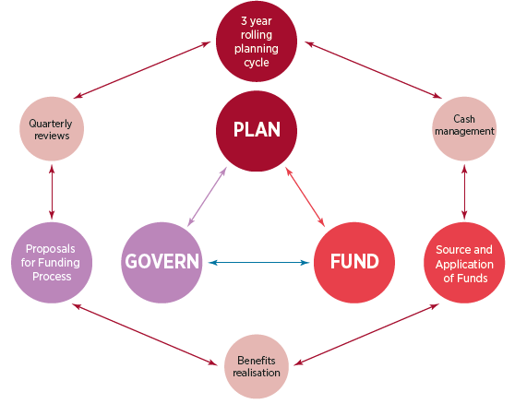
The primary purpose of this framework is to provide an explicit mechanism for connecting strategic objectives with operational plans both at a University wide level and at a School, Divisional and Entity level. At the centre of the framework is a ‘business model’ that captures a variety of operating and delivery models for teaching, research and engagement.
The rolling forecast and budget process enables the University to regularly refresh its financial outlook on a quarterly basis over a three-year time horizon to ensure funding allocations remain relevant in an ever-changing educational environment. The financial framework is utilised to ensure that the University’s decision-makers are fully informed to fund appropriate programs of work based on an equitable, accountable and transparent submissions and review process. This ensures that finite funds are applied in line with the strategic direction and objectives of the University.

Components of the Financial Framework

Planning
Planning involves the ongoing cycle of reviewing the plan; formulating, evaluating and updating the University’s financial projections against current known information. It adopts a 3 year rolling forecast process which enables the University to adapt to changing strategic and operational priorities impacted by internal and external factors. As part of this planning process, a revised 3-year financial forecast is produced and submitted by every School, Division and Entity on a quarterly basis. Submissions are then reviewed and approved by the Executive in line with strategic imperatives and the overall University financial position.

The benefits of using a rolling forecast process is that it enables agile decision making through greater flexibility, continuous planning, pro-active management of funds and greater accountability at the School, Division and Entity level.

Annual Operating Plan
The Annual Operating plan has been prepared for the Board of Trustees, representing a new approach to the University’s reporting and planning. It provides an overview of the key priorities, activities and budgets intended for each of the Schools, Divisions and Entities for the 3-year planning cycle.

The Annual Operating Plan is an integration of two key predecessor documents – the Annual Budget Book and the Vice-Chancellor’s Year in Review – and is intended to provide Board members and all other stakeholders with a more streamlined and cohesive reporting and planning instrument.

Information is provided by individual Schools, Divisions and Entities and collated by the PMO Office within the Division of Finance and Resources. This document incorporates the 3-year Budget that is developed as part of the Q3 Forecast process and is approved by the Board of Trustees in December each year.

3-Year Rolling Planning Cycle

The University’s framework works on a quarterly review cycle and a 3-Year rolling forecast view. This means that every quarter the University revisits the current and future 2 years plan.

A key requirement of a successful rolling forecast is that it needs to be updated on an ongoing and consistent basis. It is critical that the appropriate effort is spent analysing what recently happened, why it occurred and what will be done in the near future.

Diagram 2 below provides a visual representation of the 3-year rolling forecast process.

Diagram 2: 3-Year rolling forecast process

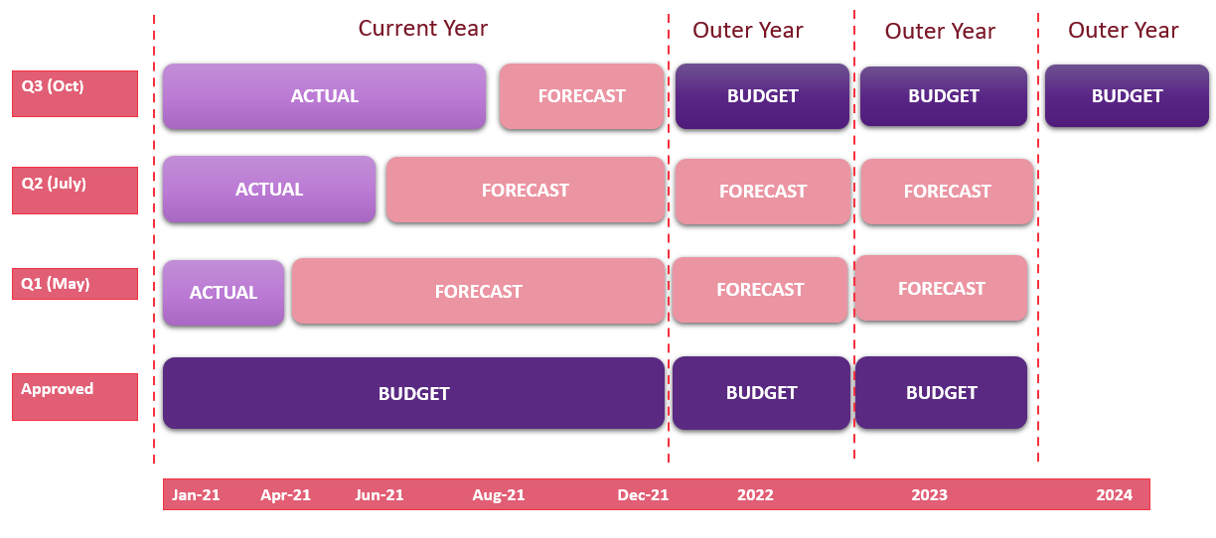

Quarterly Reviews
The rolling forecast and budget process enables the University to regularly refresh its financial outlook on a quarterly basis over a three-year time horizon to ensure funding allocations remain relevant in an ever-changing educational environment.
A critical aspect of the Quarterly Review process is that forecasts are reviewed for the entire 3 year planning period and not just the current financial year. As budget owners it is crucial that Schools, Divisions and Entities apply the necessary rigour in reviewing and updating their financial plans in order to facilitate the effective management and decision making of the University’s finite resources. The Executive member of the Schools, Divisions and Entities is ultimately accountable to the Executive and the Board for their submitted budget and forecast and has a duty of care to remain within the approved parameters of the budget and forecast.

Budget
The process starts with an approved three-year budget which is developed in Quarter 3 (Q3) of the previous year. This essentially means that every School, Division and Entity starts the current year in January with an approved 3-year financial forecast which is called the Budget.

Q1 Forecast
The first review of the Budget occurs in the Q1 Forecast process which is based on actual data from January to April. The first quarter (Q1) incorporates 4 months of data to capture final Semester 1 census data in the revised revenue forecast for Schools and Entities. Once approved, the Q1 Forecast forms the new baseline for the current 3-year review cycle.

Q2 Forecast
The second review of the 3-year forecast occurs in the Q2 Forecast process which is based on actual data from January to June. The review process compares the revised Q2 Forecast for the current 3-year planning cycle to the revised baseline forecast approved in Q1.

Q3 Forecast
The Q3 Forecast process incorporates a review of the current year forecast based on actual data up to end of August as well as formulating a Budget for the next 3-year planning cycle.

Q4 Forecast
The Q4 Forecast process is the final step in the planning cycle. This is the year-end wrap up and involves a final review of the full year actuals to the approved Q3 Forecast.

This cycle continues each year assisted by the quarterly review process as described above.

Funding

Funding is the part of the financial framework that underpins the process of receiving funds (Revenue- also known as Source of Funds) and then distributing these funds via expenses and capital with the plan to return an approved surplus at the end of the calendar year.
Revenue (Source of Funds)
The University categorises revenue in our financial reports as funding sourced from: Government Revenue or Self-Generated Revenue. Government sources comprises CGS/HECS funds for government supported students and Research funding for Research Training Program (RTP). Self-Generated sources include revenue earned from students paying full fees, (domestic and international), consulting activity, conferences, donations, research income from external sources, investment income and property development income.
Expenses (Distribution of Funds)
Expenses are categorised in our financial reports across 6 major funding categories: Operating Activity, Strategic Initiatives, University Wide Activity, Tied and Restricted Grants, Research and Corpus Funds. These funding categories operate independently of each other within the overall framework and are explained below.
Diagram 3: Revenue and Funding Categories
Government
Self-Generated
CGS/HECS
REVENUE
Performance Based Research
Student Fees
External or Tied
Commercial/Consulting
Academic/Incidental
Investment Returns
FUNDING CATAGORIES (Expenditure)

Operating Activity
Strategic Initiatives
University Wide
External or Tied
Research
Corpus Fund Initiatives
Core Revenue
DISTRIBUTION

Property Development
Property Expense

Source of Funds (Revenue)
Sources of Funds are broadly categorised as either Government or Self-Generated revenue.
Government
  - CGS / HECS – A large percentage of the University’s funding is from Commonwealth Supported Student places. Funding is a mix of Commonwealth contributions (CGS) and student contributions via the Higher Education Loan Program HELP/HECS. The amount of the Commonwealth contribution depends on field of education. There are eight different levels of Commonwealth funding clusters. This funding is allocated directly to each School based on units taught.
  - Performance Based Research – relates to Government funding to universities for the Research Training Program and the Research Support Program. The funding supports costs of research and direct support for higher degree research and PhD students.

Self-Generated
  - Student Fees – relates to funding from both Domestic and International full fee-paying students. Full tuition fees are paid directly by the student and there is no government contribution. This funding is allocated directly to each School based on units taught.
  - External or Tied Funds - The University receives both research and non-research grants. Research grants are awarded by specialist agencies such as the State Cancer Councils or other government agencies such as the National Health and Medical Research Council and the Australian Research Council.
Non research external grants are termed Tied Grants by the University. They are typically tied to certain terms and conditions that must be complied with to receive the grant. As these grants are linked to a particular purpose, they are known as 'Tied Grants'.
Philanthropic income is also categorised as external funds and can be tied or untied depending on the conditions stipulated by the donors.
  - Commercial/Consulting - The University also engages in commercial and consulting activity by utilising the expertise that exists in the University to engage in the business of giving expert advice to external entities.
  - Academic/Incidental – This includes miscellaneous student and non-student revenue such as Student Services and Amenities Fees (SSAF), miscellaneous student charges such as graduations fees, student testamurs and ID cards as well as parking and fine revenue.
  - Investment Revenue – The University has a robust treasury management process which encompasses the investment of surplus cash generated from operating activity, estate development and philanthropic income into various investment vehicles. Returns generated from this investment activity is captured under investment revenue.

Distribution of Funds (Expense Categories)
The majority of funds received into the University in a calendar year are distributed across 6 major expense categories. Each School, Division and Entity is accountable for all expense categories within their remit and are responsible for managing the budget and forecast within the approved parameters. In addition, the University has a number of expense policies and delegation of authorities which must be adhered too.
The categories are discussed below:
Operating Activity
The activity within this category reflects the running of the business, in terms of core support services and academic teaching and learning. The expenses related to operational activity are funded from Government grants-CGS, student fees - HECS, International and Domestic Fee Paying, as well as other untied funding sources, such as investment returns, commercial revenues and miscellaneous fees and charges.

Requests to increase expense allocations of operating forecasts at a School or Divisional level can only be approved by the Vice-Chancellor.
Strategic Initiatives
This category reflects initiatives that are strategic in nature and for a defined period.

SI projects are assigned to a specific business unit, who is accountable for the delivery and reporting of the project. These projects are usually approved for a defined period and can be over multiple years. Funding can be moved from year to year if the program of work requires it, however any requirement for additional total project funding can only be approved by the Vice-Chancellor.

Once the project is finalised, the project will either end or the program of works become embedded in Operating Activity.
University Wide Activity
This category incorporates whole of University overhead costs and activity. This category includes building and grounds costs including leasing, international agent’s commissions, bank fees, corporate IT costs, and other overhead ‘cross-organisational’ costs. The amount of funding allocated to each item is approved through the annual budget and rolling quarterly forecasts reviews, by the Vice-Chancellor. The various line items in this category are assigned to business units, who are responsible for the delivery of the associated activity. Any requests for additional funding for individual items can only be approval by the Vice-Chancellor.
External or Tied Funding
This funding category relates to activity that is ‘specifically funded’, excluding Research. This incorporates, specific donations, government based specific funded programs, and any other externally funded specific activity. This activity can occur across all business units of the University and over multiple years. Specific project codes are set up at a business unit level to manage these funds over the approved period. Ordinarily any requirement for additional funding is reviewed/negotiated with the external party. If additional funding is required from the University, this can only be approved by the Vice-Chancellor.
Research Funding
This expense category is split into 2 components. Internal University research expenses and External/Government funded research. The External/Government funded research is ordinarily for specific research projects and managed accordingly. Internal University research expense is funded from general student teaching fees, other untied sources, such as commercial revenue, investment revenue and miscellaneous fees and charges. The allocation of the internally funded research is approved by the Vice-Chancellor during the annual budget process and the rolling quarterly forecast reviews. Any additional internally funded research expenses can only be approved by the Vice-Chancellor.
Corpus Fund Initiatives
This expense category relates to key strategic projects that are targeted towards bringing transformational change to the University’s operations. Funding is provided directly from the annual returns generated from the investment of University’s corpus funds. Requests for new or additional funding can only be approved by the Vice-Chancellor.
Property Expense
This expense category relates to all capital and infrastructure projects including Western Growth. As these projects do not relate to the core operating activity of the University, they do not form part of the University’s Operating Result. Rather, all revenue and expenditure from such activity is reported below the Operating Result and is reflected in the Net Consolidated Result of the University.

Cash Management
Cash Management is the process of understanding and analysing the University’s actual and forecast revenue and cost drivers to ensure the University has sufficient funds to meet its financial obligations when they fall due.
Robust cash forecasting is the cornerstone of effective liquidity management. The Treasury Office maintains a Cash Flow Forecast Model to determine the amount of funding required to maintain liquidity by consolidating forecasts of expected cash inflows and comparing them with forecasts of expected cash outflows.
On the basis of the forecast cash surpluses or deficits, decisions can be made as to what borrowings or investments to make over what time horizon. It is important that the University does not hold excessive cash balances in bank accounts which could be earning better investment yields e.g. term deposits.

Governance
The 3rd core component of the Financial Framework is Governance. In relation to the budget and forecast process governance is concerned with the process of approving and monitoring the plan and the funding (source and distribution of funds).
There are three main components to the Governance process:

Ownership and Approval
Each School, Division and Entity is responsible for the formulation of their own budgets and forecasts and is accountable to report and justify their submissions within the approved timeline.
Any variations to approved budgets and forecasts within each School, Division and Entity sits with the respective School Dean, DVC, VP or Entity Head. However, any increases to the total School Divisional or Entity budget/forecast can only be approved by the Vice-Chancellor.
Below is a summary of the roles and responsibilities of key stakeholders in the Governance process:
Board of Trustees
As the governing authority of the University, the Board is responsibility for developing board policies and strategic plans. It also sets the required level of financial performance for the University. Historically, the Board has required the University to achieve a minimum annual operating surplus of 5 percent of its total revenue. The Senior Executive Group provides the board with regular updates on how the University is tracking against the approved Budget.
The Entities are governed by their own Boards which sets their own financial performance levels separate to the University.
Senior Executive Group (SEG)
The SEG is responsible for approving all budgets and forecasts for the University as well as its controlled entities. It is also responsible for providing parameters for the planning and development of budgets and forecasts each quarter in line with the financial performance levels required by the Board and the forecasted revenue for the University and its controlled entities.
The SEG review the budget and forecast commentaries and reports on a quarterly basis. These reports are a consolidation of what is produced at the School, Division and Entity level and include an overall University commentary.

School Dean’s, Deputy Vice-Chancellors (DVC), Vice-Presidents (VP) and Entity Executives
The Deans, DVCs, VPs and Entity Executives are ultimately responsible for the financial results of their respective portfolios. As the Executive member, it is their role to review all financial information, understand business drivers and communicate changes in funding and expenditure levels to all required stakeholders. Where variations (increases) are required to approved Budgets and Forecasts, the School Dean, DVC or VP is responsible for firstly identifying and implementing financial efficiencies in order to reprioritise funding to cover budget shortfalls. If this is not possible within the approved funding envelope, they can seek approval from the Vice-Chancellor for variations. Likewise, Entity Executives are responsible for implementing the required financial efficiencies within their Entity or seeking approval for variations from their respective Boards.
School Deans, DVC’s, VP’s and Entity Executives are also responsibility for ensuring all budgets and forecasts are accurate and are submitted as per the published Monthly Forecast Timelines (refer section 3.3.3 below). This also includes ensuring the commentary accurately reflects the Schools’, Divisions’ or Entities’ financial position prior to it going to SEG.

Financial Performance and Partnerships
The role of the Financial Performance and Partnerships Team is to support the SEG, Schools, Divisions and Entities in developing, monitoring and reporting on the financial performance of the University and individual Business Units. The key role of Senior Finance Business Partners (SFBP’s) is to be an active Finance Partner and proactively engage with senior management to provide timely and accurate advice in order to facilitate effective decision making. The SFBP’s work alongside Schools, Divisions and Entities to ensure Budgets and Forecasts are maintained accurately within the University’s financial systems (TM1 and Oracle) and highlight any anomalies to senior management so that decisions can be made about appropriate remedial measures. To assist in the dissemination of transparent, accurate and consistent financial information, SFBP’s are responsible for preparing a set of financial reports and commentaries each month both at a School, Divisional and Entity level and at the Consolidated University level. A more detailed description of the SFBP’s role and responsibility and key functional support areas is listed in the Financial Performance and partnerships Service Schedule which can be found in Appendix 4.

Budget Variations
The University uses two instruments to facilitate the formal approval of budget and forecast variations by the Vice-Chancellor (or delegate) being the Request for Additional Budget Adjustment (RABA) form and the Recruitment Business case (RBC). A copy of these forms can be found in Appendix 2 and 3 respectively
The RABA form must be completed in order to obtain formal approval to vary the latest approved budget and forecast expenditure. The form is submitted by the School Dean, DVC or VP at the School/Division level. There is an expectation that School/Divisions have exhausted all avenues to manage costs within the respective portfolios and the RABA is seeking adjustments for incremental costs only. In some cases, variations to budget/forecast may be endorsed by committees such as School Academic Committees (SAC) and Business Infrastructure and Development Committee (BIDC). However, this endorsement does not constitute an automatic budget variation and the School/Division must go through the RABA process to seek formal approval by the Vice-Chancellor.
The RBC is used to obtain formal approval for the recruitment of both budgeted and unbudgeted positions and includes approval for additional funding for relevant salary costs that cannot be absorbed within the School/Divisions approved Budget/Forecast.
Once a RABA or RBC is approved by the Vice Chancellor (or delegate nominated by the Vice Chancellor), the Forecast variation can be incorporated into the current forecast.

Timeline
Timely review and submission of budgets and forecasts is essential to facilitate robust decision making. The Office of Finance publishes a monthly forecast timeline that facilitates the review and submission of Budget and Forecasts by Schools, Divisions and Entities and identifies the various steps in the Budget/Forecast approval process.
It is the responsibility of each School, Division and Entity to ensure that sufficient planning and effort is put into the formulation, review and reporting of monthly Budgets and Forecast as per the published timeline. A copy of the 2021 monthly forecast timeline can be found in Appendix 1.

Appendices
- Monthly Forecast Timeline
- Request for Additional Budget Adjustment (RABA) form
- Recruitment Business Case (RBC)
- Financial Performance and Partnerships Service Schedule

Appendix 1: 2021 Monthly Forecast Timeline
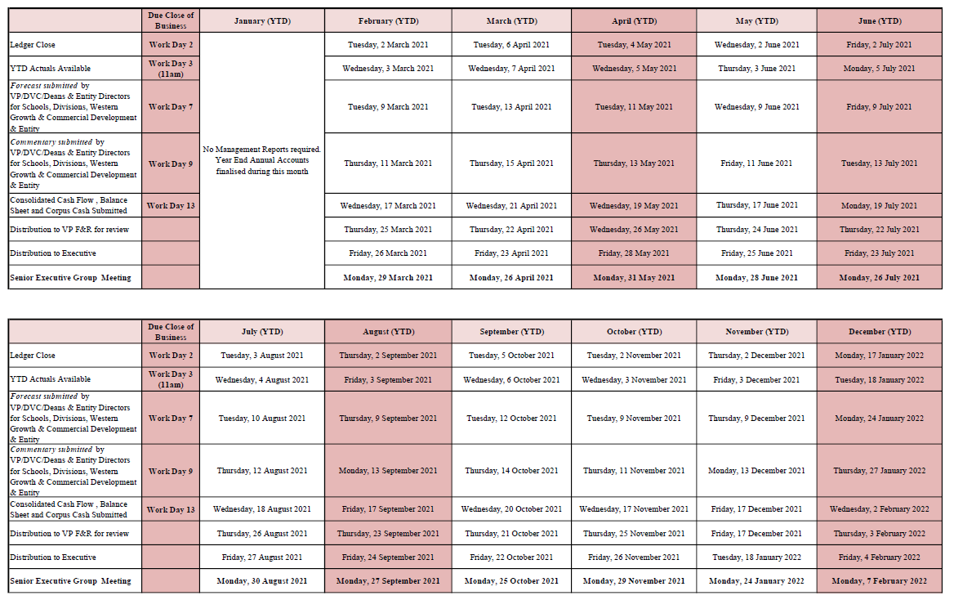

Appendix 2: Request for Additional Budget Adjustment (RABA) form

Request for additional budget adjustment (RABA)

* Arrows indicate Office sending on the form
Divisions send direct to VC by Finance office

If you have identified a requirement for additional expenditure allocation over and above your latest approved Budget/Forecast there are two paths to obtain approval:
- Recruitment Business case: If you require an additional expenditure allocation to support a new position, or a position that has been vacant for longer than 6 months, the Recruitment Business Case form should be completed. This form has been recently revised to include an “Additional Expenditure Requirements” section.
- RABA form: Complete this form for all other additional expenditure allocation requests. Examples of the types of other additional expenditure requests include casual staffing, non-salary items and capital expenditure requirements.
Please note that this request is for increases to expenditure allocations at a School or Divisional level and not to support increases for individual Business Units. Schools and Divisions are encouraged to contain any additional expenditure requirements within the School or Divisional group. If this is not possible then this form is required to support any incremental expenditure on the previously approved Budget/Forecast at the School or Divisional level.
In the “Description of Proposal” section, please ensure you provide a breakdown sufficient to support the additional expenditure requested. Please also demonstrate how avenues for cost absorption within the current funding envelope have been exhausted.
The Vice Chancellor has requested that no increases to expenditure allocations be permitted without the Vice Chancellor’s signature on either the Recruitment Business Case or this RABA form.
Contact details of requestor:
School, Unit or Division: | Contact person:

Details of additional expenditure request:
Title of Proposal:
Description of Proposal: (Please also demonstrate how avenues for cost absorption within current funding envelope have been exhausted):

Amount of additional expenditure allocation required: | 2021  $ | 2022  $ | 2023  $ | Total  $
Salaries/Casuals (including on costs)
NSI
Capital
TOTAL

REQUESTING UNIT SIGN OFF
Name | Position | Signature | Date

DVC/VP/DEAN ENDORSEMENT
Name | Position | Signature | Date

FINANCE REVIEW AND COMMENTS BY SENIOR FINANCE BUSINESS PARTNER AND EXECUTIVE DIRECTOR, FINANCIAL OPERATIONS
Name | Position | Signature | Date
 | Senior Finance Business Partner
Darren Greentree | Executive Director, Financial Operations

COMMENTS BY THE SENIOR DEPUTY VICE-CHANCELLOR (SCHOOL REQUESTS ONLY)
☐ Endorsed ☐ Not Endorsed
Name | Position | Signature | Date
Professor Clare Pollock | Senior Deputy Vice-Chancellor

COMMENTS AND APPROVAL BY THE VICE-CHANCELLOR AND PRESIDENT
☐ Approved ☐ Not Approved
Name | Position | Signature | Date
Professor Barney Glover | Vice-Chancellor and President

Please send a copy of the approved form to all signatories on this form.

Appendix 3: Recruitment Business Case (RBC)
Available online via WesternNow Staff Portal
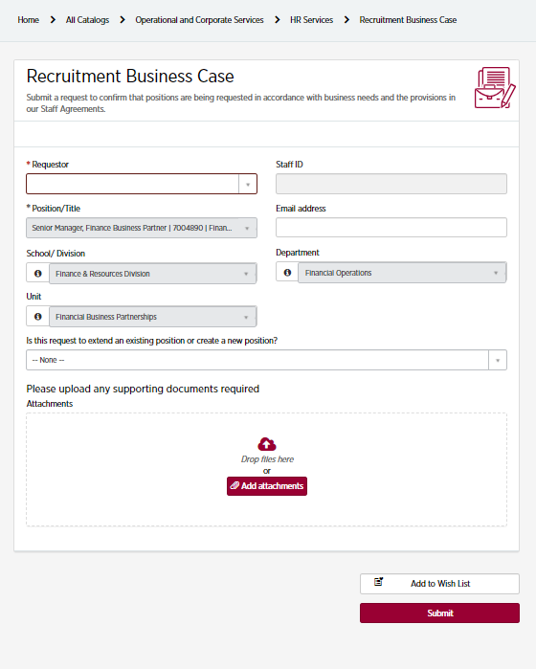

Appendix 4: Financial Performance and Partnerships Service Schedule

Functions | Activity | Financial Performance and Partnerships responsibility | Clients responsibility | Business driver
- Budgeting and Forecasting | Support the preparation of annual Budgets and quarterly Forecasts in line with the published timetable | - Proactively engage with Client’s Senior Management  - Provide advice and support  - Provide financial transparency  - Manage and coordinate internal timeframes  - Review financial input and ensure Client consolidation is in line with Client and University expectations | - Communicate changes in business dynamics e.g. restructures, change in spending priorities, changed funding requirements, staff movements  - Reflect agreed changes in TM1 in line with published timetable  - Maintain data in TM1 e.g. revenues, expenses, salary data and capital expenditure | Client ownership of Budget and Forecast  Accurate budget phasing
 | Compile and distribute Business Unit Budget and Forecast reports | - Provision of information in a timely manner  - Provision of information in a user- friendly format consistent with that which is provided to the Executive | - Review financial information and understand business drivers | Client ownership and understanding of financial position
 | Annual Budget Book publication | - Communicate timetable  - Prepare the Financial commentary section of the report  - Work with client to ensure data is finalised in line with timetable | - Prepare the overarching commentary regarding responsibilities  - Outline the objectives/risks/ opportunities for the 3-year period | Business knowledge and accountability

Appendix 4: Financial Performance and Partnerships Service Schedule – Continued

Functions | Activity | Financial Performance and Partnerships responsibility | Clients responsibility | Business driver
- Financial Reporting and Variance Analysis | Compilation of monthly Financial Management Pack (including commentary) | - Provide the Financial Management Pack in the prescribed format in line with the published timetable  - Provide the variance analysis in the prescribed format in line with the published timetable  - Proactively analyse financial information highlighting areas requiring comment | - Ultimate responsibility for financial results and the causal effects for variances to plan  - Review and understand financial information and request further information on items requiring follow up | Financial transparency and accountability
 | Provision of Business Unit Financial Reports | - Assist, support and develop reports to meet business requirements  - Provide a platform for consistent reporting | - Generate financial reports  - Review financial information and request further information on items requiring follow up | Financial transparency and accountability
- Financial oversight | Provide financial sign off as part of governance process | - Review and comment on funding availability for Recruitment Business Cases and requests to the VC for Additional Budget Approval (RABA)  - Provide financial acquittals as part of the governance process | - Prepare Recruitment Business cases and RABA forms | Financial stewardship

Appendix 4: Financial Performance and Partnerships Service Schedule – Continued

Functions | Activity | Financial Performance and Partnerships responsibility | Clients responsibility | Business driver
Financial oversight (continued) | Provide oversight of financial performance | - Highlight significant financial variances to planned performance  - Review financial systems and processes to ensure they are streamlined and escalate issues as they arise  - Provide support, guidance and help identifying financial efficiencies in conjunction with client | - Ultimate ownership of financial performance  - Application of appropriate delegation for financial transactions  - Identify and implement financial efficiencies | Financial integrity  Financial performance  Fraud prevention
 | Provision of detailed general ledger drill downs | - Provide a training platform and system access | - Undertake general ledger drill downs as required | Financial transparency
 | Ad hoc financial modelling | - Provide proactive insightful analysis as required or requested | - Communicate requirements and scenarios | Financial transparency
 | Asset management | - Provide advice and support regarding capitalisation of expenditure | - Review asset lists on an annual basis in line with the published timetable
 | Ensure staff costing is correctly aligned to current org structure | - Proactive identification of staff costing anomalies  - Assist in the alignment of FTE data between the Finance and HR systems | - Review staff allocations for accuracy  - Liaise with HR to rectify staff miscoding | Financial reporting and variance accuracy

Appendix 4: Financial Performance and Partnerships Service Schedule – Continued

Functions | Activity | Financial Performance and Partnerships responsibility | Clients responsibility | Business driver
Financial oversight (continued) | Transparent Cost of Teaching and Research Modelling | - Maintain a reliable costing model with relevant drivers  - Provide University and School based cost of teaching and research reports | - Review costing data identifying areas requiring model refinement to improve accuracy of data | Financial Performance  Financial Transparency
 | Financial Transaction Processing | - Provide advice and support around purchase order and payment processes | - Client to ensure accuracy in invoice coding and Purchase Order Policy avoiding rework | Financial Control and audit requirement
- General Ledger Maintenance | Preparation and posting of general journals | - Ensure transaction is in line with University policy and guidelines  - Ensure supporting document is attached and has appropriate delegation sign off  - Review and post journals in a timely manner | - Client to identify journal requirement  - Client to prepare journal template  - Client to provide supporting documentation and delegation sign off | Financial control  General Ledger integrity  Audit requirements  Segregation of duties
 | Chart of Accounts Updates/Funding Source Updates | - Ensure requests for new cost centres/project codes align with organisational structure, funding source hierarchy and financial framework, incl. ServiceNow request  - Provide advice on the best way to capture costs/revenues for different activities | - Client to identify need for new cost centre/project code or requirement for project closure | Financial reporting accuracy  General ledger integrity  Financial control

Appendix 4: Financial Performance and Partnerships Service Schedule – Continued
Functions | Activity | Financial Performance and Partnerships responsibility | Clients responsibility | Business driver
- Engagement/ Business Partnering | Training | - Provide system training as required (TM1, Oracle, GL Wand, Dashboard, SAS)  - Develop training packages for wider audience participation (on-line or group sessions) as the need arises | - Identify training requirements | Multiskilling  Job enrichment  Staff development
 | Understand the client’s business | - Proactively engage with the business  - Participation in client projects | - Invite Finance representative to relevant Senior Leadership meetings such as Planning Days  - Engage Finance in working groups and other business initiatives as appropriate | Transparency  Financial insight  Cross unit collaboration
 | Face of Finance | - Be the initial point of contact for all Finance related enquiries  - Understand the broader finance functions, processes and key contacts | - Communicate requirements

