Dragon Professional.

Using Dragon Hands-free

Support Manual 7 of 7

Contents

Using Dragon Hands-free 2

Desktop Commands 2

Using a web browser 3

Adding the Dragon web extension for Chrome 3

Adding the Dragon web extension for Firefox 4

Web Browser Commands 5

Using Mouse Control or Mouse Grid 6

Mouse commands 6

What is Mouse Grid? 7

Working with applications 8

Microsoft PowerPoint 8

Microsoft Word 8

Dragon Bar Help Topics 9

# Using Dragon Hands-free

Refer to the supporting video [*07. Using Dragon Hands-free*](https://westernsydney.ap.panopto.com/Panopto/Pages/Viewer.aspx?id=f0899727-b289-4e8a-945d-abc901841c12).

Dragon has an immense number of commands that can be used to control a computer hands-free. The video entitled ‘Using Dragon hands-free’ that accompanies this document demonstrates the following commands in action.

## Desktop Commands

|  |  |
| --- | --- |
| What you say | What happens |
| Show Desktop | Minimises all open applications |
| List applications | Displays a list of open applications and files |
| Choose <*number*> | Selects file or application from the list |
| Switch to <application> | Instantly switches to named application |
| Open My Pictures | Opens My Pictures window |
| Click <name of folder> | Opens named folder |
| Move down <*number*> | Selects file in list view |
| Press enter | Opens selected file |
| Click close | Closes selected file |

*Additional commands are located in the Command Cheat sheets located on the Dragon Training and Support page* [www.westernsydney.edu.au/dragon-training](http://www.westernsydney.edu.au/dragon-training).

## Using a web browser

### Adding the Dragon web extension for Chrome

View [The Dragon Web Extension for full power in Chrome](https://www.youtube.com/watch?v=G6gWXSBdK-Q&feature=youtu.be) video for full steps on how to add the Dragon web extension.

After the extension has been added you will have enhanced dictation and editing and will be able to use hands free to click links.

To install the extension:

1. Go to the [Chrome Webstore Extensions page](https://chrome.google.com/webstore/category/extensions).
2. Search for “Dragon web extension”.
3. Click “Add to Chrome” button.

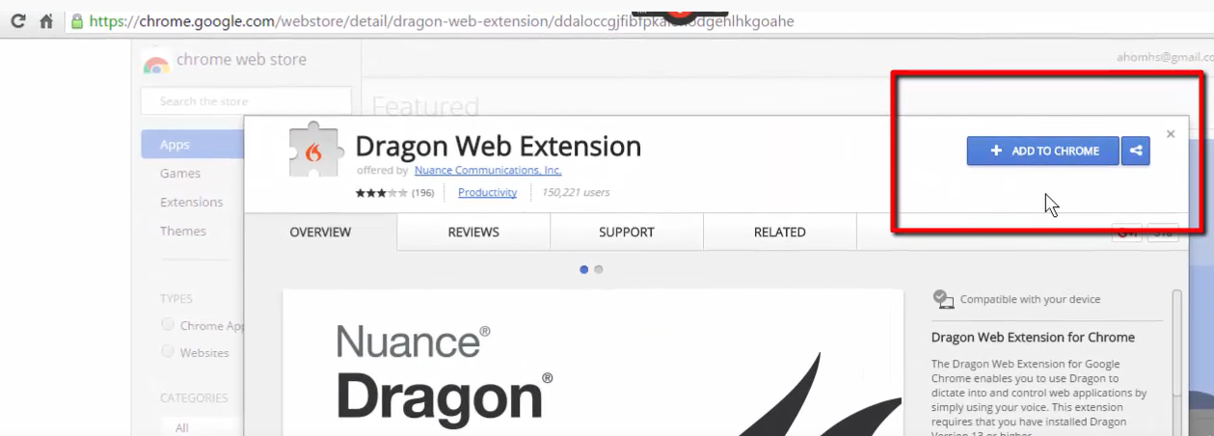

1. Click “Add Extension”.

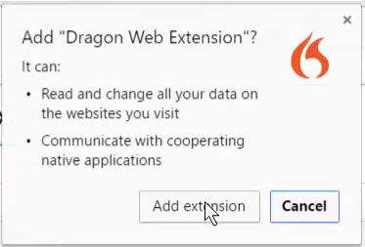

1. Refresh or restart Chrome to activate.

### Adding the Dragon web extension for Firefox

1. Open Dragon.
2. Open Firefox.
3. A dialogue box will open, click “Proceed”.

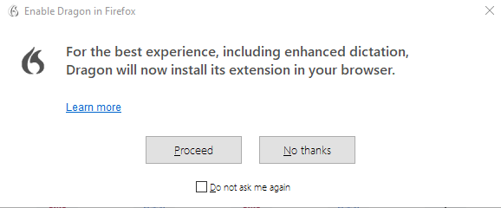

1. Click “Install web extension”.
2. Click “Allow” at the prompt.
3. Click “Add” at the prompt.
4. Click the menu icon and select “Add-ons”.
5. Click “Extensions”.
6. Once completed close the Add-ons Manager.

### Web Browser Commands

The Dragon Web Extension for Firefox or Chrome must be installed to click webpage controls by voice.

|  |  |
| --- | --- |
| What you say | What happens |
| Open Chrome / Open Firefox | Starts up your browser |
| Click <name of link> listed in Bookmarks Bar | Opens website |
| Click <link name> | Opens web link |
| Press tab | Goes to next text field in a web form |
| Press shift tab | Goes to previous text field in a web form |
| Scroll down | Jumps down to the bottom webpage |
| Start scrolling down | Begins slowly scrolling down webpage |
| Faster | Increases scrolling speed |
| Stop scrolling |  |
| Go to top | Jumps back to top of webpage |
| Show links | Allocates a number to all links on web page |
| Choose <number> | Select web link |
| Click back | Goes back to previous webpage |
| Go to next tab | Displays webpage in next tab |
| Go to previous tab | Displays webpage in previous tab |

On occasions, the show links command will stop working. It will be necessary to refresh the page.

## Using Mouse Control or Mouse Grid

### Mouse commands

The mouse can be controlled by the following commands;

* “Move mouse [left] [right]”
* “Move mouse up”
* “Move mouse down”
* “Move mouse lower [left] [right]” for diagonal down movement.
* “Move mouse upper [left] [right] for diagonal up movement.

There is the option to say commands adjust the speed of the mouse movement. After giving the command to move the mouse, the following commands spoken will adjust the speed;

* "Faster"
* "Slower"
* "Very Fast"
* "Very Slow"
* "Much Faster"
* "Much Slower"

And to stop the mouse, the command is “Stop”.

When working on large desktops the mouse trail can be very long, so using Mouse Grid in combination with mouse control is worth exploring.

### What is Mouse Grid?

Mouse Grid allows you to use your voice to select the area of the screen you want. Mouse Grid divides your screen or active window into nine numbered areas. You can then move your mouse pointer to any of those areas by saying the number. Dragon redraws the grid each time the pointer moves to a new area.

To activate, say the command “Mouse grid”. This will open the grid across your screen, where you continue to select the numbers to access the specific area of the screen you require.

To turn Mouse Grid off, say the command “cancel Mouse Grid”.

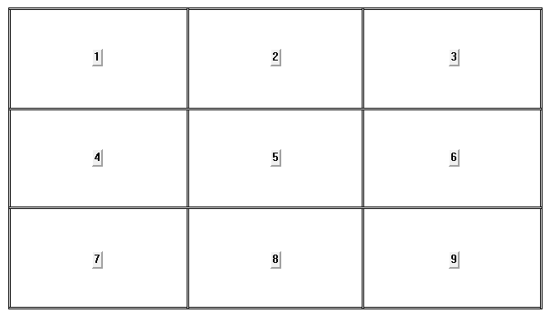

|  |  |
| --- | --- |
| What you say | What happens |
| Mouse Grid | Displays a 3 x 3 array of numbered areas |
| <*number*> <number> | Pointer moves to the area. Grid is redrawn. |
| Click | Executes a left mouse click |
| Cancel | Closes Mouse Grid |

Besides web pages, Mouse Grid can be used with applications or on the desktop screen. On your desktop, Mouse Grid can be used to click and drag objects.

## Working with applications

### Microsoft PowerPoint

|  |  |
| --- | --- |
| What you say | What happens |
| Next slide | Move around a presentation |
| Go to fifth slide | Move around a presentation |
| Add a new slide | Adds a new slide |
| Duplicate slide | Duplicates selected slide |

### Microsoft Word

|  |  |
| --- | --- |
| What you say | What happens |
| Select paragraph | Selects the paragraph |
| Make that <number> points | Changes font size |
| Make that <colour> | Changes font colour |
| Cut that | Cuts selected text |
| Paste that | Pastes selected text |
| Click Design | Selects Design tab in Ribbon |
| Click ‘blue accent 5’ | Changes page colour |
| Insert <number> by <number> table | Inserts table |
| Press tab | Navigate table in cell order |
| Press shift tab | Navigate table in reverse order |
| Move down 2 cells | Navigate table |
| Move right 3 cells | Navigate table |

Dragon allows you to create your own custom commands. Custom commands can include blocks of text much like an email signature. Commands created with recording macros can also be created to perform a mouse function. E.g. empty recycle bin.

## Dragon Bar Help Topics

Each person’s workflow and access barriers are unique. The commands demonstrated in the accompanying video are just a small sample of commands that can be used. To further explore hands-free possibilities with Dragon look at the ‘Use Dragon hands-free’ resources in Help Topics.

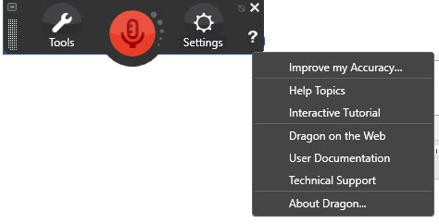

To access Help Topics:

1. Click ‘Help’, the “?” on the Dragon bar.
2. Click ‘Help Topics’.
3. Type “use Dragon hands-free” topic into the search field or navigate through the available menu options.

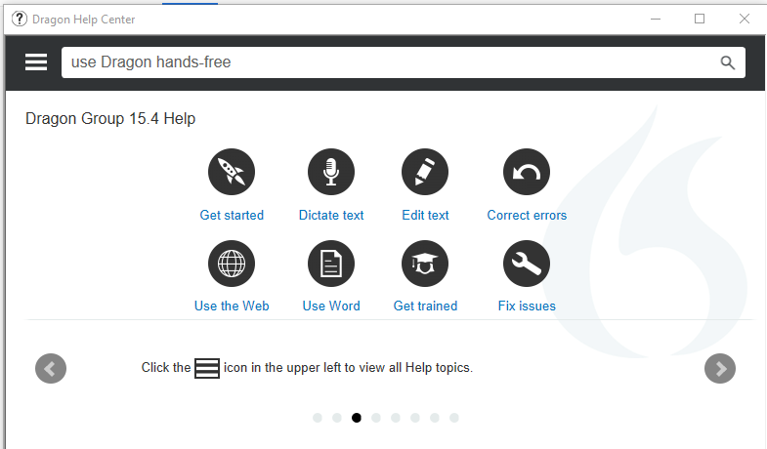

*More information is located on the Dragon Training and Support page* [www.westernsydney.edu.au/dragon-training](http://www.westernsydney.edu.au/dragon-training).