Dragon Professional.

Editing Documents

Support Manual 5 of 7

Contents

Editing documents 2

Page Navigation 2

Editing a document 3

Additional Edit Commands 4

Dragon Bar Help Topics 5

# Editing documents

Refer to the supporting video [*05. Editing documents*](https://westernsydney.ap.panopto.com/Panopto/Pages/Viewer.aspx?id=277924af-53f3-4b02-87d1-abc90183c64f).

As well as initially dictating your text into a document, voice commands can be used to insert, replace or delete text. Keep in mind that commands must be spoken without hesitating or Dragon will interpret this as dictation.

The video tutorial entitled “[Editing Documents](https://westernsydney.ap.panopto.com/Panopto/Pages/Viewer.aspx?id=277924af-53f3-4b02-87d1-abc90183c64f)” that accompanies this document demonstrates the following commands in action.

## Page Navigation

|  |  |
| --- | --- |
| What you say | What happens |
| Go to end of sentence | Places cursor after current sentence |
| Go back | Places cursor at previous position |
| Select sentence | Selects current sentence |
| Select paragraph | Selects current paragraph |
| Go to end of paragraph | Places cursor at end of current paragraph |
| Move down four paragraphs | Cursor moves down four paragraphs |
| Go to end of next paragraph | Moves cursor to end of the next paragraph |

## 

## Editing a document

The most efficient way to edit is to be precise with placing the cursor before or after a specific word.

|  |  |
| --- | --- |
| What you say | What happens |
| Insert before <*word*> | Places cursor before the word |
| Insert after <*word*> | Places cursor after the word |
| Insert before <*word word*> | Places cursor before a set of words |
| Insert after <*word word*> | Places cursor after a set of words |
| Delete last word | Deletes the word before the cursor |
| Delete next word | Deletes the word after the cursor |
| Delete previous four words | Deletes the four words before the cursor |
| Delete next three words | Deletes the three words after the cursor |
| Delete <*word*> | Deletes the specified word from the document |
| Choose <*number*> or <*number*> | To specify the word from multiple occurrences |
| Cap that | Capitalises previously spoken word or phrase |
| Delete sentence | Deletes sentence where cursor is placed |
| Delete <*word*> to <*word*> | Deletes string of text inclusive of the two words |
| Undo that | An essential command to keep in mind! |
| Delete <*word*> | Deletes the specified word from the document |
| Choose <*number*> or <*number*> | To specify the word from multiple occurrences |
| Cap that | Capitalises previously spoken word or phrase |
| Delete sentence | Deletes sentence where cursor is placed |
| Delete <*word*> to <*word*> | Deletes string of text inclusive of the two words |

## Additional Edit Commands

|  |  |
| --- | --- |
| Click: | To learn about: |
| Cutting, copying, and pasting text | Commands to cut, copy, and paste selected text. For example:  •"Cut That".  •"Copy That".  •"Paste That". |
| Inserting, replacing, and deleting text | Commands to delete, replace and insert text while you are dictating. For example:  •"Undo that".  •"Scratch that".  •"Delete <text>". |
| Selecting and deselecting text | Commands to select text. For example:  •"Select Next Line".  •"Select <text>".  •"Unselect That". |
| Aligning text | Commands to align text. For example:  •"Center that".  •"Left Align That". |
| Working with multiple text matches | Choosing the right text when Dragon finds multiple text matches. Multiple text matches can occur when you say a text command and Dragon finds multiple instances of that text. |

Step by step in-depth instructions are located in the   
Dragon Help Center available through the Dragon Toolbar.

## Dragon Bar Help Topics

The commands demonstrated are just a small sample of commands that can be used. Refer to the Help Topics in the Dragon Bar for more information.

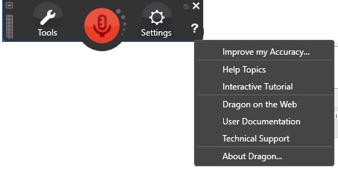

1. Click the “?” on the Dragon bar.
2. Click ‘Help Topics’.
3. Type your topic into the search field or navigate through the available menu options.

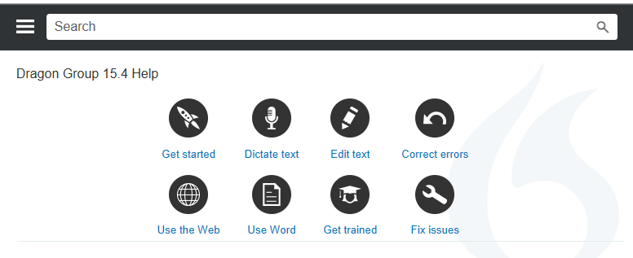

*More information is located on the Dragon Training and Support page* [www.westernsydney.edu.au/dragon-training](http://www.westernsydney.edu.au/dragon-training).