The University remains open. Managers are asked to balance the need for their staff to be on campus, the ability to work at home, and importantly, consider any extenuating circumstances.
Supervisors are required to evaluate the operating requirements of the University when making a recommendation to the Manager of the Unit to approve a working from home arrangement.
Please seek direction from your supervisor about working from home, including what work can be undertaken remotely. If you have existing medical conditions, you are encouraged to also discuss your individual circumstances with your supervisor.
Once approval has been given for your working from home arrangements, you are required to still complete your on line time sheet and please remember WSU standard 7-hour work day applies. In order to work efficiently and to take good care of your health, there are many simple things you can do to make working at home productive and enjoyable.

1- Get your seating position right:
Create a study area, with a desk and upright chair. Lighting is key to ensuring you don't strain your eyes, ensure the area is tidy and free of slip trip fall hazards. Try not to work in your bedroom — keep this for relaxing and sleeping only. The workstation set up below depicts an optimal ergonomic setup. Remember to report all incidents or injury to WHS whs@westernsydney.edu.au.
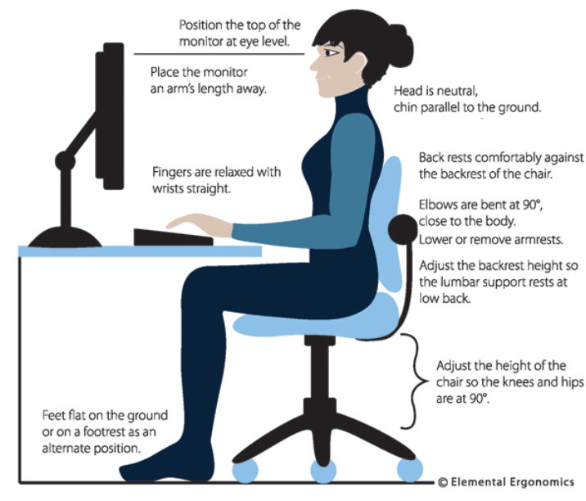

2- Look after your overall well-being:
Your wellbeing and self-care is just as vital in the office as it is when you're working from home. Start the day by dressing for work this allows you to mentally prepare for work. Drink plenty of water and maintain a healthy balanced diet- WHS&Wellbeing tips for healthy eating. Also make sure you move your body! Set an hourly alarm on your computer to stretch and take breaks along with getting up and to stand, walk, or exercise to promote circulation and prevent muscle stiffness.

3- Stay connected:
Use zoom to schedule meetings with colleagues and manager, use your morning tea to connect digitally, typing hello to an email is not the same feeling you get as you see the smiling faces of your co-workers in the morning. Ask your manager to schedule time to chat. The more you communicate with colleagues, the more connected to the team you will feel.

4- Set clear objectives for yourself:
When you're working from home you are your own motivator. When you are away from colleagues and team members, you rely on your own motivation to get through the working day. A great way to begin each morning is by making a to-do list of everything that needs to be done. If you're feeling overwhelmed, prioritise what can wait for another day and what needs to be done immediately, your manager can assist you here. You'll feel much better ticking everything off as it gets done.

5- Needing ITDS support:
ITDS has prepared a website which you can access which contains details around how to obtain support whilst working at home, along with how to access use the Digital Services of the University.

https://www.westernsydney.edu.au/information_technology_services/its/covid-19_itds_advice,_guides_and_support

6- Need further help:
As part of WSU duty of care, our staff are entitled to free, confidential counselling services through the Employee Assistance Program (EAP) contactable on 1800818728.

