Globally Harmonised System of Classification and Labelling of Chemicals (GHS)

There are nine hazard pictograms which represent physical, health and environmental hazards:

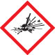 | 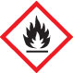 | 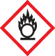
Exploding bomb | Flame | Flame over circle
Explosives  Self-reactives  Organic peroxides | Flammables  Self reactives  Pyrophorics  Self-heating  Organic peroxides  Emits flammable gas | Oxidisers

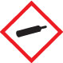 | 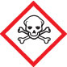 | 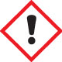
Gas cylinder | Skull and crossbones | Exclamation mark
Gases under pressure | Acute toxicity (severe) | Acute toxicity (harmful)  Skin/eye irritation  Skin sensitisation  Specific target organ toxicity (single)  Hazardous to the ozone layer

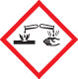 | 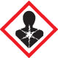 | 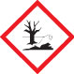
Corrosion | Health hazard | Environment
Corrosive to metals  Skin corrosion  Serious eye damage | Carcinogenicity  Respiratory sensitisation  Reproductive toxicity  Specific target organ (single)  Specific target organ (repeated)  Germ cell mutagenicity  Aspiration hazard | Aquatic toxicity (acute)  Aquatic toxicity (chronic)

Adapted from: http://www.safeworkaustralia.gov.au/sites/swa/safetyinyourworkplace/hazardoussubstancesanddangerousgoods/ghs/pages/ghs.aspx
http://www2.unitar.org/cwm/publications/cw/ghs/GHS_Companion_Guide_final_June2010.pdf
http://www.unece.org/fileadmin/DAM/trans/danger/publi/ghs/ghs_rev04/English/ST-SG-AC10-30-Rev4e.pdf

