Western Sydney University Student Elections Guide
National Union of Students (NUS) Delegates – National Conference
2020

BAKER, Tash
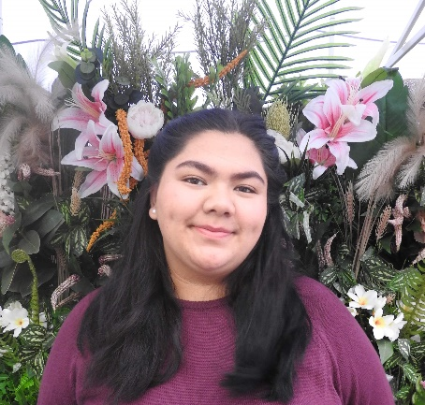
20111739
Tash BAKER
My name is Natasha Baker. I am writing to apply for a position for National Union of Student Delegates at Nirimba campus. I am a recent high school graduate and I am currently in my first year and I am studying a Diploma in Health Science Extended.
I would use this as an opportunity to prosper and advocate for the needs of the student body. I may not have any experience of being a member of NUS, but I am eager to learn. I am confident that if I were to take part in the National Union of Students, we can combat inequity and grant accessible education, creating an expansion in job prospects for everyone with the inclusion of minorities to evidently assist in shaping the future of education.
I look forward to hearing from you. Thank you for your time and consideration.
BOJANIC, Matt
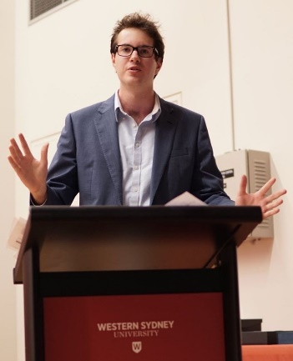
18703623
Matt BOJANIC
My name is Matt Bojanic and I’m currently the President of the Student Representative Council. Having been involved in student representation for over two years, and studied at Western for almost five, not only do I understand many of the challenges faced by our students on a day to day basis, I’ve actively fought for change. I strongly believe in the importance of the student voice, having previously worked to increase student consultation on decisions relating to SSAF Funding, Facilities and Services, and having fought for the University to provide greater support for student employment, mental health and rights in general. And this hasn’t stopped in 2020, with me actively advocating for students impacted by the COVID-19 Outbreak, to ensure they receive adequate support from the University as they are shifted online. So, trust experience, and ensure you’re better represented at a national level. Vote #1 Matt Bojanic for NUS!
BONATTI, Daniel
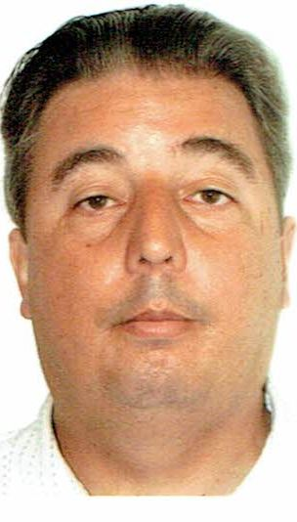
19257310
Daniel BONATTI
I am currently one of six National Union of Students (NUS) Western Sydney University delegate, 2019-2020 seeking re-election. During my representation I convinced the SRC from not disaffiliating of NUS with a speech of the purpose of national representation. I was sent as I of 4 delegates for WSU to, NUS’s National Conference (NatCon) at Federation University, Ballarat. This was a chance to debate policy, meet student representatives and student activists, and decide NUS direction into the future. At the conference I used my Justice of Peace wider community appointment, certifying, nominations for Greenindes, (Greens &independents). Notwithstanding getting General Secretary of WSU SRC which led to his election as WSU NUS representative. WSU SRC provided leadership getting, in NUS when our four motions all went through, for which we publicly advocated for neutral gender toilets, blood transfusion and two disability issues. Backed with experience please vote for me.
CHUNG, Mary-Pearl
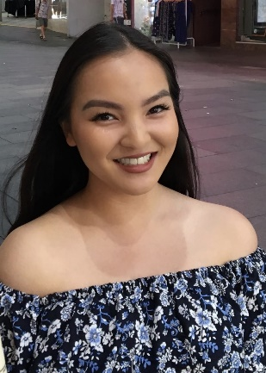
19951124
Mary-Pearl CHUNG
I’m Pearl! I’m currently an undergraduate communications student at WSU. I’m nominating for a delegate opportunity for the National Union of Students Conference in 2020.
Throughout my student life I have been actively involved in a range advocacy and leadership experiences, such as having been awarded an Australian Defence Force Long Tan Youth Leadership Award in 2018, school captaincy, and youth ambassadorship in Multicultural Youth Affairs Network (MYAN) NSW, Youth Action (Young Women Lead- Western Sydney program), Vinnies Youth Social Justice, PLAN International Australia Youth Activist Leader— to name a few.
My passions include art, music, food and social justice. I consider myself a very positive-minded and understanding person, and I would love to create and maintain a great university experience for all my peers by encouraging involvement, diversity and tolerance. If given the opportunity, I will do my best to contribute to a dynamic and inclusive university student life.
CUPITT, Sarah
19760041
Sarah Jane CUPITT
Hi, I'm Sarah Cupitt, and I want to continue representing student's rights and interests at WSU alongside my team 'Strength & Integrity'. I'm an ambitious 2nd-year student studying a Bachelor of Communication (Journalism & PR) playing a vital role in student advocacy relating to university-wide issues, collaborating on programs and services that offer a range of student opportunities. During my first year at Western, I was the SRC Online Students Representative, NUS delegate, became an exec of 8 student clubs and was last years recipient of the Western Sydney University Community Scholarship and the winner of The Academy's Emerging Leader Award. Recently, as the Vice President of Education (Undergraduate), I've been able to make a further positive impact on student engagement. This year in the SRC, my goal is to connect students to ensure optimal participation by including students in shaping the policies and practices that affect their learning experiences.
DAOUD, Tony
19398336
Tony DAOUD
Hi I’m Tony. I came to the realisation that inaction is a part of the problem. Criticising others while sitting on the sidelines isn’t good enough and so I will actively be taking part in this campaign. I take this role very seriously and the only promise I will make is that I will do all that I can to the very best of my abilities. The truth is often pushed aside for mistruths and white lies especially by people in positions of trust and power but that will not be the case with me. I take inspiration from my mentor Donald Trump and will be as open and upfront about all activities and ensure an open forum is present between us all so that we can work together to finally bring about a better university experience for us all. So Vote [1] Tony Daoud for President and for JUMPSTART.
FICARRA, Veronica
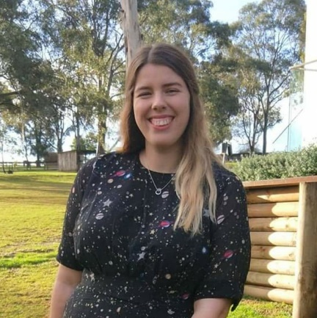
19980137
Veronica FICARRA
My name is Veronica Ficarra, I’m a second year Sustainable Agriculture and Food Security student, and I want to Jumpstart our National Union of Students Conference! The NUS is the best way forward for the improvement of tertiary student welfare in Australia. It has the power to change the lives of every university student in Australia. We're stronger together when united under the NUS, and if elected as a Delegate to the NUS National Conference I will proudly vote to truly represent students of Western Sydney to get the best NUS that Aussie students deserve. Please vote for JUMPSTART for NUS!
FISARA-FITZPATRICK, Fletcher
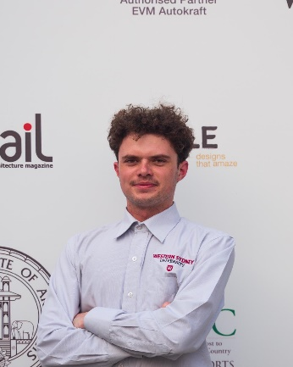
19033756
Fletcher FISARA-FITZPATRICK
Hey all, I’m fletcher and this year I’ll be running for SRC along with my colleagues from JumpStart WSU.
But why pick me?
Well, having proven myself to the harshest critics in society, local pub veterans have gone as far to say I’m an exceptional athlete, communicator, visionary and all-round top bloke.
With 2020 as of far being nothing short of a big kick in the marbles, it’s time to hit reset and bring back the roaring 20s into 2020. With your vote, I’ll strive to improve our campus community and let your ideas be heard. It’s time to better our community; environmentally and socially.
Just remember to vote Fletcher and the JumpStart Team.
HAQUE, Ishmamul
19478584
Ishmamul HAQUE
Hey, I am running for the National Union of Students (NUS) to represent WSU. The NUS is the peak representative body for students. They advocate for students across Australia and their advocacy leads to results for every student. As an international student who has been in 3 different countries, I am capable of evaluating policies from different perspectives. For the same reason, I am not easily swayed by the dominant local political affiliations because my primary focus is on the welfare of my peers and not political gains. As part of the union, I would push for a united front to lobby the university into investing more into mental healthcare for all students. I am the President of the Debating Union and hence am trained to get my arguments (student concerns) across and the NUS support will empower us to take stronger action. Vote me to increase uni accountability!
HAMMOND, Hollie
16727869
Hollie HAMMOND
[candidate did not supply statement for this position]
HUQUE, Samira
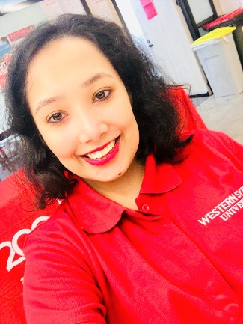
17810438
Samira HUQUE
My name is Samira Huque I am a student from Western Sydney University Sydney City Campus studying Bachelor of Social Science majoring in Criminology. The main reason behind nominating myself for National Union of students (NUS) National Conference 2020 Delegate.
Being at WSU Sydney City Campus I’ve always enjoyed participating in different social activities and events that took place knowing that Sydney City Campus has a lot of ethnics and a vast majority of international students
I strongly support the values of student’s rights especially when it comes towards a serious issue like the coronavirus, whilst this is happening I strongly think that every student has the right to feel safe and healthy from an environment where the virus is likely to harm a person’s wellbeing, students have the right to ask university to put their units online as precaution and minimising the spread of the virus
JHA, Vageesh
19218726
Vageesh JHA
Hi everyone, I would like to put forward my candidacy for VPP as I feel I can bring in a change towards the Postgraduate students. Having been part of the SRC for a year, I have worked alongside many student communities and have been a strong advocator for changes that need to be brought towards the shuttle services, and I am currently representing the interests of the international students to receive concession travel cards. I know what effective policies to implement that will fix these issues having worked on and applied some at Western Sydney. The focus of my efforts would be towards employment and mental health of postgraduate students, as these are the primary concerns of these students.
I am looking forward to the opportunity to work as your new Vice President Postgraduate.
JIWANI, Adeem
19533719
Adeem JIWANI
My name is Adeem Jiwani, I'm a final year Master of Business Administration Student. I am running for National Union of Students Delegate because I am currently working as a NUS delegate and I am aware of the student advocacy. I have been a regular participant in student activities on campus and have been working as an "Ask Us Assistant" for a while now. I would like to ask you for your support to be elected as an NUS Delegate of the Westerns Sydney University for 2020, so we can continue to embrace to take our point of view and ideologies at WSU to the National Conference and create a place that is welcoming, warm and courteous to students and bringing equality to students. I promise no more sitting there! It’s about moving forward and creating change for my peers.
KEHER, Anna
19952736
Anna KEHER
Hi! My name is Anna and I am studying a Bachelor of Business (Human Resource Management). I am a bubbly, honest and hard-working young student. I want to advocate for students with disabilities by fighting for easily accessible lecture recordings, cheap/free hand writers, wheelchair accessible buildings on campus and adequate mental health services (especially during the coronavirus pandemic). I also want to fight climate change through supporting the work of the environmental collective on campus and encouraging the Uni to divest from fossil fuels. Lastly, I also aspire to support staff and student unionism. I believe we’re stronger when we work together. Please vote me to be one of the NUS (National Union of Students) Representatives!
LEWIS, Rose
18220285
Rose LEWIS
Hey lovelies!!! 👋
My name is Rose, I’m a fifth-year student studying business and law in Parramatta and I think I’m a top pick for NUS Delegate for these reasons:
(1) I’m brave and ready to speak up for equality and quality education. I have experience in public speaking, research and I hold my ground in a debate.
(2) I’m well connected. In addition to sitting on WSU’s Board of Trustees, I’ve been a WSU Student Curriculum Partner and an advocate for feminism, multiculturalism and wellbeing so I have extensive knowledge on topics to be discussed.
(3) I’m a content creator! If selected, I will commit to making vlogs, social media posts and an article regarding the experience so dozens of people can learn from my experience.
So that’s me in a nutshell - thanks for your time in reading this, I hope you decide to vote for me! 😎
OLI, Ash
19281054
Sash OLI

Hi my name is Ash. I’m running in the election to be a NUS Delegate. Vote for ASH OLI and Vote for your JUMPSTART Candidates!
PARKAR, Rameez
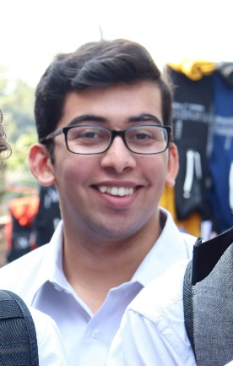
19290573
Rameez PARKAR
Hi I’m Rameez. I never thought I would ever run for the Western SRC but I don’t think I could sit by quietly any longer. For too long now the students of Western Sydney University have had their interests ignored. Like many students I have met my “uni life” consists of coming to class and going home because there is not enough to do on campus. That is why I started a student club and that’s why I’m now running for the SRC. I think that so much can be done to serve the interests of students rather than spending hundreds of thousands of dollars on merchandise that the vast majority of the 45,000 Western students have never seen. There has never been a more important time for strong progressive, principled and pragmatic students representatives fighting for us! Let’s make WSU even better! Vote [1] Rameez Parkar and JUMPSTART!
RAM, Crystal
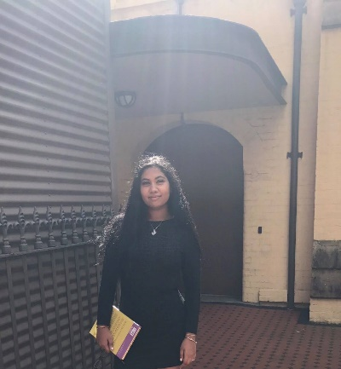
18702590
Crystal RAM
Hi, everyone! I'm Crystal, I'm a candidate at our student elections, and I want to JUMP START WSU. Currently on the executive of Student Clubs, I want to put my leadership experience to work for all of WSU.
This election is very important because our voice will be listened to. This will happen unless you do not vote. And other students’ ideas and thoughts will be heard. I’m the right person to do this job. In the first place, I’m a very responsible person and I love speaking before an audience. Second, if you vote for me, I will speak out for your complaints and problems that I’m sure you have on campus.

If you elect me and empower me with your trust, I will make several changes to the current leadership team. We plan on adopting and introducing more diverse and varied events, widening options for students, this will
REED, Robert
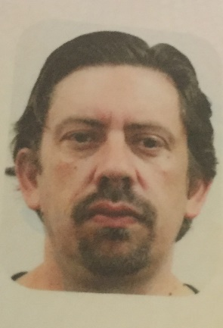
17277873
Robert REED
My name is Robert Reed, I am a current Undergraduate Student at Western Sydney University, currently studying a Bachelor of Podiatric Medicine
I have been involved in Student Representation at Western for 4 years as Disability Officer for the Campbelltown Campus. During this time, I have learnt about the urgency and need for advocacy for the rights of students from a policy level.
If I am to be elected as NUS delegate for 2020, I will strive for sustained equitable policy change to ensure a holistic level of advocacy to students regardless of their identification to any particular equity group. I am also of the belief that Western students require a strong delegation within the NUS that supports the unified interests of students within the university and does not play into party politics.

SHRESTHA, Bhabish
20050753
Bhabish SHRESTHA
I am interested to be the Student Representative of Parramatta Campus and National Students Union Delegate 2020 to be the students voice and voice of voiceless. I will ensure to unite the emerging leaders of our campus in the days to come. I will try my best to elaborate and create domestic and international network for peace, cooperation, mutual understanding and sustainable development across the campus and our community. I assure we will together work for the peace, meaningful participation of every student and innovation. I whole-heartedly reckon that we shall gain invaluable knowledge regarding the critical youth and global issues and the meaningful cum effective way to solve them from whole new perspective, to learn new tips and tactis for the sustainable development via different activities in our campus. My main objective will be to create student friendly environment throughout our campus and make sure that everyone gets the

